Research article – Supplemenatry data

Concurrent metabolic profiling and quantification of aromatic amino acids and phytohormones in Solanum lycopersicum plants responding to Phytophthora capsici.

Msizi I. Mhlongo¹, Lizelle A. Piater¹, Paul A. Steenkamp¹ Nico Labuschagne² and Ian A. Dubery¹*

¹Department of Biochemistry, University of Johannesburg, P.O. Box 524, Auckland Park, Johannesburg, South Africa; ²Department of Plant and Soil Sciences, University of Pretoria, Private Bag X20, Hatfield, Pretoria, 0028, South Africa. * Correspondence: E-mail: idubery@uj.ac.za; Tel.: +27-11-559-2401.

__________________________________________________________________________________________

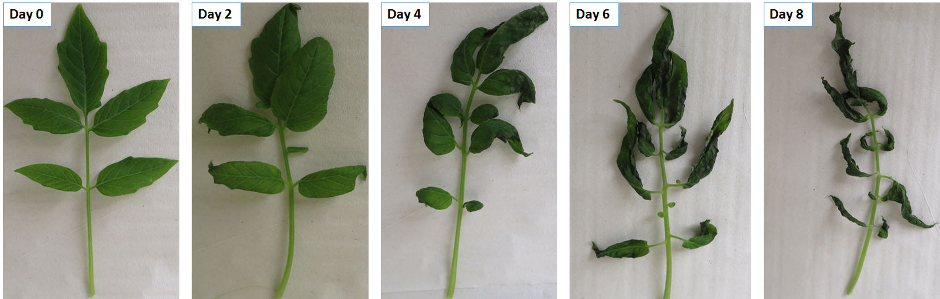

Fig. S1: Symptom development in tomato leaves harvested at different time points following inoculation with Phytophthora capsici zoospores. Leaf wilting started on day 2 and progressed over time, and at day 8 the tomato leaves were completely wilted.

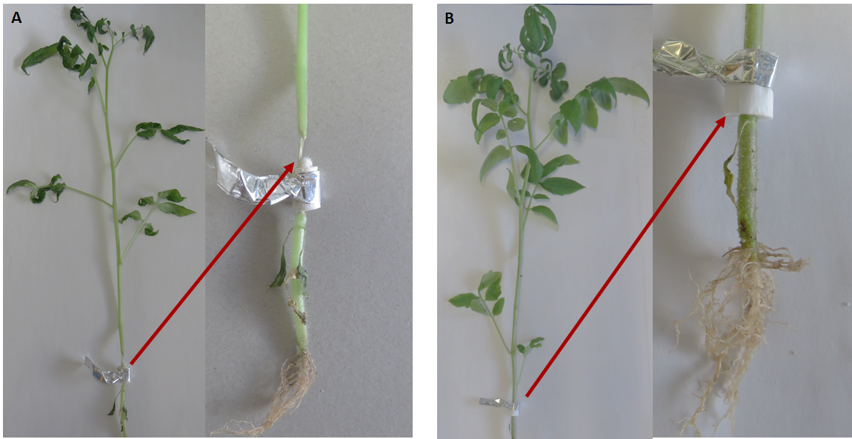

Figure S2: Eight days post-infection comparison between P. capsici -infected and control tomato plants.
(A): Zoospore inoculated plant with arrow indicating infection and necrosis at the inoculation site and
(B): Control plant with arrow pointing to a Ventti filter wrapped around the inoculation site. (Section 4.1).

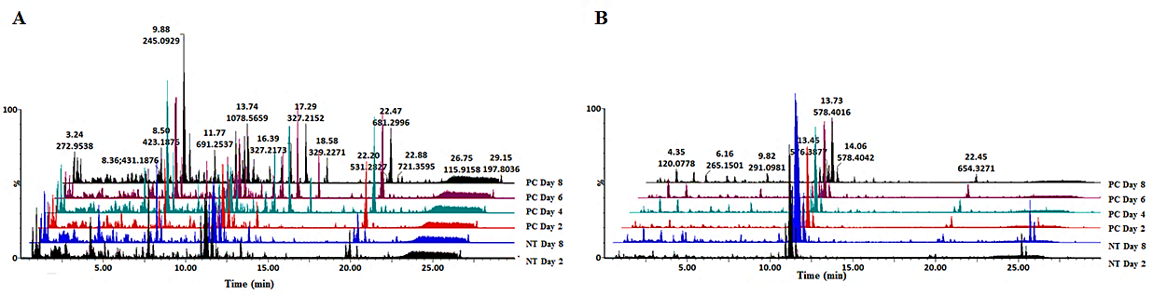
Figure S3: Representative BPI MS chromatograms of extracts from tomato plants infected with Phytophthora capsici; leaf tissue. Base peak mass chromatograms displaying comparative chromatographic differences in different time points: non-treated (NT, days 2 and 8) and P. capsici (PC, days 2, 4, 6 and 8) infected. Visual inspection of the chromatograms evidently shows differential peak populations, for instance in the 4-20 min chromatographic region. (A): ESI negative mode and (B): ESI positive mode.

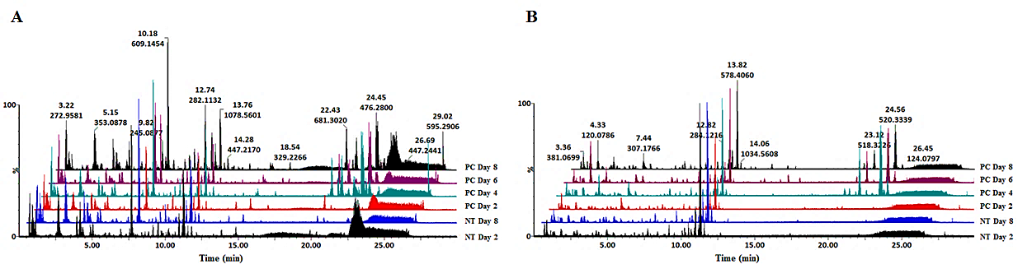
Figure S4: Representative BPI MS chromatograms of extracts from tomato plants infected with Phytophthora capsici; stem tissue. Base peak mass chromatograms displaying comparative chromatographic differences in different time points: (i) non-treated (NT, days 2 and 8) and (ii) P. capsici (PC, days 2, 4, 6 and 8) infected. Visual inspection of the chromatograms evidently shows differential peak populations, for instance in the 4-20 min chromatographic region. (A): ESI negative mode and (B): ESI positive mode.

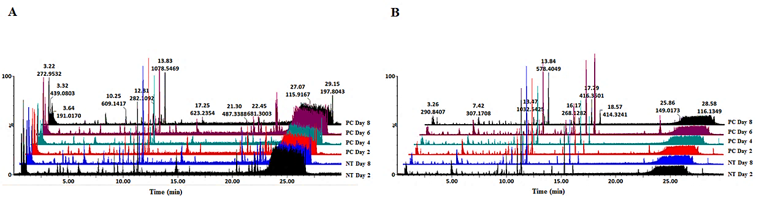
Figure S5: Representative BPI MS chromatograms of extracts from tomato plants infected with Phytophthora capsici; root tissue. Base peak mass chromatograms displaying comparative chromatographic differences in different time points: (i) non-treated (NT, days 2 and 8) and (ii) P. capsici (PC, days 2, 4, 6 and 8) infected. Visual inspection of the chromatograms evidently shows differential peak populations, for instance in the 4-20 min chromatographic region. (A): ESI negative mode and (B): ESI positive mode.

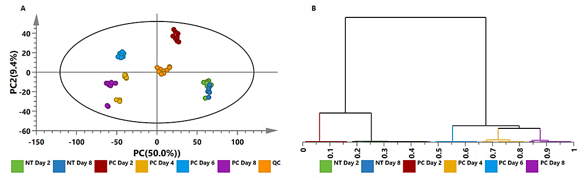

Figure S6: Unsupervised statistical analysis of extracts from tomato plants infected with Phytophthora capsici; leaf data acquired in ESI⁺ mode. (A): A PCA scores scatter plot of all the samples, including the QC samples, colored according to time points. The PCA model presented here was a 7-component model, with R² of 0.697 and Q² of 0.645. (B): The HCA dendrogram corresponding to (A). Unsupervised statistical analysis is used to generate subgrouping of samples based on similar observations in (A) while the HCA dendrogram shows the hierarchical relationship between samples (B).

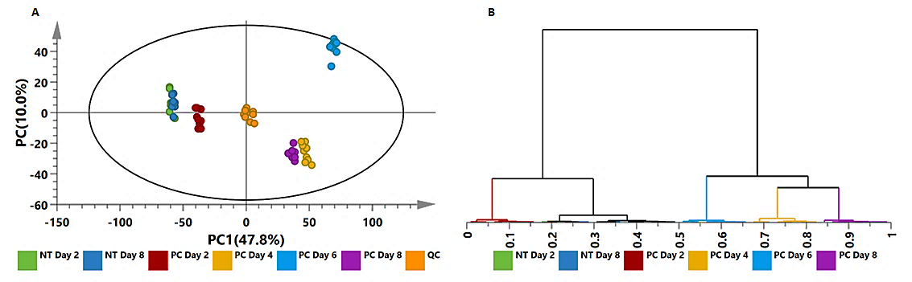

Figure S7: Unsupervised statistical analysis of extracts from tomato plants infected with Phytophthora capsici; stem data acquired in ESI⁻ mode. (A): A PCA scores scatter plot of all the samples, including the QC samples, colored according to time points. The PCA model presented here was a 7-component model, with R² of 0.804 and Q² of 0.752. (B): The HCA dendrogram corresponding to (A). Unsupervised statistical analysis is used to generate subgrouping of samples based on similar observations in (A) while the HCA dendrogram shows the hierarchical relationship between samples (B).

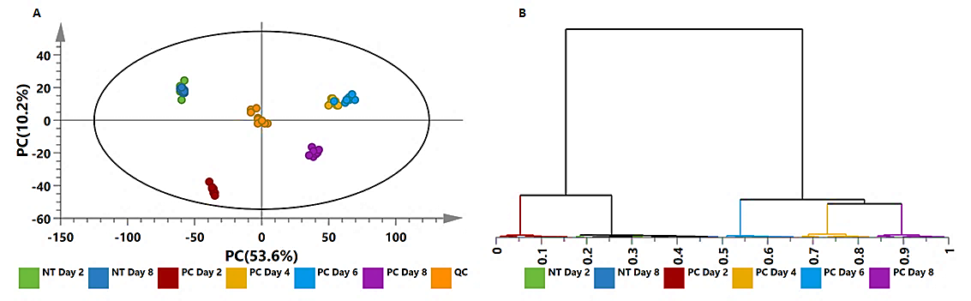

Figure S8: Unsupervised statistical analysis of extracts from tomato plants infected with Phytophthora capsici; stem data acquired in ESI⁺ mode. (A): A PCA scores scatter plot of all the samples, including the QC samples, colored according to time points. The PCA model presented here was a 7-component model, with R² of 0.835 and Q² of 0.783. (B): The HCA dendrogram corresponding to (A). Unsupervised statistical analysis is used to generate subgrouping of samples based on similar observations in (A) while the HCA dendrogram shows the hierarchical relationship between samples (B).

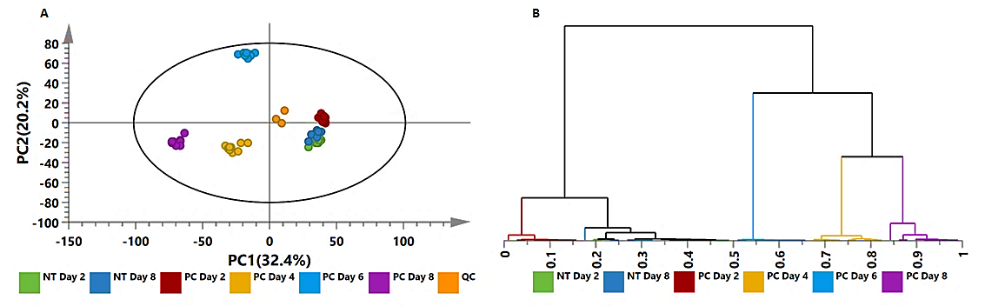

Figure S9: Unsupervised statistical analysis of extracts from tomato plants infected with Phytophthora capsici; root data acquired in ESI⁻ mode. (A): A PCA scores scatter plot of all the samples, including the QC samples, colored according to time points. The PCA model presented here was a 7-component model, with R² of 0.759 and Q² of 0.640. (B): The HCA dendrogram corresponding to (A). Unsupervised statistical analysis is used to generate subgrouping of samples based on similar observations in (A) while the HCA dendrogram shows the hierarchical relationship between samples (B).

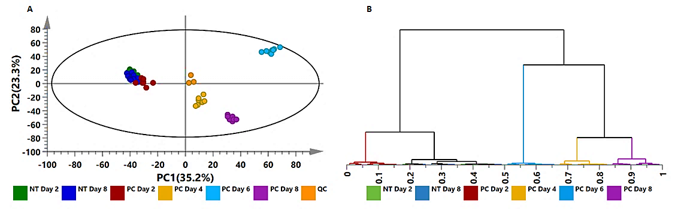

Figure S10: Unsupervised statistical analysis of extracts from tomato plants infected with Phytophthora capsici; root data acquired in ESI⁺ mode. (A): A PCA scores scatter plot of all the samples, including the QC samples, colored according to time points. The PCA model presented here was a 7-component model, with R² of 0.788 and Q² of 0.692. (B): The HCA dendrogram corresponding to (A). Unsupervised statistical analysis is used to generate subgrouping of samples based on similar observations in (A) while the HCA dendrogram shows the hierarchical relationship between samples (B).

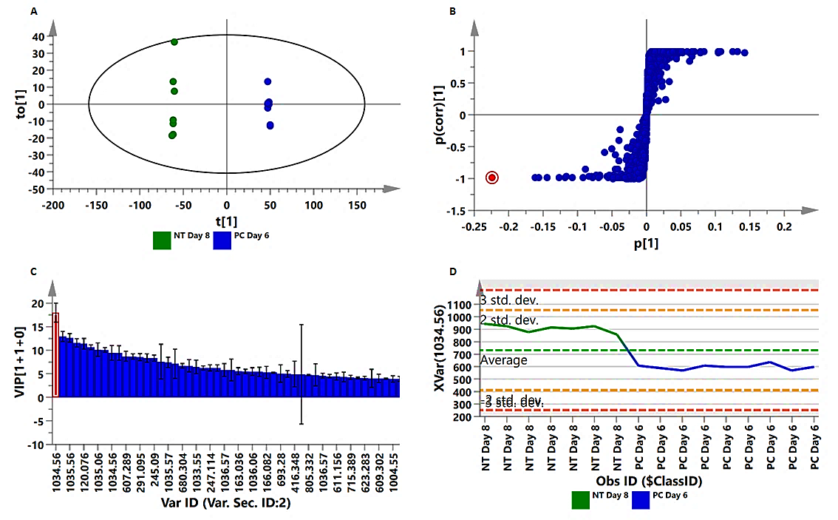

Figure S11: OPLS-DA modeling and variable/feature selection of extracts from tomato plants infected with Phytophthora capsici; leaf data acquired on ESI⁺ mode. (A): A typical OPLS-DA score plot separating non-treated (NT) day 8 plants vs. P. capsici (PC)-treated day 6 plants (1 + 1 + 0 components, R²X = 0.741, Q² = 0.998, CV-ANOVA p-value = 7.96 × 10⁻¹⁵). (B): An OPLS-DA loadings S-plot for the same model in (A); only variables with the correlation [(p(corr)] ≥ |0.6| and covariance (p1) ≥ |0.5| were chosen as discriminating variables and identified using the m/z to generate elemental composition. (C): A variable importance for the projection (VIP) plot for the same model, pointing mathematically to the importance of each variable in contributing to group separation in the OPLS-DA model. (D): A typical variable trend plot (of the selected variable in VIP and S-plots), displaying the changes of the selected variables across the samples (NT day 8 vs. PC day 6). This shows that the selected features significantly discriminate the treated from the control samples.

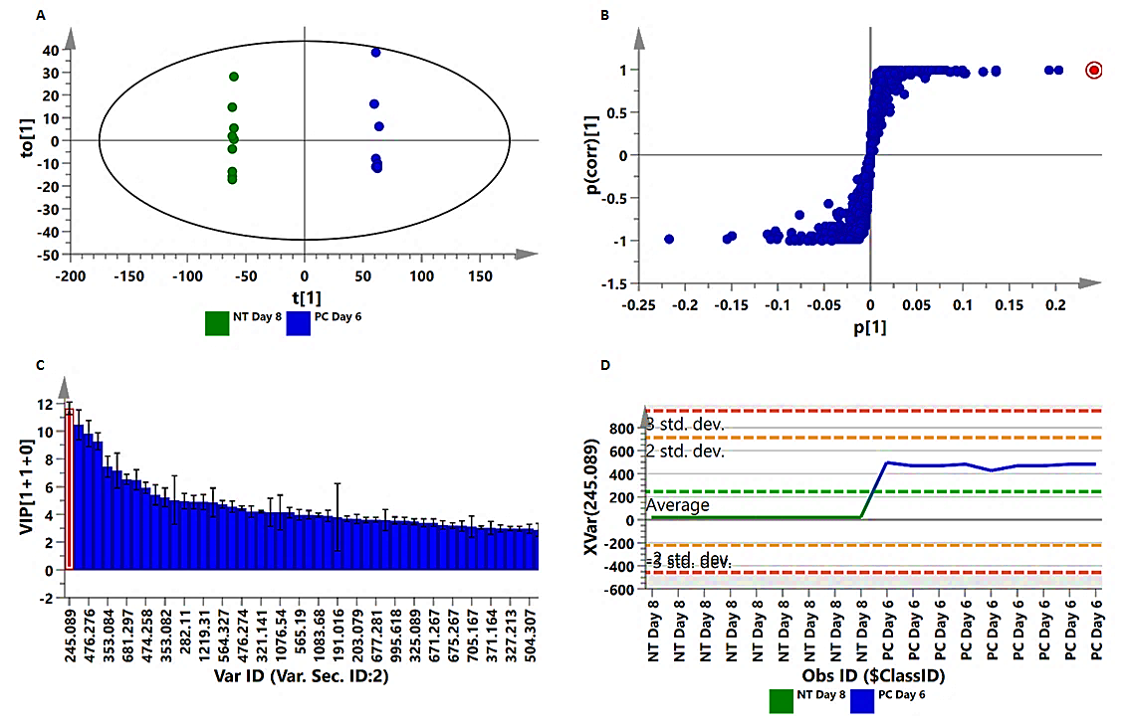

Figure S12: OPLS-DA modeling and variable/feature selection of extracts from tomato plants infected with Phytophthora capsici; stem data acquired on ESI⁻ mode. (A): A typical OPLS-DA score plot separating non-treated (NT) day 8 plants vs. P. capsici (PC)-treated day 6 plants (1 + 1 + 0 components, R²X = 0.817, Q² = 0.999, CV-ANOVA p-value = 3.19 × 10⁻²⁰). (B): An OPLS-DA loadings S-plot for the same model in (A); only variables with the correlation [(p(corr)] ≥ |0.6| and covariance (p1) ≥ |0.5| were chosen as discriminating variables and identified using the m/z to generate elemental composition. (C): A variable importance for the projection (VIP) plot for the same model, pointing mathematically to the importance of each variable in contributing to group separation in the OPLS-DA model. (D): A typical variable trend plot (of the selected variable in VIP and S-plots), displaying the changes of the selected variables across the samples (NT day 8 vs. PC day 6). This shows that the selected features significantly discriminate the treated from the control samples.

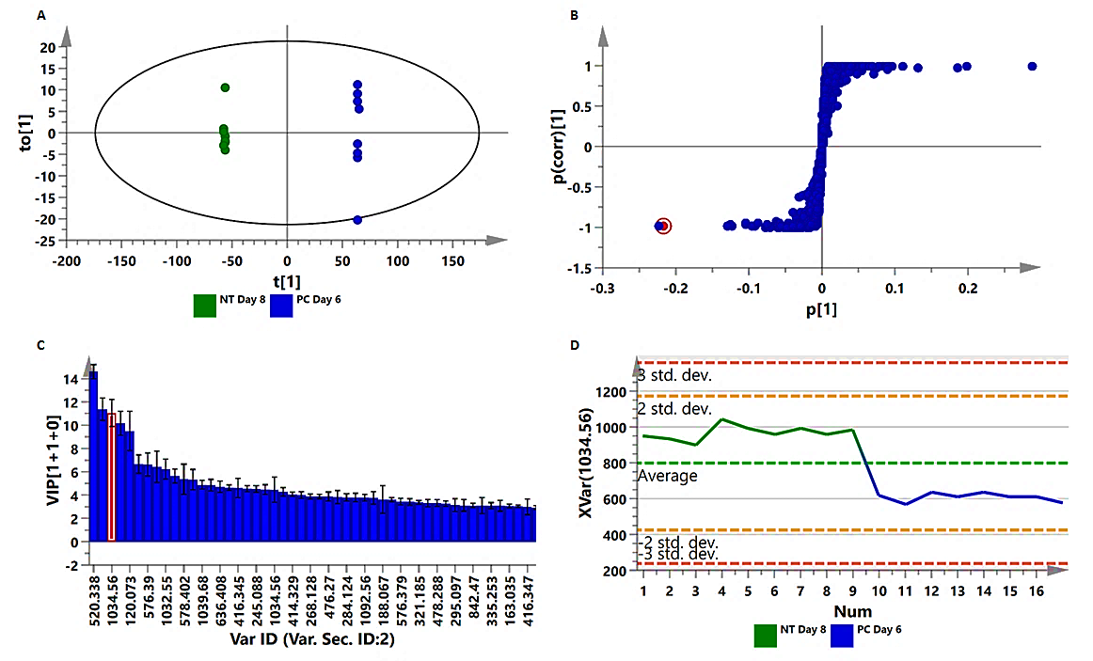

Figure S13: OPLS-DA modeling and variable/feature selection of extracts from tomato plants infected with Phytophthora capsici; stem data acquired on ESI⁺ mode. (A): A typical OPLS-DA score plot separating non-treated (NT) day 8 plants vs. P. capsici (PC)-treated day 6 plants (1 + 1 + 0 components, R²X = 0.855, Q² = 0.995, CV-ANOVA p-value = 3.9 × 10⁻¹⁸). (B): An OPLS-DA loadings S-plot for the same model in (A); only variables with the correlation [(p(corr)] ≥ |0.6| and covariance (p1) ≥ |0.5| were chosen as discriminating variables and identified using the m/z to generate an elemental composition. (C): A variable importance for the projection (VIP) plot for the same model, pointing mathematically to the importance of each variable in contributing to group separation in the OPLS-DA model. (D): A typical variable trend plot (of the selected variable in VIP and S-plots), displaying the changes of the selected variables across the samples (NT day 8 vs. PC day 6). This shows that the selected features significantly discriminate the treated from the control samples.

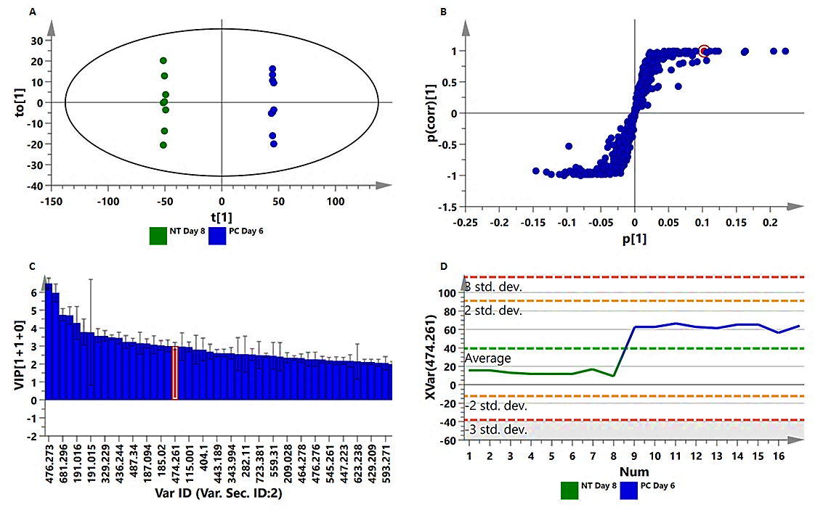

Figure S14: OPLS-DA modeling and variable/feature selection of extracts from tomato plants infected with Phytophthora capsici; root data acquired on ESI⁻ mode. (A): A typical OPLS-DA score plot separating non-treated (NT) day 8 plants vs. P. capsici (PC)-treated day 6 plants (1 + 1 + 0 components, R²X = 0.677, Q² = 0.998, CV-ANOVA p-value = 9.48 × 10⁻¹⁶). (B): An OPLS-DA loadings S-plot for the same model in (A); only variables with the correlation [(p(corr)] ≥ |0.6| and covariance (p1) ≥ |0.5| were chosen as discriminating variables and identified using the m/z to generate an elemental composition. (C): A variable importance for the projection (VIP) plot for the same model, pointing mathematically to the importance of each variable in contributing to group separation in the OPLS-DA model. (D): A typical variable trend plot (of the selected variable in VIP and S-plots), displaying the changes of the selected variables across the samples (NT day 8 vs. PC day 6). This shows that the selected features significantly discriminate the treated from the control samples.

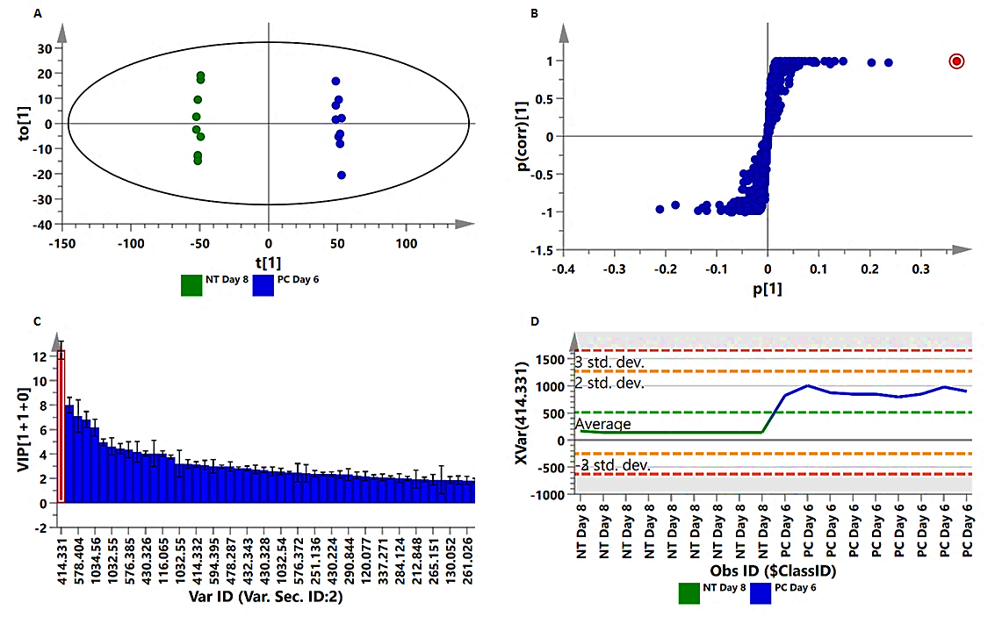

Figure S15: OPLS-DA modeling and variable/feature selection of extracts from tomato plants infected with Phytophthora capsici; root data acquired on ESI⁺ mode. (A): A typical OPLS-DA score plot separating non-treated (NT) day 8 plants vs. P. capsici (PC)-treated day 6 plants (1 + 1 + 0 components, R²X = 0.742, Q² = 0.996, CV-ANOVA p-value = 1.08 × 10⁻¹⁵). (B): An OPLS-DA loadings S-plot for the same model in (A); only variables with the correlation [(p(corr)] ≥ |0.6| and covariance (p1) ≥ |0.5| were chosen as discriminating variables and identified using the m/z to generate an elemental composition. (C): A variable importance for the projection (VIP) plot for the same model, pointing mathematically to the importance of each variable in contributing to group separation in the OPLS-DA model. (D): A typical variable trend plot (of the selected variable in VIP and S-plots), displaying the changes of the selected variables across the samples (NT day 8 vs. PC day 6). This shows that the selected features significantly discriminate the treated from the control samples.

Table S1: Summary of annotated (MSI-level 2) metabolites that contributed to the discriminating variability in the altered metabolomes of root -, stem - and leaf tissue of tomato plants infected with Phytophthora capsici (as described by chemometric models). These discriminating metabolites were identified based on OPLS-DA S-plots, with a rigorous statistical validation (as explained in the text – Figure 4). These reported metabolites had VIP scores ˃ 1.0.

No. | Rt  (min) | Ionization | m/z | Compound name | Abbreviation | Chemical formula | Fragments  (m/z)
1 | 0.87 | [M-H]- | 191.018 | Citric acid I | C-acid I | C6H8O7 | 173, 115, 111
2 | 0.87 | [M+H]+ | 116.063 | L-Proline | L-Pro | C5H9NO2 | 70
3 | 0.92 | [M-H]- | 191.017 | Citric acid II | C-acid II | C6H8O7 | 173, 111
4 | 0.95 | [M-H]- | 133.007 | Malic acid | M-Acid | C4H6O5 | 114, 89, 72
5 | 1.85 | [M+H]+ | 166.082 | L-Phenylalanine | L-Phe | C9H11NO2 | 120, 103, 91, 77
6 | 2.19 | [M+H]+ | 220.117 | N', N'',N'''-Triferuloylagmatine | tri-F-agmatine | C35H38N4O9 | 660
7 | 2.62 | [M+H]+ | 176.105 | N-Acetyl-aspartic acid | N-Acetyl-Asp | C6H9NO5 | 115
8 | 2.72 | [M-H]- | 353.084 | 3-Caffeoylquinic acid | 3-CQA | C16H18O9 | 191, 179, 135
9 | 2.92 | [M-H]- | 203.077 | Tryptophan | Trp | C11H12N2O2 | 142, 116
10 | 3.16 | [M-H]- | 285.058 | Dihydroxybenzoic acid pentose | diHydro-Be acid pent | C12H14O8 | 153
12 | 3.96 | [M-H]- | 343.186 | Homovanillic acid glycoside | H-acid glyc | C15H20O9 | 181
13 | 4.22 | [M-H]- | 353.083 | 5-Caffeoylquinic acid | 5-CQA | C16H18O9 | 191, 179, 173, 135
14 | 4.35 | [M-H]- | 367.099 | 4-Feruloylquinic acid | 4-FQA | C17H20O9 | 193
15 | 4.39 | [M+H]+ | 323.154 | N-Feruloylspermidine I | F-spe I | C17H27N3O3 | 321, 177, 145, 117
16 | 4.4 | [M-H]- | 353.082 | 4-Caffeoylquinic acid | 4-CQA | C17H20O9 | 191, 179, 173, 135
17 | 4.9 | [M-H]- | 355.098 | Feruloylglycoside I | F-glyco I | C16H20O9 | 193
18 | 4.94 | [M+H]+ | 307.17 | N-Feruloylagmatine I | F-agm I | C15H22N4O3 | 177, 145, 114
19 | 5.06 | [M-H]- | 385.107 | Sinapoylglycoside II | S-glyc I | C17H20O10 | 223
20 | 5.27 | [M+H]+ | 337.184 | N-Feruloylagmatine II | F-agm II | C15H22N4O3 | 177, 145, 114
21 | 5.42 | [M+H]+ | 322.187 | N-Feruloylspermidine II | F-spe II | C17H27N3O3 | 321, 177, 145, 117
22 | 6.21 | [M-H]- | 367.099 | 5-Feruloylquinic acid | 5-FQA | C17H20O9 | 191
23 | 7 | [M-H]- | 741.189 | Quercetin-3-O-trisacharide | Qu-3-O-trisach | C31H36O21 | 300
24 | 7.34 | [M-H]- | 245.089 | Acetyl tryptophan | Acetyl Trp | C13H14O3 | 203
25 | 7.7 | [M-H]- | 609.145 | Rutin | Rutin | C27H30O16 | 300
26 | 8.02 | [M-H]- | 463.083 | Quercetin 7-O-glucoside | Qu-7-O-gluc | C15H20O12 | 300
27 | 8.63 | [M-H]- | 593.149 | Kaempferol-3-O-B-rutinoside | Ka-3-O-B-rut | C27H30O15 | 285
28 | 9.48 | [M-H]- | 349.094 | Azelaic acid-glycoside | Aza-glyc | C15H26O9 | 187
29 | 9.97 | [M+H]+ | 1032.54 | Dehydrotomatine | De-tomatine | C50H81NO21 | 588, 576, 414
30 | 10.07 | [M+H]+ | 738.443 | Alpha tomatine I | A-tom I | C50H83NO21 | 738, 578, 416
31 | 10.26 | [M-H]- | 745.27 | Delphinidin-coumaroyltyramine glycoside | De-Cotyr glyc | C38H36NO14 | 282, 162, 119
32 | 10.7 | [M-H]- | 312.12 | Feruloyltyramine I | F-tyr | C18H19NO4 | 178, 134
33 | 10.73 | [M+H]+ | 1032.251 | Dehydrotomatine I | De-tomatine I | C9H81NO21 | 576, 414
34 | 10.97 | [M+H]+ | 1032.55 | Dehydrotomatine II | De-tomatine II | C50H81NO21 | 576, 414
35 | 11.1 | [M+H]+ | 344.146 | Alpha tomatine II | A-tom II | C50H83NO21 | 578, 416
36 | 11.11 | [M+H]+ | 344.147 | Filotomatine | Filo | C50H83NO21 | 578, 416, 207
37 | 11.13 | [M-H]- | 299.183 | Salicylic acid glycoside I | SA-glyc I | C13H16O8 | 137
38 | 11.2 | [M+H]+ | 1092.56 | Alpha tomatine III | A-tom III | C50H83NO21 | 578, 416, 295
39 | 11.56 | [M+H]+ | 1034.56 | Alpha-tomatine IV | A-tom IV | C50H83NO21 | 578, 416, 416, 295
40 | 11.66 | [M+H]+ | 1004.55 | Alpha tomatine V | A-tom V | C50H83NO21 | 578, 416, 295
41 | 11.8 | [M-H]- | 447.219 | Kaempferol-3-glucoside | Ka-3-O-gluc | C21H20O11 | 285
42 | 12.06 | [M-H]- | 299.182 | Salicylic acid glycoside II | SA-glyc II | C13H16O8 | 137
43 | 13.41 | [M+H]+ | 414.333 | Tomatidenol | Tomato I | C27H43NO2 | 273, 255, 161
44 | 13.42 | [M-H]- | 313.197 | Methyl salicylate glycoside | MeSA-glyc | C14H18O8 | 151
45 | 14.14 | [M+H]+ | 412.318 | Tomatid-4-en-3-one | Toma-one | C27H43NO2 | 325, 271, 161
46 | 14.75 | [M+H]+ | 414.334 | Tomatidenol | Tomato II | C27H43NO2 | 273, 255, 161
47 | 14.87 | [M-H]- | 329.228 | Hydroxyoctadecanedioc acid | C27H43NO2 | C27H43NO2 | 171, 139
48 | 15.28 | [M+H]+ | 416.345 | Tomatidine | Tomati I | C27H45NO2 | 273, 255, 163
49 | 15.99 | [M+H]+ | 416.347 | Tomatidine | Tomati II | C27H45NO2 | 273, 255, 163
50 | 16.08 | [M-H]- | 329.229 | Hydroxyoctadecanedioc acid | C27H43NO2 | C18H33O5 | 171, 139
51 | 16.09 | [M+H]+ | 353.225 | Tomatidenol | Tomato II | C27H43NO2 | 414, 369
52 | 16.49 | [M-H]- | 329.229 | Hydroxyoctadecanedioc acid | C27H43NO2 | C18H33O5 | 171, 139
53 | 20.54 | [M-H]- | 474.258 | Feruloytyramine glycoside | F-tyr glyc I | C24H29NO9 | 312, 178
54 | 20.99 | [M-H]- | 474.26 | Feruloytyramine glycoside | F-tyr glyc II | C24H29NO9 | 312, 178
55 | 22.06 | [M-H]- | 504.305 | Feruloyl-3-methoxytyramine glycoside | F-met-tyr glyc I | C25H31NO10 | 342, 178
56 | 22.51 | [M-H]- | 504.307 | Feruloyl-3-methoxytyramine glycoside | F-met-tyr glyc II | C25H31NO10 | 342, 178

Note: The table only shows the identified metabolites in the various tissue. For differential reprogramming and tissue-specific metabolites, please refer to the correlation analysis (Figure 5) and VIP score-plots (Figure 6).

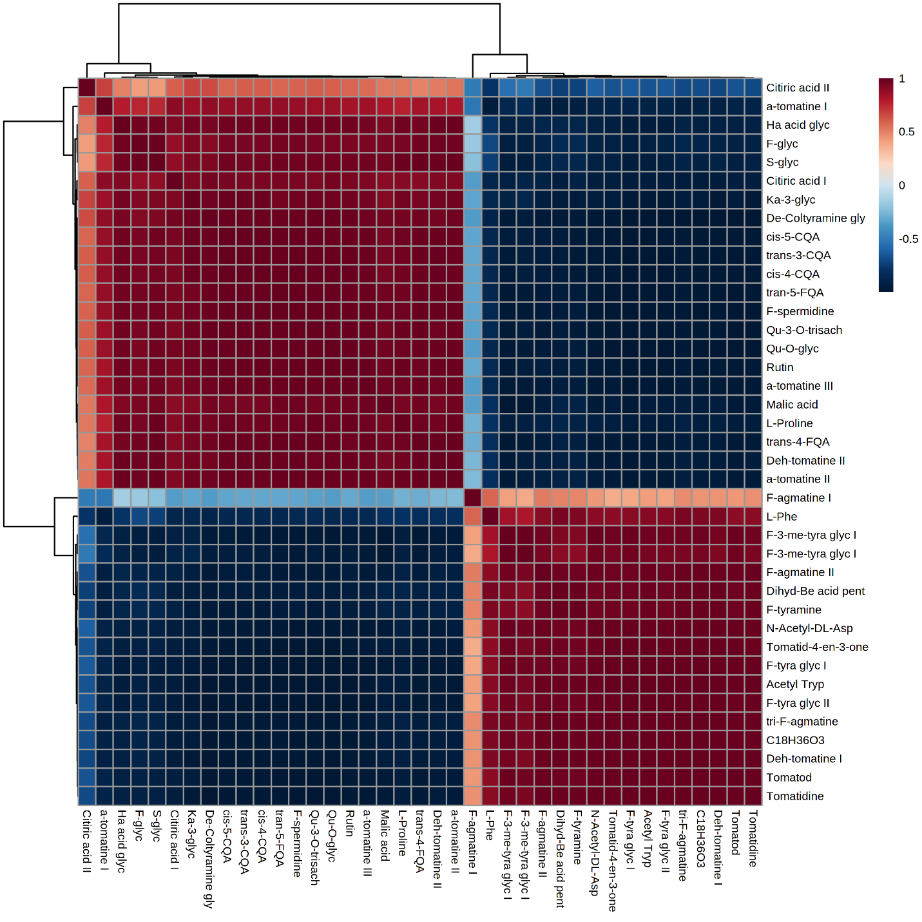
Figure S16: Correlation matrix among the changes (Δ) within/between extracts from stems of non-treated (NT) day 8 tomato plants and Phytophthora capsici (PC)-treated day 6 plants. Metabolite-metabolite correlations among identified molecules were obtained by deriving a Pearson correlation coefficient. Red indicates a positive correlation, and blue indicates a negative correlation. Abbreviations are explained in Table S1. Dendrograms are shown on the top and left of the correlation, indicating clustering of positive and negative correlations.

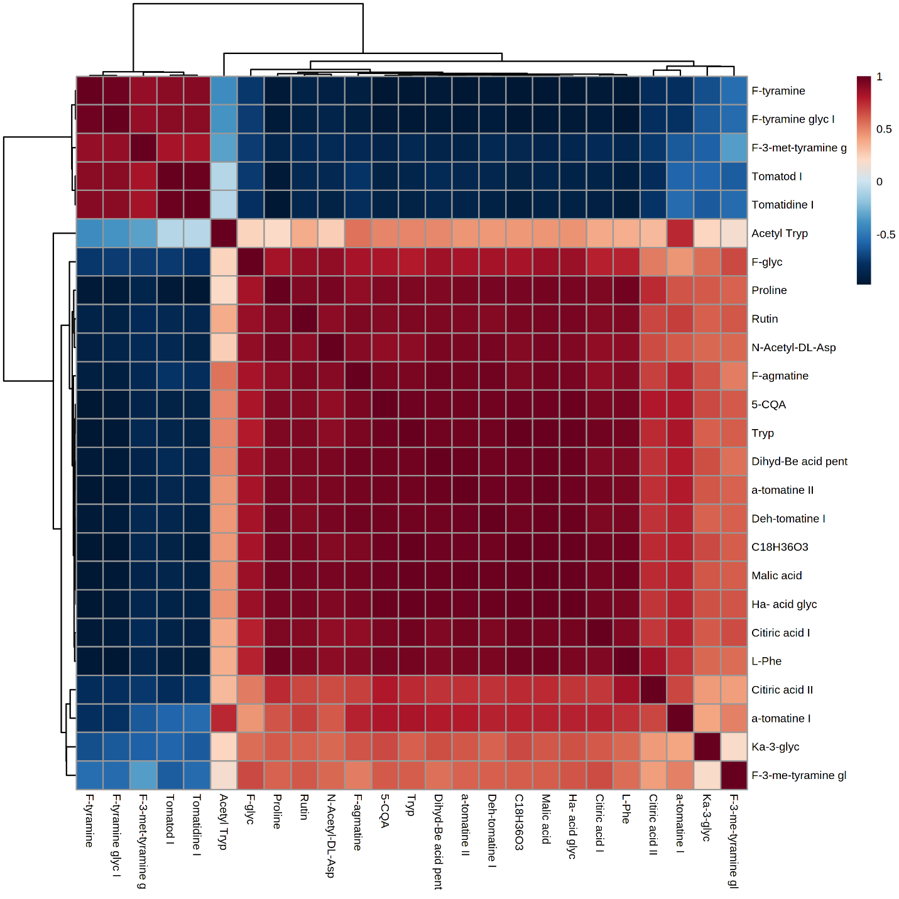
Figure S17: Correlation matrix among the changes (Δ) within/between extracts from roots of non-treated (NT) day 8 tomato plants and Phytophthora capsici (PC)-treated day 6 plants. Metabolite-metabolite correlations among identified molecules were obtained by deriving a Pearson correlation coefficient. Red indicates a positive correlation, and blue indicates a negative correlation. Abbreviations are explained in Table S1. Dendrograms are shown on the top and left of the correlation, indicating clustering of positive and negative correlations.

Table S2: One-way ANOVA comparing mean values of quantified aromatic amino acids and phytohormones in various tissue of tomato plants infected with Phytophthora capsici.

Compound | p-value
Roots
Phe |  | 0.000
Trp |  | 0.000
Tyr |  | 0.000
MeSA |  | 0.000
ACC |  | 0.000
Stems
Phe |  | 0.000
Trp |  | 0.000
Tyr |  | 0.000
MeSA |  | 0.000
ACC |  | 0.000
Leaves
Phe |  | 0.000
Trp |  | 0.000
Tyr |  | 0.000
MeSA |  | 0.000
ACC |  | 0.000

Table S3: Post-hoc tests comparing mean values of quantified aromatic amino acids and phytohormones in various tissue of tomato plants infected with Phytophthora capsici.

Compound name | (I) Treatment | (J) Treatment |  | p-value
Roots
Phe | NT Day 2 | NT Day 8 |  | 0.000
Phe | NT Day 2 | PC Day 2 |  | 0.000
Phe | NT Day 2 | PC Day 4 |  | 0.000
Phe | NT Day 2 | PC Day 6 |  | 0.000
Phe | NT Day 2 | PC Day 8 |  | 0.000
Phe | NT Day 8 | NT Day 2 |  | 0.000
Phe | NT Day 8 | PC Day 2 |  | 0.000
Phe | NT Day 8 | PC Day 4 |  | 0.000
Phe | NT Day 8 | PC Day 6 |  | 0.000
Phe | NT Day 8 | PC Day 8 |  | 0.000
Trp | NT Day 2 | NT Day 8 |  | 0.013
Trp | NT Day 2 | PC Day 2 |  | 0.000
Trp | NT Day 2 | PC Day 4 |  | 0.000
Trp | NT Day 2 | PC Day 6 |  | 0.000
Trp | NT Day 2 | PC Day 8 |  | 0.005
Trp | NT Day 8 | NT Day 2 |  | 0.013
Trp | NT Day 8 | PC Day 2 |  | 0.000
Trp | NT Day 8 | PC Day 4 |  | 0.000
Trp | NT Day 8 | PC Day 6 |  | 0.000
Trp | NT Day 8 | PC Day 8 |  | 0.999
Tyr | NT Day 2 | NT Day 8 |  | 0.914
Tyr | NT Day 2 | PC Day 2 |  | 0.000
Tyr | NT Day 2 | PC Day 4 |  | 0.000
Tyr | NT Day 2 | PC Day 6 |  | 0.000
Tyr | NT Day 2 | PC Day 8 |  | 0.000
Tyr | NT Day 8 | NT Day 2 |  | 0.914
Tyr | NT Day 8 | PC Day 2 |  | 0.000
Tyr | NT Day 8 | PC Day 4 |  | 0.000
Tyr | NT Day 8 | PC Day 6 |  | 0.000
Tyr | NT Day 8 | PC Day 8 |  | 0.000
MeSA | NT Day 2 | NT Day 8 |  | 0.510
MeSA | NT Day 2 | PC Day 2 |  | 0.004
MeSA | NT Day 2 | PC Day 4 |  | 0.000
MeSA | NT Day 2 | PC Day 6 |  | 0.198
MeSA | NT Day 2 | PC Day 8 |  | 0.001
MeSA | NT Day 8 | NT Day 2 |  | 0.510
MeSA | NT Day 8 | PC Day 2 |  | 0.000
MeSA | NT Day 8 | PC Day 4 |  | 0.000
MeSA | NT Day 8 | PC Day 6 |  | 0.002
MeSA | NT Day 8 | PC Day 8 |  | 0.122
ACC | NT Day 2 | NT Day 8 |  | 0.302
ACC | NT Day 2 | PC Day 2 |  | 0.000
ACC | NT Day 2 | PC Day 4 |  | 0.000
ACC | NT Day 2 | PC Day 6 |  | 0.000
ACC | NT Day 2 | PC Day 8 |  | 0.000
ACC | NT Day 8 | NT Day 2 |  | 0.302
ACC | NT Day 8 | PC Day 2 |  | 0.001
ACC | NT Day 8 | PC Day 4 |  | 0.000
ACC | NT Day 8 | PC Day 6 |  | 0.000
ACC | NT Day 8 | PC Day 8 |  | 0.000
Stems
Phe | NT Day 2 | NT Day 8 |  | 1.000
Phe | NT Day 2 | PC Day 2 |  | 0.010
Phe | NT Day 2 | PC Day 4 |  | 0.000
Phe | NT Day 2 | PC day 6 |  | 0.000
Phe | NT Day 2 | PC Day 8 |  | 0.000
Phe | NT Day 8 | NT Day 2 |  | 1.000
Phe | NT Day 8 | PC Day 2 |  | 0.022
Phe | NT Day 8 | PC Day 4 |  | 0.000
Phe | NT Day 8 | PC day 6 |  | 0.000
Phe | NT Day 8 | PC Day 8 |  | 0.000
Trp | NT Day 2 | NT Day 8 |  | 0.999
Trp | NT Day 2 | PC Day 2 |  | 0.666
Trp | NT Day 2 | PC Day 4 |  | 0.000
Trp | NT Day 2 | PC day 6 |  | 0.000
Trp | NT Day 2 | PC Day 8 |  | 0.000
Trp | NT Day 8 | NT Day 2 |  | 0.999
Trp | NT Day 8 | PC Day 2 |  | 0.862
Trp | NT Day 8 | PC Day 4 |  | 0.000
Trp | NT Day 8 | PC Day 6 |  | 0.000
Trp | NT Day 8 | PC Day 8 |  | 0.000
Tyr | NT Day 2 | NT Day 8 |  | 0.908
Tyr | NT Day 2 | PC Day 2 |  | 0.008
Tyr | NT Day 2 | PC Day 4 |  | 0.000
Tyr | NT Day 2 | PC Day 6 |  | 0.000
Tyr | NT Day 2 | PC Day 8 |  | 0.000
Tyr | NT Day 8 | NT Day 2 |  | 0.908
Tyr | NT Day 8 | PC Day 2 |  | 0.108
Tyr | NT Day 8 | PC Day 4 |  | 0.000
Tyr | NT Day 8 | PC Day 6 |  | 0.000
Tyr | NT Day 8 | PC Day 8 |  | 0.000
MeSA | NT Day 2 | NT Day 8 |  | 0.810
MeSA | NT Day 2 | PC Day 2 |  | 0.001
MeSA | NT Day 2 | PC Day 4 |  | 0.002
MeSA | NT Day 2 | PC Day 6 |  | 0.888
MeSA | NT Day 2 | PC Day 8 |  | 0.000
MeSA | NT Day 8 | NT Day 2 |  | 0.810
MeSA | NT Day 8 | PC Day 2 |  | 0.025
MeSA | NT Day 8 | PC Day 4 |  | 0.059
MeSA | NT Day 8 | PC Day 6 |  | 1.000
MeSA | NT Day 8 | PC Day 8 |  | 0.001
ACC | NT Day 2 |  | NT Day 8 | 0.994
ACC |  |  | PC Day 2 | 0.939
ACC |  |  | PC Day 4 | 0.000
ACC |  |  | PC Day 6 | 0.000
ACC |  |  | PC Day 8 | 0.000
ACC | NT Day 8 |  | NT Day 2 | 0.994
ACC |  |  | PC Day 2 | 0.683
ACC |  |  | PC Day 4 | 0.000
ACC |  |  | PC Day 6 | 0.000
ACC |  |  | PC Day 8 | 0.000
Leaves
Phe | NT Day 2 |  | NT Day 8 | 1.000
Phe |  |  | PC Day 2 | 0.000
Phe |  |  | PC Day 4 | 0.000
Phe |  |  | PC Day 6 | 0.000
Phe |  |  | PC Day 8 | 0.000
Phe | NT Day 8 |  | NT Day 2 | 1.000
Phe |  |  | PC Day 2 | 0.000
Phe |  |  | PC Day 4 | 0.000
Phe |  |  | PC Day 6 | 0.000
Phe |  |  | PC Day 8 | 0.000
Phe | PC Day 2 |  | NT Day 2 | 0.000
Phe |  |  | NT Day 8 | 0.000
Phe |  |  | PC Day 4 | 0.000
Phe |  |  | PC Day 6 | 0.000
Phe |  |  | PC Day 8 | 0.000
Trp | NT Day 2 |  | NT Day 8 | 0.993
Trp |  |  | PC Day 2 | 0.000
Trp |  |  | PC Day 4 | 0.000
Trp |  |  | PC Day 6 | 0.000
Trp |  |  | PC Day 8 | 0.000
Trp | NT Day 8 |  | NT Day 2 | 0.993
Trp |  |  | PC Day 2 | 0.000
Trp |  |  | PC Day 4 | 0.000
Trp |  |  | PC Day 6 | 0.000
Trp |  |  | PC Day 8 | 0.000
Tyr | NT Day 2 |  | NT Day 8 | 1.000
Tyr |  |  | PC Day 2 | 0.395
Tyr |  |  | PC Day 4 | 0.000
Tyr |  |  | PC Day 6 | 0.000
Tyr |  |  | PC Day 8 | 0.000
Tyr | NT Day 8 |  | NT Day 2 | 1.000
Tyr |  |  | PC Day 2 | 0.379
Tyr |  |  | PC Day 4 | 0.000
Tyr |  |  | PC Day 6 | 0.000
Tyr |  |  | PC Day 8 | 0.000
MeSA | NT Day 2 |  | NT Day 8 | 0.946
MeSA |  |  | PC Day 2 | 0.747
MeSA |  |  | PC Day 4 | 0.390
MeSA |  |  | PC Day 6 | 0.449
MeSA |  |  | PC Day 8 | 0.110
MeSA | NT Day 8 |  | NT Day 2 | 0.946
MeSA |  |  | PC Day 2 | 0.997
MeSA |  |  | PC Day 4 | 0.900
MeSA |  |  | PC Day 6 | 0.086
MeSA |  |  | PC Day 8 | 0.011
ACC | NT Day 2 |  | NT Day 8 | 0.933
ACC |  |  | PC Day 2 | 1.000
ACC |  |  | PC Day 4 | 0.000
ACC |  |  | PC Day 6 | 0.000
ACC |  |  | PC Day 8 | 0.000
ACC | NT Day 8 |  | NT Day 2 | 0.933
ACC |  |  | PC Day 2 | 0.856
ACC |  |  | PC Day 4 | 0.000
ACC |  |  | PC Day 6 | 0.000
ACC |  |  | PC Day 8 | 0.000

