Reduced fracture toughness of a metallic glass at cryogenic temperature
Yihao Zhou, Jiaxin Liu, Dongxue Han, Xiangru Chen*, Gang Wang, Qijie Zhai
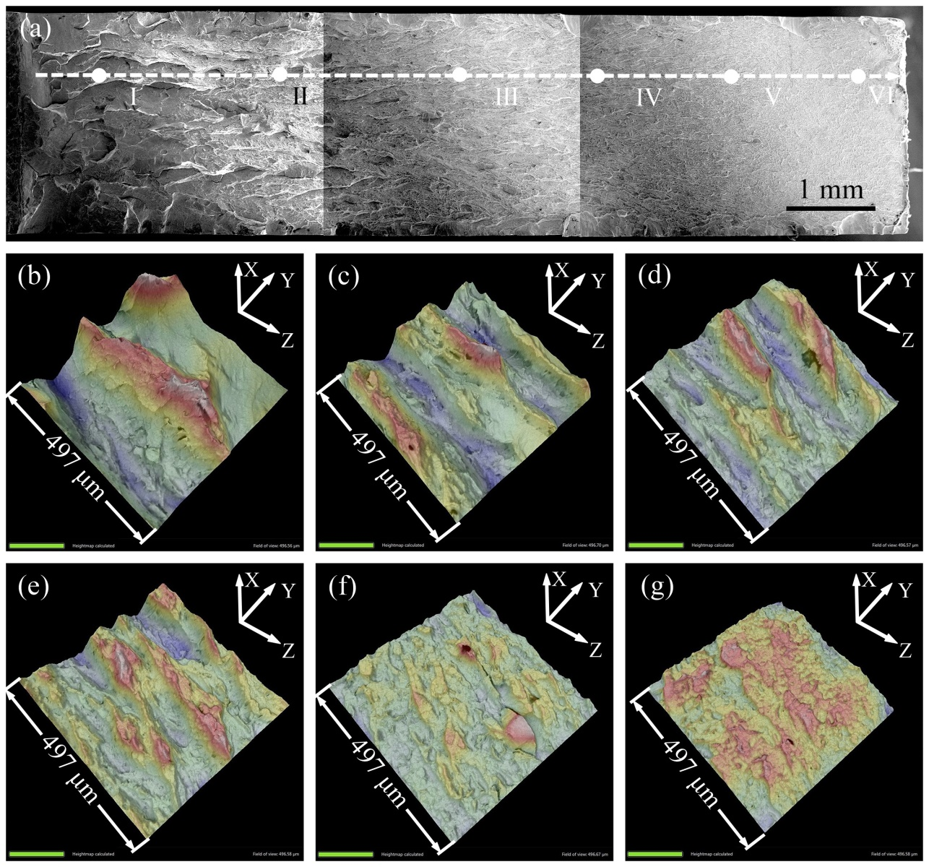
Figure S1. Fractographic evolution for the specimen tested at room temperature with notch toughness value of 102 MPa m^{0.5}. (a) overview ( arrow indicates the crack propagation direction ); (b)-(g) are 3D fractographies at point Ⅰ, Ⅱ, Ⅲ, Ⅳ, Ⅴ and Ⅵ in (a), respectively.

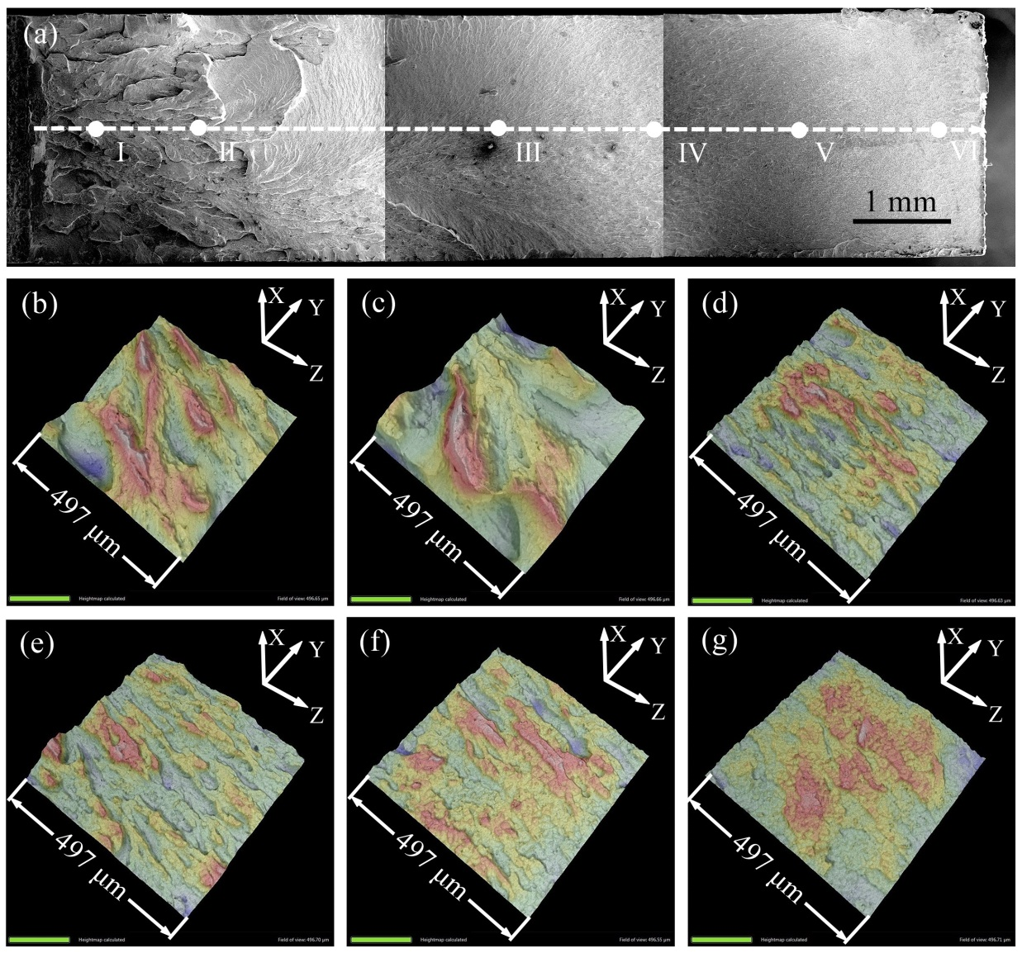
Figure S2. Fractographic evolution for the specimen tested at 213 K with notch toughness value of 79 MPa m^{0.5}. (a) overview ( arrow indicates the crack propagation direction ); (b)-(g) are 3D fractographies at point Ⅰ, Ⅱ, Ⅲ, Ⅳ, Ⅴ and Ⅵ in (a), respectively.

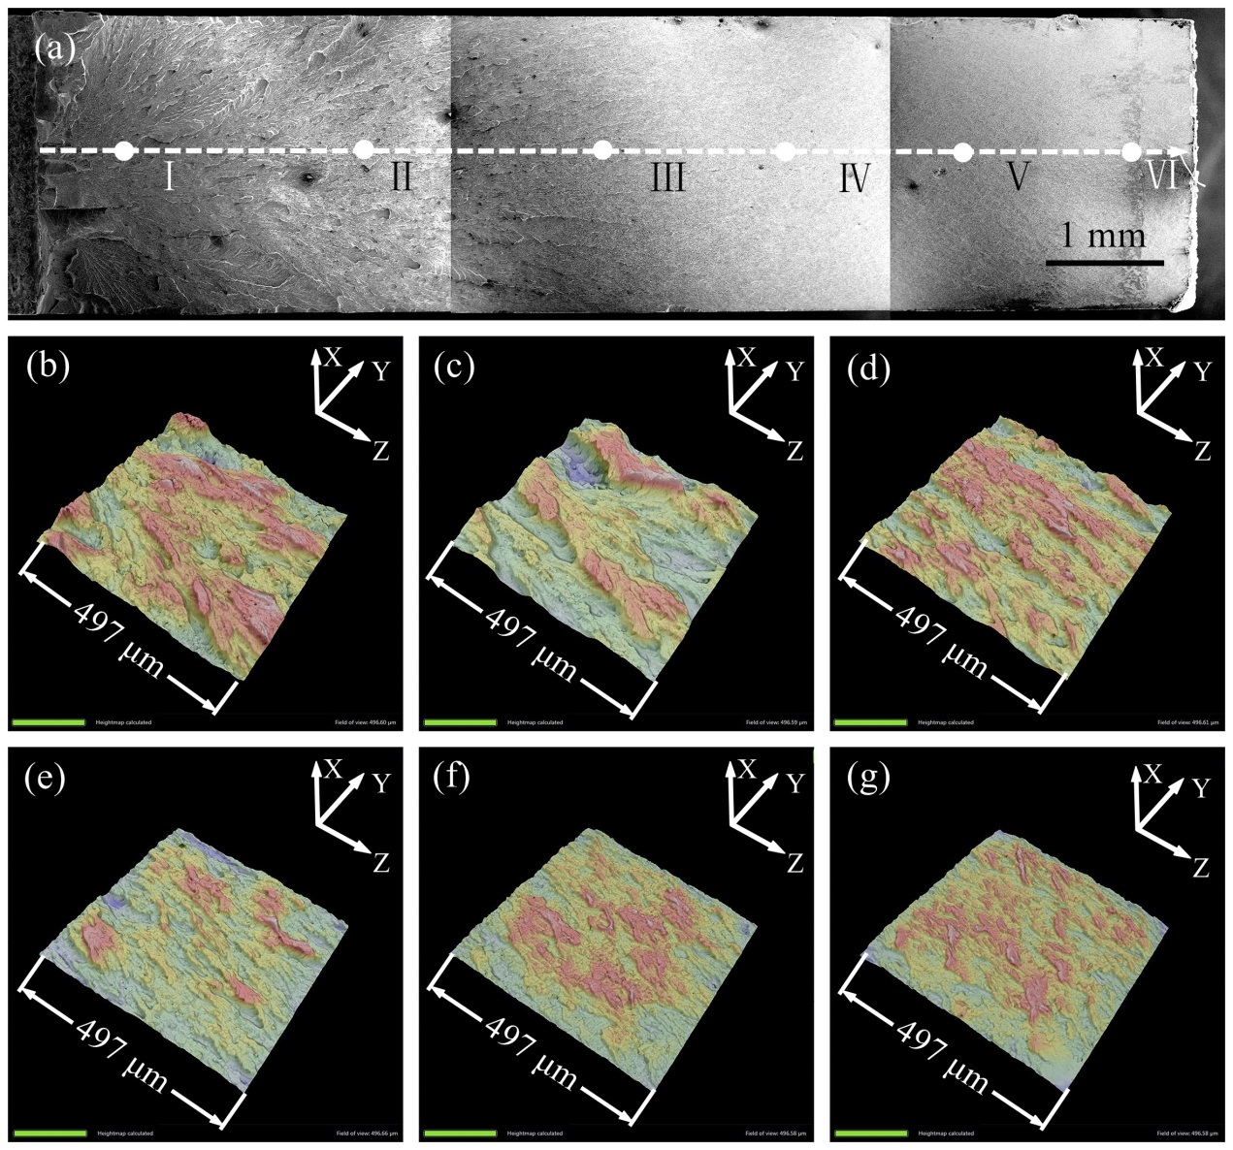

Figure S3. Fractographic evolution for the specimen tested at 183 K with notch toughness value of 53 MPa m^{0.5}. (a) overview ( arrow indicates the crack propagation direction ); (b)-(g) are 3D fractographies at point Ⅰ, Ⅱ, Ⅲ, Ⅳ, Ⅴ and Ⅵ in (a), respectively

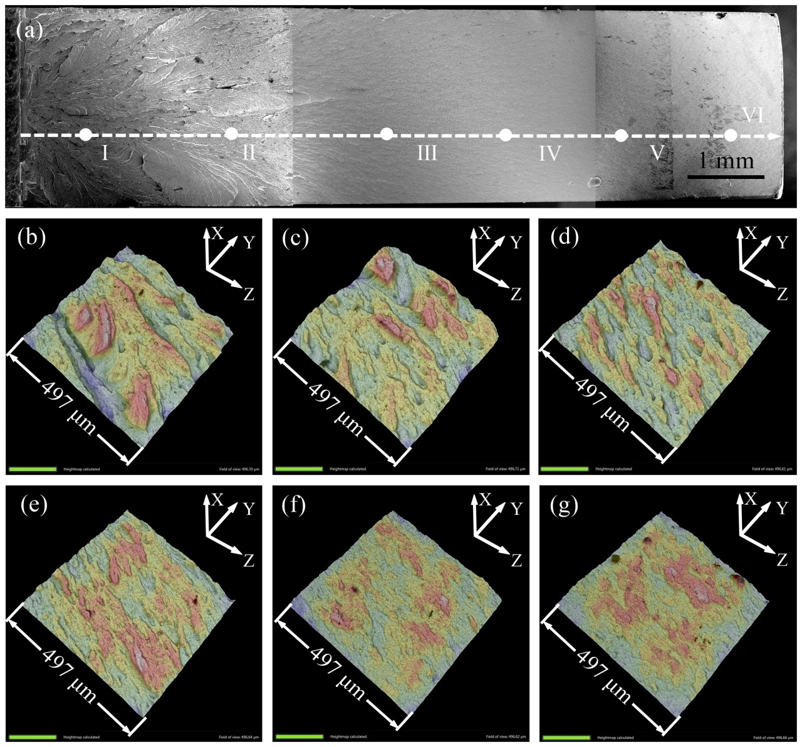
Figure S4. Fractographic evolution for the specimen tested at 153 K with notch toughness value of 59 MPa m^{0.5}. (a) overview ( arrow indicates the crack propagation direction ); (b)-(g) are 3D fractographies at point Ⅰ, Ⅱ, Ⅲ, Ⅳ, Ⅴ and Ⅵ in (a), respectively

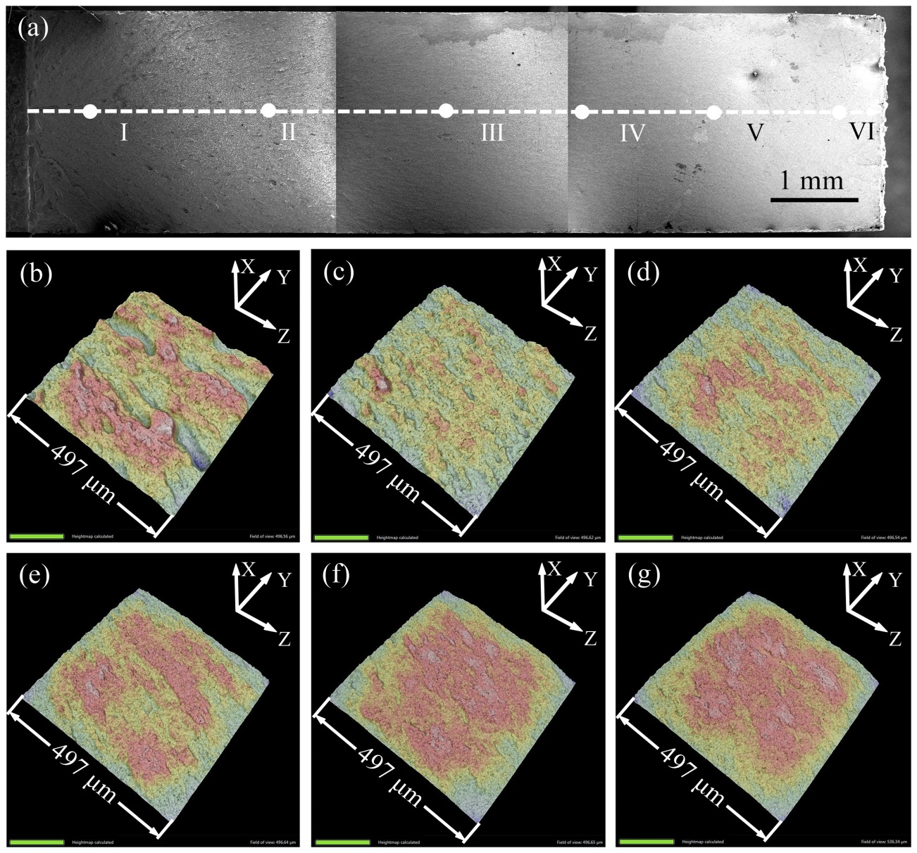

Figure S5. Fractographic evolution for the specimen tested at 123 K with notch toughness value of 47 MPa m^{0.5}. (a) overview ( arrow indicates the crack propagation direction ); (b)-(g) are 3D fractographies at point Ⅰ, Ⅱ, Ⅲ, Ⅳ, Ⅴ and Ⅵ in (a), respectively.

