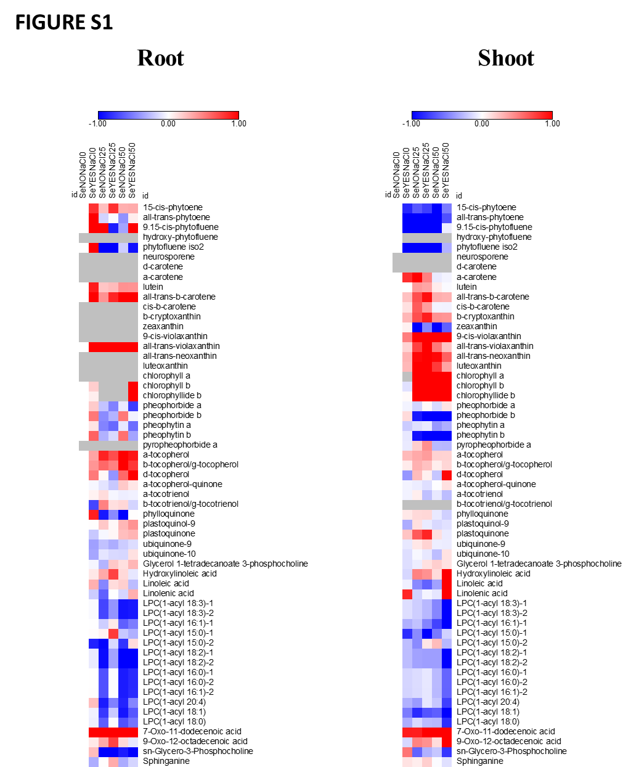
Figure S1: Heatmap visualization of non-polar metabolomes. Data are reported as log2 fold with respect to Se_{NO}NaCl₀ treatment.

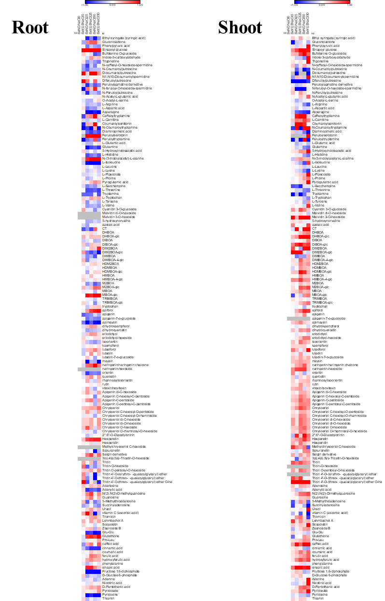
Figure S2: Heatmap visualization of semipolar metabolomes. Data are reported as log2 fold with respect to Se_{NO}NaCl₀ treatment.

Table S1: LC-HRMS analysis of the non-polar metabolome in maize sprouts obtained at 0, 25, or 50 mM NaCl (i.e., NaCl₀, NaCl₂₅, and NaCl₅₀, respectively) from grains produced without or with Se fertilization (i.e., Se_{NO} and Se_{YES}, respectively). Data are represented as the mean (standard deviation) of two independent biological replicates, with three separate measurements per replicate. Asterisks indicate significant differences according to a t-test (pValue: *<0.05; **<0.01) carried out by comparing each treatment against the control treatment Se_{NO}NaCl₀. Red and green boxes refer to metabolites showing a higher and lower content compared to Se_{NO}NaCl₀, respectively.

Table S2. LC-HRMS analysis of semipolar metabolome in maize sprouts obtained at 0, 25, or 50 mM NaCl (i.e., NaCl₀, NaCl₂₅, and NaCl₅₀, respectively) from grains produced without or with Se fertilization (i.e., Se_{NO} and Se_{YES}, respectively). Data are represented as the mean (standard deviation) of two independent biological replicates, with three separate measurements per replicate. Asterisks indicate significant differences according to a t-test (p-Value: *<0.05; **<0.01) carried out by comparing each treatment against the control treatment Se_{NO}NaCl₀. Red and green boxes refer to metabolites showing a higher and lower content compared to Se_{NO}NaCl₀, respectively.

