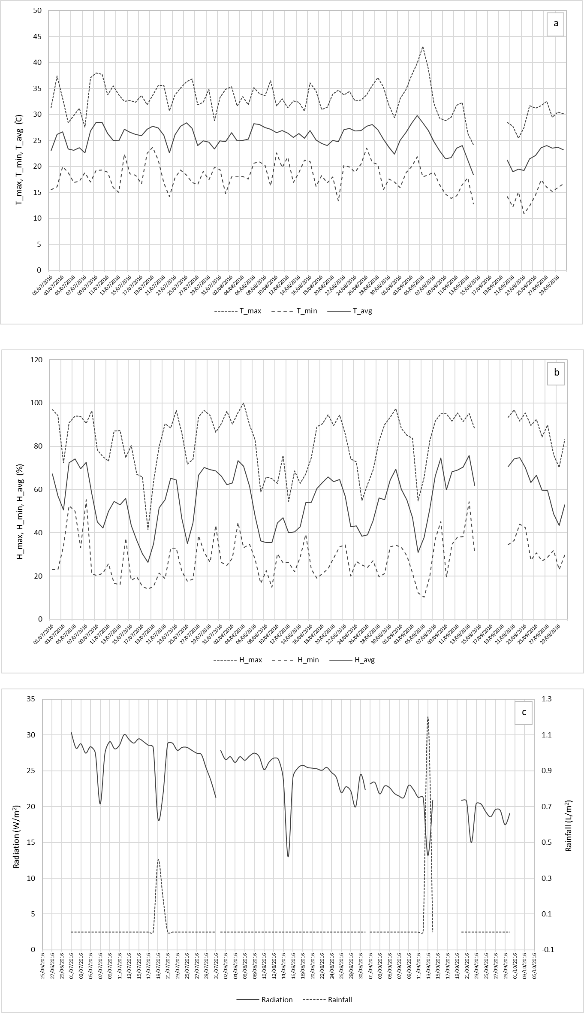
Figure S1a-c. (a) Temperature (°C) (T_max, T_min, T_avg), (b) humidity (%) (H_max, H_min, H_avg) and (c) radiation (W/m²) and rainfall (L/m²) among July and September 2016.
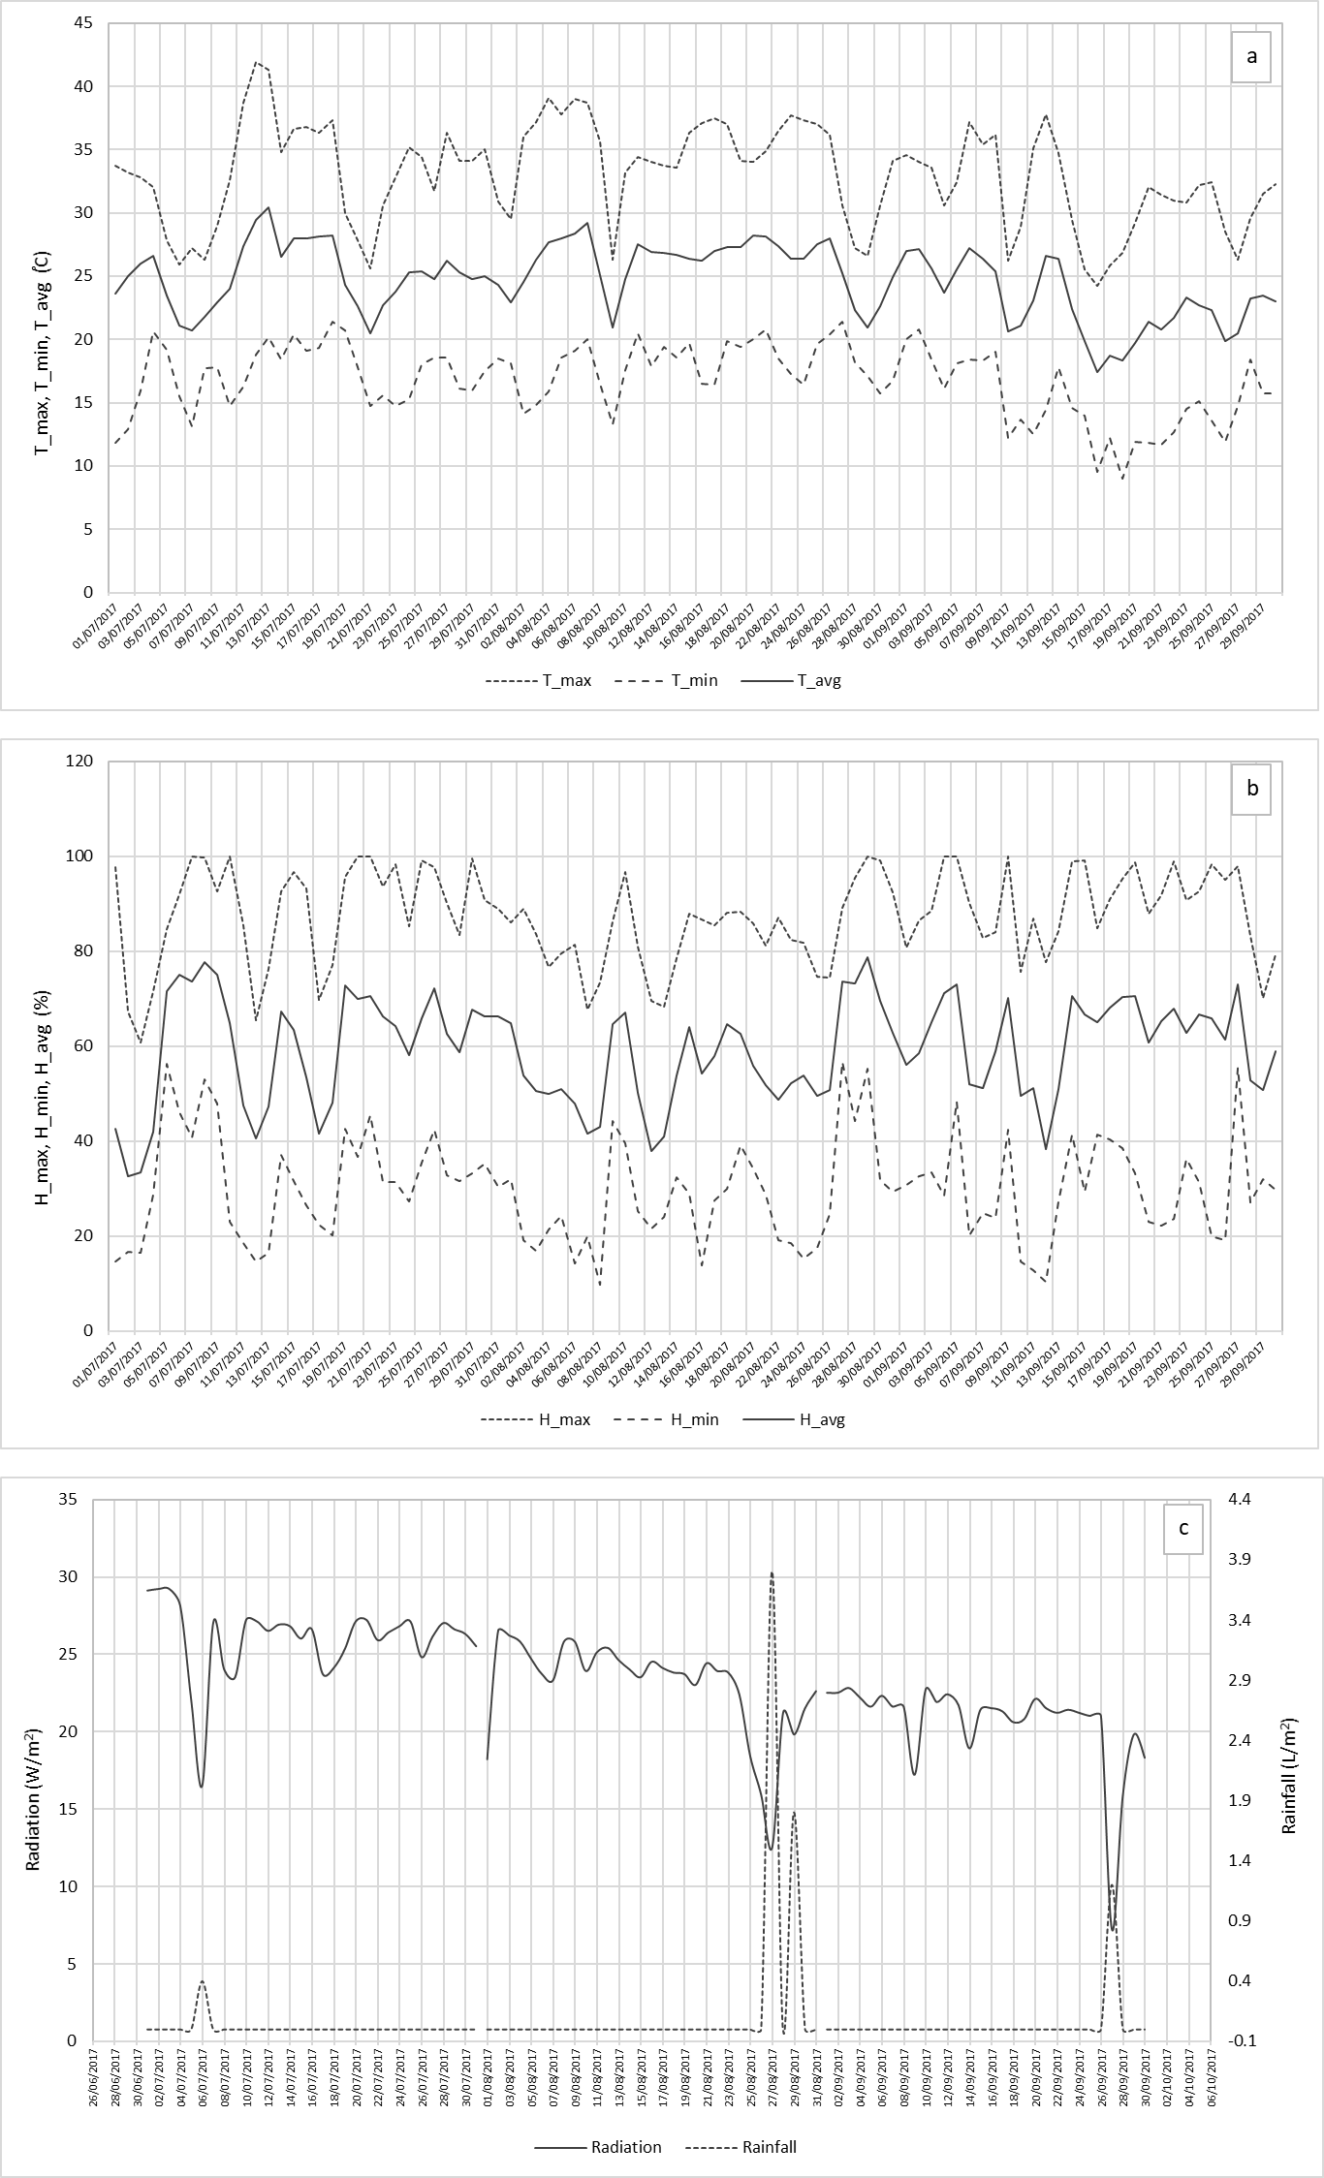
Figure S2a-c. (a) Temperature (°C) (T_max, T_min, T_avg), (b) humidity (%) (H_max, H_min, H_avg) and (c) radiation (W/m²) and rainfall (L/m²) among July and September 2017.

