Supplementary Materials

Cobalt oxide catalysts on stainless steel meshes prepared by magnetron sputtering: performance in ethanol oxidation
K. Jirátová^{1*}, R. Perekrestov², M. Dvořáková³, J. Balabánová¹, P. Topka¹, M. Koštejn¹, J. Olejníček², M. Čada², Z. Hubička², F. Kovanda³
¹Institute of Chemical Process Fundamentals of the CAS, v.v.i., Rozvojová 135, 165 02 Prague, Czech Republic
²Institute of Physics of the CAS, v.v.i., Na Slovance 2, 182 21 Prague, Czech Republic
³Department of Solid State Chemistry, University of Chemistry and Technology, Technická 5, 166 28 Prague, Czech Republic

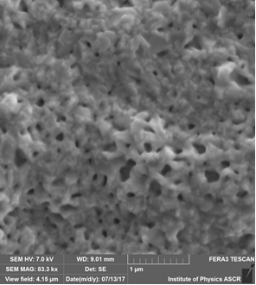
a
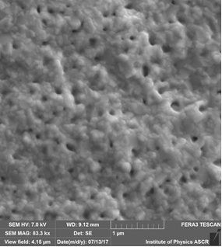
b

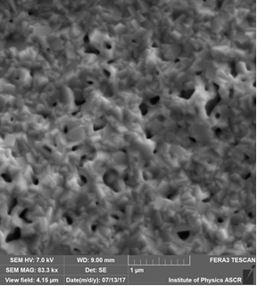
c

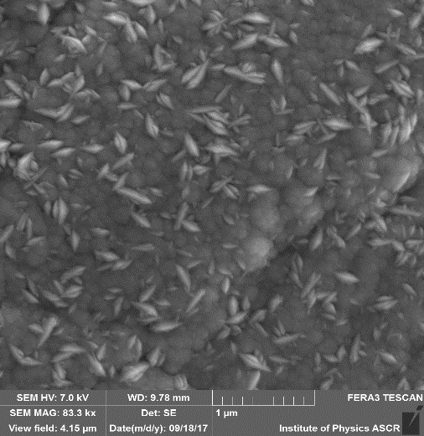
d

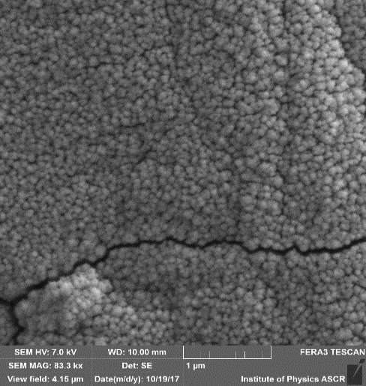
e

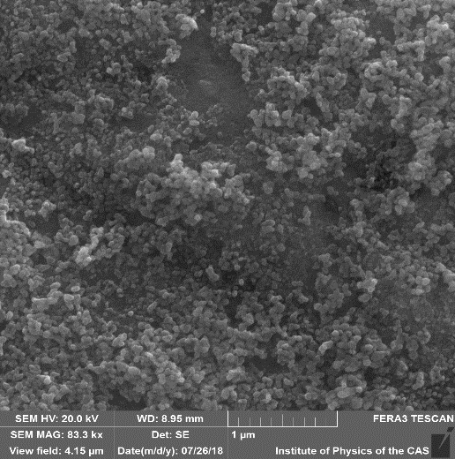
f

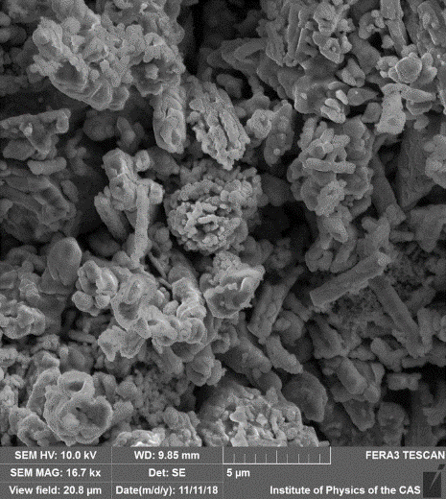
g
Figure S1: SEM images documenting surface morphology of the prepared catalysts: a) Co-RF-1, b) Co-RF-2, c) Co-RF-3, d) Co-RF-ox/ap, e) Co-RF-ox, f) Co-I, and g) pelletized commercial Co₃O₄ (PEL)

