Supplementary Materials: Effect of Synthesis Conditions of Nitrogen and Platinum Co-Doped Titania Films on the Photocatalytic Performance under Simulated Solar Light
Daryna Ihnatiuk ^{1,2} Camilla Tossi ¹, Ilkka Tittonen ¹ and Oksana Linnik ^{3,}*
a | b
c
Figure S1. Absorption spectra of the films obtained by Method 1 (a) and Method 2 (b) 0.5mol%Pt -doped films: TiO₂ (1), Pt-TiO₂ (2), Pt-TiO_{2UV} (3), Pt,N-TiO₂ (4), Pt,N-TiO_{2UV} (5). Emission spectra (c) of a 1000 W middle-pressure mercury lamp without (1) and with (2) the cut-off filter, the solar radiation spectrum is shown in curve (3).
a | b
Figure S2. Tauc plots of the films obtained by Method 1 (a) and Method 2 (b) TiO₂ (1) and N-TiO₂ (2) films.
Figure S3. XRD patterns of N-TiO₂ films obtained by Method 1 (1) and Method 2 (2): a-anatase and b-brookite.
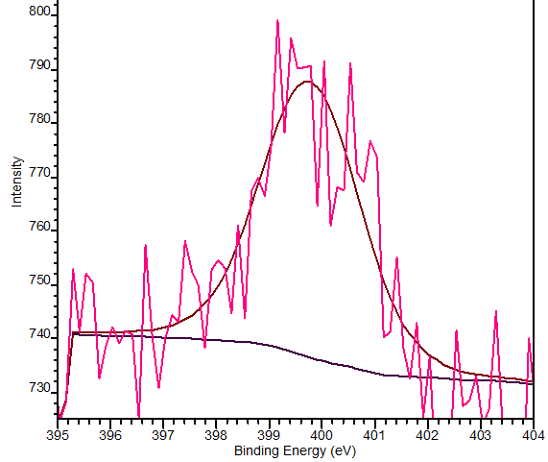 | 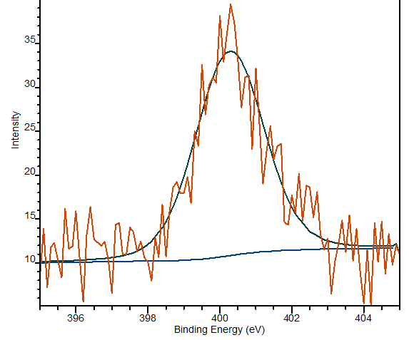
N1s
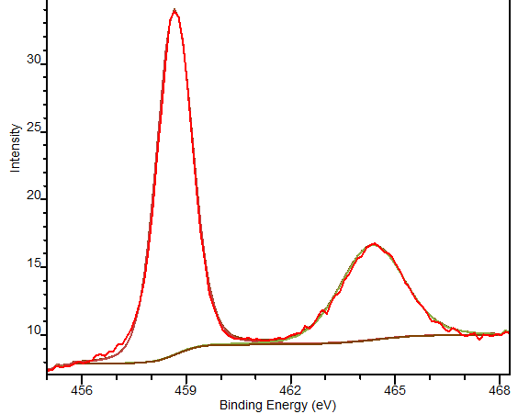 | 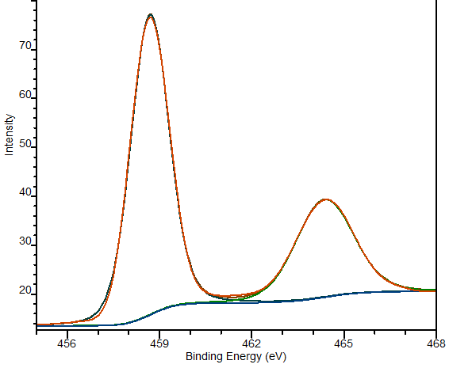
Ti2p
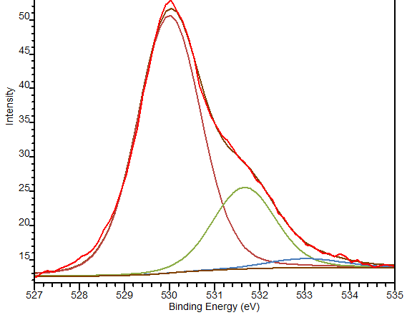 | 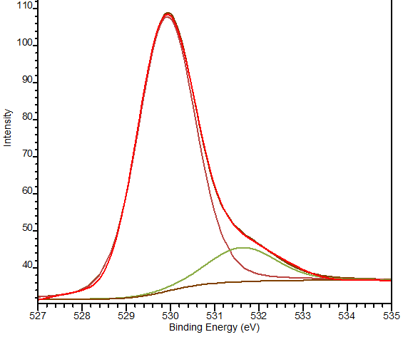
O1s
Figure S4. N1s, Ti2p and O1s XPS spectra of the N-TiO₂ films obtained by Method 1 (left) and Method 2 (right).
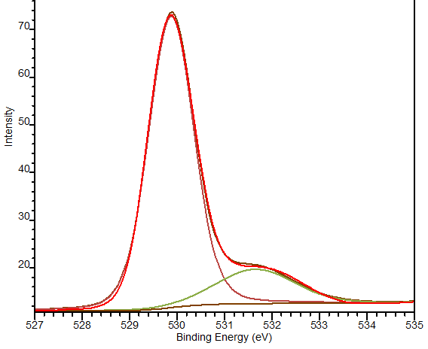  1Pt-TiO_{2M1} | 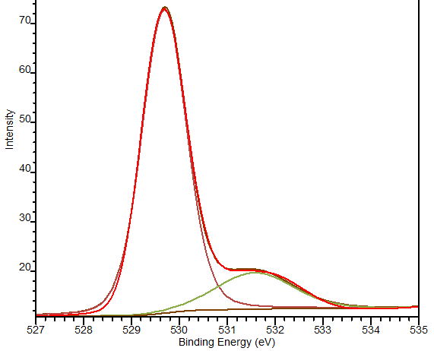  1Pt,N-TiO_{2M1}
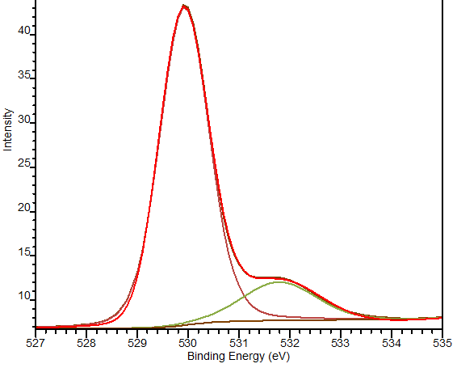  1Pt-TiO_{2M1UV} | 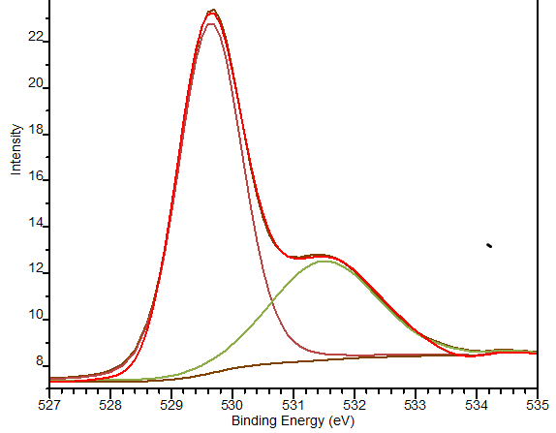  1Pt,N-TiO_{2M1UV}
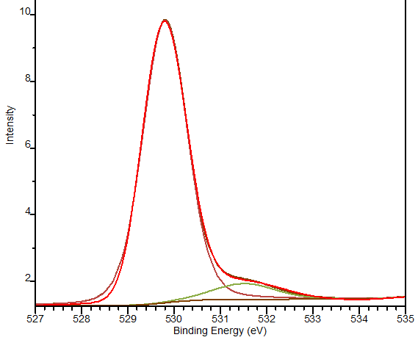  1Pt-TiO_{2M2} | 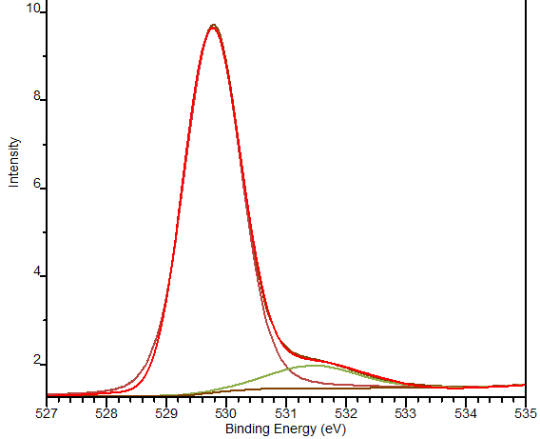  1Pt,N-TiO_{2M2}
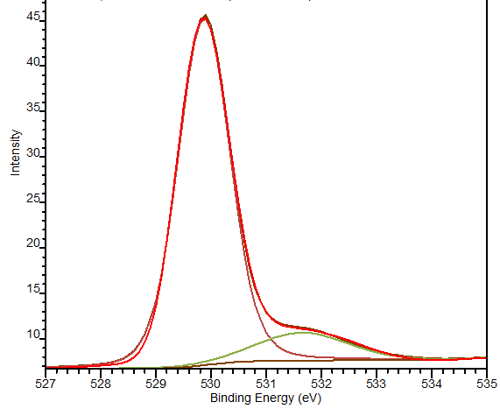  1Pt-TiO_{2M2UV} | 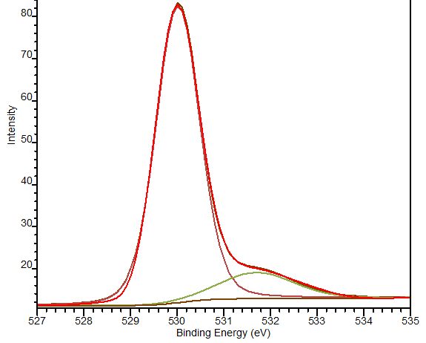1Pt,N-TiO_{2M2UV}
Figure S5. Deconvoluted XPS O1s spectra of Pt and Pt,N co-doped titania films.
Table S1. Binding energy values of Pt4f XPS spectra.
Film | Pt⁰ |  | Pt²⁺ |  | Pt⁰ |  | Pt²⁺ |  | Pt⁴⁺
Film | Pt4f_{7/2} | Pt4f_{5/2} | Pt4f_{7/2} | Pt4f_{5/2} | Pt4f_{7/2} | Pt4f_{5/2} | Pt4f_{7/2} | Pt4f_{5/2} | Pt4f_{7/2} | Pt4f_{5/2}
Film | Method 1 |  |  |  | Method 2
0.5Pt-TiO₂ | 70.2 | 73.5 | 71.0  72.4 | 74.4  75.8 | - | - | 72.3 | 75.7
0.5Pt,N-TiO₂ | 70.8 | 74.1 | 72.4 | 75.8 | 70.6 | 74.0 | 72.3 | 75.6 | - | -
0.5Pt-TiO_{2UV} | 70.7 | 74.0 | 72.5 | 75.9 | - | - | 72.4 | 75.8 | 74.2 | 77.6
0.5Pt,N-TiO_{2UV} | 71.0 | 74.3 | 72.1 | 75.4 | 70.6 | 74.0 | 72.3 | 75.7 | - | -
1Pt-TiO₂ | 71.4 | 74.7 | 72.1 | 75.4 | - | - | 72.0 | 75.4 | - | -
1Pt,N-TiO₂ | 70.4 | 73.7 | 72.0 | 75.3 | 70.5 | 73.8 | 71.2  72.5 | 74.6  75.8 | 74.3 | 77.6
1Pt-TiO_{2UV} | 70.3 | 73.6 | 71.1 | 74.4 | - | - | 72.3 | 75.6 | 74.3 | 77.6
1Pt,N-TiO_{2UV} | 69.6 | 73.0 | 71.4 | 74.7 | 70.8 | 74.2 | 72.5 | 75.8 | 74.6 | 78.0

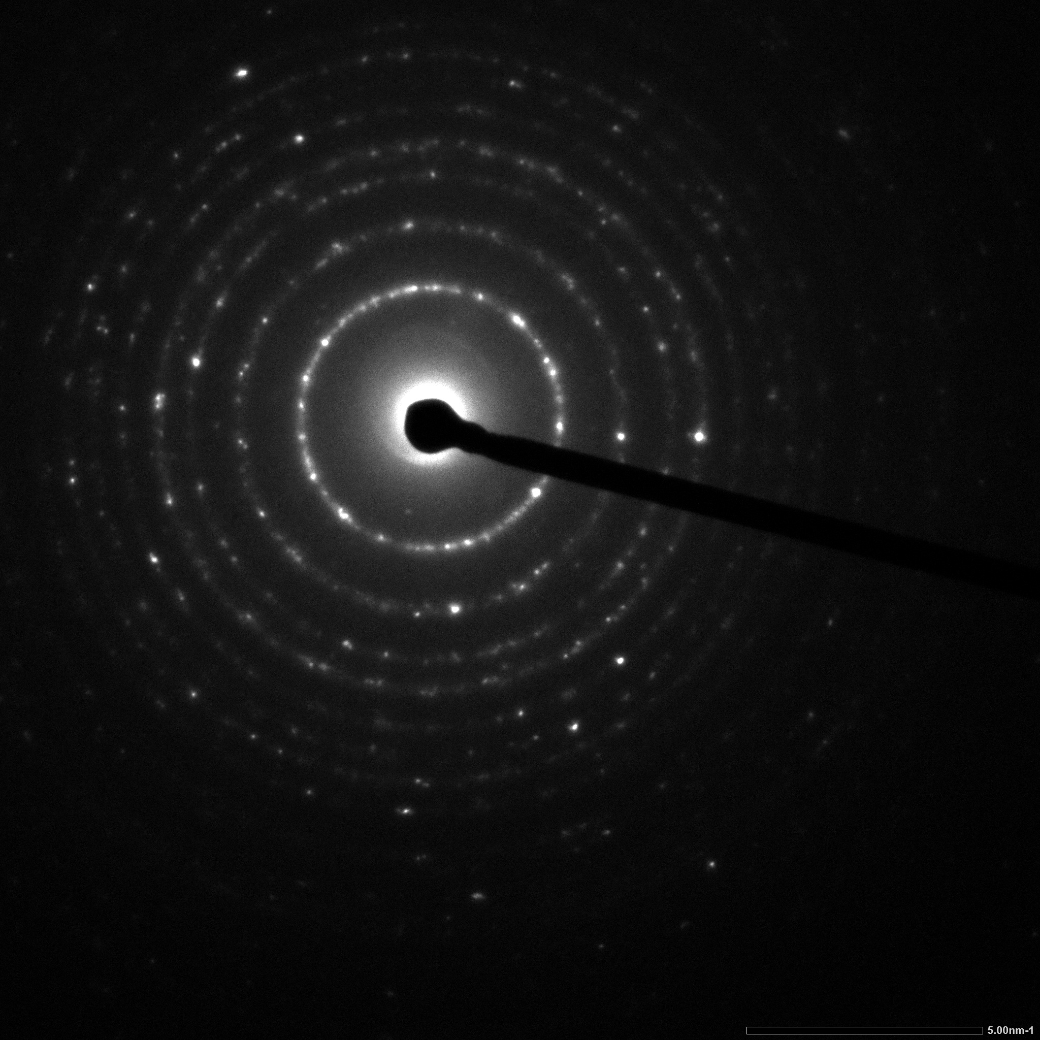 | 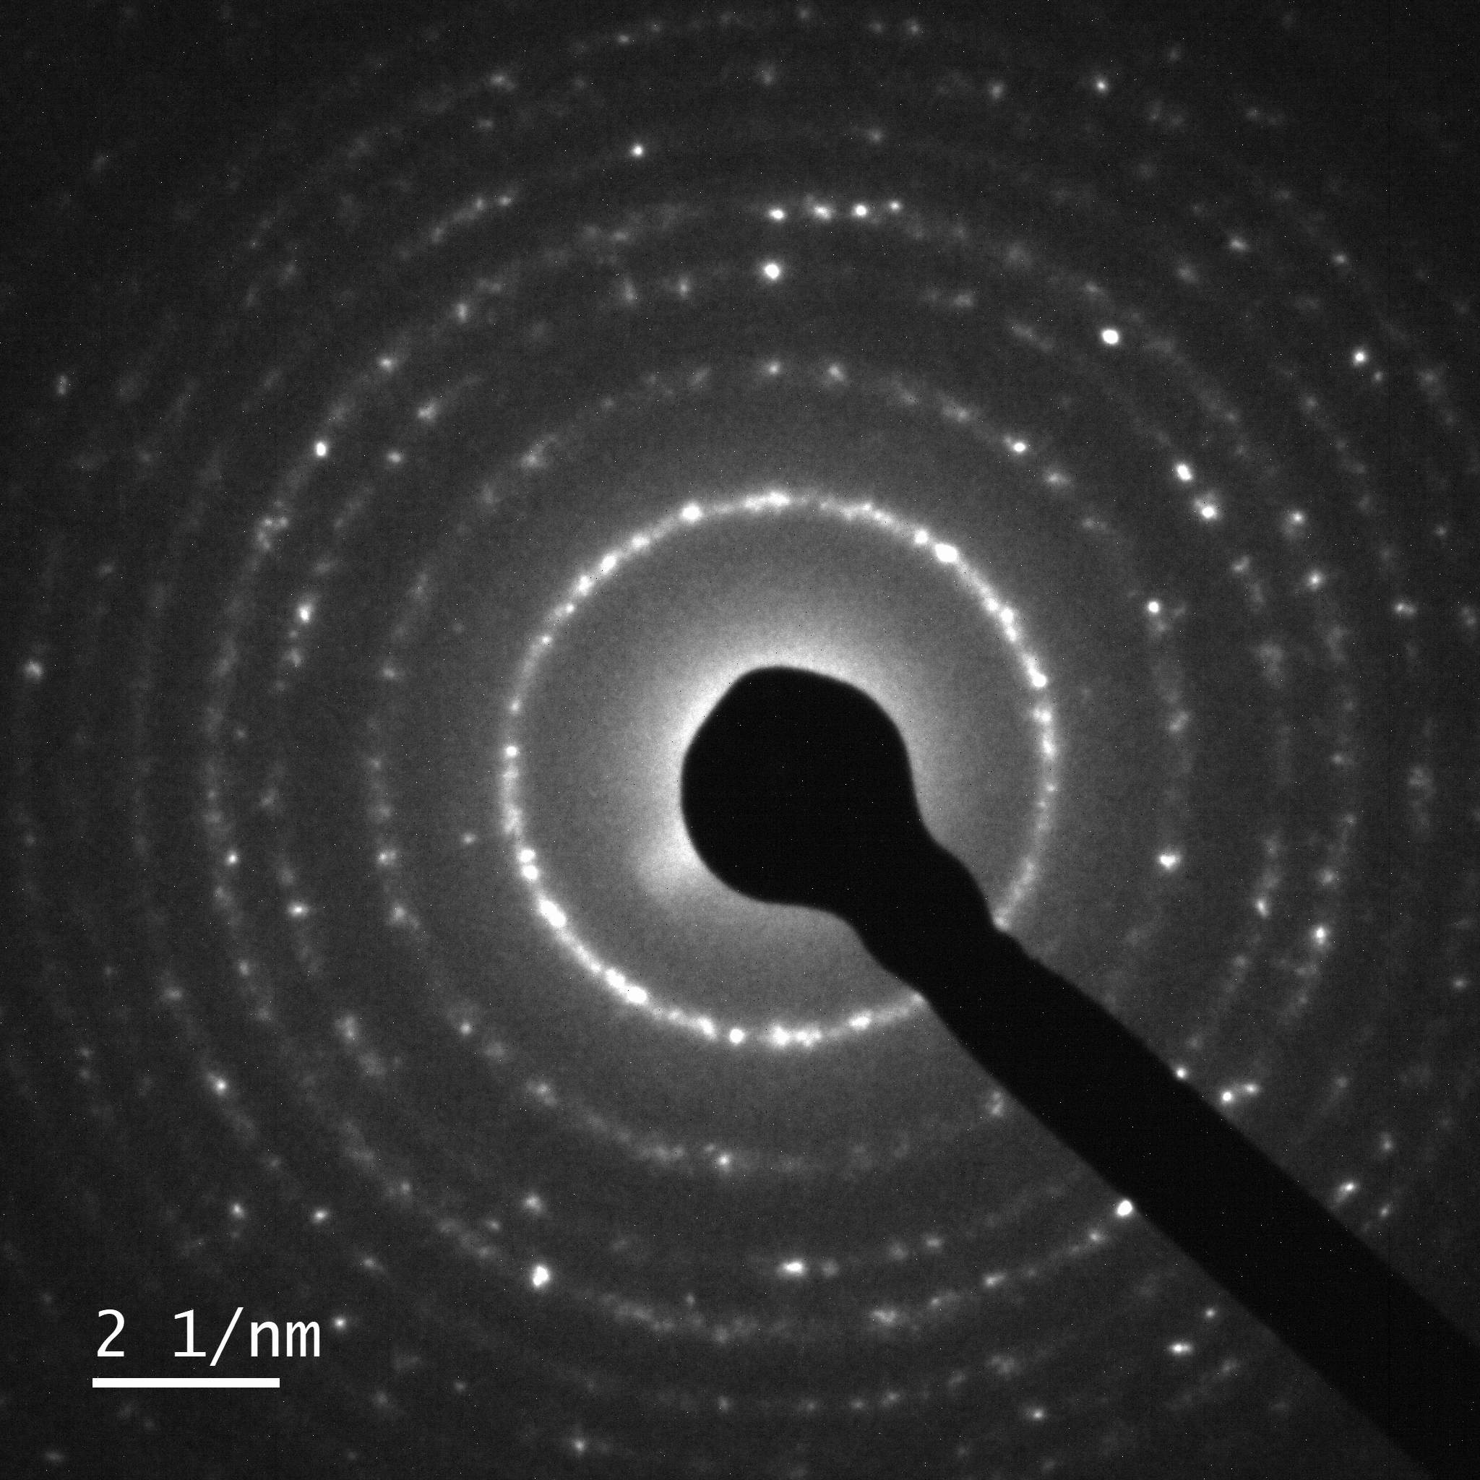 | 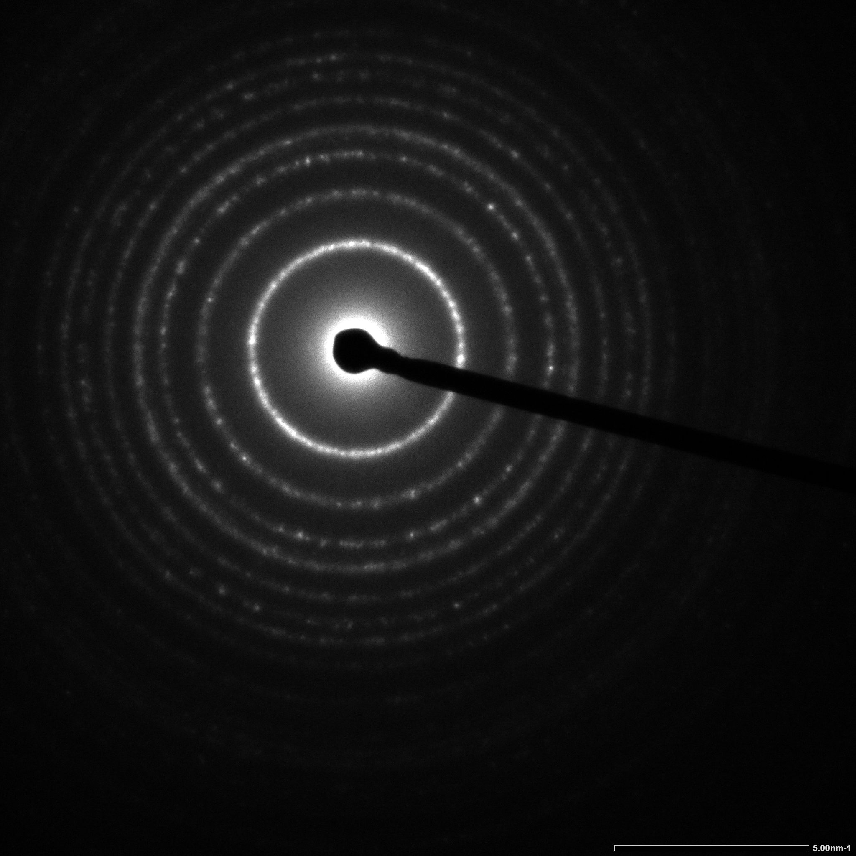
(a) | (b) | (c)
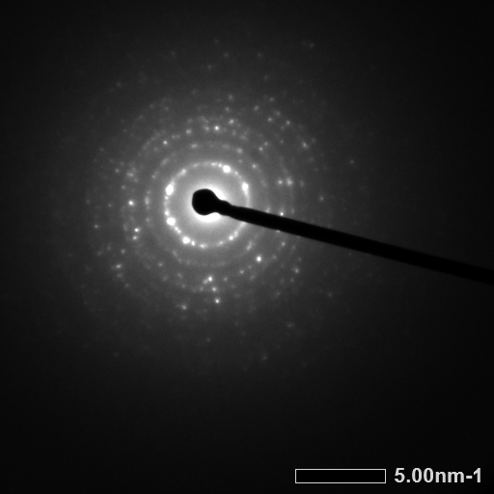 | 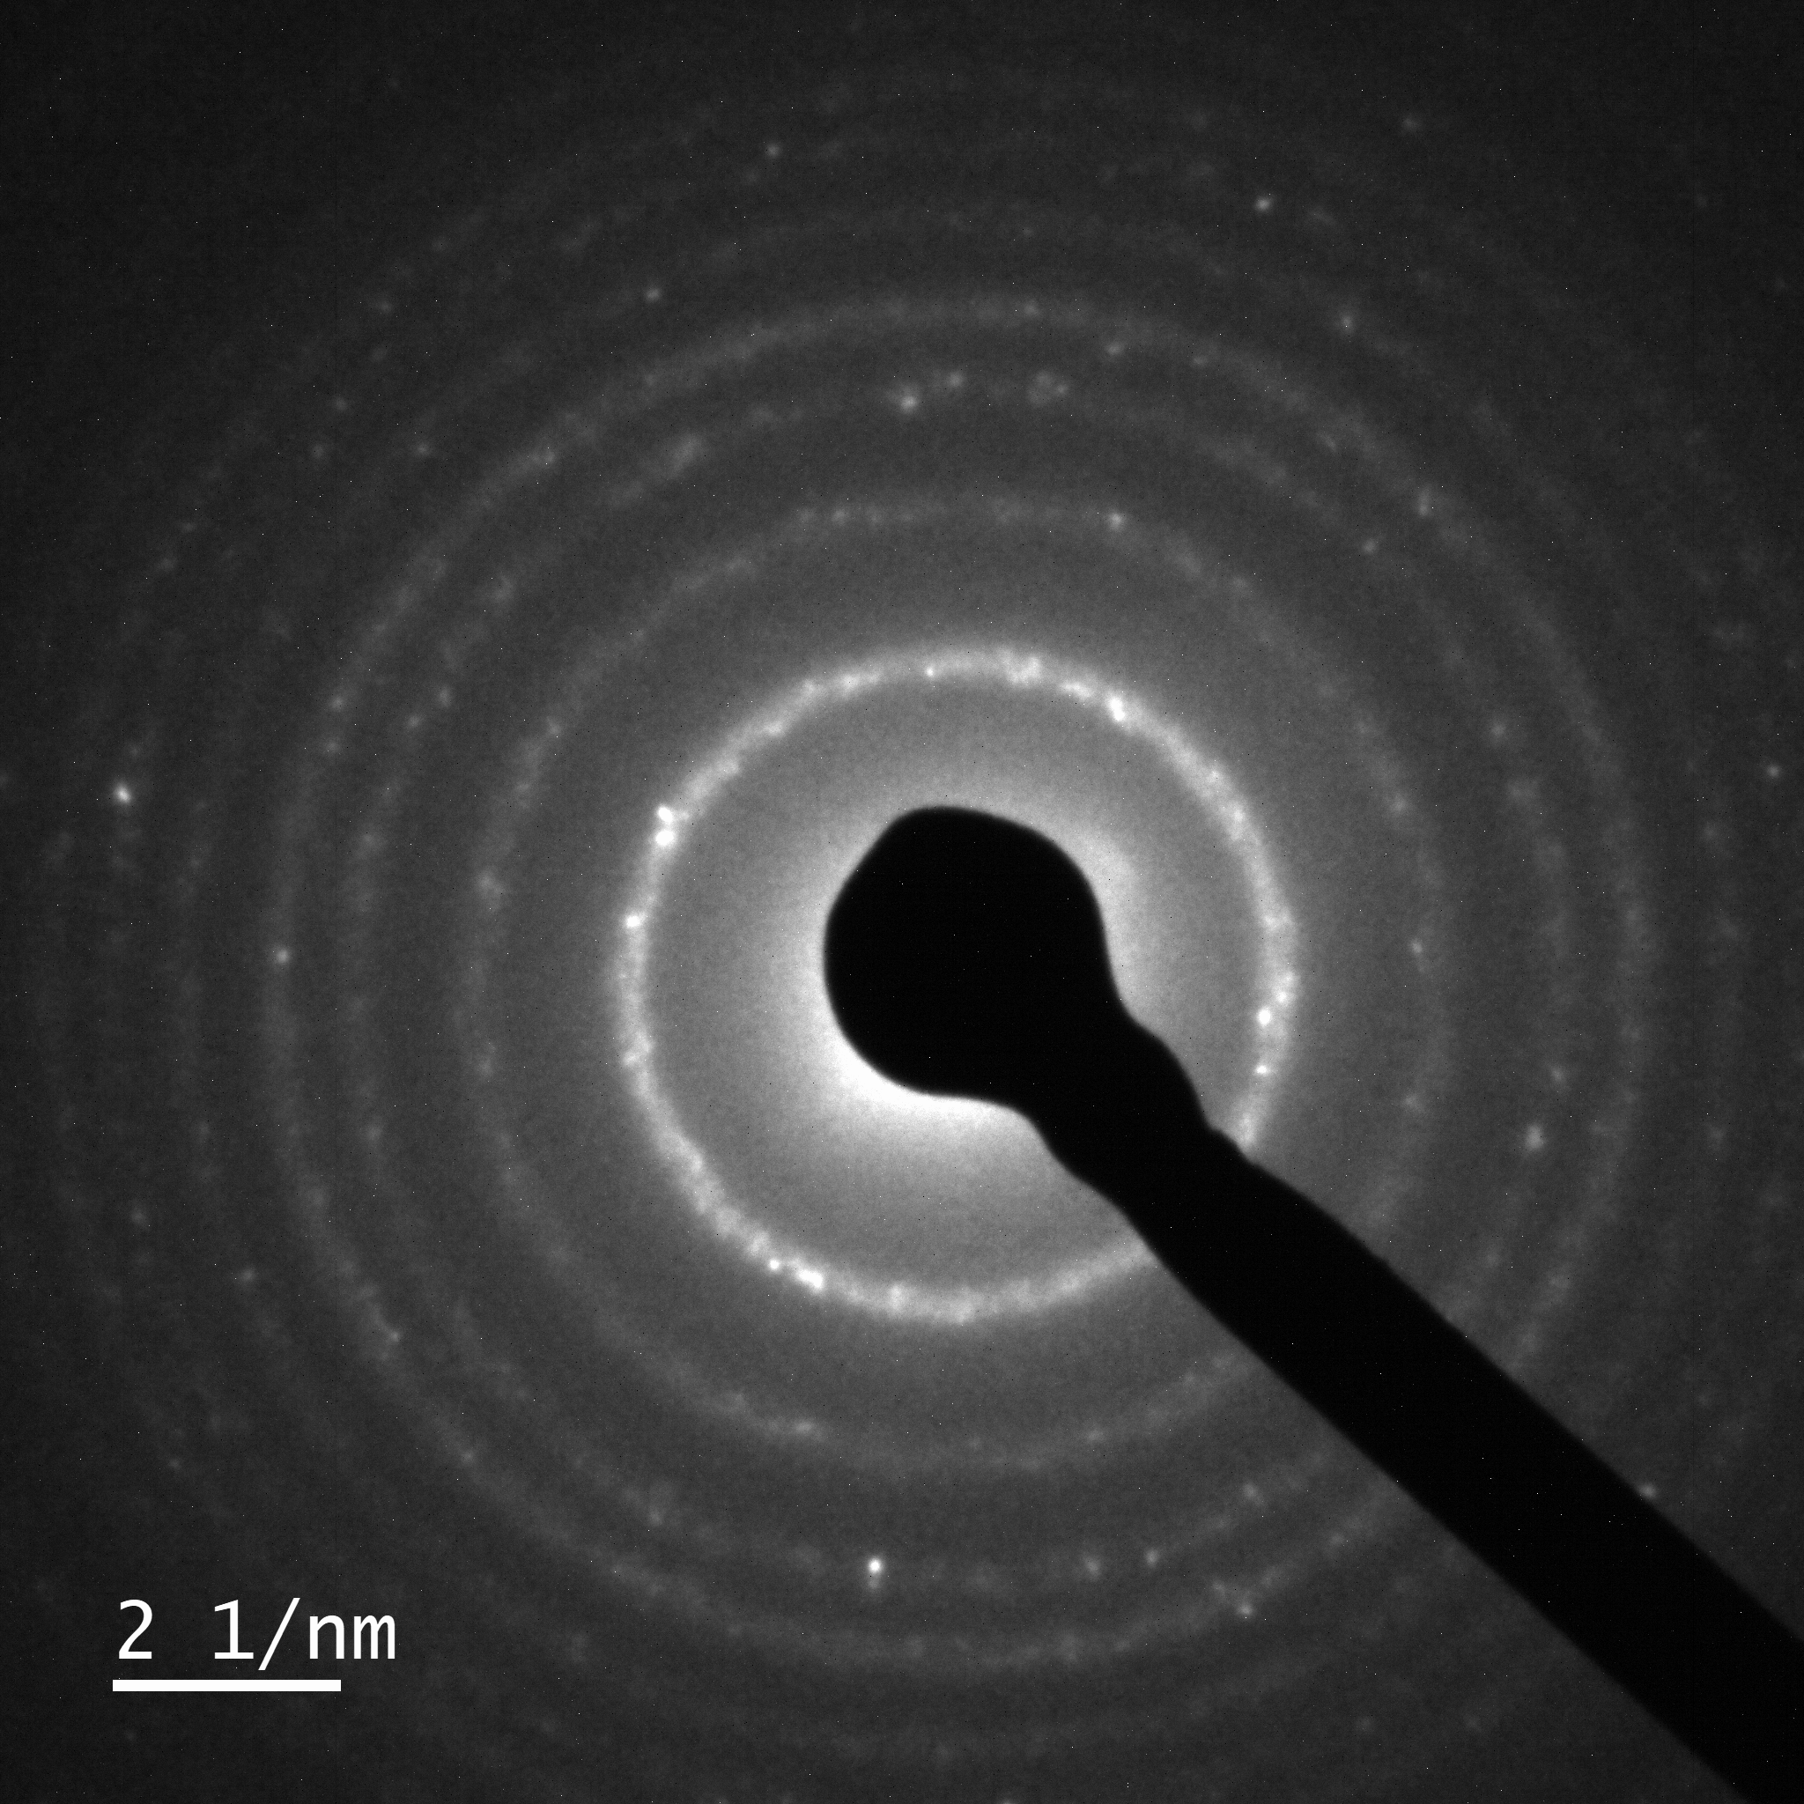 | 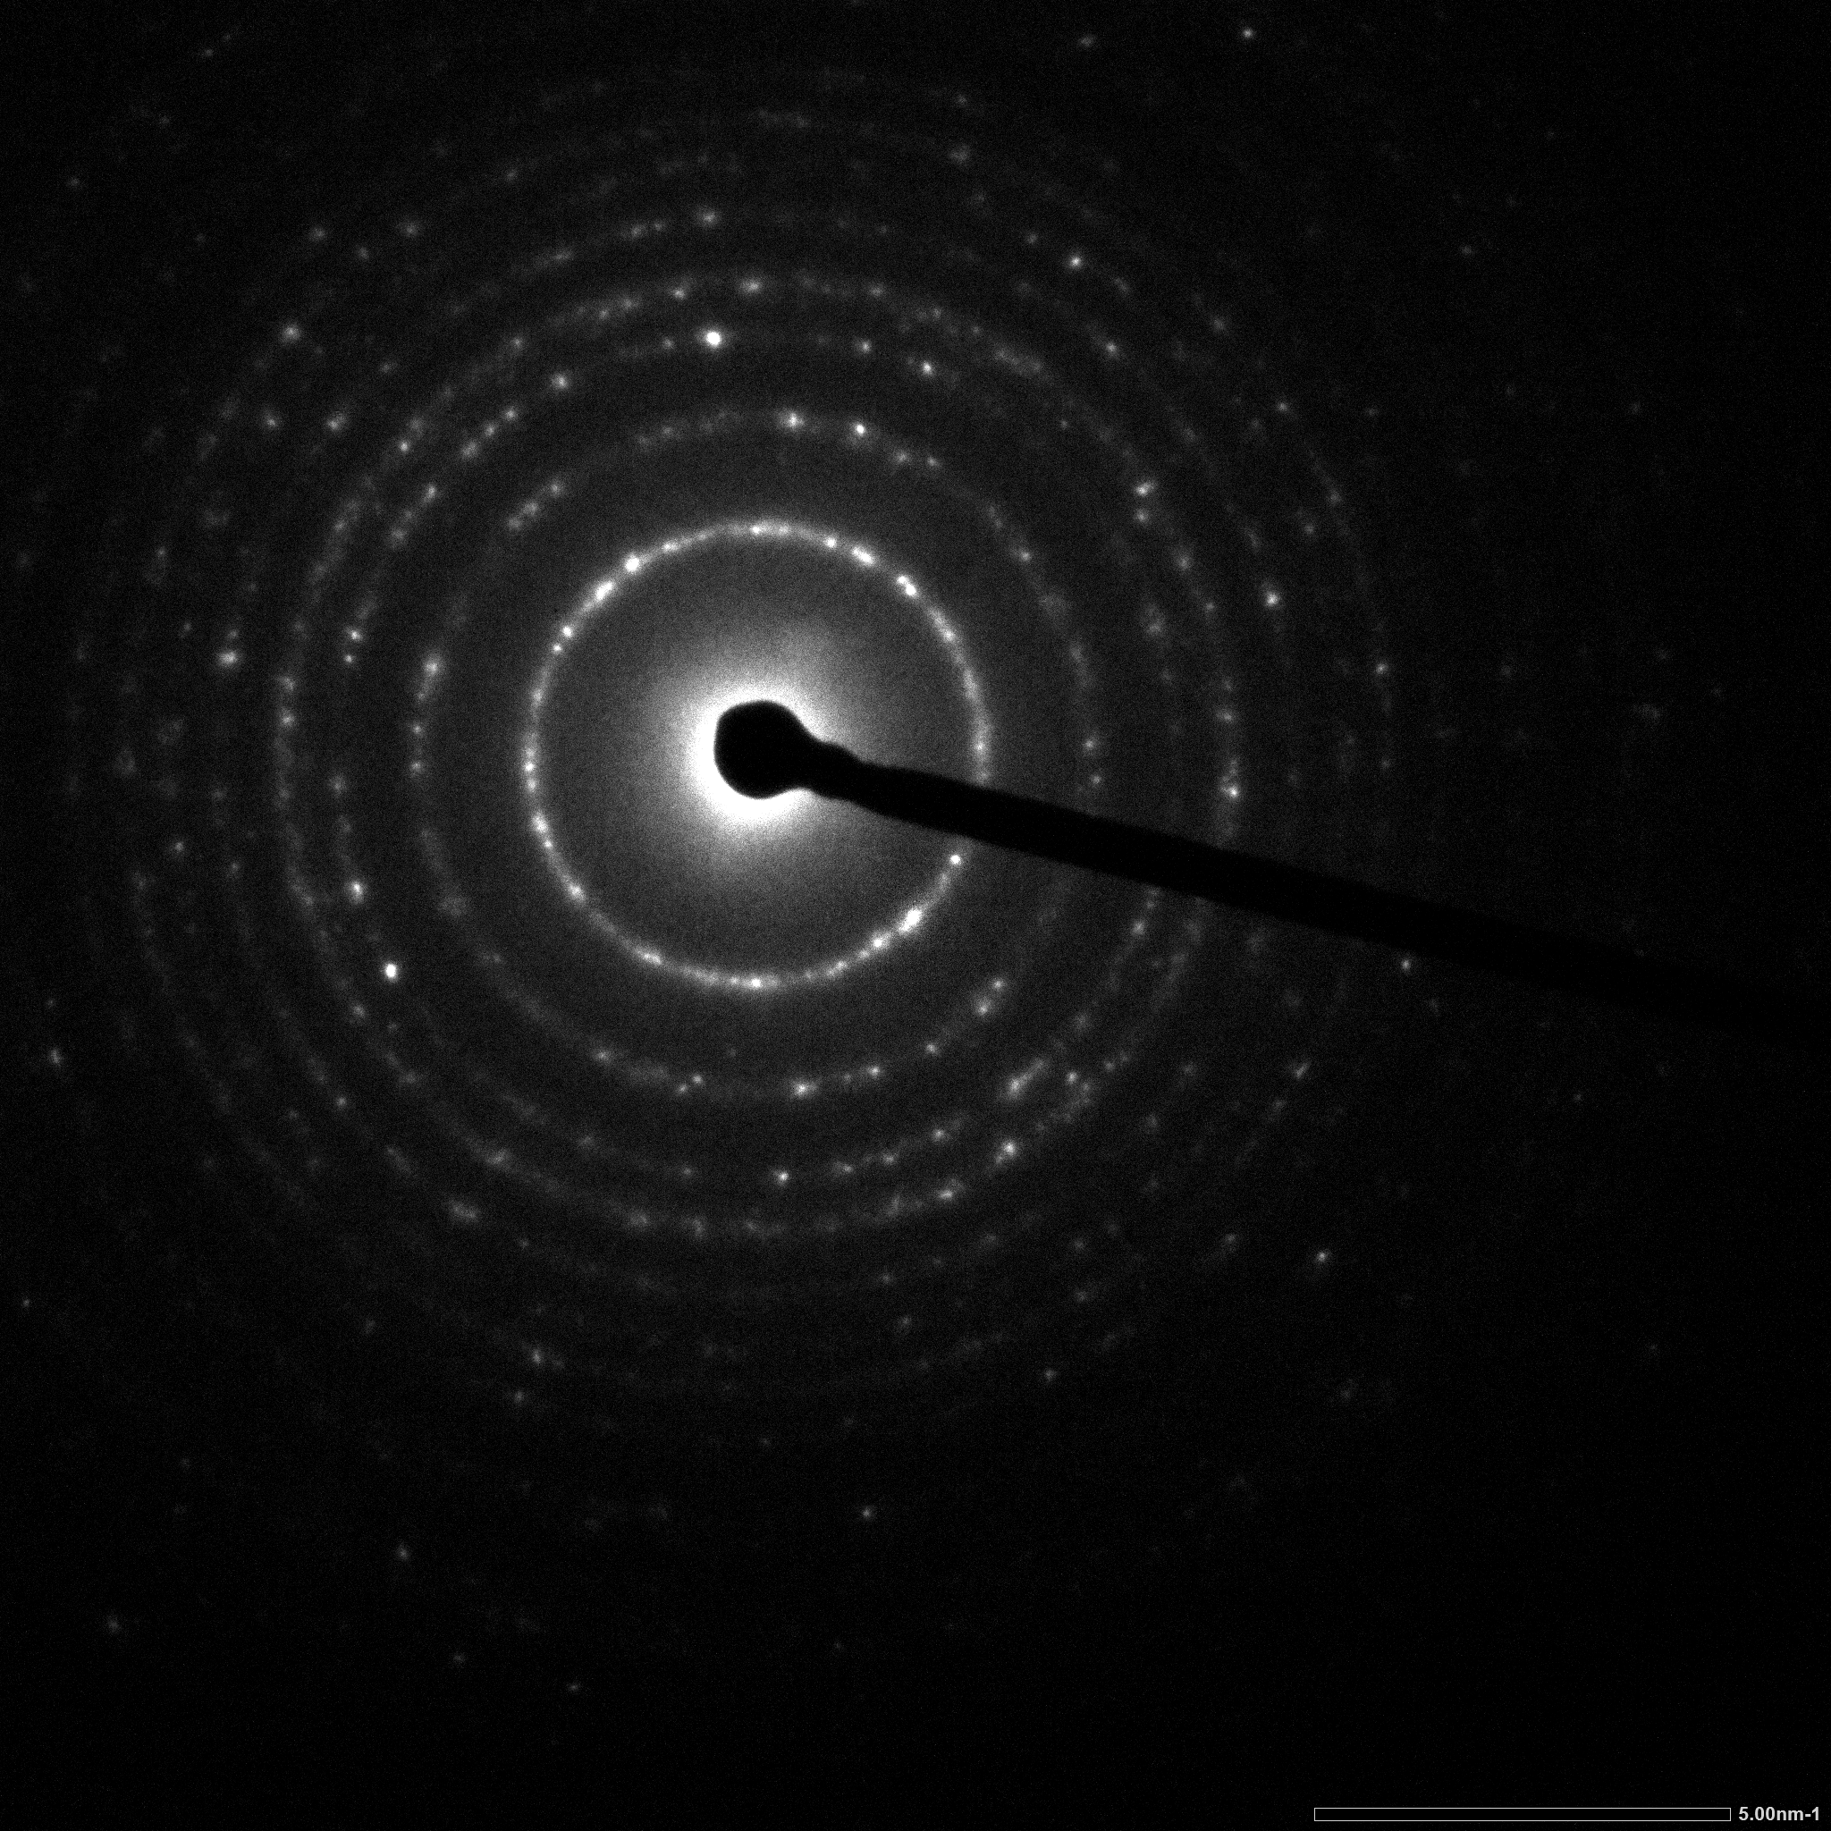
(d) | (e) | (f)
Figure S6. (a) 1%Pt-TiO_{2M2}; (b) 1%Pt-TiO_{2M1}; (c) 1%Pt-TiO_{2M1UV}; (d) 1%Pt,N-TiO_{2M2}; (e) 1%Pt,N-TiO_{2M1}; (f) 1%Pt,N-TiO_{2M1UV.}

