Supplementary Information
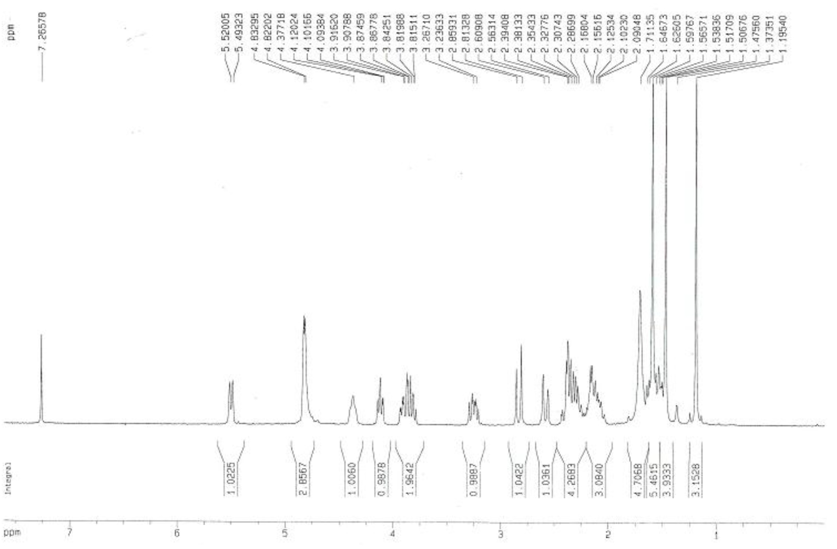
Figure S1. ¹H NMR spectrum (300 MHz, CDCl₃) of Cespilamide A (1).
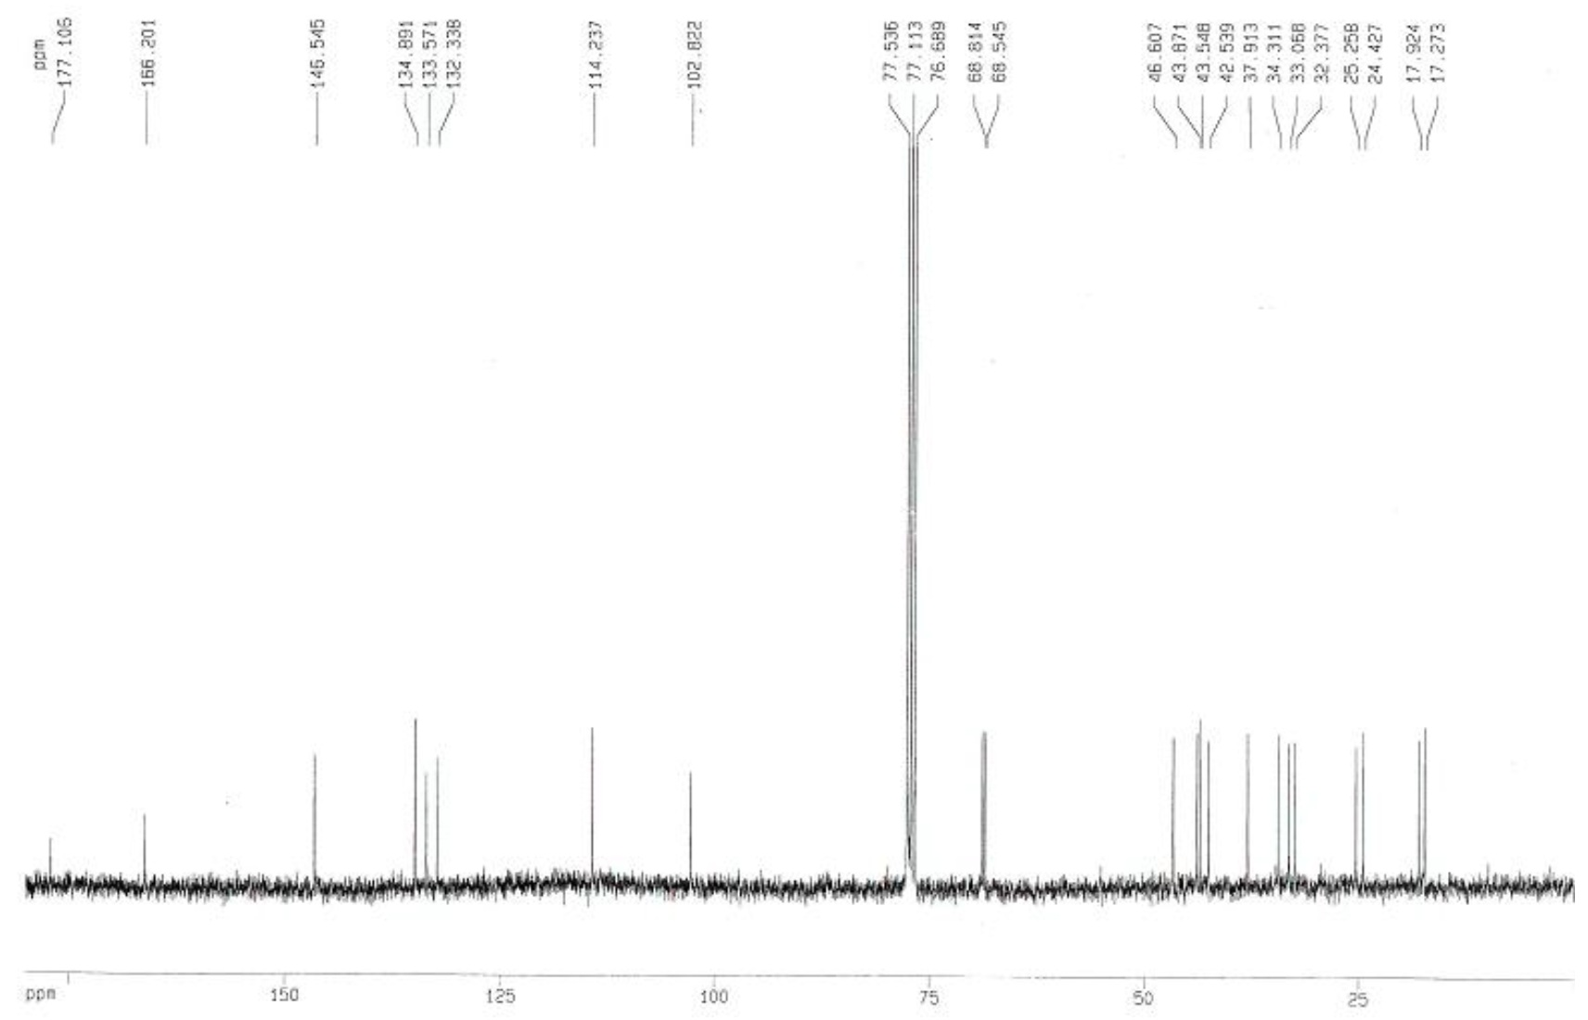
Figure S2. ¹³C NMR spectrum (75 MHz, CDCl₃) of Cespilamide A (1).
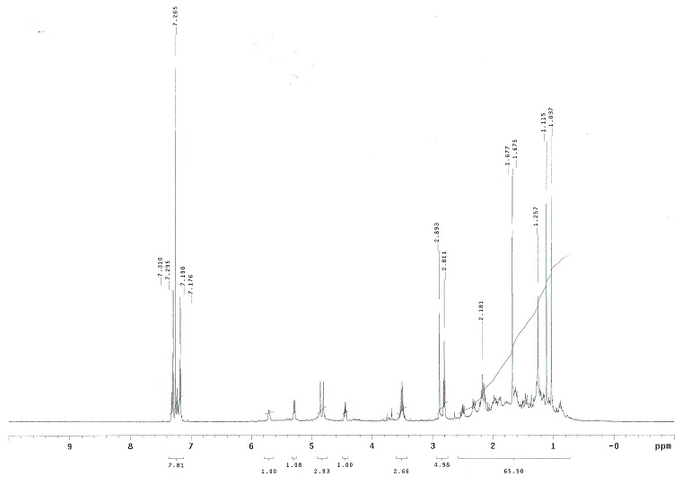
Figure S3. ¹H NMR spectrum (500 MHz, CDCl₃) of Cespilamide B (2).
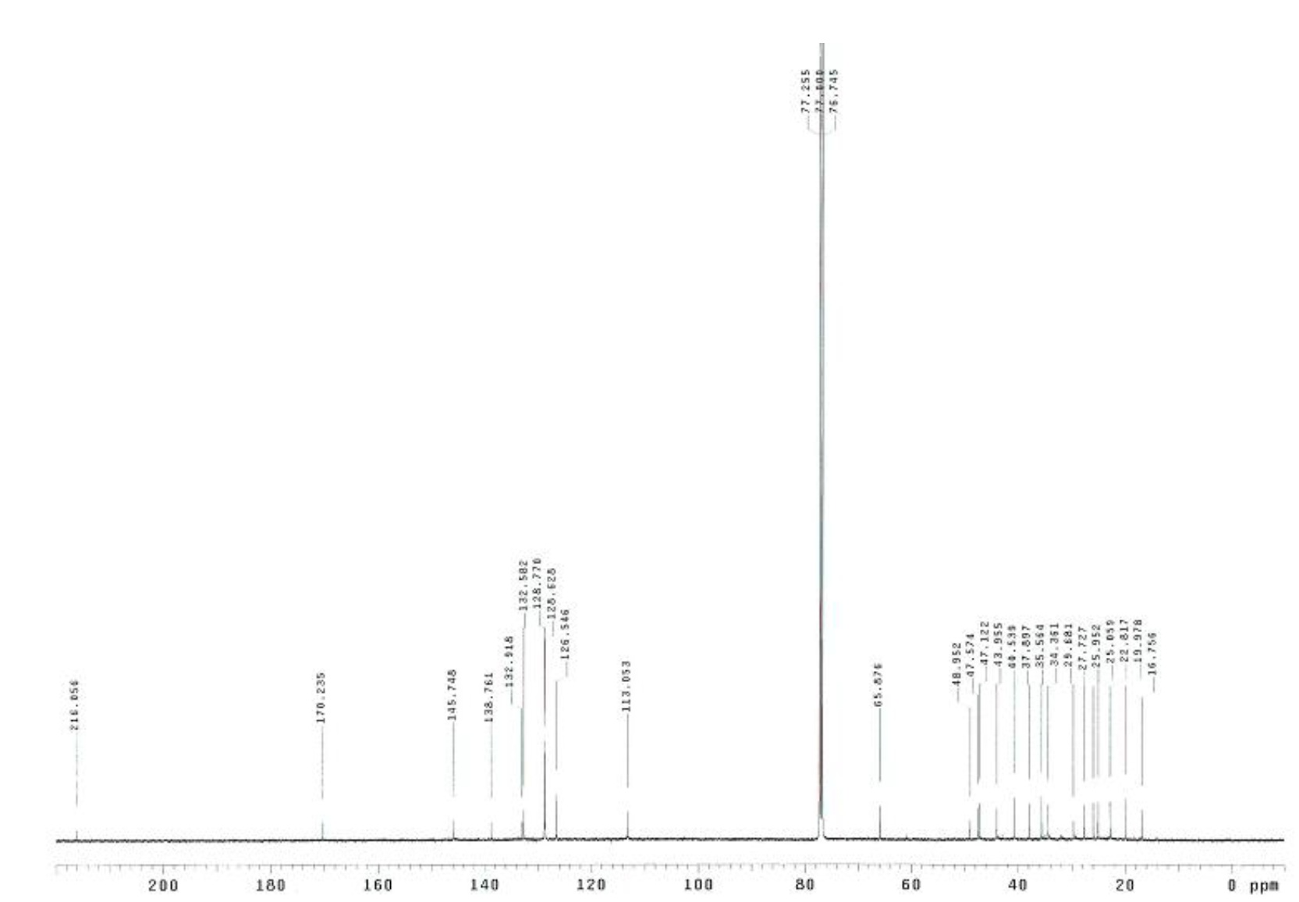
Figure S4. ¹³C NMR spectrum (125 MHz, CDCl₃) of Cespilamide B (2).
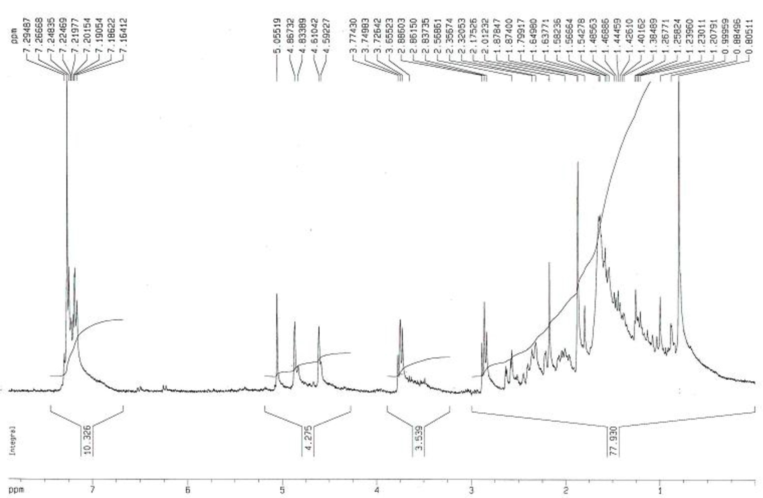
Figure S5. ¹H NMR spectrum (300 MHz, CDCl₃) of Cespilamide C (3).
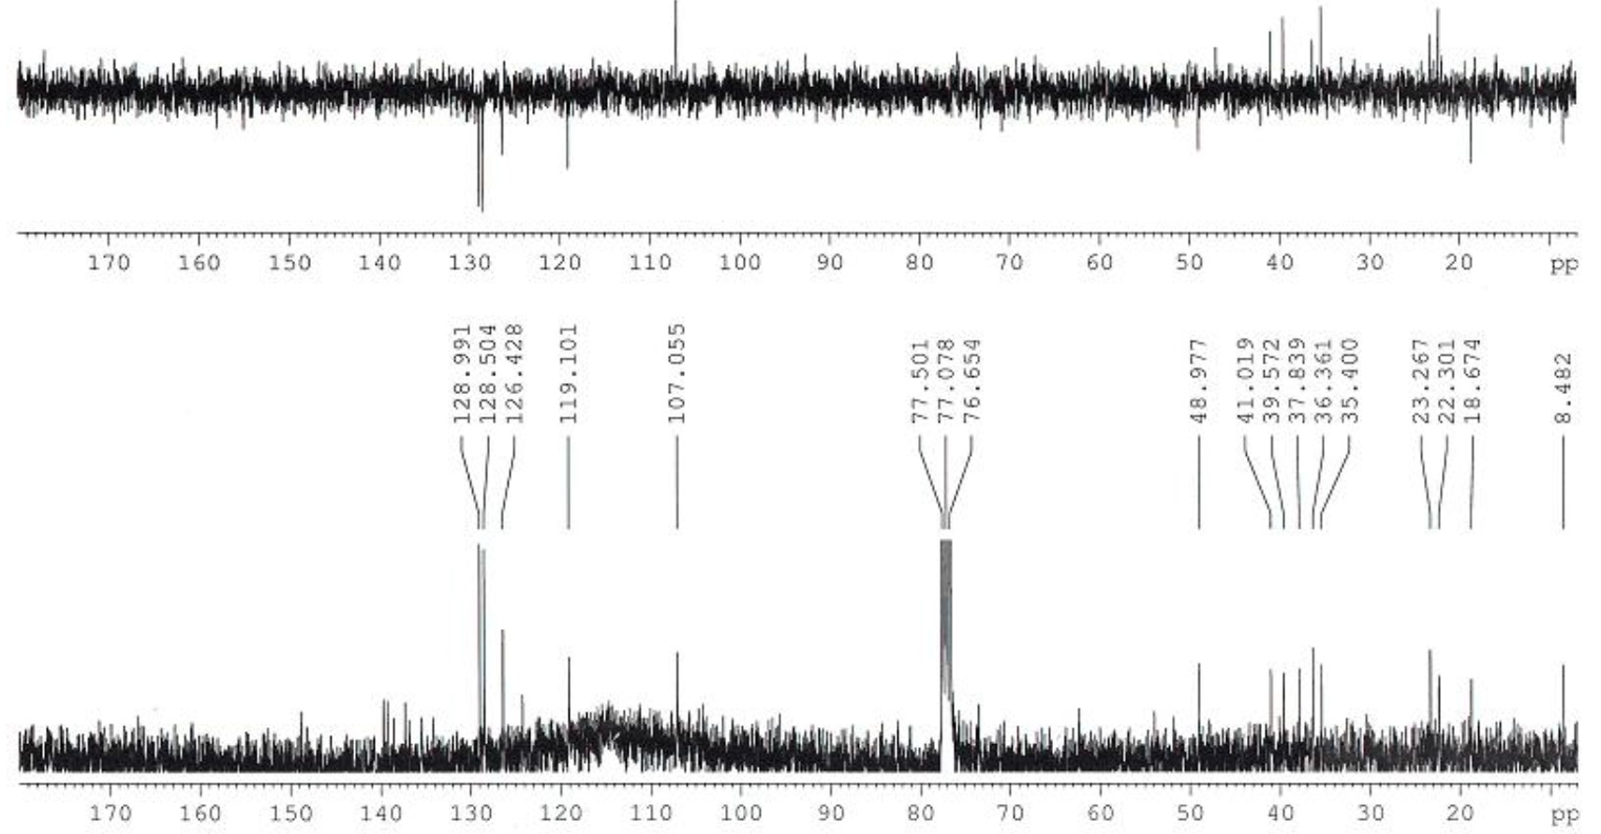
Figure S6. ¹³C NMR spectrum (75 MHz, CDCl₃) of Cespilamide C (3).

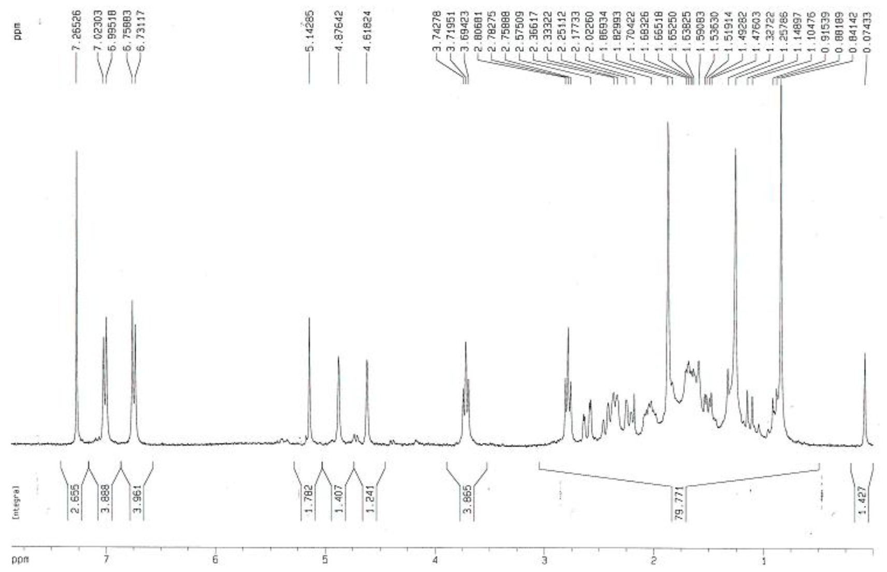
Figure S7. ¹H NMR spectrum (300 MHz, CDCl₃) of Cespilamide D (4).
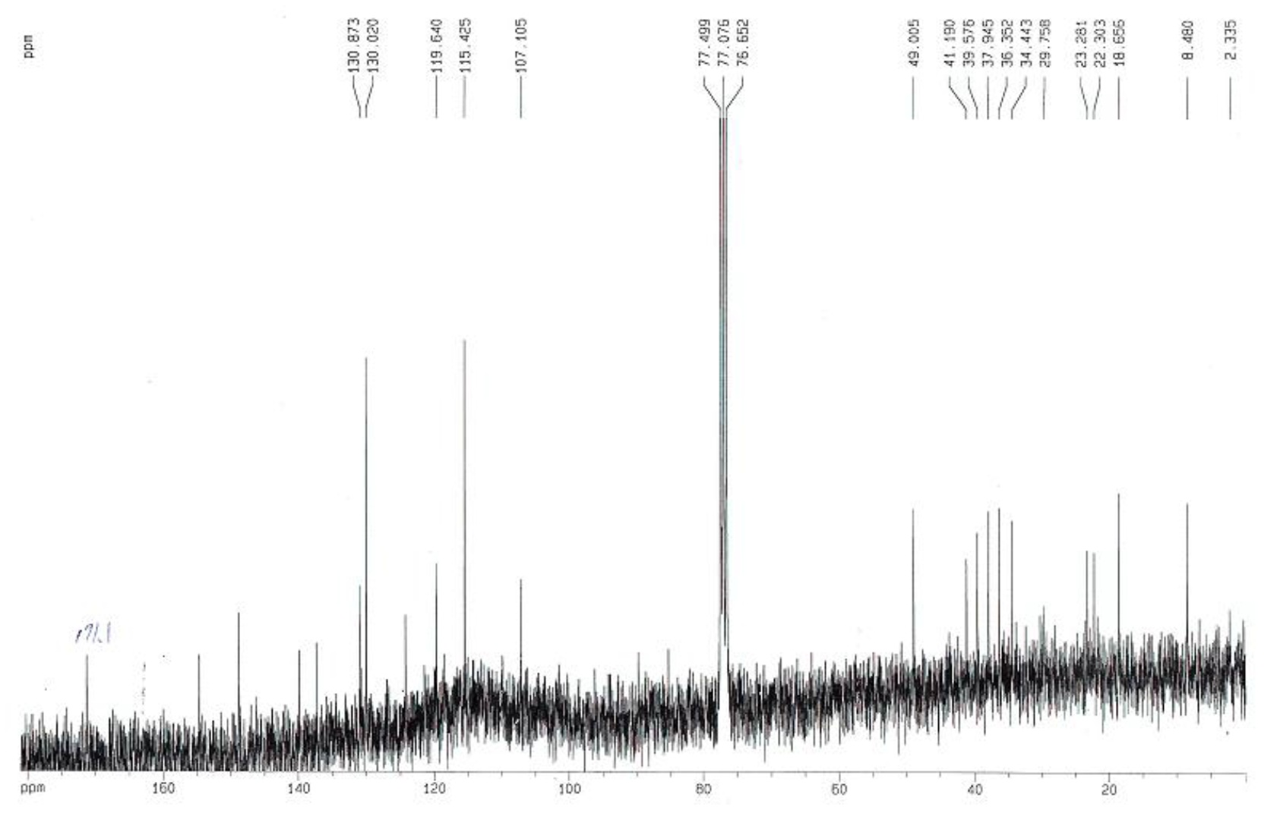
Figure S8. ¹³C NMR spectrum (75 MHz, CDCl₃) of Cespilamide D (4).
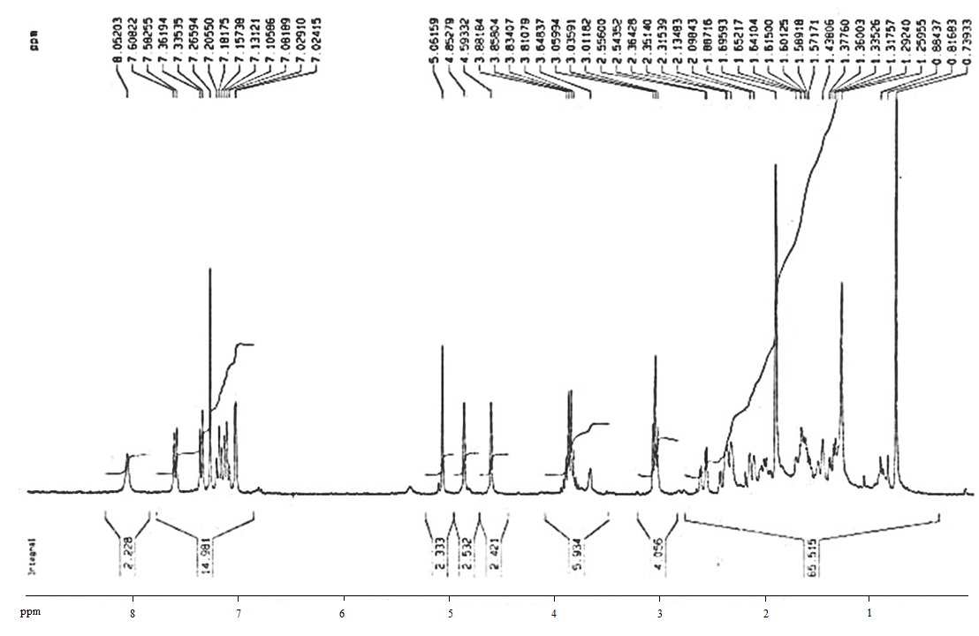
Figure S9. ¹H NMR spectrum (300 MHz, CDCl₃) of Cespilamide E (5).
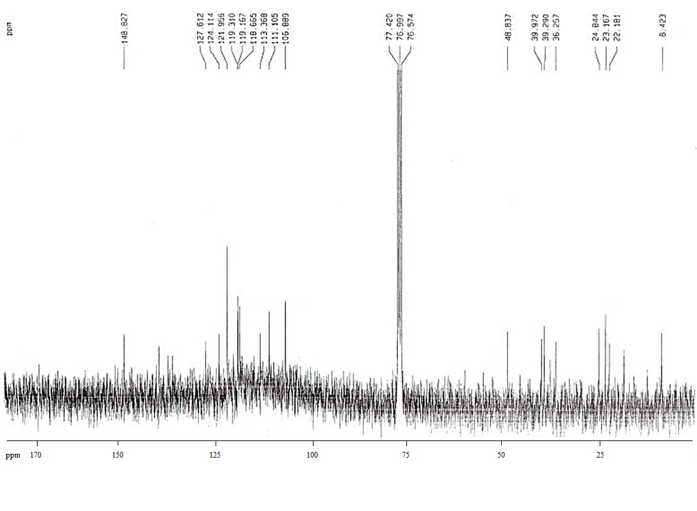
Figure S10. ¹³C NMR (75 MHz, CDCl₃) of Cespilamide E (5).
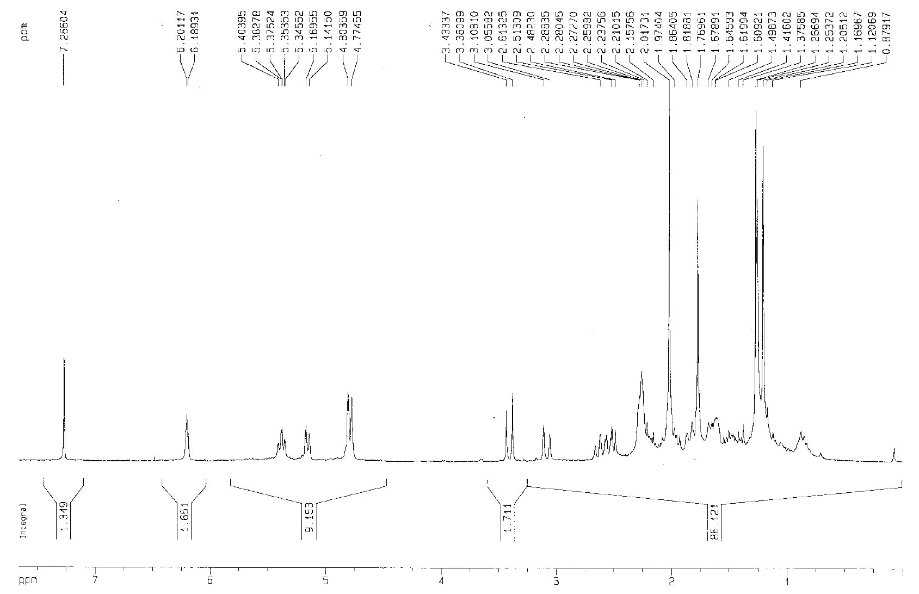
Figure S11. ¹H NMR (300 MHz, CDCl₃) of Cespitaenin A (6).
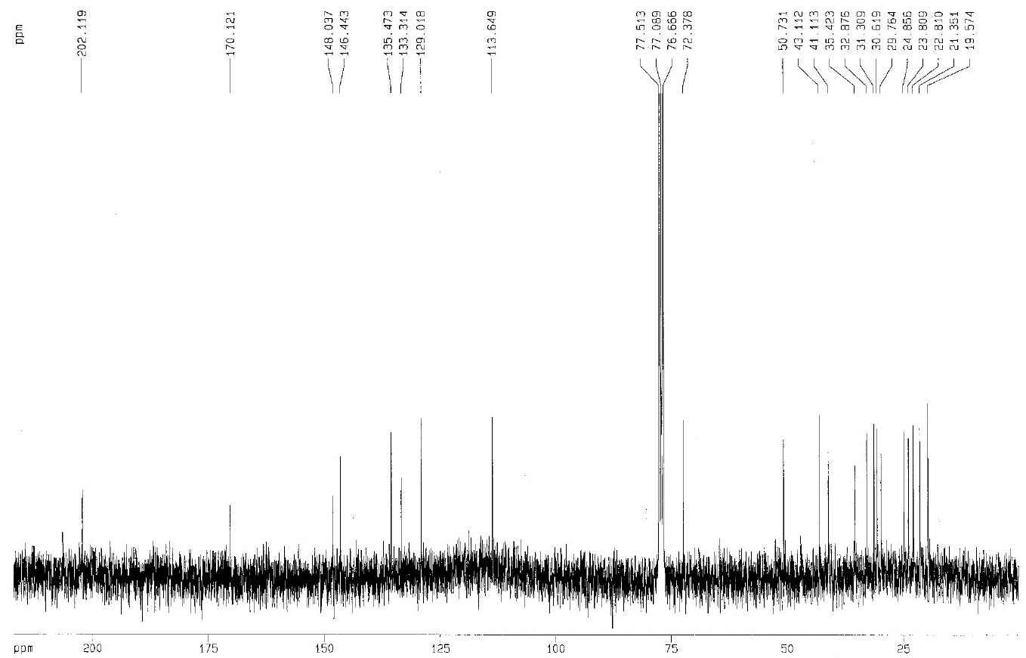
Figure S12. ¹³C NMR (75 MHz, CDCl₃) of Cespitaenin A (6).
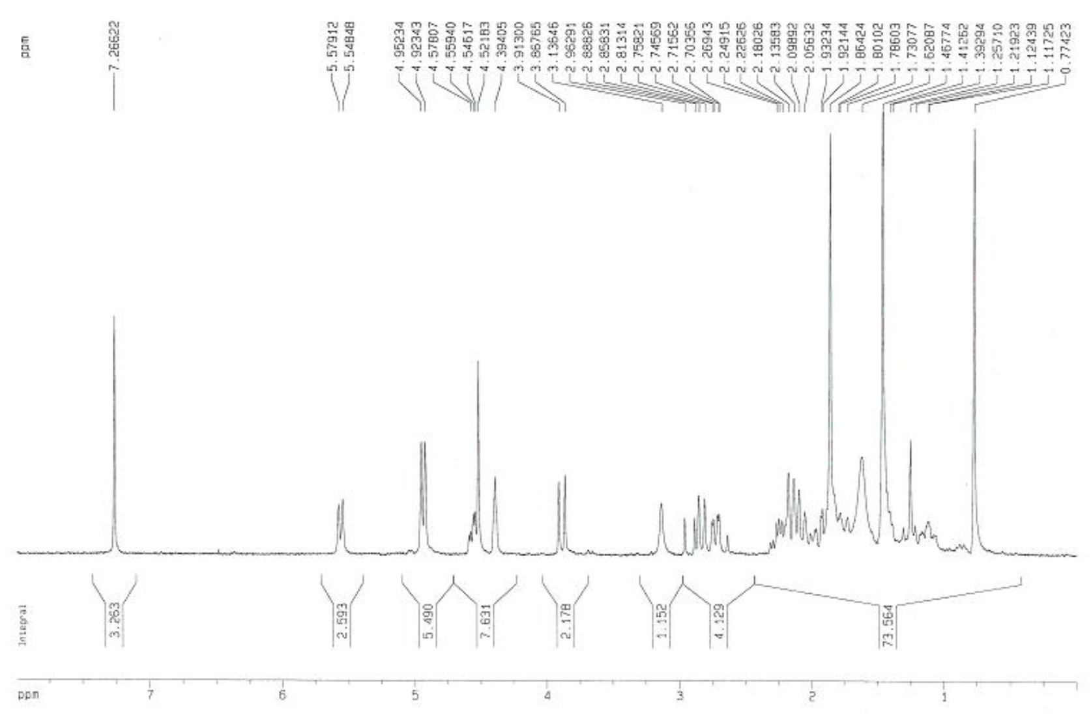
Figure S13. ¹H NMR (300 MHz, CDCl₃) of Cespitaenin B (7).
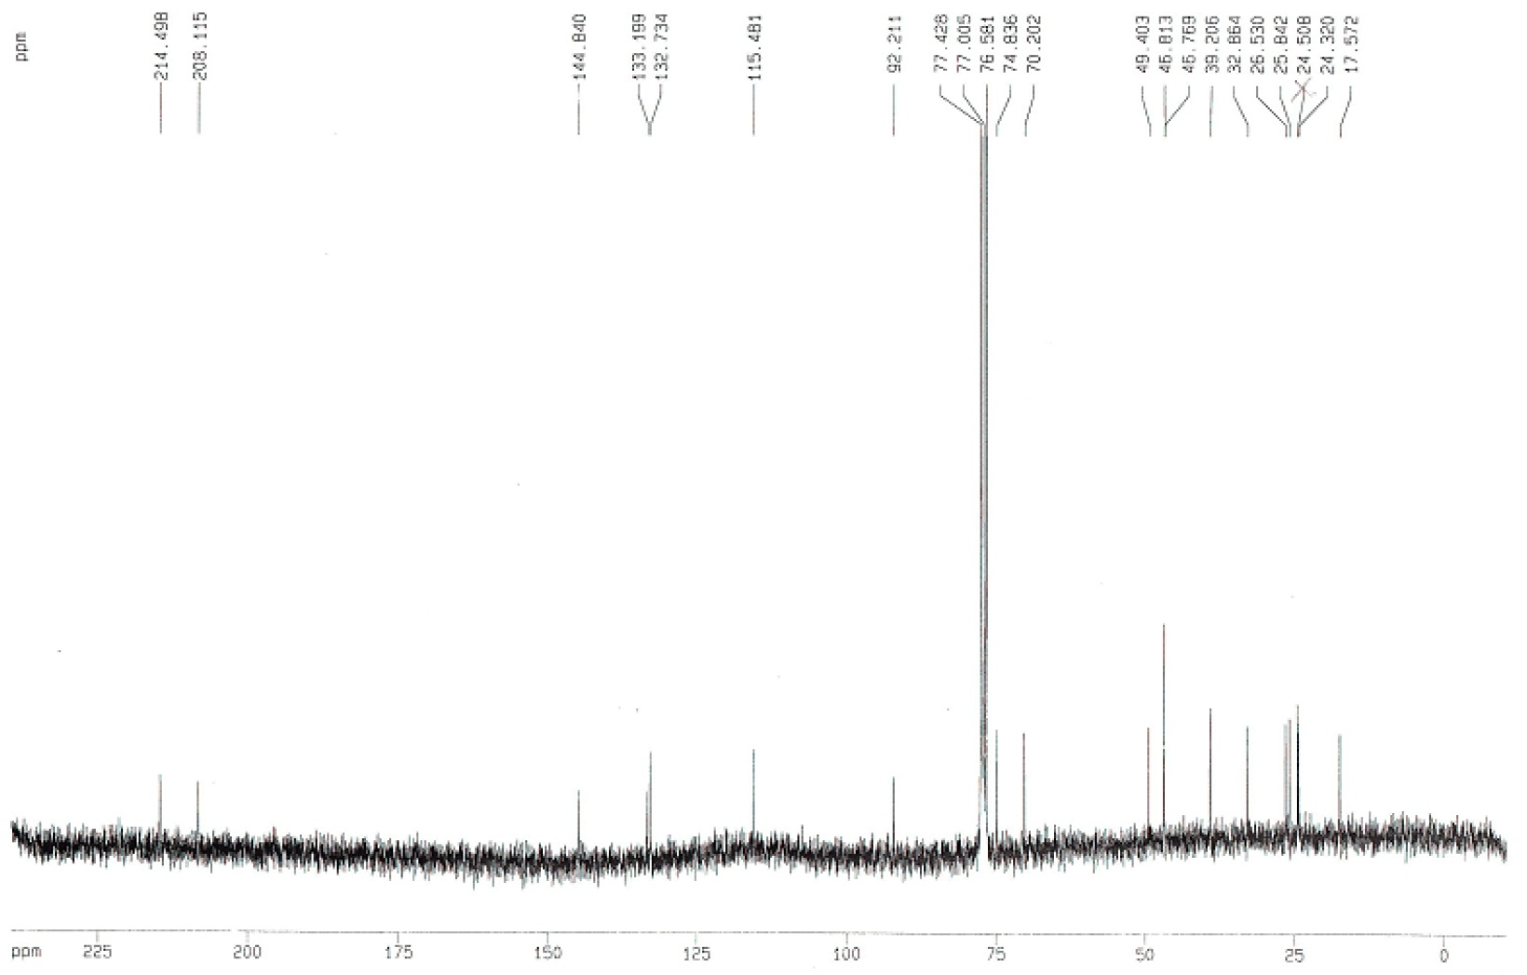
Figure S14. ¹³C NMR (75 MHz, CDCl₃) of Cespitaenin B (7).
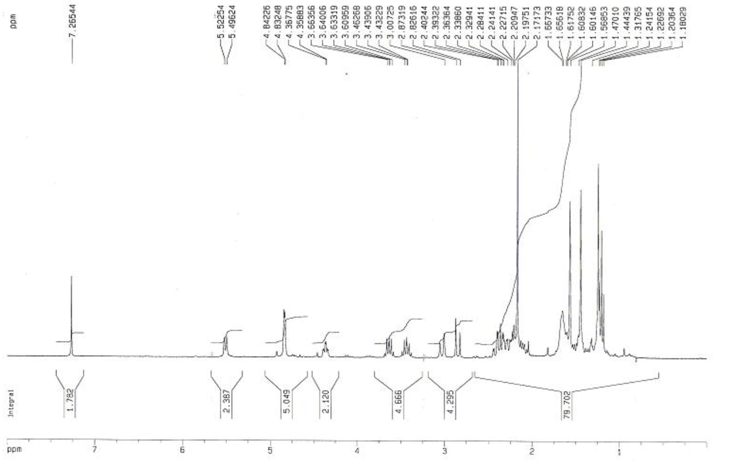
Figure S15. ¹H NMR (300 MHz, CDCl₃) of Cespitaenin C (8).
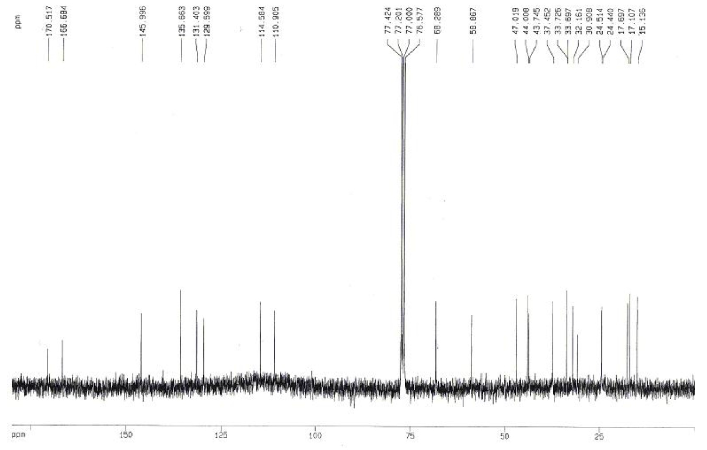
Figure S16. ¹³C NMR (75 MHz, CDCl₃) of Cespitaenin C (8).
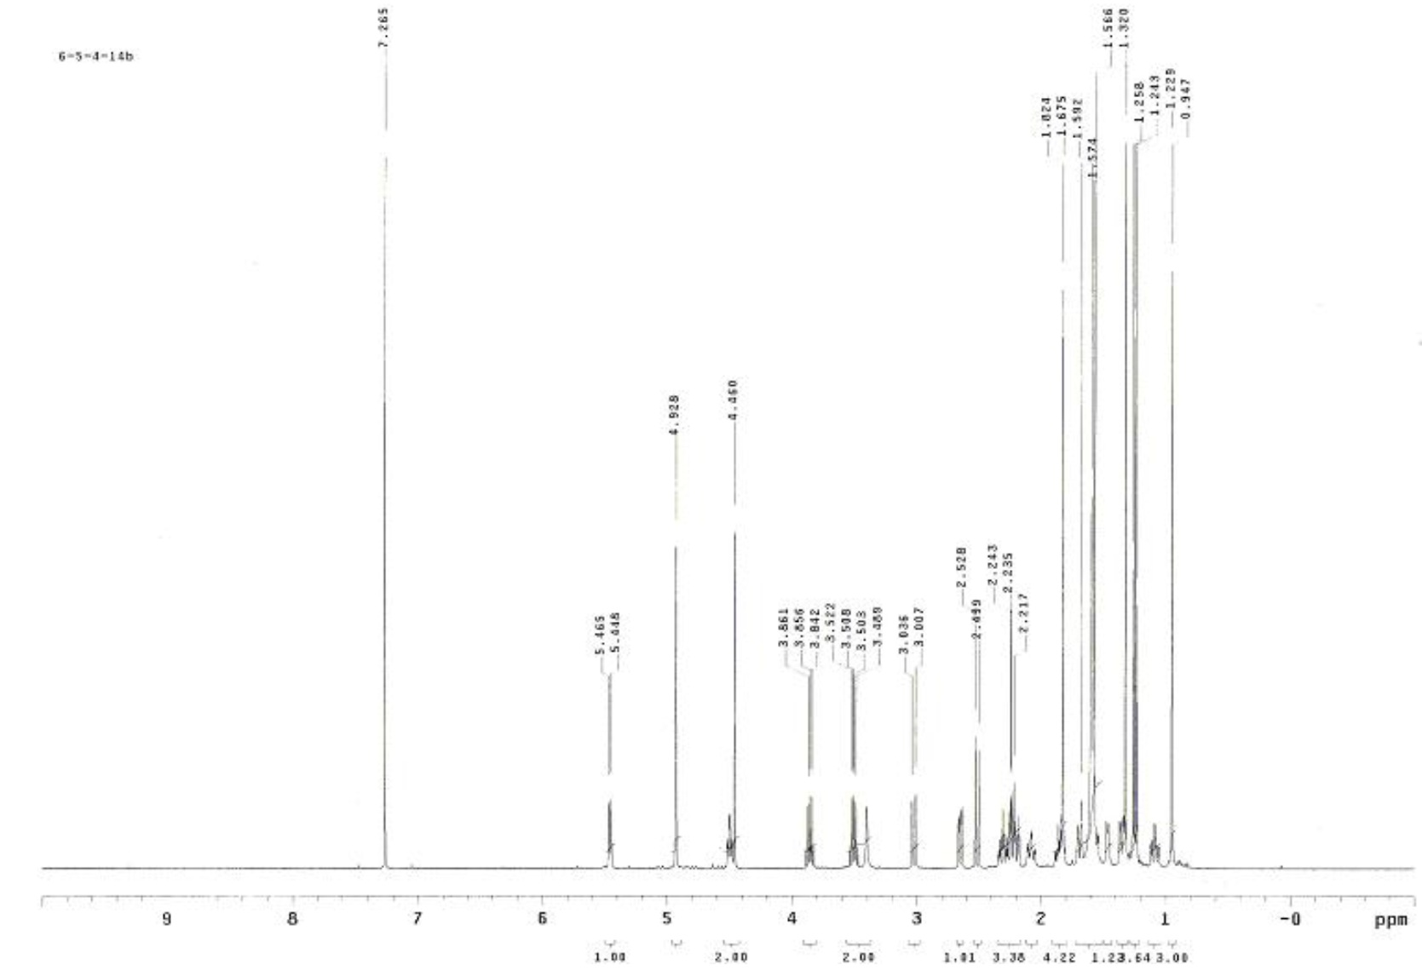
Figure S17. ¹H NMR (500 MHz, CDCl₃) of Cespitaenin D (9).
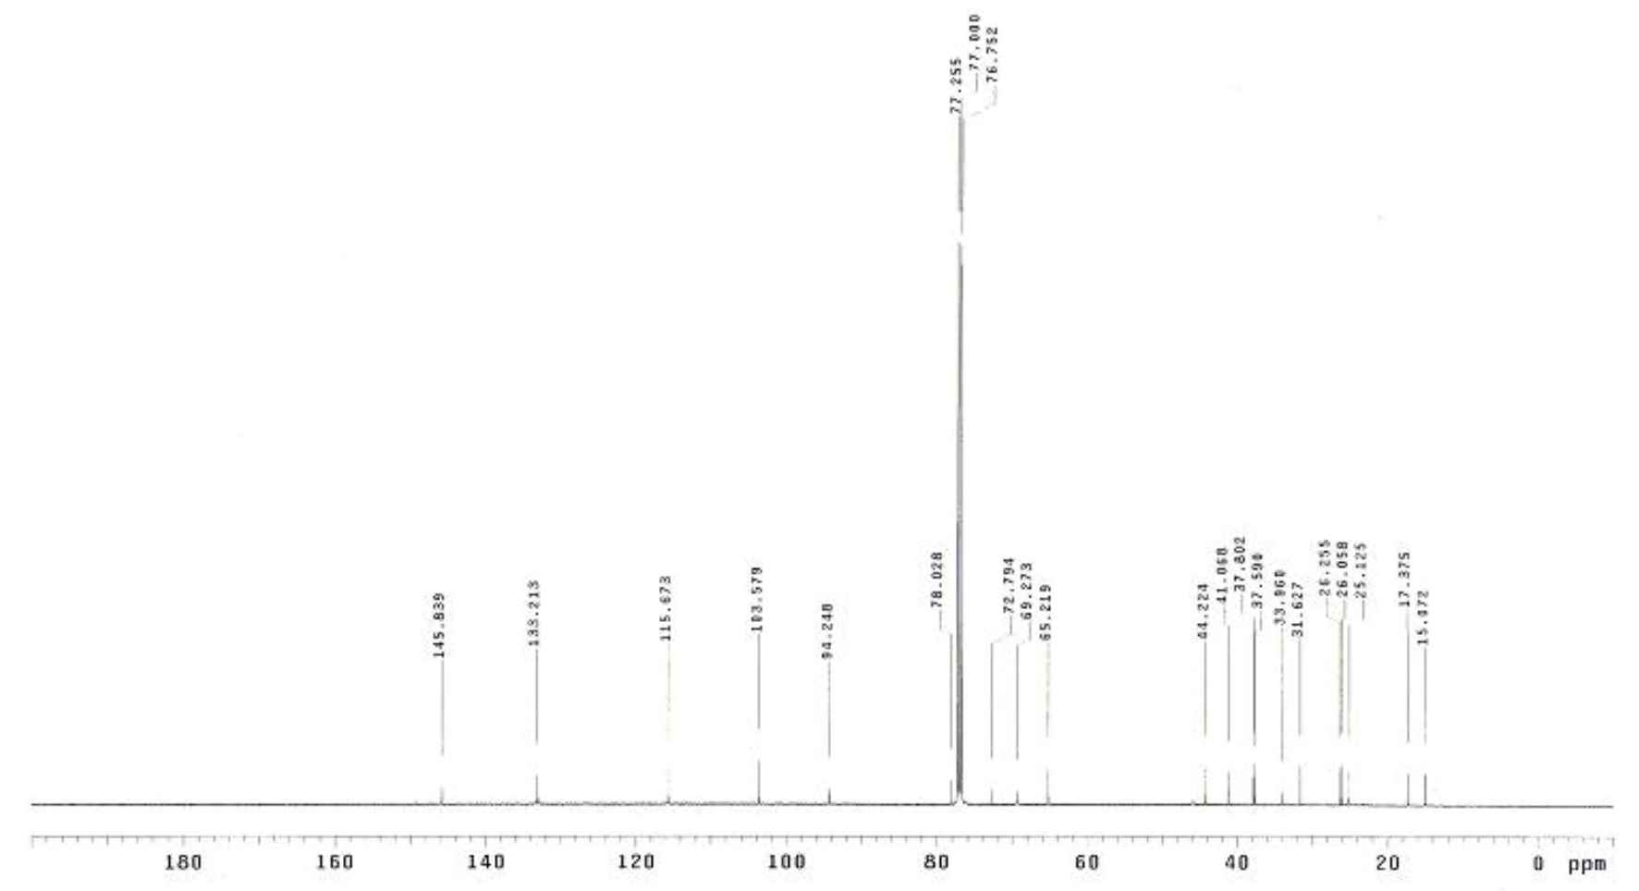
Figure S18. ¹³C NMR (125 MHz, CDCl₃) of Cespitaenin D (9).
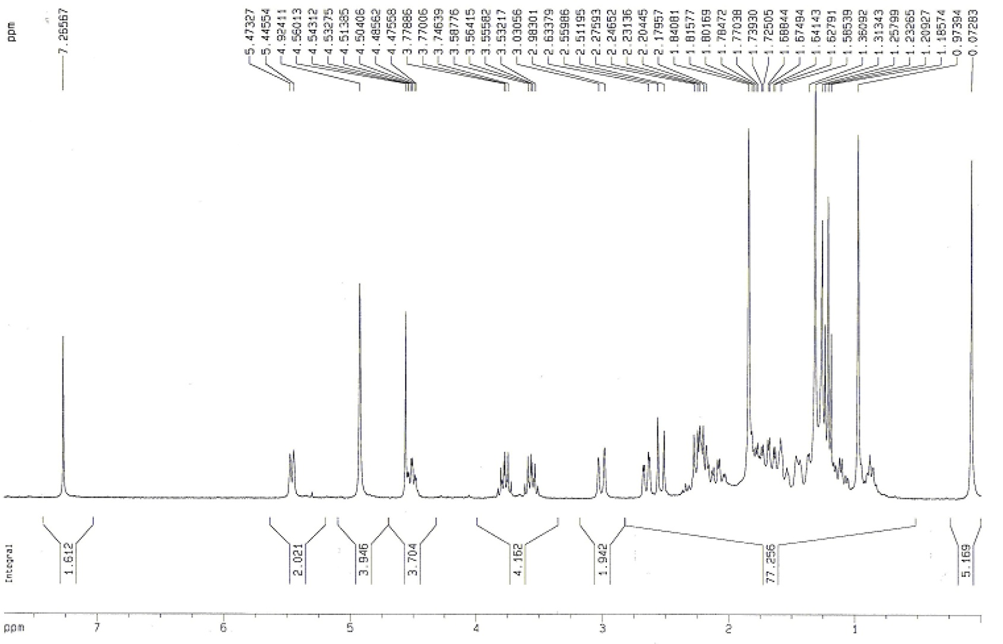
Figure S19. ¹H NMR (300 MHz, CDCl₃) of Cespitaenin E (10).
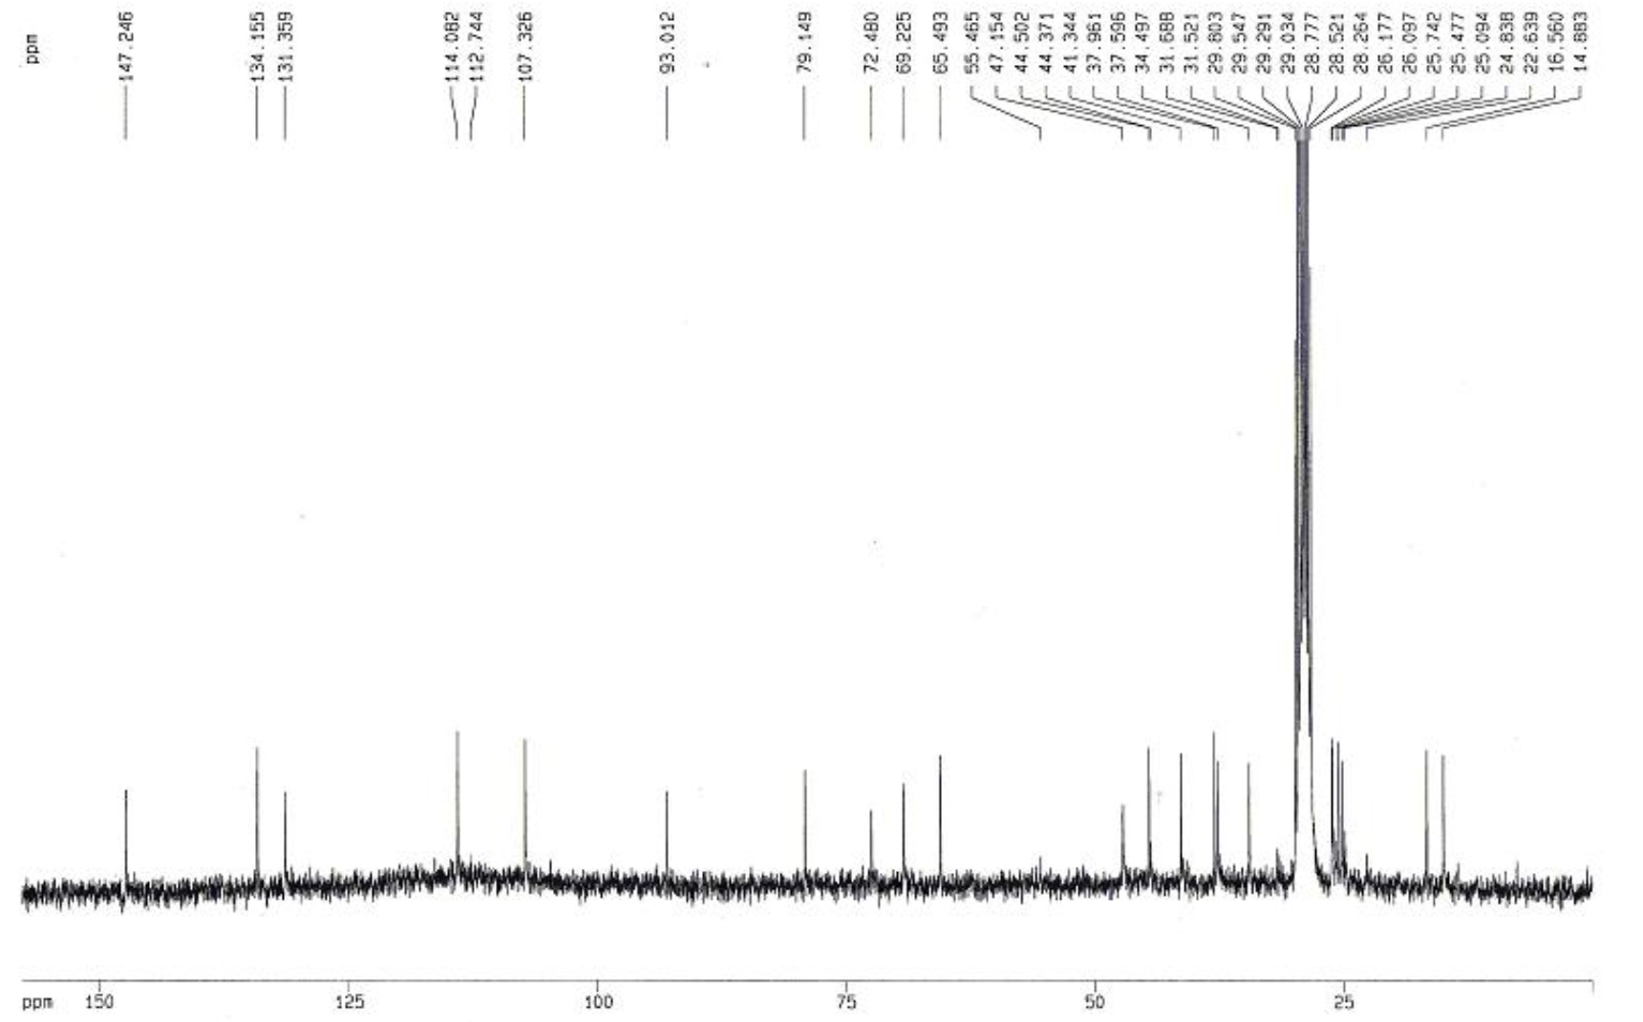
Figure S20. ¹³C NMR (75 MHz, CDCl₃) of Cespitaenin E (10).
© 2015 by the authors; licensee MDPI, Basel, Switzerland. This article is an open access article distributed under the terms and conditions of the Creative Commons Attribution license (http://creativecommons.org/licenses/by/4.0/).

