Supplementary Materials
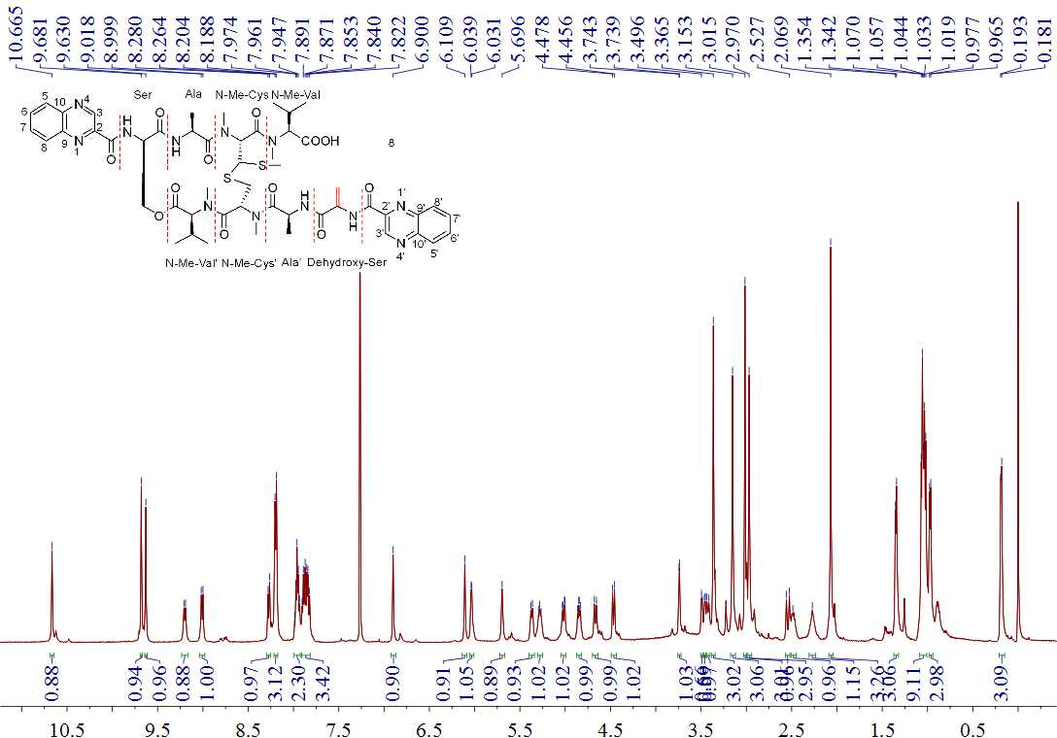
Figure S1. The ¹H NMR spectrum of quinomycin G (1) in CDCl₃.
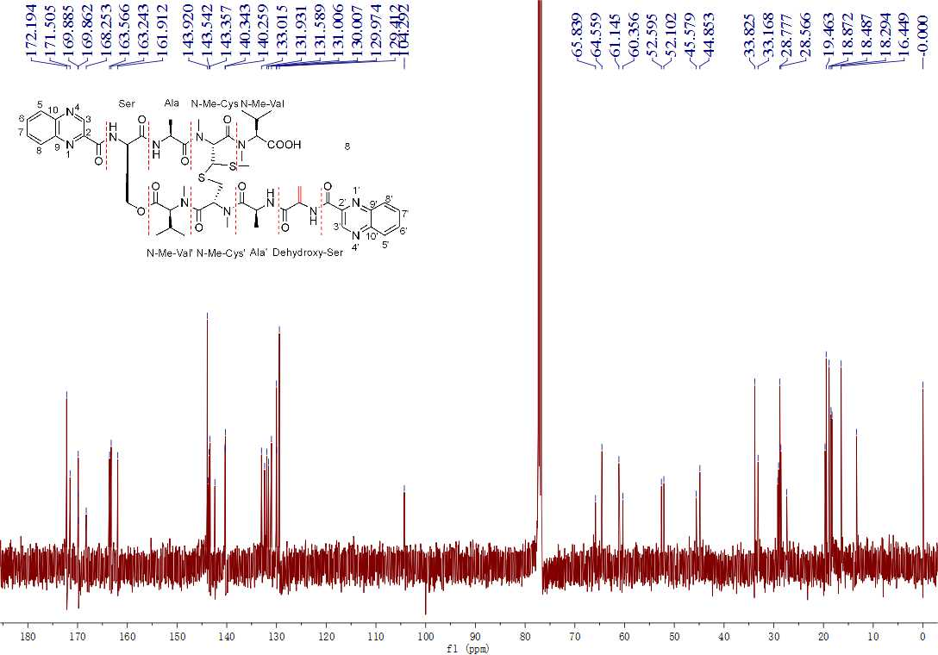
Figure S2. The ¹³C NMR spectrum of quinomycin G (1) in CDCl₃.
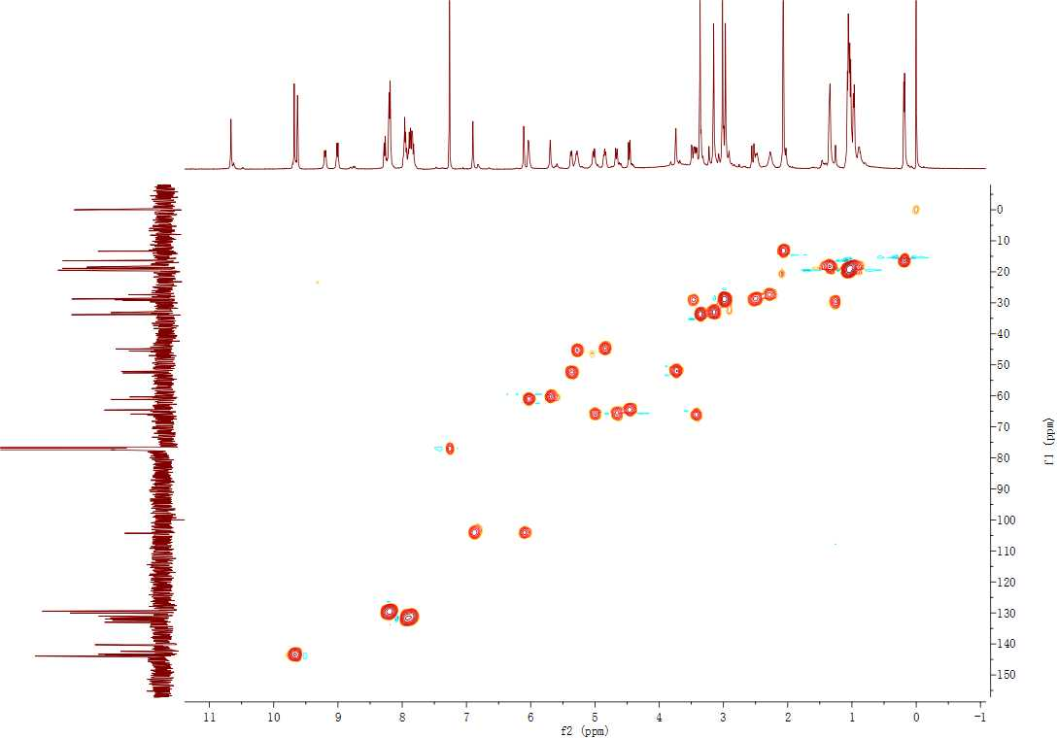
Figure S3. The HSQC spectrum of quinomycin G (1) in CDCl₃.
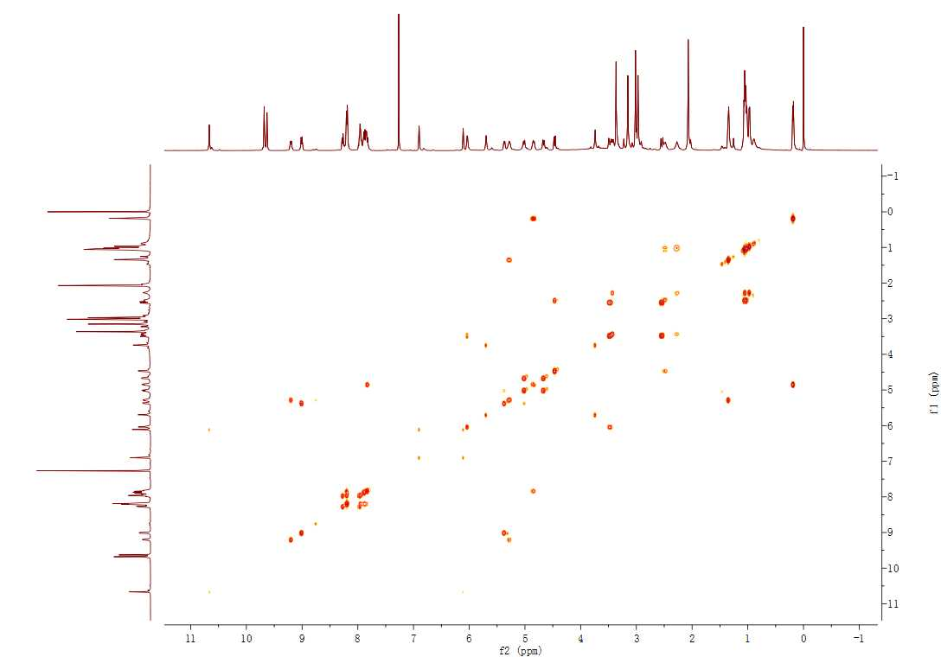
Figure S4. The ¹H-¹H COSY spectrum of quinomycin G (1) in CDCl₃.
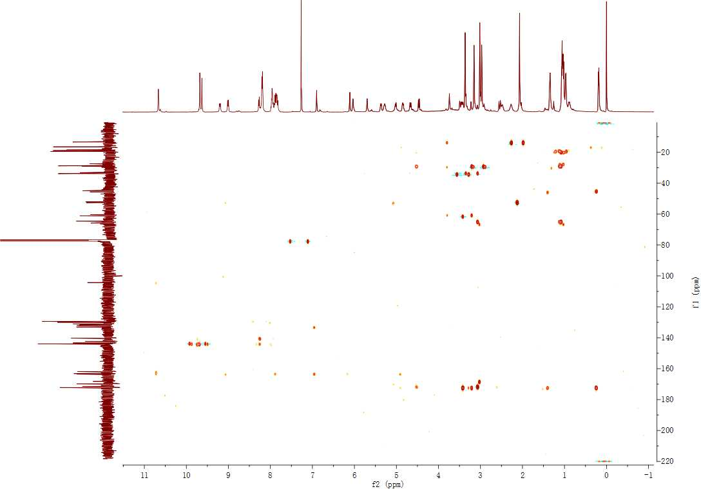
Figure S5. The HMBC spectrum of quinomycin G (1) in CDCl₃.
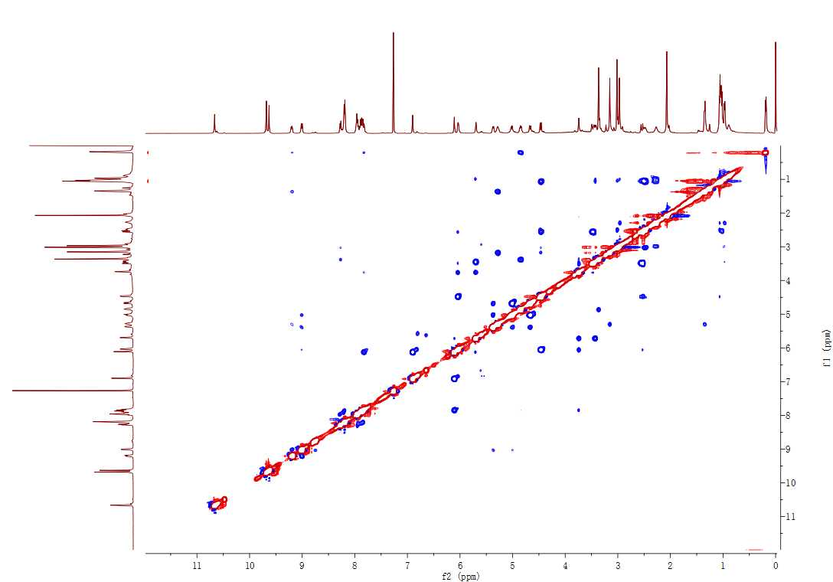
Figure S6. The ROESY spectrum of quinomycin G (1) in CDCl₃.
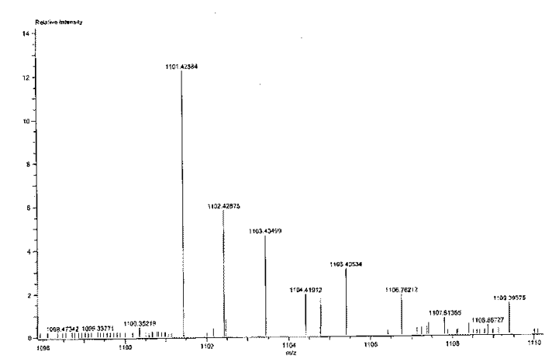
Figure S7. The HRESIMS spectrum of quinomycin G (1).
Figure S8. The key ¹H-¹H COSYcorrelations of quinomycin G (1).
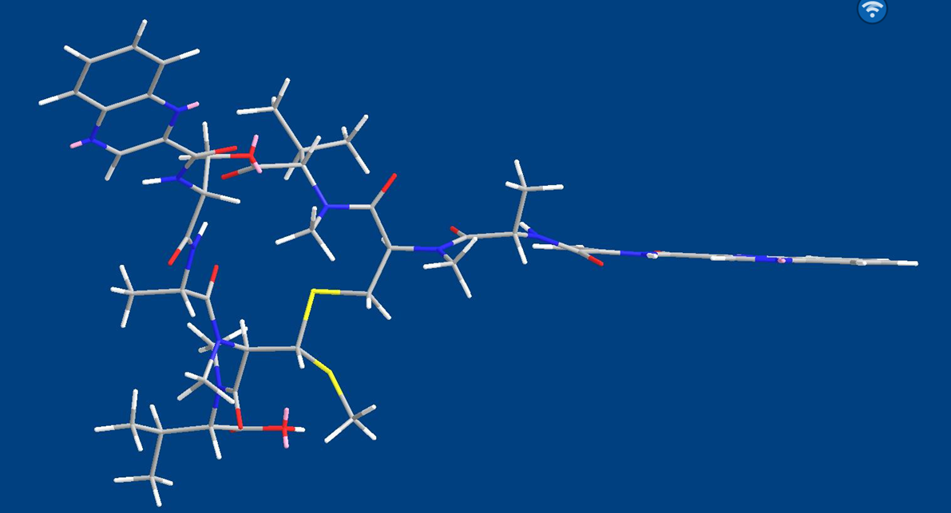
Figure S9. The Chem3D MM2 energy minimization model of quinomycin G (1).
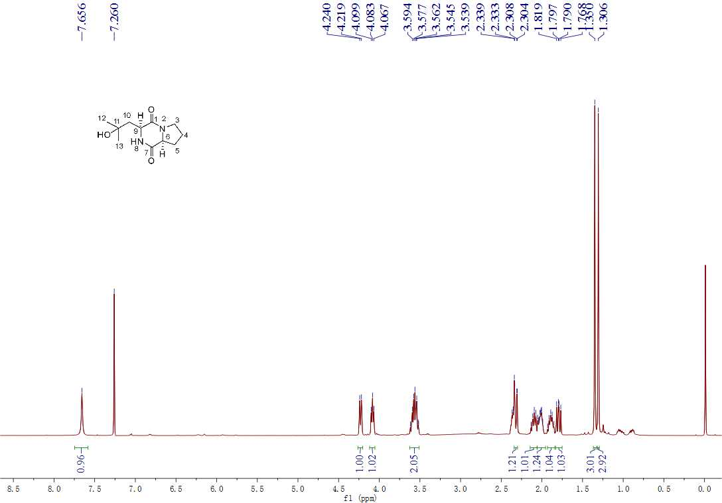
Figure S10. The ¹H NMR spectrum of cyclo-(l-Pro-4-OH-l-Leu) (2) in CDCl₃.
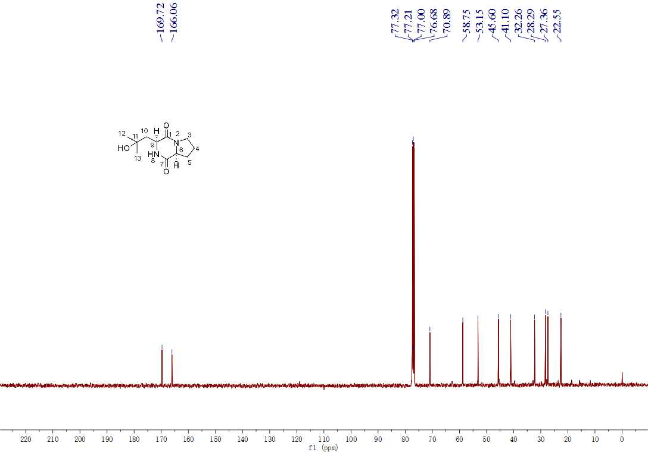
Figure S11. The ¹³C NMR spectrum of cyclo-(l-Pro-4-OH-l-Leu) (2) in CDCl₃.
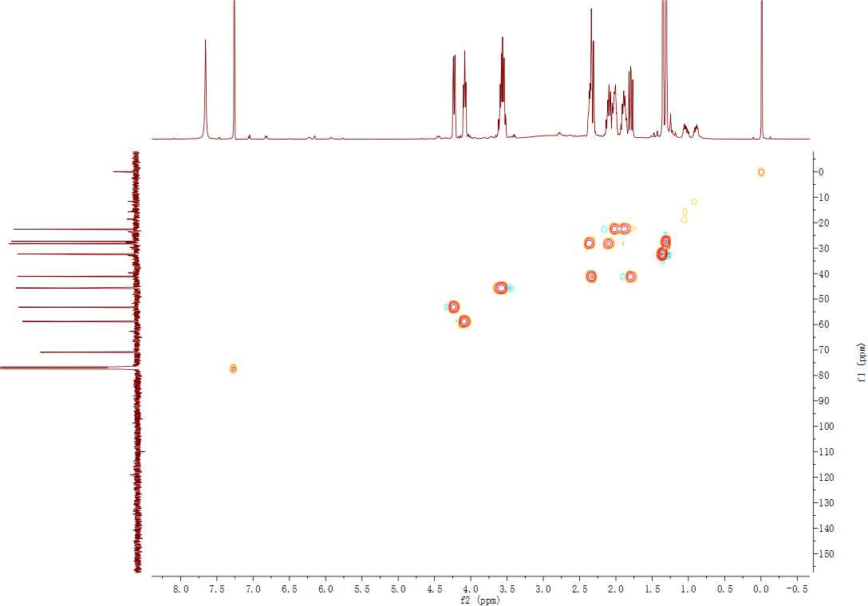
Figure S12. The HSQC spectrum of cyclo-(l-Pro-4-OH-l-Leu) (2) in CDCl₃.
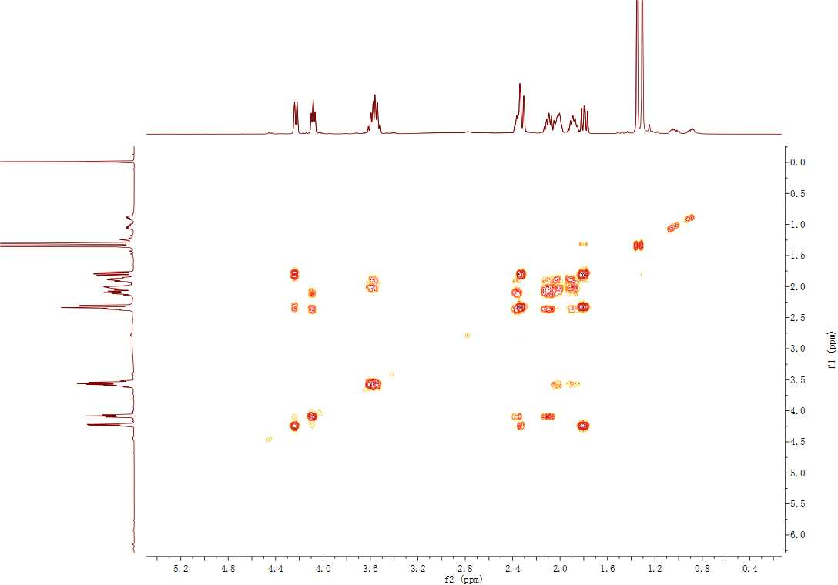
Figure S13. The ¹H-¹H COSY spectrum of cyclo-(l-Pro-4-OH-l-Leu) (2) in CDCl₃.
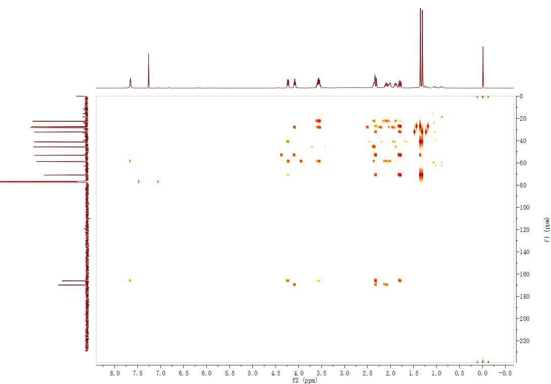
Figure S14. The HMBC spectrum of cyclo-(l-Pro-4-OH-l-Leu) (2) in CDCl₃.
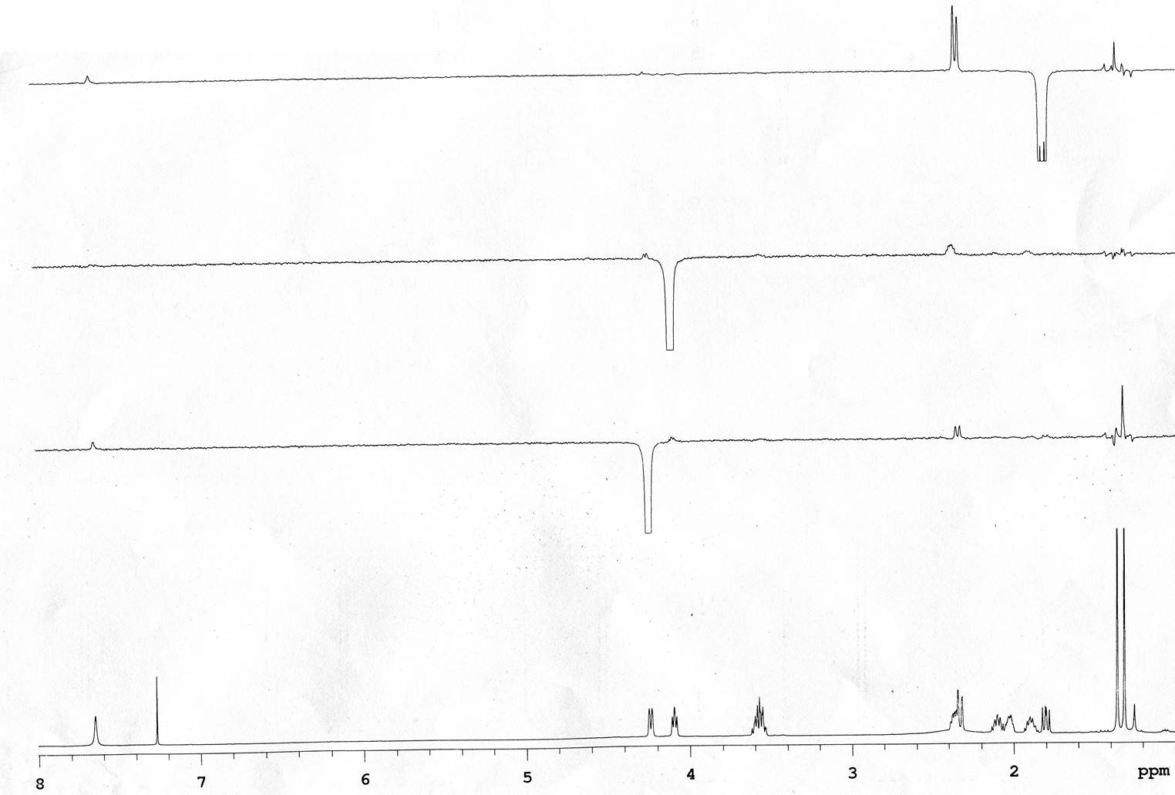
Figure S15. The NOE spectrum of cyclo-(l-Pro-4-OH-l-Leu) (2) in CDCl₃.
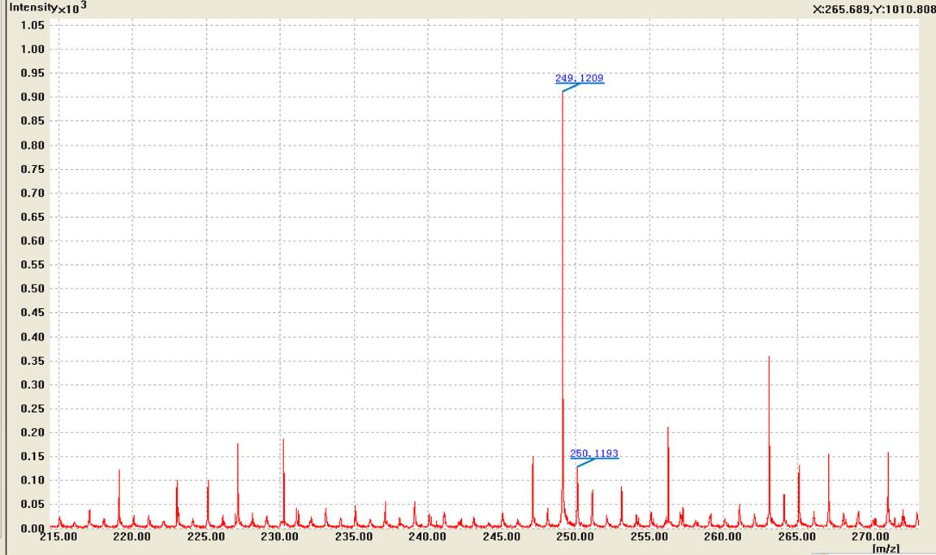
Mass | Calc. Mass | Mass Difference (ppm) | ¹²C | ¹H | ¹⁴N | ¹⁶O | ²³Na
249.1209 | 249.1210 | 0.40 | 11 | 18 | 2 | 3 | 1
Figure S16. The HRESIMS spectrum of cyclo-(l-Pro-4-OH-l-Leu) (2).
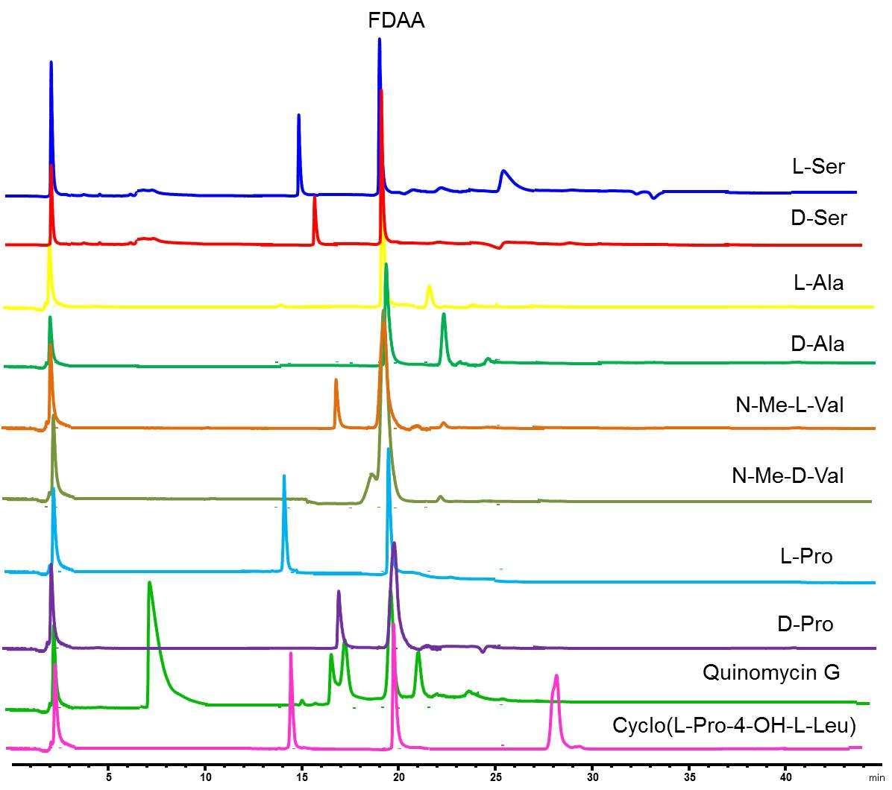
Figure S17. The chromatograms of FDAA derivatives of the hydrolysates of compounds 1–2 and amino acids standards.
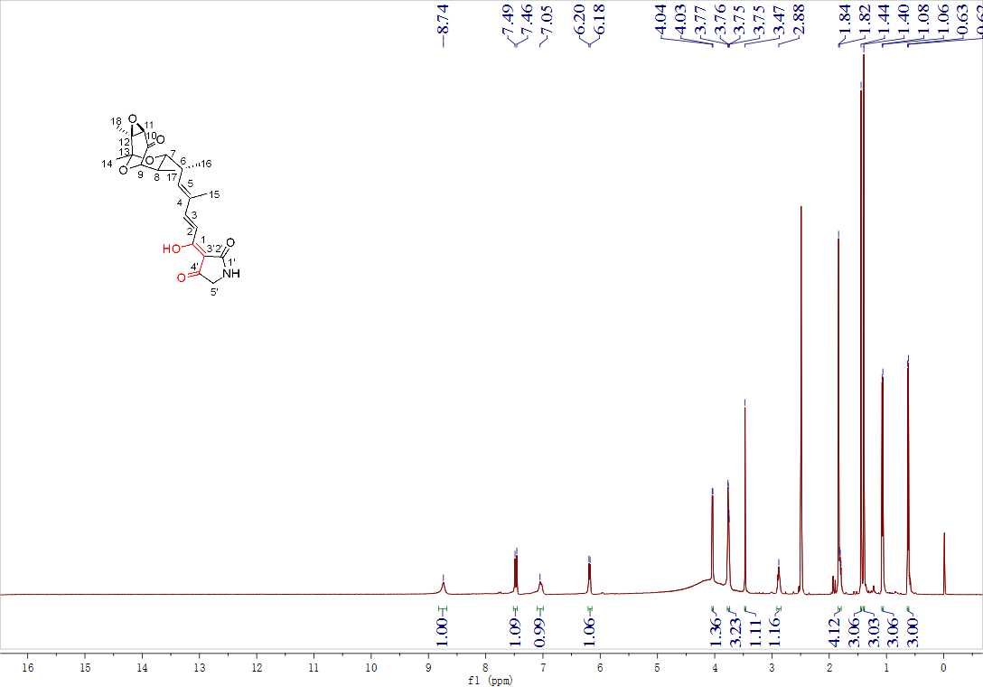
Figure S18. The ¹H NMR spectrum of tirandamycin A (3) in DMSO-d₆.
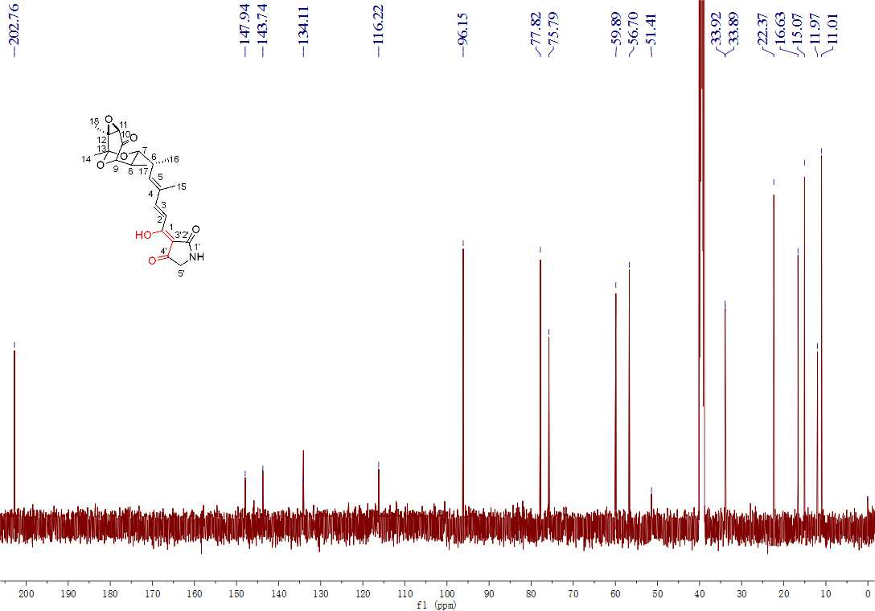
Figure S19. The ¹³C NMR spectrum of tirandamycin A (3) in DMSO-d₆.
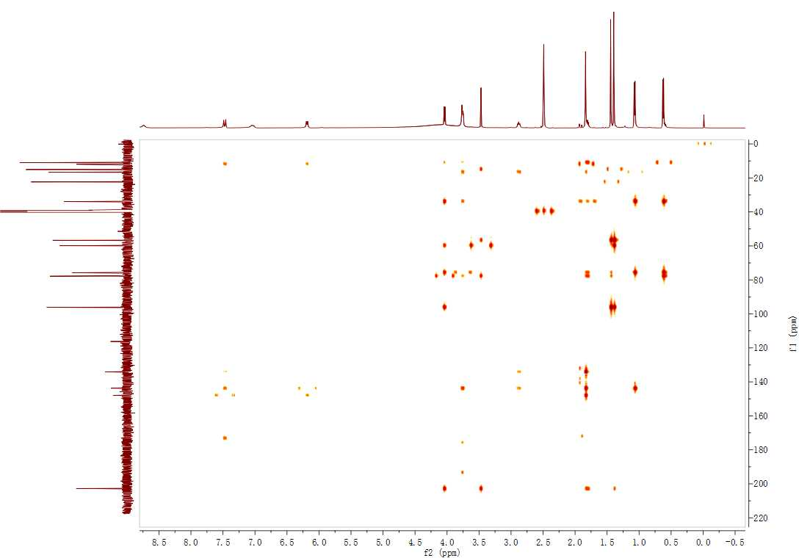
Figure S20. The HMBC spectrum of tirandamycin A (3) in DMSO-d₆.
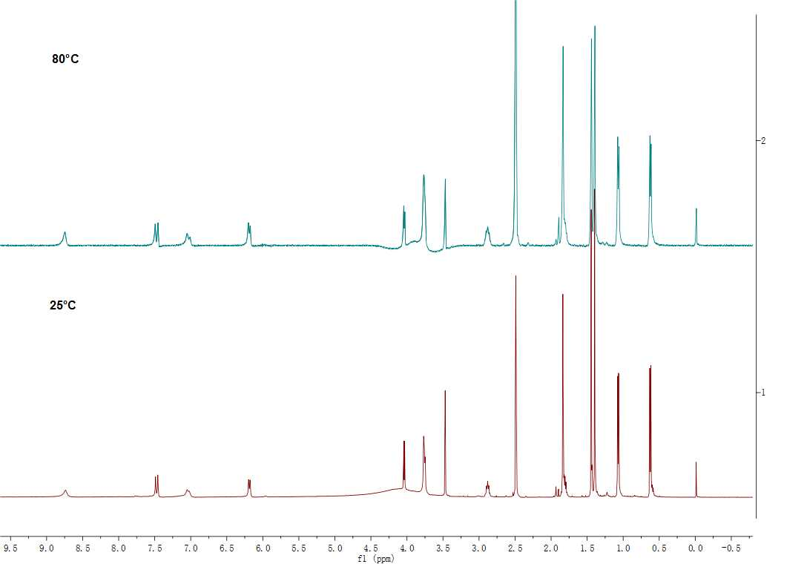
Figure S21. The variable temperature experiment for ¹H-NMR of tirandamycin A (3).
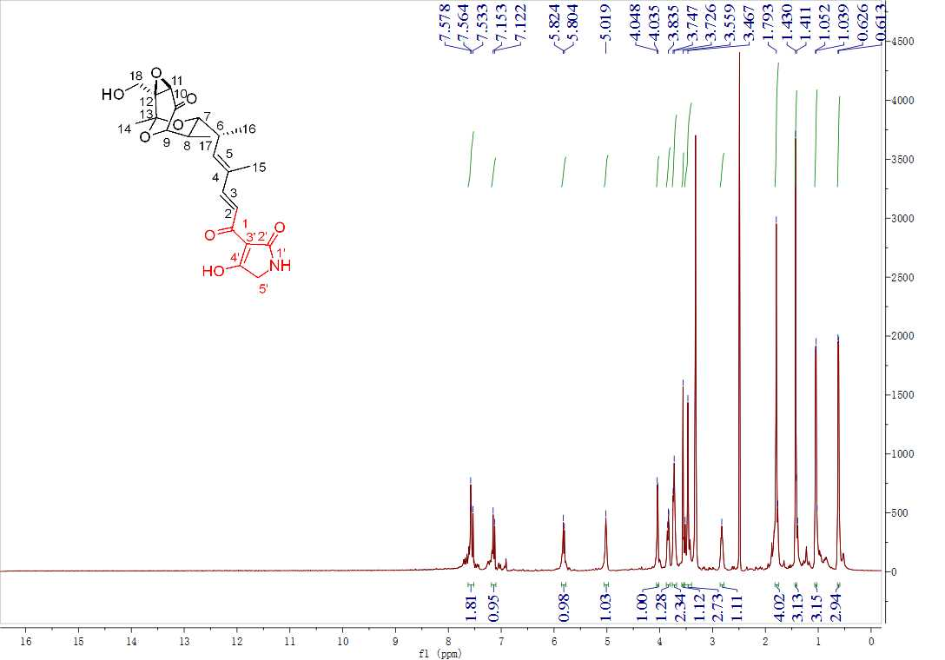
Figure S22. The ¹H NMR spectrum of tirandamycin B (4) in DMSO-d₆.
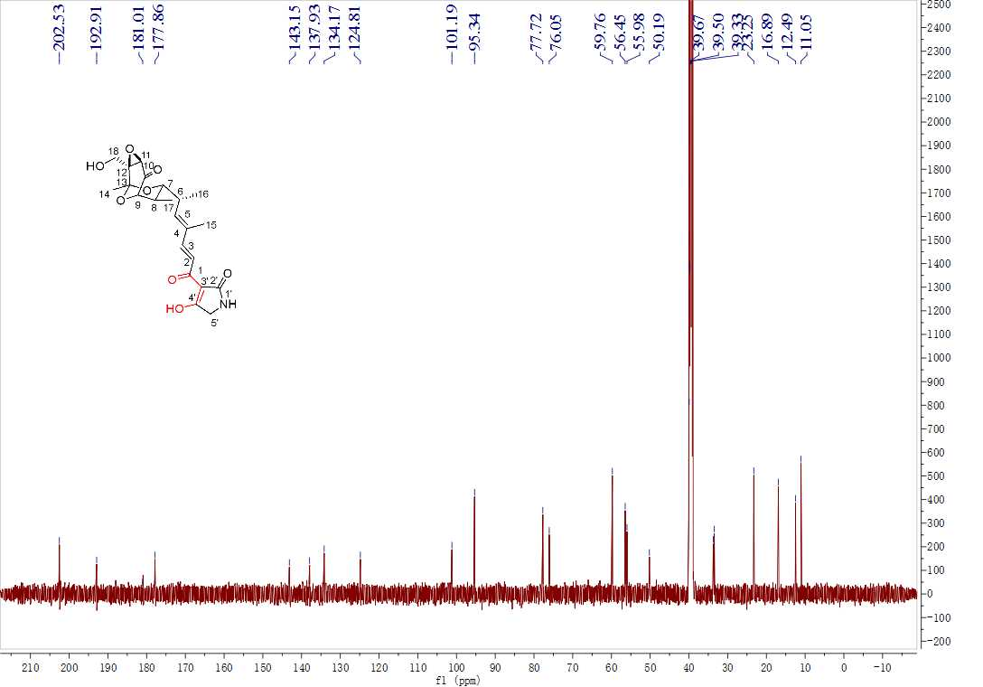
Figure S23. The ¹³C NMR spectrum of tirandamycin B (4) in DMSO-d₆.
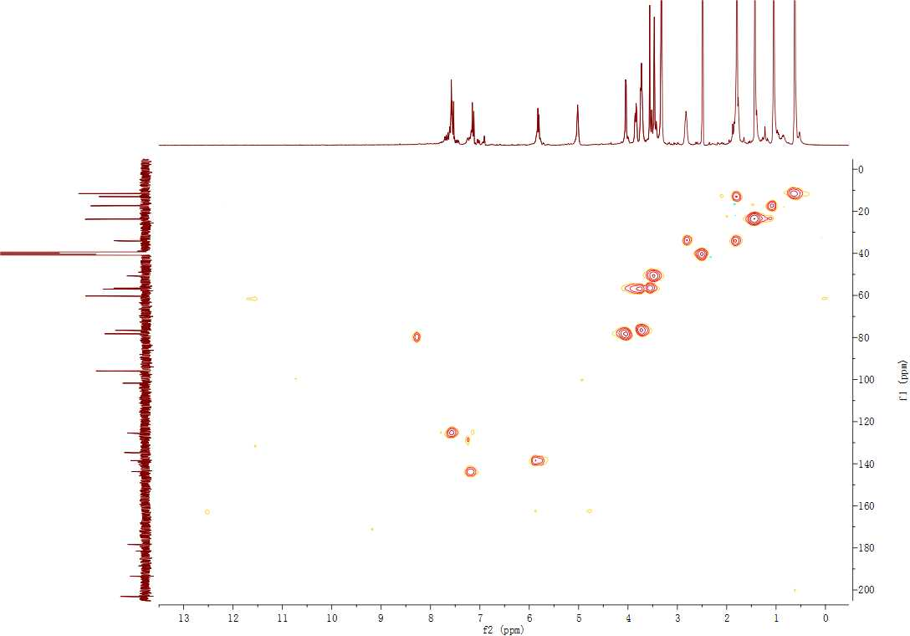
Figure S24. The HSQC spectrum of tirandamycin B (4) in DMSO-d₆.
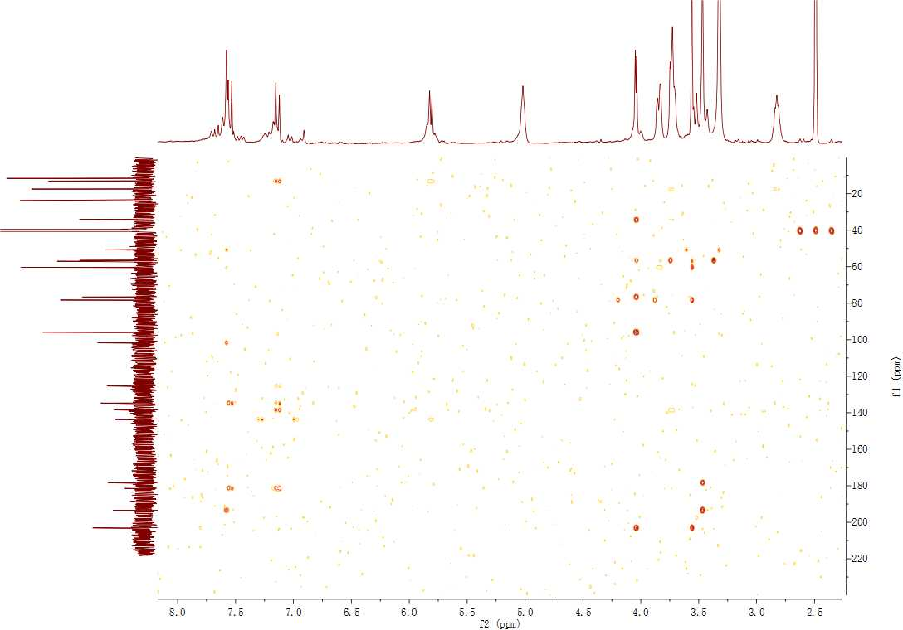
Figure S25. The HMBC spectrum of tirandamycin B (4) in DMSO-d₆.
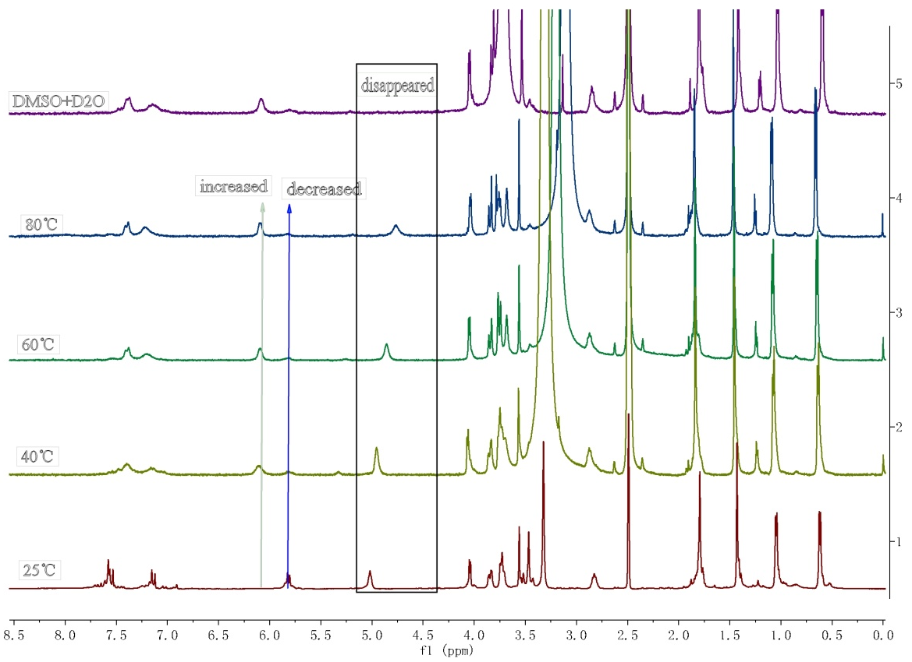
Figure S26. The variable temperature experiments and the deuterium exchange experiment for ¹H NMR of tirandamycin B (4).
Figure S27. The key HMBC correlations of tirandamycin A (3) and tirandamycin B (4).
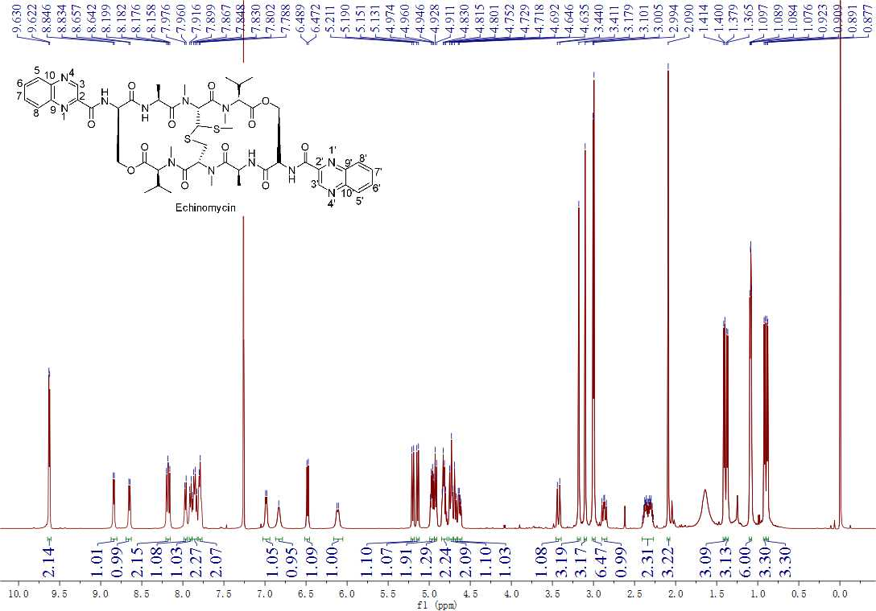
Figure S28. The ¹H NMR spectrum of echinomycin.
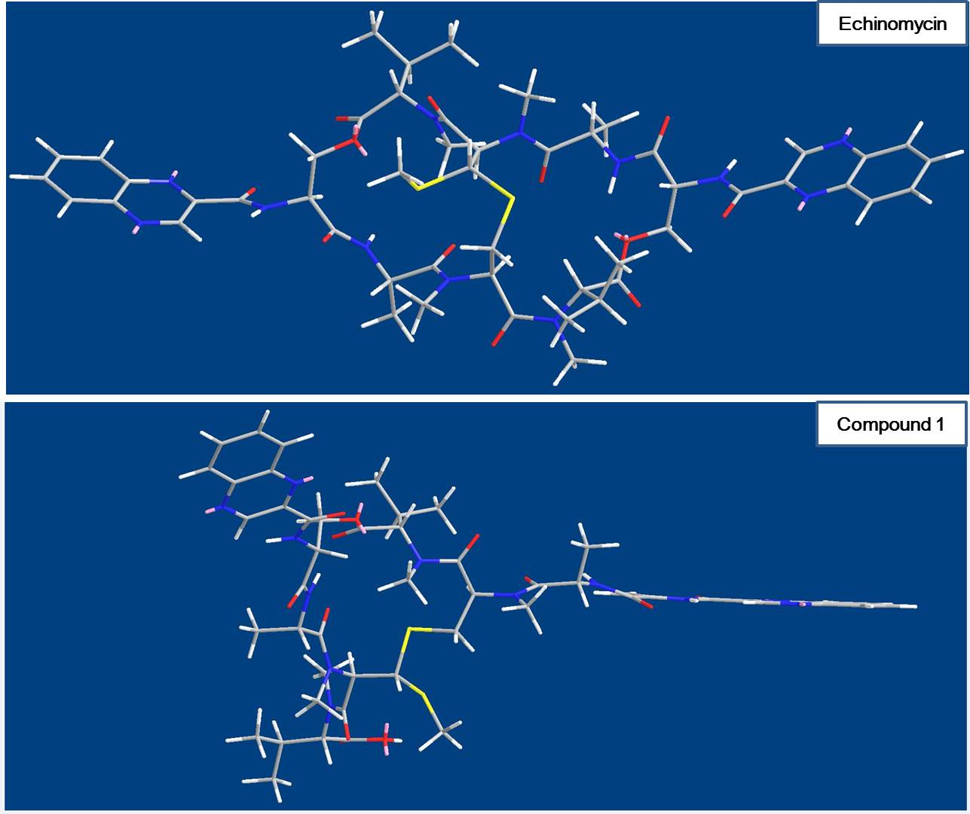
Figure S29. The Chem3D MM2 energy minimization models of echinomycin and quinomycin G (1).
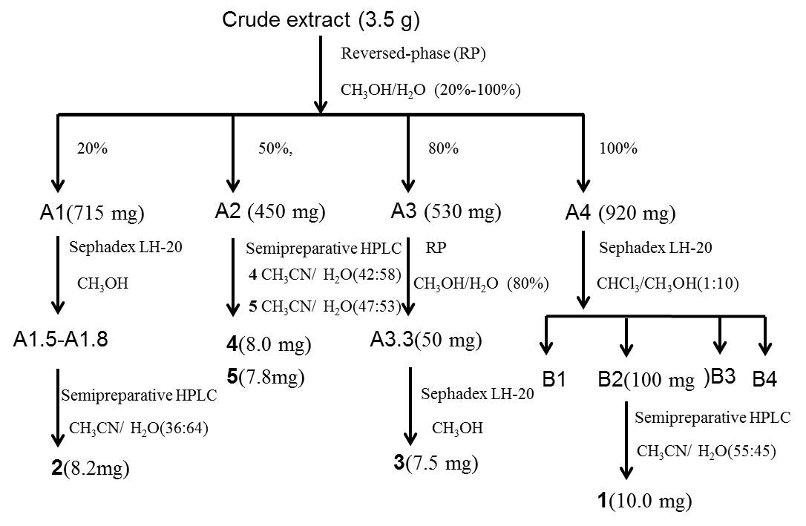
Figure S30. The schematic diagram of isolation and identification of compounds 1–5.

