Supplemental Data
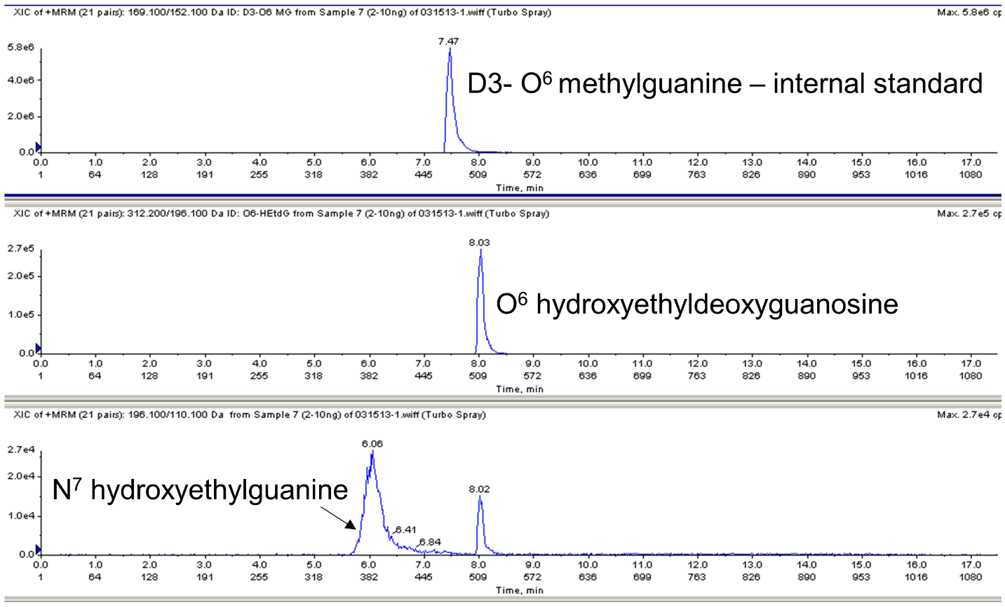
Figure S1. LC/MS/MS Multiple Reaction Monitoring (MRM) analysis for O⁶ hydroxyethyldeoxyguanosine, N⁷ hydroxyethylguanine and D3-O⁶ methylguanine.
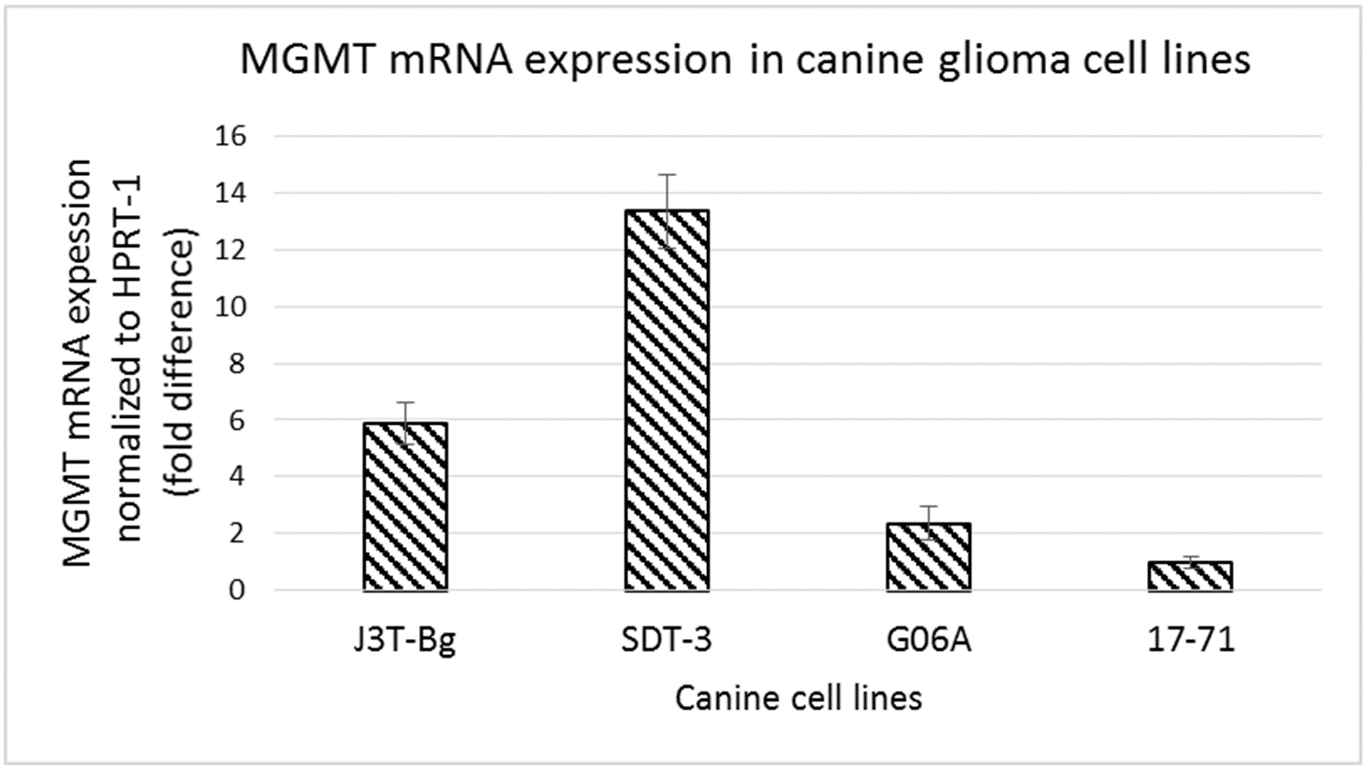
Figure S2. Graph showing MGMT mRNA expression in canine glioma cell lines J3T-Bg,
SDT-3 and G06A and canine lymphoma cell line 17–71.
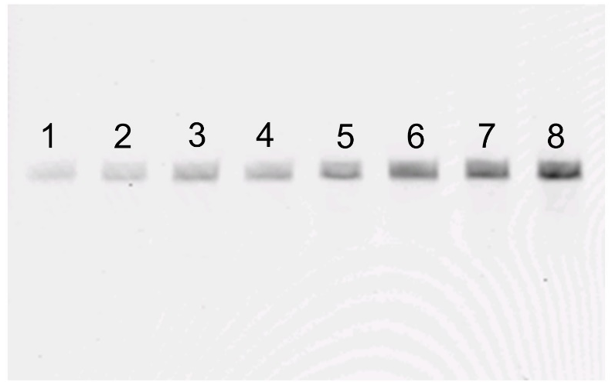
Figure S3. Serially diluted oligo from 1–200 fmols to detect LOD and LOQ of the method. Amount of oligo in each lane is as follows: Lane 1 = 1 fmol, lane 2 = 5 fmols, lane 3 = 10 fmols, lane 4 = 20 fmols, lane 5 = 50 fmols, lane 6 = 100 fmols, lane 7 = 150 fmols and lane
8 = 200 fmols.
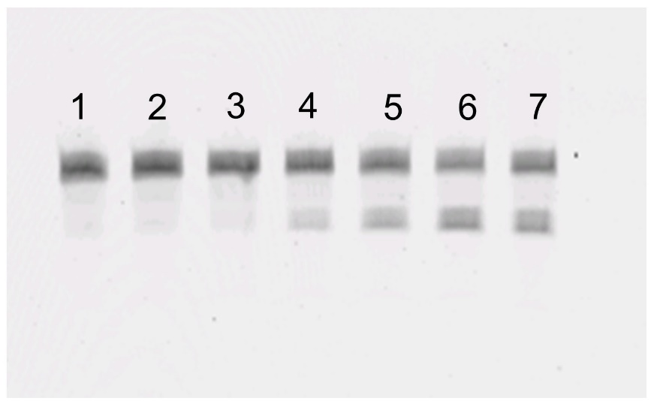
Figure S4. Oligo treated with increasing concentration of human recombinant MGMT. Lane 1 represents untreated oligo. Oligos in lane 2–7 were treated with MGMT at 5, 10, 20, 50, 100 and 200 ng/mL concentration. Upper and lower bands represent 18 bp substrate and 10 bp cleavage product, respectively.

