Supplementary Materials: Aldehydes in Exhaled Breath during E-Cigarette Vaping: Pilot Study Results
Vera Samburova, Chiranjivi Bhattarai, Matthew Strickland, Lyndsey Darrow, Jeff Angermann, Yeongkwon Son and Andrey Khlystov
Keywords: Electronic cigarettes; aldehydes; breath analysis; respiratory tract retention; exposure

Experimental Section
The breakthrough was checked for several e-cigarettes using the second DNPH cartridge. Except for CE-4 e-cigarette, which generated the highest concentration of aldehydes, the concentration levels of aldehydes collected on the second “breakthrough” DNPH cartridge were similar to the background levels. In case of CE-4, for some flavoring e-liquids (e.g., Bubble Gum) carbonyls’ breakthrough was up to 20%.
Table S1. Used e-cigarette devices.
Session # | E-cigarette * | Flavor * | Battery Brand | Type | PG/VG (v/v) | Nicotine (mg·mL⁻¹) | Power (W)
1 | BLU | Menthol | Built-in | Cigarette like device | 0/100 | 18 | 4.75
2 | BLU | Menthol | Built-in | Single coil | 0/100 | 18 | 4.75
3 | BLU | Classic | Built-in | - | 0/100 | 18 | 4.75
4 | BLU | Classic | Built-in | - | 0/100 | 18 | 4.75
5 | BLU | Classic | Built-in | - | 0/100 | 18 | 4.75
6 | V2 | Red Tobacco | Built-in | - | 80/20 | 18 | 5.2
7 | CE4 | Bubble gum | eGo | 2nd generation | 80/20 | 12 | 4.9
8 | CE4 | Watermelon | eGo | Top single coil | 80/20 | - | -
9 | CE4 | Watermelon | eGo | - | 80/20 | - | -
10 | CE4 | Watermelon | eGo | - | 80/20 | - | -
11 | Aspire Cleito | Watermelon | Reuleaux RX200 | 3rd generation | 40/60 | 6 | 50
12 | Sigelei | Fruit mix | Sigelei | Three-battery vaporizer | N/A | 6–20 | 80–100
13 | Aspire Cleito | PG/VG | Reuleaux RX200 | - | N/A | 6 | 90
14 | Aspire Cleito | PG/VG/nicotine | Reuleaux RX200 | - | N/A | 6 | 90
15 | Segelei | Vanilla | Sigelei | - | 70/30 | 6–20 | 80–100
16 | Aspire Cleito | Butterspot | Reuleaux RX200 | - | N/A | 6–20 | 80–100
17 | Aspire Cleito | Snozberry | Reuleaux RX200 | - | N/A | 6–20 | 80–100
18 | Sigelei | Vanilla+fruit | Sigelei | - | N/A | 6–20 | 80–100
19 | Sigelei | Vanilla+fruit | Sigelei | - | N/A | 6–20 | 80–100
*—e-liquids and/built-in e-cigarettes (BLU and V2) were purchased several days prior to use; e-liquids and cartridges with e-liquids were kept at room temperature in closed cabinets; only non-expired e-liquids and premade.
Table S2. Difference (ΔC) in carbonyl concentrations between exhaled e-cigarette breath (C_{e-cig breath}) and background breath (C_{background}).
Sessions # | Formaldehyde | Acetaldehyde | Acrolein | Glyoxal | Propionaldehyde | MEK | Valeraldehyde | Benzaldehyde
1 | −0.001 | 0.028 | 0.000 | 0.000 | 0.014 | 0.000 | 0.000 | 0.000
2 | −0.001 | 0.023 | 0.000 | 0.000 | 0.000 | 0.000 | 0.000 | 0.000
3 | 0.001 | −0.009 | 0.000 | 0.000 | 0.000 | 0.000 | 0.000 | 0.000
4 | 0.000 | 0.031 | 0.000 | 0.000 | 0.099 | 0.000 | 0.000 | 0.000
5 | 0.000 | 0.003 | 0.000 | 0.000 | 0.000 | 0.000 | 0.000 | 0.000
6 | 0.019 | 0.055 | 0.000 | 0.000 | 0.010 | 0.000 | 0.000 | 0.000
7 | 0.037 | 0.021 | 0.000 | 0.000 | 0.000 | 0.000 | 0.000 | 0.000
8 | 0.408 | 0.555 | 0.000 | 0.072 | 0.129 | 0.101 | 0.000 | 0.000
9 | 0.012 | 0.017 | 0.000 | 0.000 | 0.044 | 0.000 | 0.000 | 0.000
10 | 0.072 | 0.021 | 0.000 | 0.000 | 0.045 | 0.000 | 0.000 | 0.000
11 | 0.003 | 0.004 | 0.000 | 0.000 | 0.043 | 0.000 | 0.000 | 0.013
12 | 0.083 | 0.104 | 0.000 | 0.036 | 0.159 | 0.000 | 0.000 | 0.000
13 | −0.002 | 0.000 | 0.000 | 0.000 | 0.034 | 0.000 | 0.000 | 0.000
14 | −0.002 | −0.011 | 0.000 | 0.000 | 0.019 | 0.000 | 0.000 | 0.000
15 | 0.006 | 0.041 | 0.000 | 0.000 | 0.063 | 0.000 | 0.000 | 0.000
16 | 0.000 | 0.005 | 0.000 | 0.000 | 1.054 | 0.000 | 0.000 | 0.079
17 | 0.000 | 0.006 | 0.000 | 0.000 | 0.352 | 0.000 | 0.000 | 0.181
18 | −0.001 | 0.030 | 0.000 | 0.000 | 0.026 | 0.000 | 0.000 | 0.000
19 | 0.001 | −0.007 | 0.000 | 0.000 | 0.041 | 0.000 | 0.000 | 0.007
units: µg·breath⁻¹.
Table S3. Level of exposure to different aldehydes.
Session # | Formaldehyde  μg·puff⁻¹ | Acetaldehyde  μg·puff⁻¹ | Acrolein  μg·puff⁻¹ |  | Glyoxal  μg·puff⁻¹ | Propionaldehyde  μg·puff⁻¹ | Benzaldehyde  μg·puff⁻¹ | Total Carbonyl Exposure  μg·puff⁻¹
1 | 0.212 | 0.142 | 0.012 | 0.030 |  | 0.018 | 0.000 | 0.414
2 | 0.213 | 0.147 | 0.012 | 0.030 |  | 0.032 | 0.000 | 0.433
3 | 10.605 | 1.958 | 0.224 | 1.324 |  | 0.072 | 0.000 | 14.183
4 | 0.363 | 0.303 | 0.015 | 0.038 |  | −0.062 | 0.000 | 0.657
5 | 0.363 | 0.331 | 0.015 | 0.038 |  | 0.038 | 0.000 | 0.785
6 | 1.530 | 1.346 | 0.034 | 0.299 |  | 0.301 | 0.000 | 3.510
7 | 24.401 | 22.445 | 1.373 | 0.848 |  | 4.175 | 0.000 | 53.242
8 | 0.078 | −0.433 | 0.000 | 0.107 |  | −0.109 | 0.161 | −0.196
9 | 1.941 | 0.372 | 0.028 | 0.840 |  | −0.011 | 0.192 | 3.363
10 | 4.110 | 1.191 | 0.128 | 1.622 |  | 0.055 | 0.108 | 7.215
11 | 0.411 | 0.154 | 0.058 | 0.000 |  | −0.023 | 0.343 | 0.944
12 | 4.509 | 0.329 | 0.000 | 0.658 |  | 0.029 | 0.000 | 5.525
13 | 0.207 | 0.026 | 0.000 | 0.000 |  | −0.034 | 0.000 | 0.198
14 | 0.132 | 0.033 | 0.000 | 0.019 |  | −0.019 | 0.000 | 0.165
15 | 0.303 | 0.107 | 0.086 | 0.000 |  | −0.025 | 0.000 | 0.471
16 | 0.172 | 0.202 | 0.000 | 0.771 |  | 11.061 | 0.539 | 12.745
17 | 0.059 | 0.185 | 0.034 | 0.000 |  | −0.172 | 3.739 | 3.845
18 | 0.230 | 0.087 | 0.000 | 0.000 |  | 0.020 | 0.483 | 0.820
19 | NA | NA | NA | NA |  | NA | NA | NA

Table S4. Exposure levels in mg·m⁻³ for 10 min.
Session # | Formaldehyde | Acetaldehyde | Acrolein | Glyoxal | Propionaldehyde | Benzaldehyde
1 | 0.039 | 0.031 | 0.002 | 0.005 | 0.006 | 0.000
2 | 0.039 | 0.031 | 0.002 | 0.005 | 0.006 | 0.000
3 | 1.928 | 0.354 | 0.041 | 0.241 | 0.013 | 0.000
4 | 0.066 | 0.061 | 0.003 | 0.007 | 0.007 | 0.000
5 | 0.066 | 0.061 | 0.003 | 0.007 | 0.007 | 0.000
6 | 0.282 | 0.255 | 0.006 | 0.054 | 0.056 | 0.000
7 | 4.443 | 4.085 | 0.250 | 0.154 | 0.759 | 0.000
8 | 0.089 | 0.022 | 0.000 | 0.033 | 0.004 | 0.029
9 | 0.355 | 0.071 | 0.005 | 0.153 | 0.006 | 0.035
10 | 0.760 | 0.220 | 0.023 | 0.295 | 0.018 | 0.020
11 | 0.075 | 0.029 | 0.011 | 0.000 | 0.004 | 0.065
12 | 0.835 | 0.079 | 0.000 | 0.126 | 0.034 | 0.000
13 | 0.037 | 0.005 | 0.000 | 0.000 | 0.000 | 0.000
14 | 0.024 | 0.004 | 0.000 | 0.003 | 0.000 | 0.000
15 | 0.056 | 0.027 | 0.016 | 0.000 | 0.007 | 0.000
16 | 0.031 | 0.038 | 0.000 | 0.140 | 2.203 | 0.112
17 | 0.011 | 0.035 | 0.006 | 0.000 | 0.033 | 0.713
18 | 0.042 | 0.021 | 0.000 | 0.000 | 0.008 | 0.088
19 | 0.000 | 0.000 | 0.000 | 0.000 | 0.000 | 0.000
To calculate the exposure the aldehyde levels were multiplied by 20 puffs (averaged number of puffs per e-cigarette use session) and divided by 0.11 m³—inhaled volume of air per 10 min for an adult (16 m³—inhaled volume of air per 24 h for an adult). The obtained levels were compared with available Acute Exposure Guideline Levels (AEGL-1) [1]: formaldehyde—1.1 mg·m⁻³ for 10 min exposure, acetaldehyde—81 mg·m⁻³, and acrolein—0.07 mg·m⁻³.
Table S5. Spearman correlations between elevated aldehyde levels in exhales e-cigarette breath (∆C_{aldehyde}) for three groups of e-cigarettes.
E-cigarette | Formaldehyde | Acetaldehyde | Propionaldehyde
BLU and V2 | r = 0.948 (p = 0.013) | r = 0.527 (p = 0.362) | r = −0.063 (p = 0.906)
CE4 | r = −0.400 (p = 0.750) | r = −0.200 (p = 0.917) | r = −0.800 (p = 0.330)
Aspire Cleito and Segelei | r = 0.695 (p = 0.056) | r = −0.619 (p = 0.115) | r = 0.495 (p = 0.213)

Figure S1. Sampling systems for collection of a) exhaled breath and b) mainstream e-cigarette emissions.
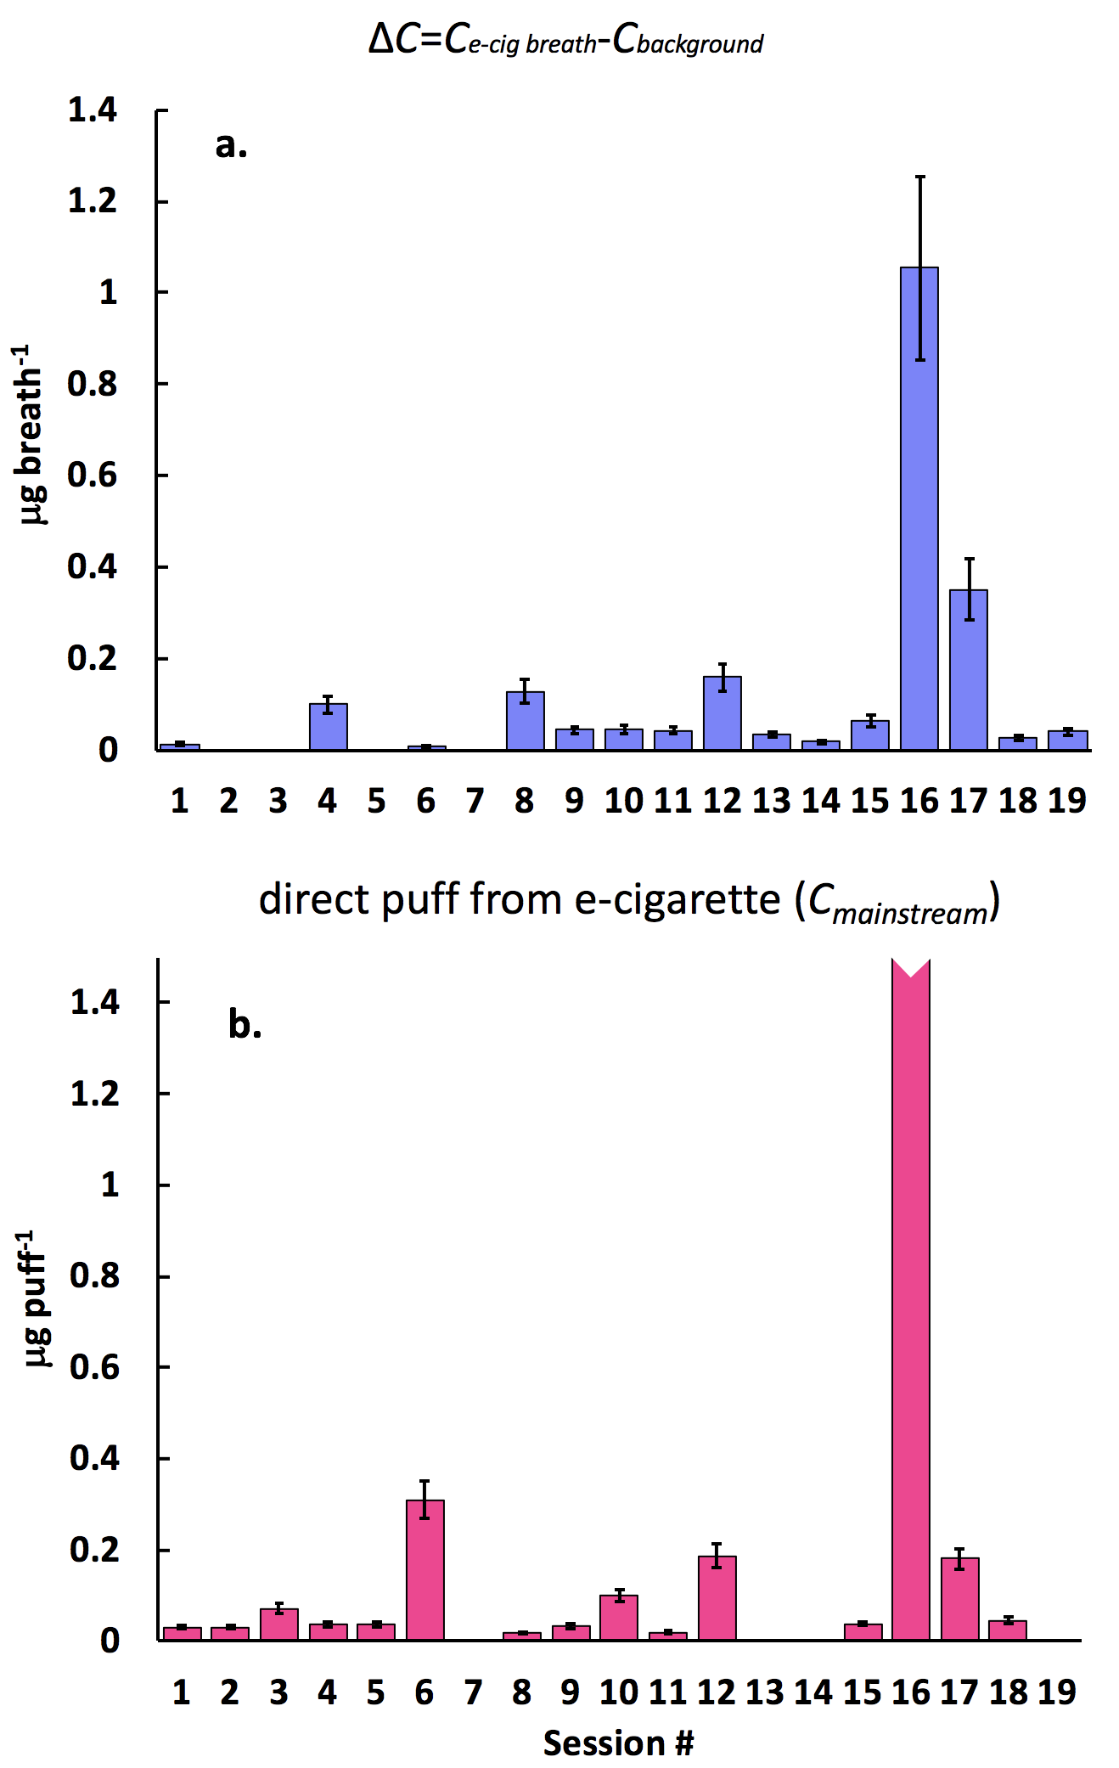
Figure S2. Propionaldehyde concentrations in (a) “vape” breath (∆C = C_{e-cig breath} − C_{background}) and (b) direct e-cigarette emissions; the mean values of standard deviations for propionaldehyde in direct e-cigarette emissions and ∆C were 23 ± 14% and 19 ± 14%, respectively.
Figure S3. Fraction of formaldehyde and acetaldehyde retained by human RT measured for one male volunteer (number of replicates: n = 9).
Figure S4. Correlations between elevated aldehyde levels in exhales e-cigarette breath (∆C_{aldehyde}) and aldehyde concentration in mainstream of e-cigarette aerosol.

References
1. National Research Council. Committee on acute exposure guideline levels. In Acute Exposure Guideline Levels for Selected Airborne Chemicals; National Academies Press: Washington, DC, USA, 2008; Volume 8.

