Supplementary Information
Table S1. Effect of mono- and divalent metal on activity of L-malate dehydrogenases from Methylosinus trichosporium OB3b and Methylomicrobium alcaliphilum 20Z.
Ions | Concentration (mM) | Residual Activity (%)
 |  | M. trichosporium OB3b | M. alcaliphilum 20Z
Without addition |  | 100 | 100
Na⁺ | 100 | 103 | 98
 | 500 | 64 | 82
 | 1000 | 37 | 61
K⁺ | 100 | 100 | 103
 | 500 | 73 | 98
 | 1000 | 41 | 74
Zn²⁺ | 1 | 102 | 103
 | 0.1 | 101 | 113
Mg²⁺ | 1 | 106 | 118
 | 0.1 | 94 | 108
Co²⁺ | 1 | 94 | 96
 | 0.1 | 100 | 94
Ca²⁺ | 1 | 111 | 112
 | 0.1 | 101 | 103
Cu²⁺ | 1 | 97 | 133
 | 0.1 | 110 | 134
Ba²⁺ | 1 | 104 | 106
 | 0.1 | 101 | 103
Mn²⁺ | 1 | 106 | 103
 | 0.1 | 100 | 115
Metals were added as chloride salts. One hundred percent corresponded to activity of either 187 U/mg of protein (M. trichosporium OB3b) or 12 U/mg of protein
(M. alcaliphilum 20Z) in the direction of OAA reduction.
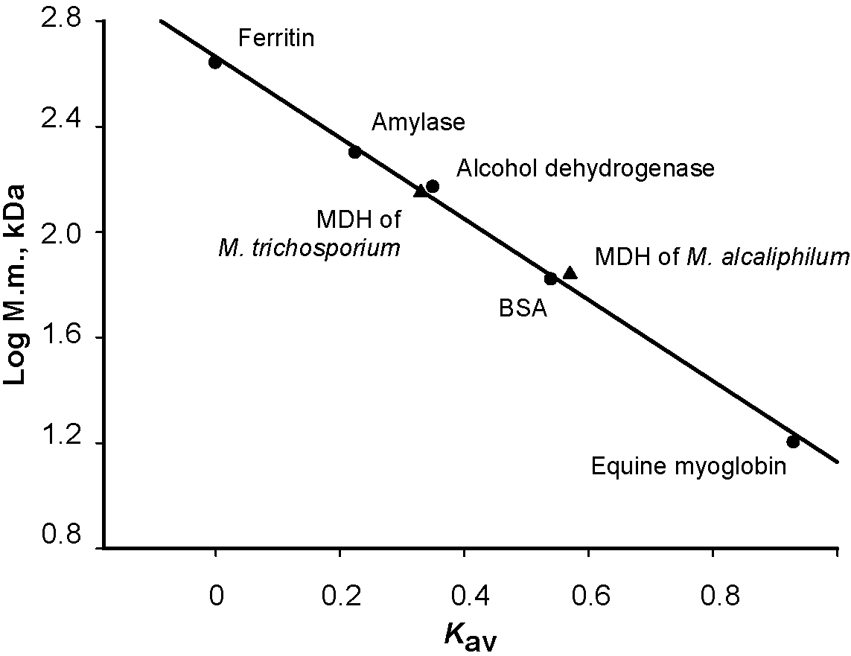
Figure S1. Determination of the native molecular mass for the M. alcaliphilum and M. trichosporium MDHs with Sephacryl S-200 column. K_{av}, Relative elution volume.
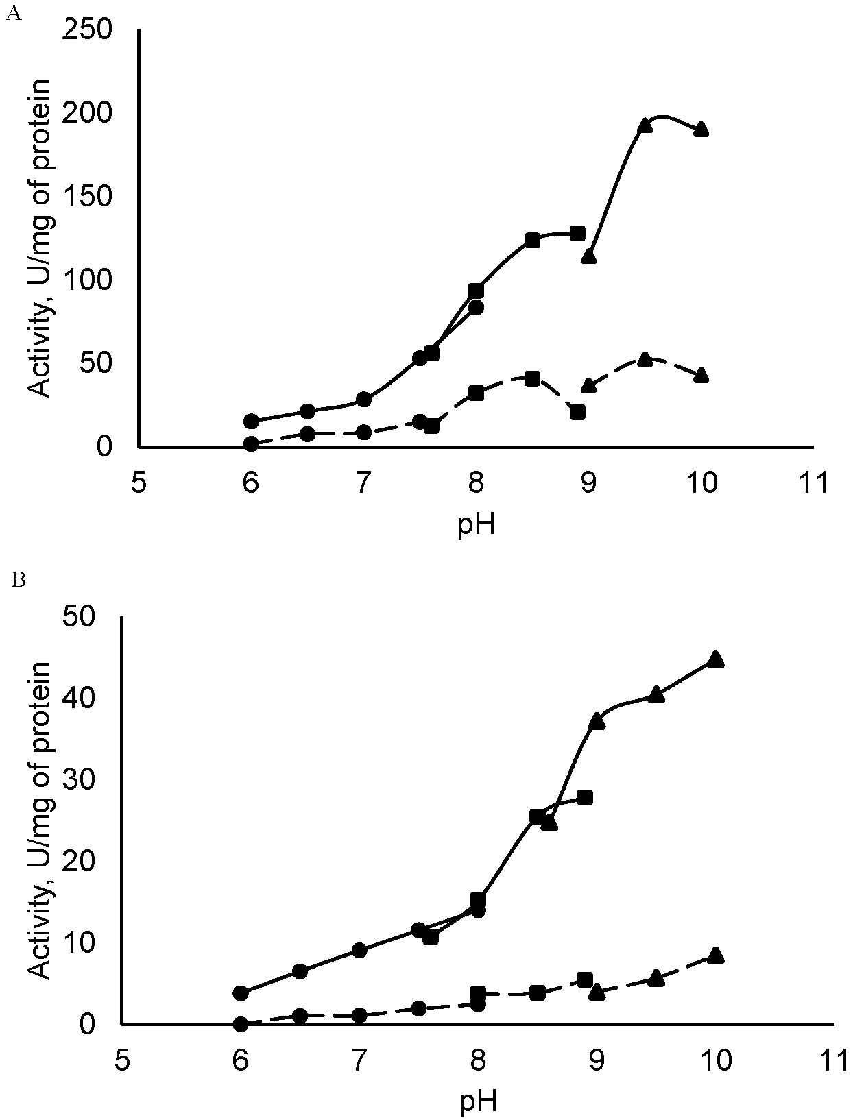
Figure S2. Effect of pH on activity of MDH from M. trichosporium OB3b (solid line) and M. alcaliphilum MDH (dashed line) in the direct (A) and reverse (B) reactions in ● K-phosphate, in ■ Tris-HCl and ▲ Glycine-NaOH buffers.
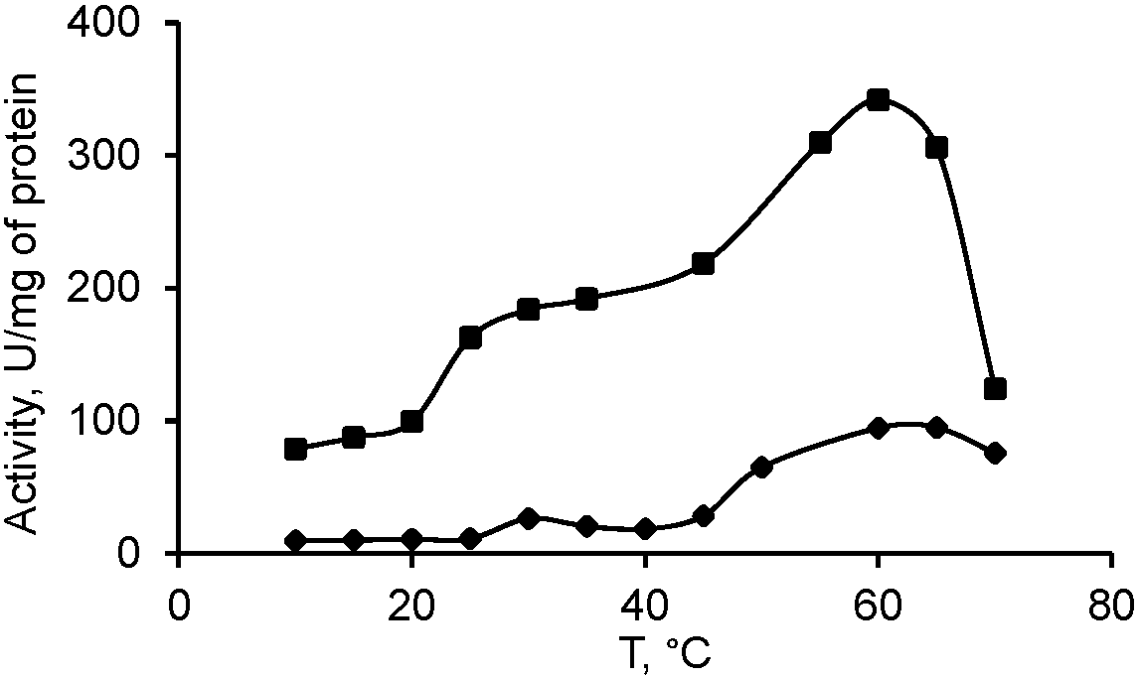
Figure S3. Effect of temperature on activity of MDHs from M. alcaliphilum (♦) and M. trichosporium OB3b (■).
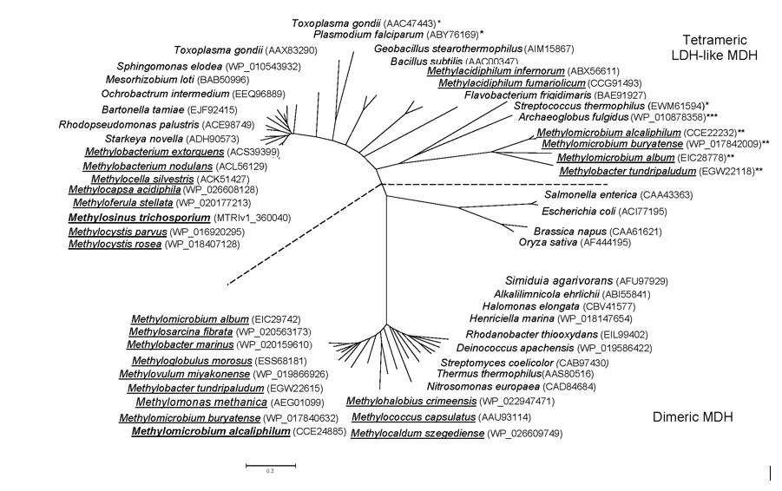
Figure S4. Phylogenetic relationships of MDHs from M. alcaliphilum 20Z and M. trichosporium OB3b to selected MDHs of (micro)organisms. The tree was constructed using the MEGA 6 program (computed from 100 independent trials). Underlined organisms are methane-utilizing bacteria. In brackets the protein sequence accession numbers in the GeneBank are given. The scale bar corresponds to the number of substitutions per site. * Lactate dehydrogenase, ** Malate/Lactate dehydrogenase, *** Malate dehydrogenase of Archaeoglobus fulgidus was characterized as dimeric enzyme [16,24].

