Supplementary Materials: Chemical/Structural Modification of Canola Oil and Canola Biodiesel: Kinetic Studies and Biodegradability of the Alkoxides
Venu Babu Borugadda, Asish K. R. Somidi and Ajay K. Dalai
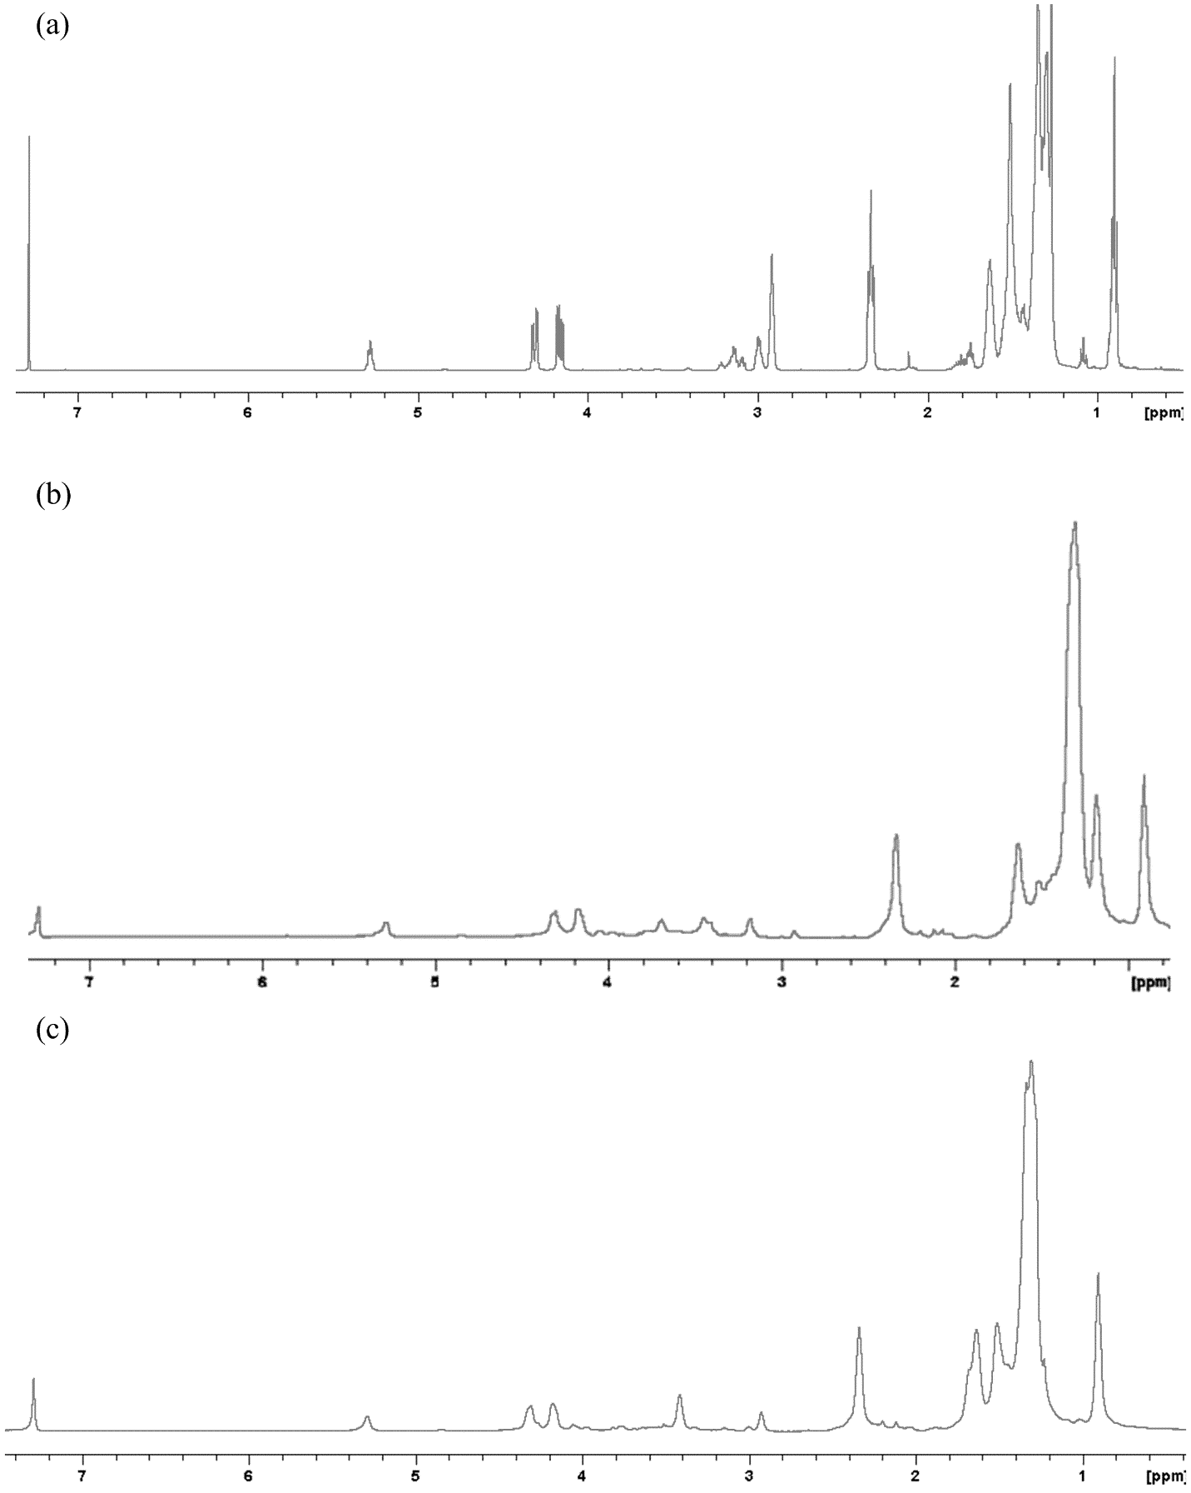
Figure S1. ¹H NMR spectra of (a) Epoxidized canola oil; (b) 2-propanol derived canola oil biolubricant basestock and (c) tert-butanol derived canola oil biolubricant basestock.
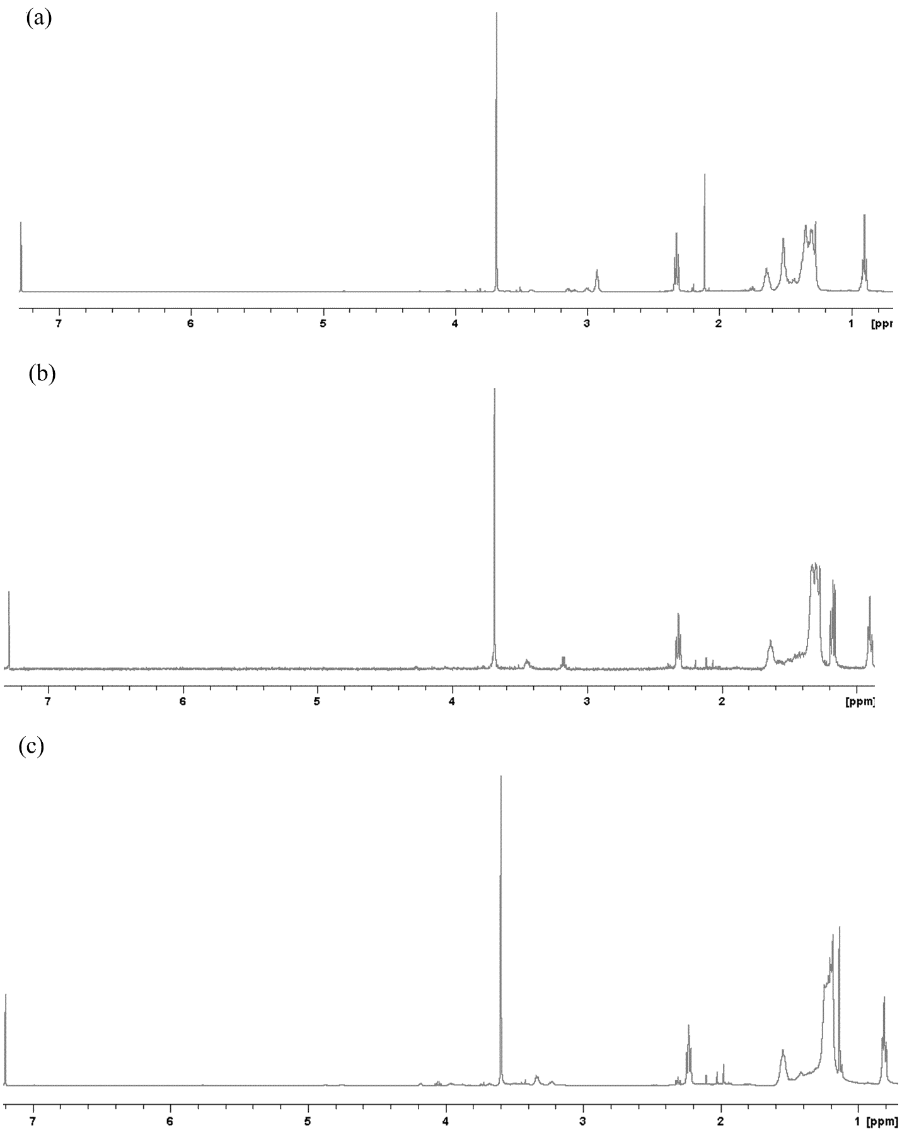
Figure S2. ¹H NMR spectra of (a) Epoxidized canola biodiesel; (b) 2-propanol derived canola biodiesel biolubricant basestock and (c) tert-butanol derived canola biodiesel biolubricant basestock.

Table S1. ¹H NMR data for the amount of the protons at each chemical shift for the prepared biolubricant basestocks.
 | Amount of the protons at each chemical shift
Chemical Shift | Propylated Canola Oil  Biolubricant Basestock (PCOB) | Butylated Canola Oil  Biolubricant Basestock (BCOB)
δ 0.75–0.97 | 11.31 | 0.9
δ 1.05–1.8 | 84.77 | 76.8
δ 2.2–2.5 | 6.95 | 6.72
δ 2.86–3.04 | 0.24 | 0.78
δ 3.09–3.23 | 0.67 | 0.21
δ 3.36–3.52 | 1.75 | 2.1
δ 3.63–3.74 | 1.12 | 0.47
δ 4.09–4.2 | 1.94 | 2.01
δ 4.32–4.47 | 2 | 2
δ 5.25–5.38 | 0.75 | 0.88
Chemical Shift | Propylated Canola Biodiesel  Biolubricant Basestock (PCBB) | Butylated Canola Biodiesel  Biolubricant Basestock (BCBB)
δ 0.85–0.92 | 2.89 | 3.2
δ 1.3–1.9 | 3.3 | 1.89
δ 1.24–1.38 | 16.98 | 18.62
δ 1.58–1.69 | 2.52 | 2.79
δ 2.28–2.34 | 1.97 | 2.1
δ 3.13–3.19 | 0.42 | 0.28
δ 3.39–3.47 | 0.62 | 0.64
δ 3.66–3.7 | 3 | 3

