Article
Personal Exposure to PM_{2.5} in the Megacity of Mexico: A Multi-Mode Transport Study
Iván Y. Hernández-Paniagua ^{1,2}, Gema L. Andraca-Ayala ¹, Ulises Diego-Ayala ³,
Luis G. Ruiz-Suarez ¹, Juan C. Zavala-Reyes ¹, Silvia Cid-Juárez ⁴, Luis Torre-Bouscoulet ⁴,
Laura Gochicoa-Rangel ⁴, Irma Rosas-Pérez ¹ and Arón Jazcilevich ^{1,}*

S1.1 Determination of Two Routes Analysis along the MAQ Rd
Table S1 shows journeys duration by mode of transport for measurements of personal exposure to PM_{2.5} made along the Miguel Angel de Quevedo Road (MAQ), during 10–14 November 2014, between 11 a.m. and 2 p.m. CDT. We used journey duration as proxy of traffic conditions and hypothesise that a difference ≤10 % in variance coefficients for trips duration allows to discard the effect of traffic conditions upon the personal exposure levels observed despite sampling on different days (Table S1). The variance coefficients were calculated, dividing the relative journeys by the average duration of journeys in the two routes. The relative journeys duration by mode of transport were calculated as the duration for the MAQ to TAX journey divided by that from the TAX to MAQ, and vice-versa. The differences between variance coefficients for the two routes were equal or lower than 10% for all modes of transport, apart for the public bus, which suggested that the journeys made could be divided into two routes. The difference observed for the public bus likely arises from the route followed by the trolleybus, which runs on the confined extreme right lane while the diesel bus may run on such a lane but is not restricted to it. This supports the hypothesis that the differences observed do not arise from differences in traffic conditions but from the mode of transport and urban design, as confirmed from the public transport mode.
Table S1. Duration, average duration, relative duration and variance coefficient for journeys made along the MAQ (Miguel Angel de Quevedo Road) Rd.
Mode of Transport | MAQ to TAX * |  |  | TAX to MAQ ** |  |  | Average Duration (h) | Difference between VCs (%)
Mode of Transport | Duration (h) | RD | VC | Duration (h) | RD | VC | Average Duration (h) | Difference between VCs (%)
Walking | 1.07 | 1.05 | 1.00 | 1.02 | 0.95 | 0.91 | 1.05 | 10
Cycling | 0.51 | 1.04 | 2.08 | 0.49 | 0.96 | 1.92 | 0.50 | 8
Public bus | 0.30 | 0.83 | 2.53 | 0.36 | 1.20 | 3.64 | 0.33 | 40
Conventional car (CC) | 0.35 | 1.03 | 2.98 | 0.34 | 0.97 | 2.82 | 0.35 | 6
Hybrid-electric car (HEC) | 0.39 | 1.05 | 2.77 | 0.37 | 0.95 | 2.50 | 0.38 | 10
RD: Relative duration calculated as MAQ to TAX divided by TAX to MAQ trips duration, and vice-versa.
VC: Variance coefficient calculated as RD divided by the average duration.
* Public bus journey made in trolleybus.
** Public bus journey made in diesel bus.

S1.2 Comparison of Data from the Two Instruments
The measurements of personal exposure to PM_{2.5} were conducted using two portable aerosol real-time photometric monitors (pDR-1500 Thermo Scientific). Figure S1 shows that for all modes of transport, there was a very good agreement with R² > 0.9 between the two instruments, which suggests no significant differences in linearity between the two instruments over the exposure levels measured.
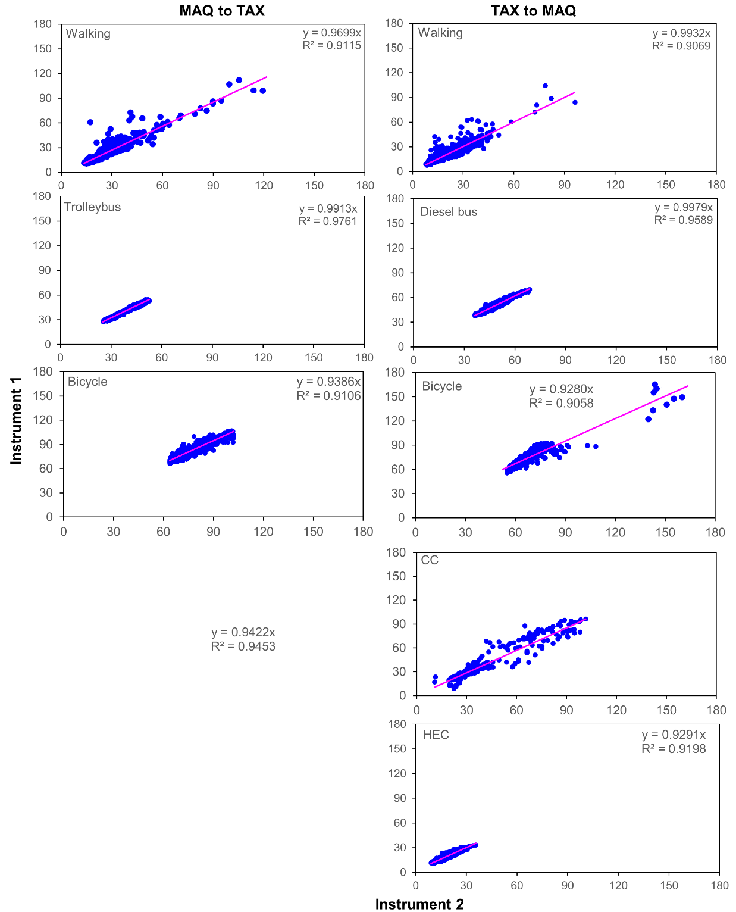
Figure S1. Comparison cross plots of instruments 1 and 2 for the 2 routes and five modes of transport, showing excellent agreement in simultaneous measurements during the sampling campaign of November 2014. Both the x-axis and y-axis show exposure concentrations of PM_{2.5} in µg m⁻³.

S1.3 Parameters Used to Calculate Total Mass Inhaled of PM_{2.5} by Mode of Transport
Table S1 lists the respiratory parameters used to calculate total mass inhaled of PM_{2.5} by mode of transport along MAQ Rd.
Table S2. Respiratory parameters used to calculate total mass inhaled of PM_{2.5}.
Transport Mode | Route | Respiratory Rate (RR) (Breaths min⁻¹) | Volume of Air Inhaled per Breath (V) (L breath⁻¹) | Volume of Air Inhaled per Minute (V_{E}) (L min⁻¹) | Total Mass of PM_{2.5} Inhaled during Journeys (I) (µg)
Walking | TAX-MAQ | 18 | 1.0 | 18.3 | 17.0 ± 3.4
Walking | MAQ-TAX | 18 | 1.0 | 18.3 | 12.1 ± 1.9
Cycling | TAX-MAQ | 34 | 1.2 | 42.1 | 104.5 ± 49.1
Cycling | MAQ-TAX | 34 | 1.2 | 42.1 | 147.4 ± 69.4
Diesel bus | TAX-MAQ | 13 | 0.9 | 11.4 | 12.7 ± 1.9
Trolleybus | MAQ-TAX | 13 | 0.9 | 11.4 | 6.3 ± 1.0
CC | TAX-MAQ | 15 | 1.0 | 14.3 | 9.4 ± 2.4
HEC | TAX-MAQ | 15 | 1.0 | 14.3 | 4.7 ± 1.2
Note that for the reader convenience V and and V_{E} are expressed in L per breath and min, respectively.

