Supplementary Materials: Lutein and Zeaxanthin—Food Sources, Bioavailability and Dietary Variety in Age-Related Macular Degeneration Protection
Bronwyn Eisenhauer, Sharon Natoli, Gerald Liew and Victoria M. Flood
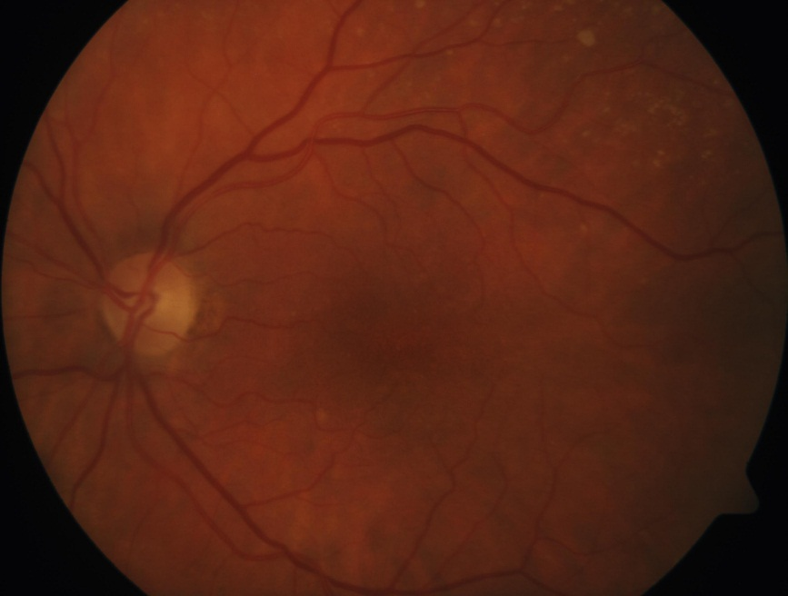
Figure S1. Intermediate AMD.
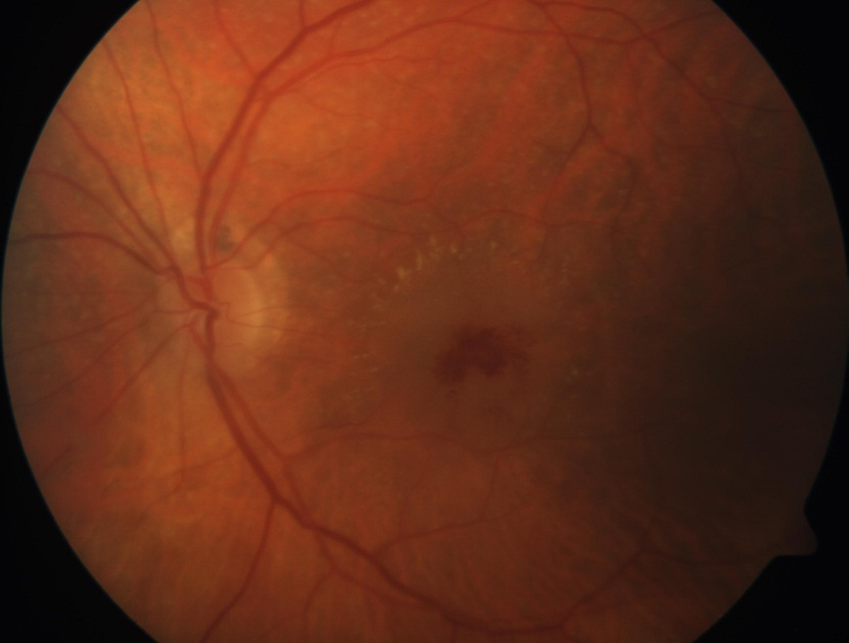
Figure S2. Neovascular late AMD.

