Supplementary Material: A Meta-Analysis of Randomized Controlled Human Trials to Explore the Role of Inter-Individual Variability
Regina Menezes, Ana Rodriguez-Mateos, Antonia Kaltsatou, Antonio González-Sarrías, Arno Greyling, Christoforos Giannaki, Cristina Andres-Lacueva, Dragan Milenkovic, Eileen R. Gibney, Julie Dumont, Manuel Schär, Mar Garcia-Aloy, Susana Alejandra Palma-Duran, Tatjana Ruskovska, Viktorija Maksimova, Emilie Combet and Paula Pinto
Table S1. Quality assessment of selected studies.
Reference | Random Sequence Generation (Score) | Allocation Concealment (Score) | Clear Blinding (Score) | Compliance Measurment (Score) | Flow of Participants (Score) | Funding (Score) | Baseline Comparability (Score) | Data Report (Score) (Notes) | Risk of Bias ¹ (Score)
Brull et al. 2015 [31] | Yes (1) | Yes (1) | Participants  Researchers  Statitians (3) | Plasma quercetin; capsule count (1) | Explained in detail (1) | Government (1) | Yes (1) | Complete (1) | Low (10)
Chen et al. 2015 [39] | Yes (1) | Yes (1) | Participants  Researchers  Statitians (3) | Self-reported (0.5) | Explained in detail (1) | Government (1) | Yes(1) | Complete (1) | Low (9.5)
Choi et al. 2015 [43] | Yes (1) | Unclear (0) | Participants  Researchers (2) | NR (0) | NR (0) | Government (1) | Yes (1) | Complete (1) | Moderate (6)
Chopra et al. 2000 [32] | Yes (1) | Unclear (0) | Participants (1) | Self-reported (0.5) | Unclear (0) | Company (0) | Yes (1) | Incomplete (0) (Values for pre-treatment are the post-placebo values) | High (3.5)
Conquer et al. 1998 [38] | Yes (1) | Unclear (0) | Participants  Researchers (2) | Plasma quercetin; capsule count (1) | NR (0) | Government (1) | Yes (1) | Complete (1) | Moderate (7)
Dower et al. 2015 [33] | Yes (1) | Yes (1) | Participants  Researchers  Statitians (3) | Plasma flavonoids; self-report (1) | Explained in detail (1) | Public-private; author from company (0) | Yes (1) | Complete (1) | Low (9)
Edwards et al. 2007 [37] | Yes (1) | Unclear (0) | Participants  Researchers (2) | Plasma quercetin; capsule count (1) | Explained in detail (1) | University (1) | Unclear (0) | Complete (1) | Moderate (7)
Egert et al. 2009 [29] | Yes (1) | Unclear (0) | Participants  Researchers (2) | Plasma quercetin; capsule count (1) | Explained in detail (1) | Government (1) | Yes (1) | Complete (1) | Low (8)
Javadi et al. 2014 [46] | Yes (1) | Unclear (0) | Participants (1) | NR (0) | Explained in detail (1) | University (1) | Yes (1) | Complete (1) | Moderate (6)
Kim et al. 2013 [42] | Yes (1) | Unclear (0) | Participants (1) | Self-reported (0.5) | NR (0) | Government (1) | Yes (1) | Complete (1) Data for t-Chol obtained from graphic | Moderate (5.5)
Kim et al. 2015 [44] | Yes (1) | Unclear (0) | Participants (1) | NR (0) | NR (0) | University (1) | Yes (1) | Complete (1) | Moderate (5)
Larmo et al. 2009 [35] | Yes (1) | Yes (1) | Participants  Researchers  Statitians (3) | Plasma quercetin; self-reported (1) | Explained in detail (1) | University (1) | Yes (1) | Complete (1) | Low (10)
Lee et al. 2011 [41] | Yes (1) | Unclear (0) | Participants (1) | Self-reported (0.5) | NR (0) | NR (0) | No (0) | Complete (1) | High (3.5)
Lu et al. 2015 [40] | Yes (1) | Unclear (0) | Participants (1) | Plasma total phenolics (1) | Explained in detail (1) | NR (0) | Yes (1) | Complete (1) | Moderate (6)
Pfeuffer et al. 2013 [30] | Yes (1) | Unclear (0) | Participants (1) | Plasma quercetin; capsule count (1) | Explained in detail (1) | Government (1) | Yes (1) | Incomplete (0) No pre values for placebo and treatment; only baseline values | Moderate (6)
Shi & Williamson 2016 [36] | Yes (1) | Yes (1) | Participants  Researchers (2) | Plasma quercetin; capsule count (1) | Explained in detail (1) | Government & University (1) | Yes (1) | Complete (1) | Low (9)
Suomela et al. 2006 [34] | Yes (1) | Unclear (0) | Participants (1) | NR (0) | NR (0) | Government (1) | Yes (1) | Complete (1) | Moderate (5)
Zahedi et al. 2013 [45] | Yes (1) | Yes (1) | Participants  Researchers (2) | Capsule count(0.5) | Explained in detail (1) | University (1) | Yes (1) | Incomplete (0) BP data not correctly reported | Moderate (7.5)
¹ Low risk of bias: 8 to 10; moderate risk of bias: 5 to 7.5; High risk of bias: <5.
Table S2. Subgroup analyses: stratification by participants’ characteristics and study characteristics.
Outcome |  | TAG |  |  |  | TC
Factor | Subgroups | N/n | DM (95%CI) | P value(I²)¹ | Q test ² | N/n | DM (95%CI) | P value (I²) ¹ | Q test ²
Age | Above 40 | 4/111 | −0.111(-0.351, 0.130) | 0.368 (0%) | 0.974 | 4/111 | −0.026 (−0.409, 0.358) | 0.896 (0%) | 0.890
 | Mixed ages | 11/700 | −0.106 (−0.188, −0.025) | 0.011 (0%)
 |  |  |  |  |  | 11/700 | −0.095 (−0.195, −0.003) | 0.062 (0%)
Sex | Female | 2/99 | −0.145 (−0.402, 0.111) | 0.266 (0%) | 0.939 | 3/111 | −0.221 (−0.529, 0.086) | 0.159 (0%) | 0.654
 | Male | 3/63 | −0.105 (−0.424, 0.215) | 0.520 (0%) |  | 3/63 | −0.028 (−0.448, 0.392) | 0.895 (0%)
 | Mixed sexes | 10/649 | −0.103 (−0.187, −0.019) | 0.016 (0%) |  | 10/649 | −0.084 (−0.187, 0.019) | 0.111 (0%)
Country | Asia | 5/255 | −0.175 (−0.319, −0.032) | 0.017 (0%) | 0.266 | 6/267 | −0.244 (−0.429, −0.059) | 0.010 (0%) | 0.069
 | EU & N. America | 10/556 | −0.079(−0.170, 0.013) | 0.092 (0%) |  | 10/556 | −0.044 (−0.155, 0.066) | 0.429 (0%)
BMI | Mixed BMI | 9/338 | −0.140 (−0.275, −0.004) | 0.043 (0%) | 0.628 | 9/338 | −0.228 (−0.403, −0.054) | 0.010 (0%) | 0.254
 | Normal | 1/229 | −0.060 (−0.165, 0.0045) | 0.262 (0%) |  | 1/229 | −0.049 (−0.175, 0.077) | 0.448 (0%)
 | Overweight | 5/274 | −0.197 (−0.403, 0.008) | 0.060 (0%) |  | 5/274 | −0.074 (−0.313, 0.165) | 0.543 (0%)
Disease status | Disease | 5/305 | −0.196 (−0.431, 0.038) | 0.100 (0%) | 0.384 | 5/305 | −0.131 (−0.331, 0.070) | 0.202 (0%) | 0.725
 | No disease | 8/399 | −0.085 (−0.174, 0.003) | 0.054 (0%) |  | 9/411 | −0.084 (−0.203, 0.024) | 0.124 (0%)
Baseline levels | Dyslipidaemia | 6/324 | −0.207 (−0.433, 0.019) | 0.072 (0%) | 0.415 | 7/283 | −0.100 (−0.316, 0.116) | 0.363 (0%) | 0.664
 | Normal | 9/487 | −0.093 (−0.176, -0.010) | 0.026 (0%) |  | 6/439 | −0.075 (−0.188, 0.039) | 0.198(0%)
Type of flavonol | Mixture | 7/471 | −0.091 (−0.177, 0.045) | 0.039 (0%) | 0.411 | 8/493 | −0.087 (−0.197, 0.024) | 0.123 (0%) | 0.727
 | Pure | 8/340 | −0.172 (−0.347, 0.000) | 0.053 (0%) |  | 8/340 | −0.125 (−0.310, 0.060) | 0.185 (0%)
Dose (mag/day) | Above 200 | 5/190 | −0.215 (−0.177, 0.004) | 0.127 (0%) | 0.424 | 5/190 | −0.202 (−0.433, 0.030) | 0.087 (0%) | 0.329
 | Below 200 | 10/621 | −0.098 (−0.178, −0.017) | 0.018 (0%) |  | 11/633 | −0.076 (−0.179, 0.028) | 0.0153 (0%)
¹ p value for intervention effect and inconsistency within subgroup. ² p value for heterogeneity between subgroups. N= number of studies; n= number of participants; DM, difference in means; CI, 95% confidence interval. Subgroup analysis was performed after removal of studies with high risk of bias.
Table S2 (continuation). Subgroup analyses: stratification by participants’ characteristics and study characteristics.
Outcome |  | LDL |  |  |  | HDL
Factor | Subgroups | N/n | DM (95%CI) | P value (I²) ¹ | Q test ² | N/n | DM (95%CI) | P value (I²) ¹ | Q test ²
Age | Above 40 | 4/111 | −0.078 (−0.376, 0.221) | 0.610 (0%) | 0.851 | 4/111 | 0.047 (−0.096, 0.190) | 0.520 (0%) | 0.981
 | Mixed ages | 11/700 | −0.091 (−0.181, −0.002) | 0.045 (0%) |  | 11/700 | 0.045 (0.008, 0.082) | 0.017 (0%)
Sex | Female | 2/99 | −0.122 (−0.413, −0.168) | 0.409 (0%) | 0.972 | 2/99 | 0.043 (−0.057, 0.143) | 0.403 (0%) | 0.966
 | Male | 3/63 | −0.075 (−0.406, 0.256) | 0.658 (0%) |  | 3/63 | 0.067 (−0.101, 0.235) | 0.432 (0%)
 | Mixed sexes | 10/649 | −0.088 (−0.181, 0.005) | 0.063 (12.7%) |  | 10/649 | 0.045 (0.005, 0.084) | 0.028 (0%)
Country | Asia | 5/255 | −0.274 (−0.455, −0.093) | 0.003 (26%) | 0.024 | 5/255 | 0.051 (−0.010, 0.112) | 0.103 (0%) | 0.829
 | EU & N. America | 10/556 | −0.037 (−0.134, 0.060) | 0.451 (0%) |  | 10/556 | 0.042 (−0.002, 0.087) | 0.061 (0%)
BMI | Mixed BMI | 8/246 | −0.282 (−0.462, −0.102) | 0.002 (0%) | 0.056 | 8/246 | 0.073 (0.006, 0.141) | 0.034 (0%) | 0.669
 | Normal | 1/229 | −0.020 (−0.135, 0.095) | 0.734 (0%) |  | 1/229 | 0.040 (−0.012, 0.092) | 0.130 (0%)
 | Overweight | 5/274 | −0.081 (−0.293, 0.132) | 0.457 (0%) |  | 5/274 | 0.029 (−0.61, 0.119) | 0.524 (0%)
Disease status | Disease | 5/305 | −0.201(−0.378, −0.024) | 0.026 (28.4%) | 0.153 | 5/305 | 0.056 (−0.009, 0.122) | 0.093 (0%) | 0.802
 | No disease | 8/399 | −0.052 (−0.155, 0.052) | 0.327 (0%) |  | 8/399 | 0.046 (0.000, 0.092) | 0.049 (0%)
Baseline levels | Dyslipidaemia | 7/283 | −0.108 (−0.295, 0.080) | 0.261 (0%) | 0.837 | 12/520 | 0.052 (0.000, 0.103) | 0.049 (0%) | 0.773
 | Normal | 7/456 | −0.085 (−0.185, 0.014) | 0.092 (33.7%) |  | 2/256 | 0.041 (−0.011, 0.092) | 0.120 (0%)
Type of flavonol | Mixture | 5/471 | −0.056 (−0.157, 0.045) | 0.281 (0%) | 0.208 | 5/471 | 0.040 (−0.004, 0.083) | 0.073 (0%) | 0.662
 | Pure | 8/340 | −0.177 (−0.338, 0.017) | 0.053 (0%) |  | 8/340 | -0.057 (−0.007, 0.121) | 0.079 (0%)
Dose (mag/day) | Above 200 | 5/190 | −0.266 (−0.476, −0.056) | 0.013 (6.2%) | 0.072 | 5/190 | 0.060 (−0.015, 0.135) | 0.116 (0%) | 0.660
 | Below 200 | 10/621 | −0.055 (−0.149, 0.039) | 0.249 (0%) |  | 11/633 | 0.041 (−0.000, 0.082) | 0.050 (0%)
¹ p value for intervention effect and inconsistency within subgroup. ² p value for heterogeneity between subgroups. N = number of studies; n= number of participants; DM, difference in means; CI, 95% confidence interval. Subgroup analysis was performed after removal of studies with high risk of bias.

Table S3. Sensitivity analysis in country, disease status and baseline levels.
Outcome |  | TAG |  |  |  | TC
Factor | Subgroups ¹ | N/n | DM (95%CI) | p value (I²) ² | Q test ³ | N/n | DM (95%CI) | p value (I²)² | Q test ³
Country | Asia | 3/133 | −0.168 (−0.329, −0.006) | 0.042 (0%) | 0.311 | 4/145 | −0.285 (−0.544, −0.027) | 0.030 (0%) | 0.098
 | EU & N. America | 7/373 | −0.071 (−0.166, 0.024) | 0.144 (0%) |  | 7/373 | −0.046 (−0.164, 0.072) | 0.449 (0%)
Disease status | Disease | 4/243 | −0.201(−0.455, 0.053 ) | 0.121 (0%) | 0.341 | 4/243 | −0.135 (−0.355, 0.082) | 0.231 (0%) | 0.498
 | No disease | 6/338 | −0.069 (−0.167, 0.030) | 0.171 (0%) |  | 6/338 | −0.048 (−0.169, 0.073) | 0.438 (0%)
Baseline levels | Dyslipidaemia | 5/262 | −0.213 (−0.457, 0.030) | 0.087 (0%) | 0.275 | 6/259 | −0.020 (−0.253, 0.213) | 0.867 (0%) | 0.472
 | Normal | 6/354 | −0.067 (−0.163, 0.028) | 0.188 (0%) |  | 2/256 | −0.046 (−0.174, 0.082) | 0.480 (0%)
Outcome |  | LDL |  |  |  | HDL
Country | Asia | 3/133 | −0.239 (−0.524, 0.047) | 0.101 (0%) | 0.182 | 3/133 | 0.036 (−0.061, 0.132) | 0.465 (0%) | 0.915
 | EU & N. America | 7/373 | −0.032 (−0.136, 0.072) | 0.546 (0%) |  | 7/373 | 0.042 (−0.006, 0.090) | 0.088 (0%)
Disease status | Disease | 4/243 | −0.257(−0.463, −0.052 ) | 0.014 (33%) | 0.053 | 4/243 | 0.072 (−0.004, 0.147) | 0.064 (0%) | 0.537
 | No disease | 6/338 | −0.028 (−0.135, 0.079) | 0.603 (0%) |  | 6/338 | 0.043 (−0.006, 0.092) | 0.083 (0%)
Baseline levels | Dyslipidaemia | 6/259 | −0.070 (−0.265, 0.125) | 0.483 (0%) | 0.925 | 8/325 | 0.071 (0.002, 0.139) | 0.042 (0%) | 0.737
 | Normal | 5/357 | −0.080 (−0.186, 0.025) | 0.135 (51.7%) |  | 2/256 | 0.041 (−0.011, 0.092) | 0.120 (0%)
¹ Analysis of country subgroups were performed after removal of studies with high risk of bias and studies conducted with participants with diagnosed diseases; analysis of disease status and baseline subgroups were performed after removal of studies with high risk of bias and studies with Asian countries; ² p value for intervention effect and inconsistency within subgroup; ³ p value for heterogeneity between subgroups; N= number of studies; n= number of participants; DM, difference in means; CI, 95% confidence interval.

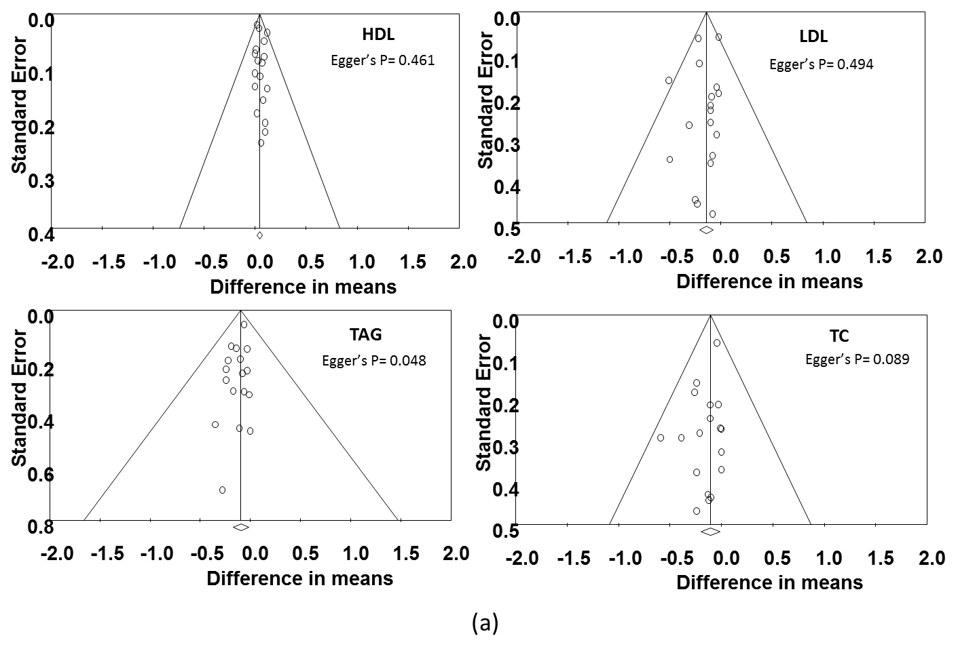

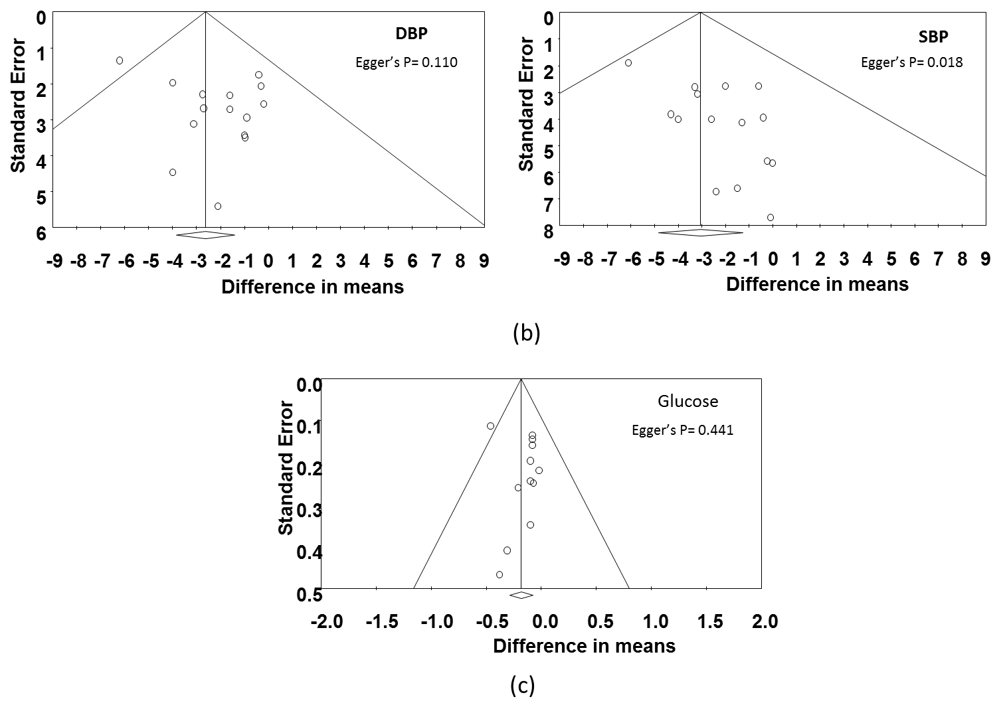
Figure S1. Funnel plots and Eggers statistics for lipids (a), blood pressure (b) and glucose (c).

