Supplementary Materials: N-3 Polyunsaturated Fatty Acids Improve Liver Lipid Oxidation-related Enzyme Levels and Increased the Peroxisome Proliferator-Activated Receptor α Expression Level in Mice Subjected to Hemorrhagic Shock/Resuscitation
Li Zhang, Feng Tian, Xuejin Gao, Xinying Wang, Chao Wu, Ning Li and Jieshou Li
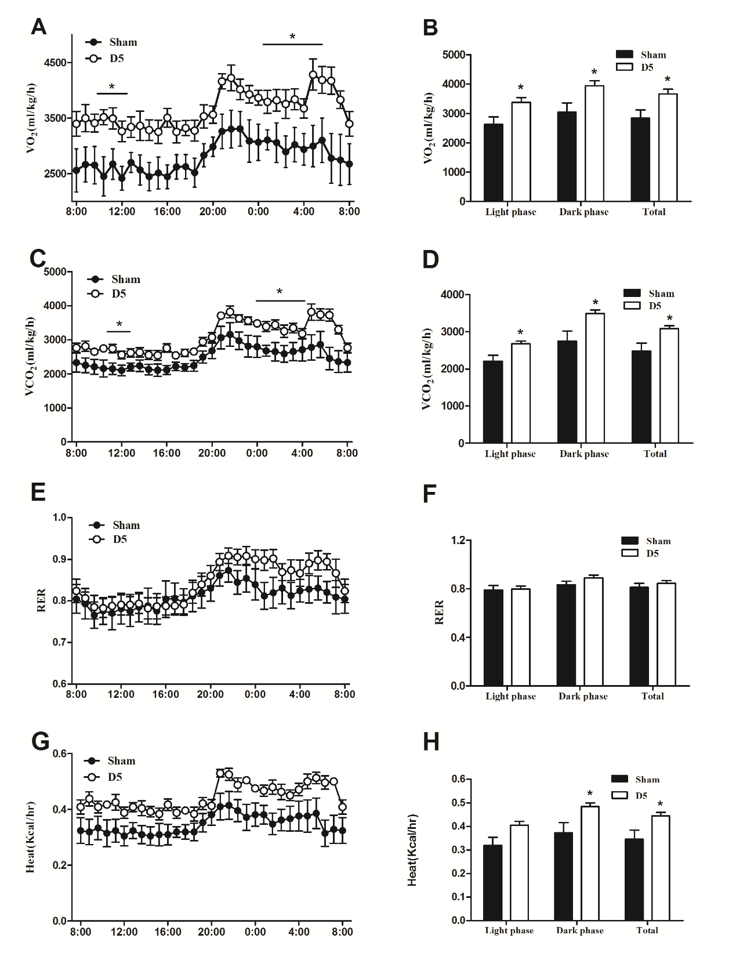
Figure S1. Energy expenditure of sham group and D5 group mice. (A,B) Volume of O₂ consumption; (C,D) Volume of CO₂ production; (E,F) RER and (G,H) Heat. * p < 0.05 compared to the sham group; Error bars indicate standard deviations. D5 indicate days after operation in the experimental groups.

