Supplementary Materials: Dietary Protein Source and Quantity during Weight Loss do not Impact, Appetite, Energy Expenditure, or Cardio-Metabolic Responses
Jia Li, Cheryl L. H. Armstrong and Wayne W. Campbell
Table S1. Changes in weight status, body composition, and other anthropometric measurements among subjects in OMV and LOV groups throughout the study.
Measurement ª | Group | Baseline | Weeks 6 | Weeks 10 | Weeks 14 | Change ^{b} (Post − Baseline)
Body mass ^{c}, kg | OMV | 87.0 ± 2.9 | 83.8 ± 2.8 | 82.0 ± 2.7 | 80.1 ± 2.9 | −6.8 ± 0.6
Body mass ^{c}, kg | LOV | 88.1 ± 2.9 | 84.5 ± 2.8 | 81.6 ± 2.7 | 79.6 ± 2.7 | −8.5 ± 0.6
Body mass index ^{c}, kg/m² | OMV | 31.0 ± 0.7 | 29.8 ± 0.6 | 29.2 ± 0.7 | 28.5 ± 0.7 | −2.4 ± 0.2
Body mass index ^{c}, kg/m² | LOV | 30.7 ± 0.6 | 29.4 ± 0.6 | 28.4 ± 0.6 | 27.7 ± 0.6 | −3.0 ± 0.2
Fat mass ^{c}, kg | OMV | 35.8 ± 2.0 | 33.2 ± 1.8 | 31.8 ±2.1 | 29.7 ± 2.1 | −6.1 ± 0.6
Fat mass ^{c}, kg | LOV | 34.8 ± 1.3 | 32.5 ± 1.4 | 29.6 ± 1.6 | 28.1 ± 1.6 | −6.8 ± 0.7
% fat mass ^{c} | OMV | 41.5 ± 2.2 | 40.0 ± 2.1 | 39.0 ± 2.4 | 37.2 ± 2.3 | −4.3 ± 0.6
% fat mass ^{c} | LOV | 40.1 ± 1.0 | 38.8 ± 1.7 | 36.6 ±1.9 | 35.5 ± 1.8 | −4.5 ± 0.7
Fat-free mass ^{d}, kg | OMV | 51.2 ± 3.0 | 50.6 ± 2.8 | 50.2 ± 2.9 | 50.5 ± 2.9 | −0.7 ± 0.4
Fat-free mass ^{d}, kg | LOV | 53.3 ± 2.9 | 52.0 ± 2.7 | 52.0 ± 2.7 | 51.5 ± 2.7 | −1.8 ± 0.5
% fat-free Mass ^{e} | OMV | 58.5 ± 2.2 | 60.0 ± 2.1 | 61.0 ± 2.4 | 62.8 ± 2.3 | 4.3 ± 0.6
% fat-free Mass ^{e} | LOV | 60.0 ± 1.6 | 61.2 ± 1.7 | 63.4 ± 1.9 | 64.5 ± 1.8 | 4.5 ± 0.7
Natural waist circumference ^{c,f}, mm | OMV | 987 ± 25 | 956 ± 22 | 923 ± 24 | 911 ± 22 | −76 ± 10
Natural waist circumference ^{c,f}, mm | LOV | 996 ± 23 | 965 ± 23 | 936 ± 22 | 922 ± 24 | −68 ± 8
Umbilical waist circumference ^{d,f}, mm | OMV | 1047 ± 20 | 1017 ± 23 | 985 ± 24 | 964 ± 21 | −83 ± 11
Umbilical waist circumference ^{d,f}, mm | LOV | 1057 ± 16 | 1033 ± 16 | 1001 ± 16 | 985 ± 16 | −66 ± 8
Hip circumference ^{g,h}, mm | OMV | 1166 ± 49 | 1151 ± 53 | 1112 ± 53 | 1081 ± 45 | −64 ± 21
Hip circumference ^{g,h}, mm | LOV | 1120 ± 13 | 1081 ± 16 | 1054 ± 16 | 1032 ± 17 | −78 ± 12
Waist to hip ratio | OMV | 0.86 ± 0.03 | 0.85 ± 0.03 | 0.85 ± 0.03 | 0.86 ± 0.03 | −0.017 ± 0.017
Waist to hip ratio | LOV | 0.89 ± 0.03 | 0.89 ± 0.02 | 0.89 ± 0.03 | 0.90 ± 0.03 | 0.002 ± 0.009
ª Mean ± SEMs. There were no significant differences at baseline between groups; ^{b} Weeks 14 − Baseline. There were no significant differences in the change over time between groups; ^{c} Independent of protein source there was a main effect of time (p < 0.001). Post-hoc: Baseline > Weeks 6 > Weeks 10 > Weeks 14 (p < 0.001 for all); ^{d} Independent of protein source there was a main effect of time (p < 0.001). Post-hoc: Baseline > Weeks 6, 10 and 14 (p < 0.01 for all); ^{e} Independent of protein source there was a main effect of time (p < 0.001). Post-hoc: Baseline < Weeks 6 < Weeks 10 < Weeks 14 (p < 0.001 for all); ^{f} OMV: M = 5, F = 11 at Week 6; LOV: M = 5, F = 11 at Baseline; ^{g} Independent of protein source there was a main effect of time (p < 0.001). Post-hoc: Baseline > Weeks 6 > Weeks 10 (p < 0.05 for all); ^{h} OMV: M = 5, F = 10 at Weeks 6 and 14; LOV: M = 5, F = 11 at Baseline.
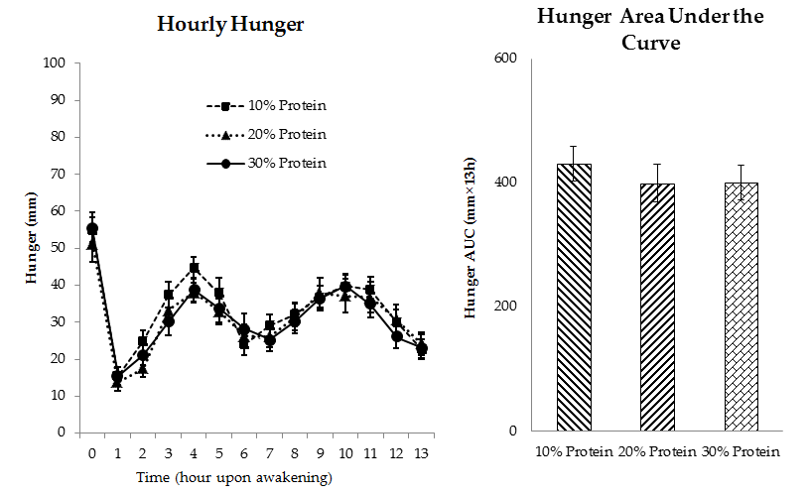

(A)
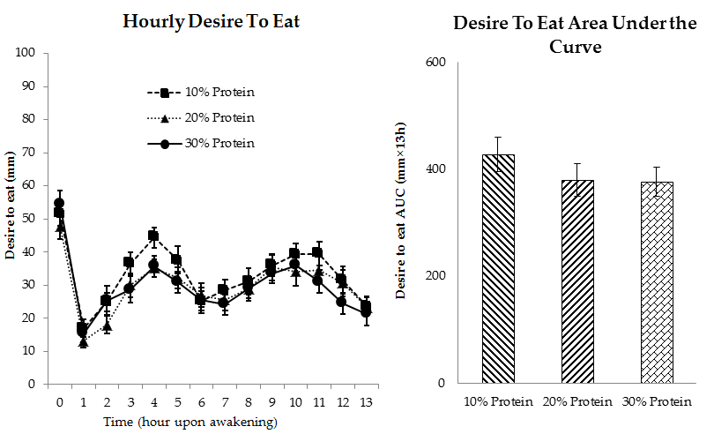

(B)
Figure S1. Daily ratings of (A) hunger and (B) desire to eat at the end of each 4-weeks (days 25–27) period independent of protein source.
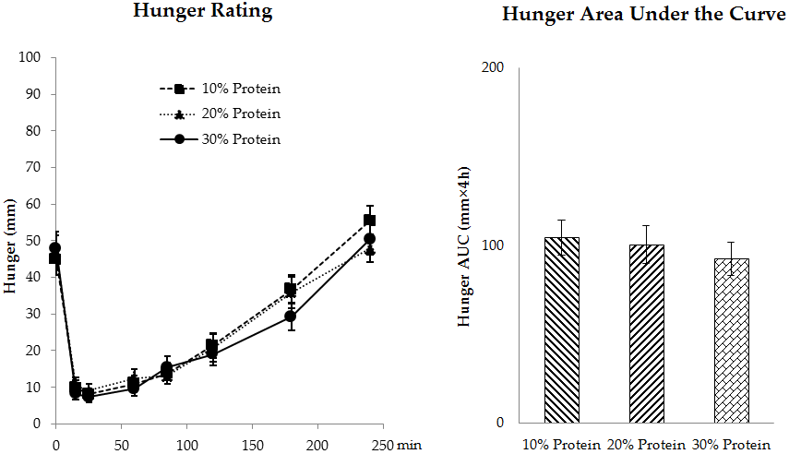

(A)
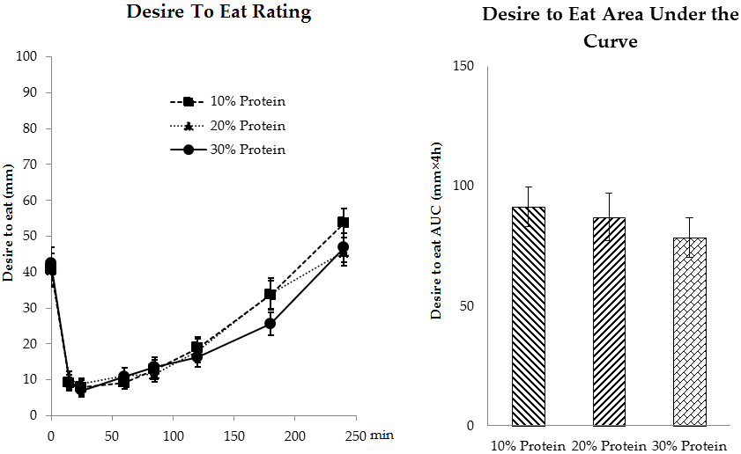

(B)
Figure S2. Postprandial ratings of (A) hunger and (B) desire to eat at the end of each 4-week (day 28) period independent of protein source.

