Supplementary Materials: Analysis of global LAI/FPAR products from VIIRS and MODIS sensors for spatio-temporal consistency and uncertainty over 2012-2016
Baodong Xu, Taejin Park , Kai Yan, Chi Chen, Yelu Zeng, Wanjuan Song, Gaofei Yin, Jing Li, Qinhuo Liu, Yuri Knyazikhin and Ranga B. Myneni

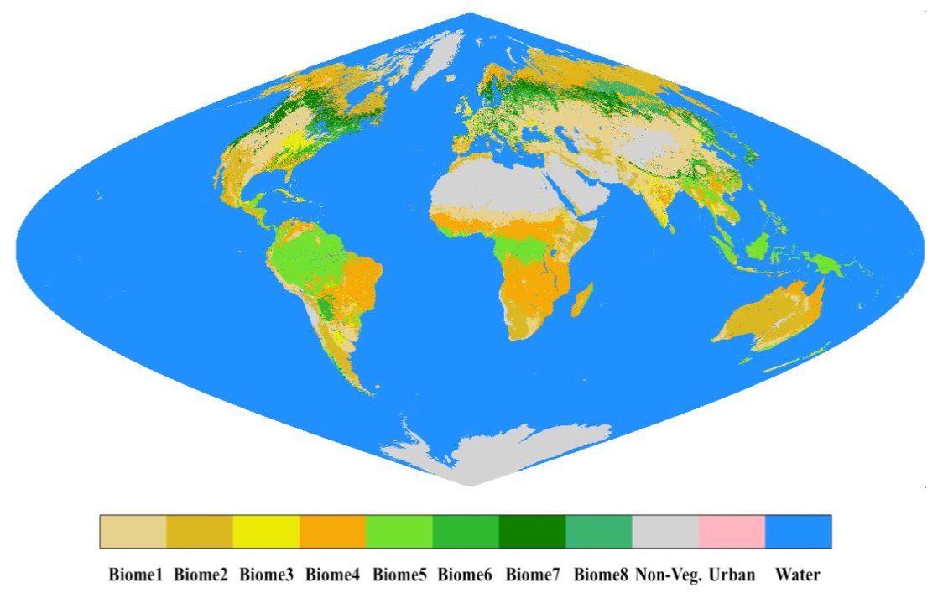
Figure S1. Global land cover map used in this study. The eight biomes (B1-B8) are (1) grasses and cereal crops, (2) shrubs, (3) broadleaf crops, (4) savannas, (5) evergreen broadleaf forest, (6) deciduous broadleaf forest, (7) evergreen needleleaf forest, (8) deciduous needleleaf forest. An equal-area sinusoidal projection is used here.
Figure S2. The quality control based on “FparLai_QC” and “FparExtra_QC” layers for VIIRS and MODIS products under study.

Table S1. Characteristics of the available ground sites and aggregated LAI_effective/LAI_true/FPAR values over 3 km × 3 km area. The biome type (B1-B8) are same as in Figure S1. ”Lat”, ”Lon”, ”DOY”, ”LAI_eff”, and ”LAI_true” stand for “latitude”, “longitude”, “day of year”, “effective LAI”, and “true LAI”, respectively. The “-” indicates no data are available. Note that the LAI/FPAR ground values were not shown in the table if the information entropy of this site is greater than 1.
Site ID | Site Name | Location | Lat | Lon | Biome | Biome proportion (%) | Entropy | Year | DOY | LAI_eff | LAI_true | FPAR | VIIRS & MODIS Valid pixels (%)
1 | Pshenichne | Ukraine | 50.08 | 30.23 | B1 | 100 | 0 | 2013 | 134 | 0.42±0.39 | 0.57±0.59 | 0.26±0.18 | 48.89
 |  |  |  |  |  |  |  | 2013 | 166 | 1.39±0.49 | 2.08±0.81 | 0.58±0.13 | 77.78
 |  |  |  |  |  |  |  | 2013 | 196 | 2.42±0.45 | 3.53±0.62 | 0.81±0.07 | 2.22
 |  |  |  |  |  |  |  | 2014 | 163 | 1.55±0.87 | 2.14±1.19 | 0.64±0.21 | 57.78
 |  |  |  |  |  |  |  | 2014 | 212 | 2.01±0.92 | 2.76±1.29 | 0.7±0.25 | 91.11
 |  |  |  |  |  |  |  | 2015 | 174 | 1.37±0.64 | 2.36±0.91 | 0.58±0.17 | 44.44
 |  |  |  |  |  |  |  | 2015 | 188 | 1.86±1.02 | 2.61±1.37 | 0.69±0.19 | 53.33
 |  |  |  |  |  |  |  | 2015 | 204 | 1.47±0.92 | 2.12±1.41 | 0.56±0.29 | 60.00
2 | Merguellil | Tunisia | 35.57 | 9.91 | B1 | 57.89 | 1.12 | - | - | - | - | - | -
3 | SouthWest_1 | France | 43.55 | 1.09 | B1 | 93.88 | 0.33 | 2013 | 173 | 1.14±0.50 | 1.39±0.60 | 0.61±0.20 | 2.04
 |  |  |  |  |  |  |  | 2013 | 191 | 0.81±0.60 | 1.01±0.83 | 0.32±0.30 | 83.67
 |  |  |  |  |  |  |  | 2013 | 207 | 1.00±0.70 | 1.19±0.85 | 0.39±0.27 | 87.76
 |  |  |  |  |  |  |  | 2013 | 230 | 1.08±0.80 | 1.7±0.90 | 0.39±0.30 | 93.88
 |  |  |  |  |  |  |  | 2013 | 247 | 1.1±0.79 | 1.15±0.86 | 0.34±0.21 | 77.55
4 | SouthWest_2 | France | 43.45 | 1.15 | B1 | 91.84 | 0.41 | 2013 | 173 | 1.07±0.50 | 1.31±0.60 | 0.58±0.30 | 18.37
 |  |  |  |  |  |  |  | 2013 | 191 | 0.49±0.51 | 0.64±0.69 | 0.29±0.22 | 79.59
 |  |  |  |  |  |  |  | 2013 | 207 | 0.67±0.73 | 0.69±0.87 | 0.46±0.20 | 71.43
 |  |  |  |  |  |  |  | 2013 | 230 | 1.62±1.00 | 2.33±1.20 | 0.53±0.25 | 100
 |  |  |  |  |  |  |  | 2013 | 247 | 1.79±0.90 | 1.88±1.00 | 0.53±0.25 | 71.43
5 | Guangdong | China | 20.84 | 110.11 | B1 | 100 | 0 | 2013 | 146 | 5.33±1.00 | - | - | 0
6 | 25de Mayo_Alfalfa | Argentina | -37.91 | -67.75 | B2 | 100 | 0 | 2014 | 40 | 0.93±0.74 | 1.30±1.08 | 0.39±0.24 | 91.11
7 | 25de Mayo_Shurb | Argentina | -37.94 | -67.79 | B2 | 100 | 0 | 2014 | 40 | 0.31±0.41 | 0.42±0.59 | 0.19±0.13 | 56.52
8 | Rosasco | Italy | 45.25 | 8.56 | B1 | 55.32 | 0.99 | 2014 | 184 | 2.62±0.59 | 4.2±0.76 | 0.85±0.17 | 42.55
9 | LaReina_Cordoba_1 | Spain | 37.82 | -4.86 | B1 | 67.44 | 0.91 | 2014 | 140 | 0.74±0.78 | 1.08±1.16 | 0.30±0.28 | 34.88
10 | LaReina_Cordoba_2 | Spain | 37.79 | -4.83 | B1 | 100 | 0 | 2014 | 140 | 1.07±0.68 | 1.59±1.02 | 0.42±0.25 | 41.67
11 | Barrax-LasTiesas | Spain | 39.05 | -2.10 | B3 | 78.57 | 0.75 | 2014 | 149 | 1.51±1.61 | 2.55±2.68 | 0.356±0.35 | 0
 |  |  |  |  |  |  |  | 2015 | 145 | 0.74±1.03 | 1.01±1.52 | 0.29±0.31 | 23.81
 |  |  |  |  |  |  |  | 2015 | 203 | 0.70±1.19 | 0.83±1.40 | 0.23±0.30 | 35.71
12 | Albufera | Spain | 39.27 | -0.32 | B1 | 61.11 | 0.96 | 2014 | 158 | 0.45±0.18 | 0.58±0.27 | 0.21±0.08 | 72.22
 |  |  |  |  |  |  |  | 2014 | 175 | 1.19±0.33 | 1.51±0.34 | 0.46±0.09 | 66.67
 |  |  |  |  |  |  |  | 2014 | 196 | 3.16±0.72 | 3.76±0.83 | 0.73±0.14 | 66.67
 |  |  |  |  |  |  |  | 2014 | 219 | 4.28±0.86 | 5.77±1.09 | 0.85±0.15 | 72.22
 |  |  |  |  |  |  |  | 2014 | 234 | 4.57±0.92 | 5.9±1.28 | 0.85±0.20 | 52.78
13 | Ottawa | Canada | 45.31 | -75.77 | B1 | 93.33 | 0.46 | 2014 | 159 | 1.03±1.29 | - | - | 75.56
 |  |  |  |  |  |  |  | 2014 | 176 | 1.46±1.49 | - | - | 42.22
 |  |  |  |  |  |  |  | 2014 | 187 | 1.82±1.67 | - | - | 60
 |  |  |  |  |  |  |  | 2014 | 210 | 2.79±1.15 | - | - | 6.67
14 | SanFernando | Chile | -34.72 | -71.00 | B1 | 53.33 | 0.99 | 2015 | 19 | 1.01±0.66 | 1.96±1.24 | 0.43±0.26 | 77.78
15 | AHSPECT-Meteopol | France | 43.57 | 1.37 | B1 | 30.95 | 1.85 | - | - | - | - | - | -
16 | AHSPECT-Peyrousse | France | 43.67 | 0.22 | B1 | 94.44 | 0.31 | 2015 | 174 | 0.9±0.60 | 1.33±0.83 | 0.41±0.22 | 91.67
17 | AHSPECT-Urgons | France | 43.64 | -0.43 | B3 | 67.34 | 0.91 | 2015 | 174 | 1.39±0.61 | 2.01±0.84 | 0.60±0.17 | 79.59
18 | AHSPECT-Creón D'armagnac | France | 43.99 | -0.05 | B6 | 40.48 | 1.96 | - | - | - | - | - | -
19 | AHSPECT-Condom | France | 43.97 | 0.34 | B1 | 55.56 | 0.99 | 2015 | 176 | 0.77±0.59 | 1.16±0.80 | 0.36±0.22 | 55.56
20 | AHSPECT-Savenès | France | 43.82 | 1.17 | B1 | 97.62 | 0.16 | 2015 | 176 | 0.65±0.51 | 0.99±0.70 | 0.31±0.21 | 83.33
21 | Collelongo | Italy | 41.85 | 13.59 | B6 | 64.10 | 1.33 | - | - | - | - | - | -
22 | Capitanata | Italy | 41.46 | 15.49 | B1 | 100 | 0 | 2014 | 77 | 1.62±0.99 | 1.82±1.06 | 0.56±0.22 | 100
 |  |  |  |  |  |  |  | 2014 | 133 | 2.93±1.99 | 3.08±2.01 | - | 64.44
 |  |  |  |  |  |  |  | 2015 | 113 | 3.28±1.97 | 3.49±1.96 | 0.76±0.25 | 6.67
23 | Maragua_UpperTana | Kenya | -0.77 | 36.97 | B4 | 69.05 | 1.19 | - | - | - | - | - | -
24 | Huailai | China | 40.36 | 115.80 | B1 | 41.2 | 1.57 | - | - | - | - | - | -
25 | HiWater | China | 38.85 | 100.37 | B1 | 100 | 0 | 2012 | 176 | 1.90±0.75 | - | - | 13.16
 |  |  |  |  |  |  |  | 2012 | 195 | 2.28±0.73 | - | - | 78.95
 |  |  |  |  |  |  |  | 2012 | 225 | 2.22±0.69 | - | - | 100
 |  |  |  |  |  |  |  | 2012 | 264 | 1.74±0.49 | - | - | 68.42
26 | HiWater | China | 38.87 | 100.36 | B1 | 100 | 0 | 2013 | 164 | 1.24±0.37 | - | - | 100
27 | HiWater | China | 38.87 | 100.35 | B1 | 100 | 0 | 2012 | 151 | - | - | 0.18±0.03 | 100
 |  |  |  |  |  |  |  | 2012 | 167 | - | - | 0.42±0.03 | 95.74
 |  |  |  |  |  |  |  | 2012 | 176 | - | - | 0.56±0.04 | 23.4
 |  |  |  |  |  |  |  | 2012 | 192 | - | - | 0.76±0.03 | 91.49

Figure S3. Spatial distribution of the BELMANIP-2.1 network and ground measurements for VIIRS LAI/FPAR product assessment.
Table S2. The mean and standard deviation of LAI/FPAR difference between VIIRS and MODIS products (VIIRS - MODIS) at seasonal scale for each biome type from 2012 to 2016. The eight biomes (B1-B8) are same as in Figure S1. The “MAM”, “JJA”, “SON” and “DJF” stand for “March-May”, “June-August”, ”September-November” and “December-February”, respectively.
Product | Month | Statistical  indicator | B1 | B2 | B3 | B4 | B5 | B6 | B7 | B8
LAI | Overall | Mean | 0.000 | 0.004 | -0.006 | -0.001 | 0.010 | -0.005 | -0.051 | -0.028
LAI | Overall | Std. | 0.117 | 0.056 | 0.130 | 0.256 | 0.668 | 0.256 | 0.248 | 0.172
LAI | MAM | Mean | 0.003 | 0.009 | 0.005 | -0.008 | 0.018 | -0.003 | -0.066 | -0.026
LAI | MAM | Std. | 0.097 | 0.044 | 0.093 | 0.223 | 0.669 | 0.202 | 0.203 | 0.127
LAI | JJA | Mean | -0.012 | -0.012 | -0.026 | -0.002 | 0.017 | -0.005 | -0.028 | -0.033
LAI | JJA | Std. | 0.152 | 0.078 | 0.161 | 0.273 | 0.542 | 0.341 | 0.301 | 0.225
LAI | SON | Mean | 0.005 | 0.014 | 0.007 | 0.007 | 0.014 | -0.012 | -0.043 | -0.019
LAI | SON | Std. | 0.105 | 0.038 | 0.115 | 0.242 | 0.729 | 0.244 | 0.223 | 0.073
LAI | DJF | Mean | 0.006 | 0.015 | -0.008 | 0.001 | -0.009 | 0.002 | -0.098 | -0.045
LAI | DJF | Std. | 0.089 | 0.025 | 0.136 | 0.277 | 0.720 | 0.178 | 0.213 | 0.177
FPAR | Overall | Mean | 0.001 | 0.002 | -0.002 | -0.004 | -0.005 | -0.003 | -0.013 | -0.009
FPAR | Overall | Std. | 0.025 | 0.018 | 0.026 | 0.038 | 0.047 | 0.037 | 0.045 | 0.040
FPAR | MAM | Mean | 0.000 | 0.002 | -0.001 | -0.007 | -0.004 | -0.004 | -0.019 | -0.014
FPAR | MAM | Std. | 0.022 | 0.019 | 0.020 | 0.036 | 0.046 | 0.033 | 0.044 | 0.053
FPAR | JJA | Mean | -0.002 | -0.002 | -0.006 | -0.003 | -0.003 | -0.004 | -0.006 | -0.005
FPAR | JJA | Std. | 0.026 | 0.019 | 0.028 | 0.036 | 0.040 | 0.033 | 0.035 | 0.023
FPAR | SON | Mean | 0.002 | 0.005 | -0.001 | -0.001 | -0.005 | -0.003 | -0.008 | -0.007
FPAR | SON | Std. | 0.026 | 0.018 | 0.027 | 0.039 | 0.052 | 0.041 | 0.048 | 0.033
FPAR | DJF | Mean | 0.004 | 0.005 | 0.001 | -0.004 | -0.006 | -0.002 | -0.030 | -0.028
FPAR | DJF | Std. | 0.026 | 0.011 | 0.027 | 0.043 | 0.051 | 0.043 | 0.055 | 0.087

Figure S4. The examples for the comparison between VIIRS and MODIS products at the native spatiotemporal (500-m/8-day) resolution. The histogram shows the distribution of product difference (VIIRS - MODIS) for (a) LAI in January, (b) LAI in July, (c) FPAR in January, and (d) FPAR in July.
Figure S5. The annual variation of global retrieval rate of different algorithm paths for eight biome types (B1-B8 are same as in Figure S1). Three algorithm paths were analyzed: (1) Main algorithm; (2) Backup-G (Backup algorithm due to the bad sun-sensor geometry); (3) Backup-O (Backup algorithm due to other reasons, such as snow coverage, etc.). The left and right panels stand for VIIRS and MODIS products, respectively.
Figure S6. The annual variation of mean difference of retrieval index (DRI, calculated from VIIRS - MODIS) for non-forest biome (B1-B4) and forest biome (B5-B8) in January and July from 2012 to 2016.

