Supplementary

**(A)**

**E:\實驗室公務\paper submission\kandelia2 population size\Revision\tree file\FIG S1A.tif**

**Figure S1.** *Cont.*

**(B)**

**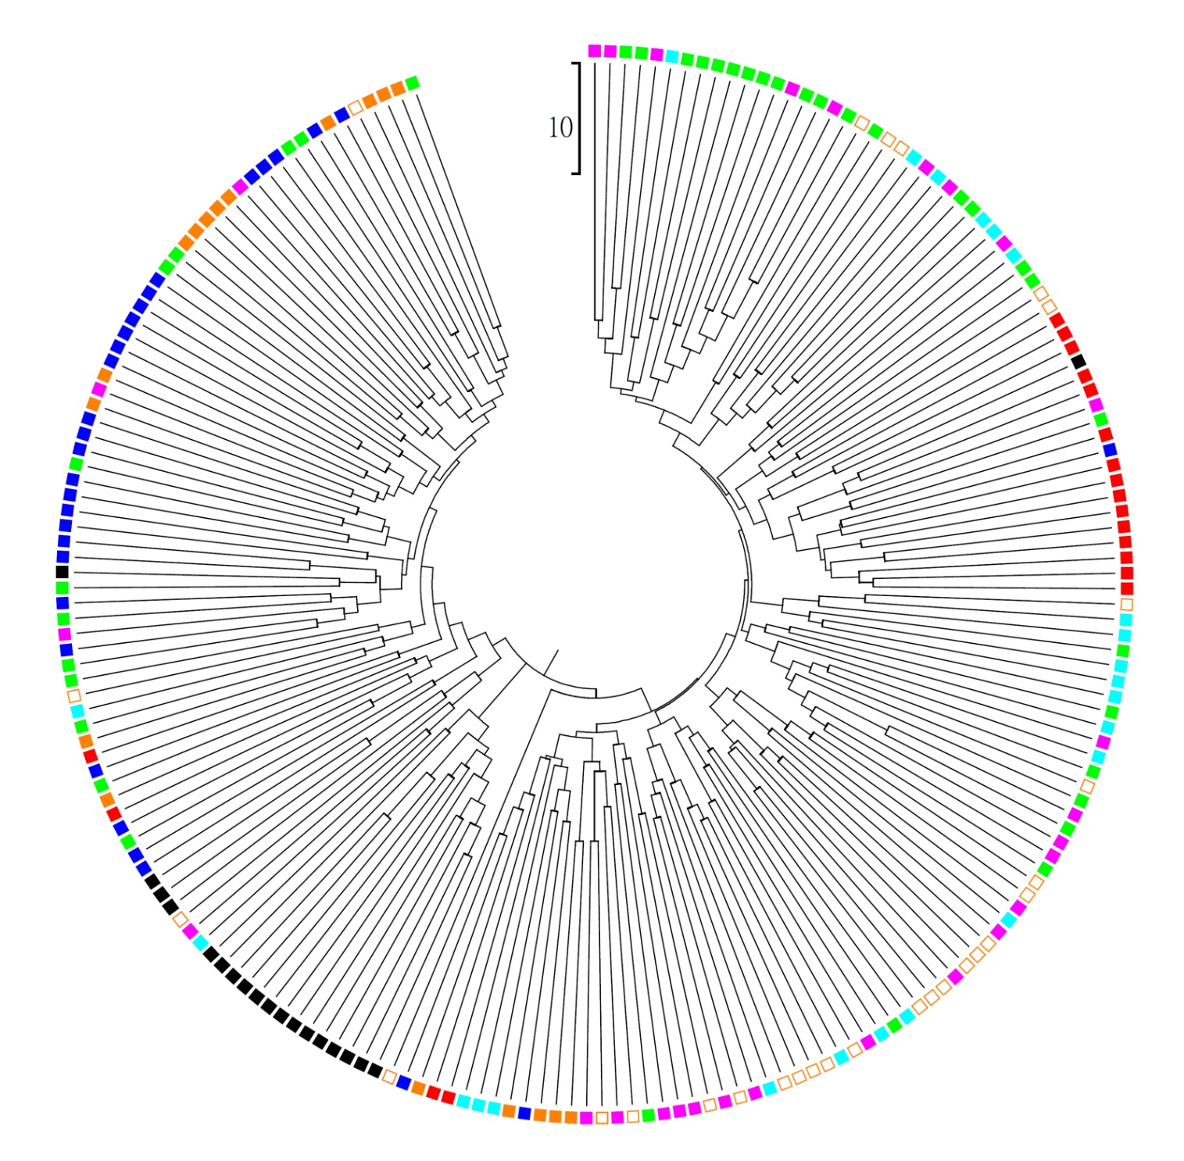**

**Figure S1.** *Cont.*

**(C)**

**E:\實驗室公務\paper submission\kandelia2 population size\Revision\tree file\FIG S1C.tif**

**Figure S1.** Neighbor-Joining tree reconstructed by (**A**) total, (**B**) 99% CI, and (**C**) 95% CI dataset. Sampling sites are indicated with different color.

**Figure S2.** Demographic skylines of (**A**) total populations and (**B**)~(**I**) every single populations of *K. obovata* off the southeastern China estimated by all AFLP loci (221 loci). Dotted lines are the classic skylines; thin and bold lines are the medians and 95% CI of skylines estimated by rjMCMC method.

**C:\Users\user\Desktop\Kandelia_Ne\Figures\Fig.S Ne(221loci).tif**

**Figure S3.** Demographic skylines of (**A**) total populations and (**B**)~(**I**) every single populations of *K. obovata* off the southeastern China estimated by the loci under 99% CI (209 loci). Dotted lines are the classic skylines; thin and bold lines are the medians and 95% CI of skylines estimated by rjMCMC method.

C:\Users\user\Desktop\Kandelia_Ne\Figures\Fig.S Ne(209loci).tif

**Figure S4.** Demographic skylines of (A) total populations and (B)~(I) every single populations of *K. obovata* off the southeastern China estimated by the loci under 95% CI (179 loci). Dotted lines are the classic skylines; thin and bold lines are the medians and 95% CI of skylines estimated by rjMCMC method.

C:\Users\user\Desktop\Kandelia_Ne\Figures\Fig.S Ne(179loci).tif

**Figure S5.** The skyline plots of *Ne* of FD population and the reforested population simulated from 50% (*N* = 15), 33% (*N* = 10), 20% (*N* = 6), and 10% (*N* = 3) *Nc* of FD. The rjMCMC skylines estimated from 20% and 10% *Nc* of FD are not available due to small sample sizes (*N* = 6 and *N* = 3, respectively). Dotted lines are the classic skylines; thin and bold lines are the medians and 95% CI of skylines estimated by rjMCMC method.

C:\Users\user\Desktop\Kandelia_Ne\Figures\Fig.S Ne_FD(sim).tif

**Table S1.** Summary of the current *Ne* of *K. obovata* off the southeastern China with total loci and Loci of 99% CI.

|  |  |  |  |  |  |  |  |  |  |
| --- | --- | --- | --- | --- | --- | --- | --- | --- | --- |
|  | **ALL** | **JW** | **FD** | **ZJ** | **SZ** | **DZG** | **YQ** | **LG1** | **LG2** |
| Total loci |  |  |  |  |  |  |  |  |  |
| Mean | 242041 | 2368 | 14477 | 7057 | 3402 | 14711 | 4562 | 4752 | 5597 |
| Median | 203055 | 1987 | 11215 | 5383 | 2789 | 12273 | 3911 | 4136 | 4200 |
| 95% CI | 67374 - 639574 | 807 - 6259 | 3424 - 44987 | 1598 - 20106 | 1050 - 9385 | 3032 - 41120 | 1177 - 12120 | 1247 - 12087 | 1575 - 17648 |
| Loci of 99% CI |  |  |  |  |  |  |  |  |  |
| Mean | 228581 | 2593 | 13424 | 6265 | 3243 | 15004 | 4898 | 4480 | 7710 |
| Median | 170143 | 2248 | 11110 | 5325 | 2735 | 12315 | 4024 | 3966 | 6578 |
| 95% CI | 74728 - 721385 | 798 - 6527 | 3728 - 35247 | 1305 - 16627 | 847 - 8273 | 3116 - 42348 | 1224 - 12784 | 812 - 11535 | 2254 - 19838 |