Supplementary Materials: Cytoglobosins H
and I, New Antiproliferative Cytochalasans from Deep-Sea-Derived Fungus Chaetomium globosum
Zhihan Zhang, Xitian Min, Junjun Huang, Yue Zhong, Yuehua Wu, Xiaoxia Li, Yinyue Deng, Zide Jiang, Zongze Shao, Lianhui Zhang and Fei He
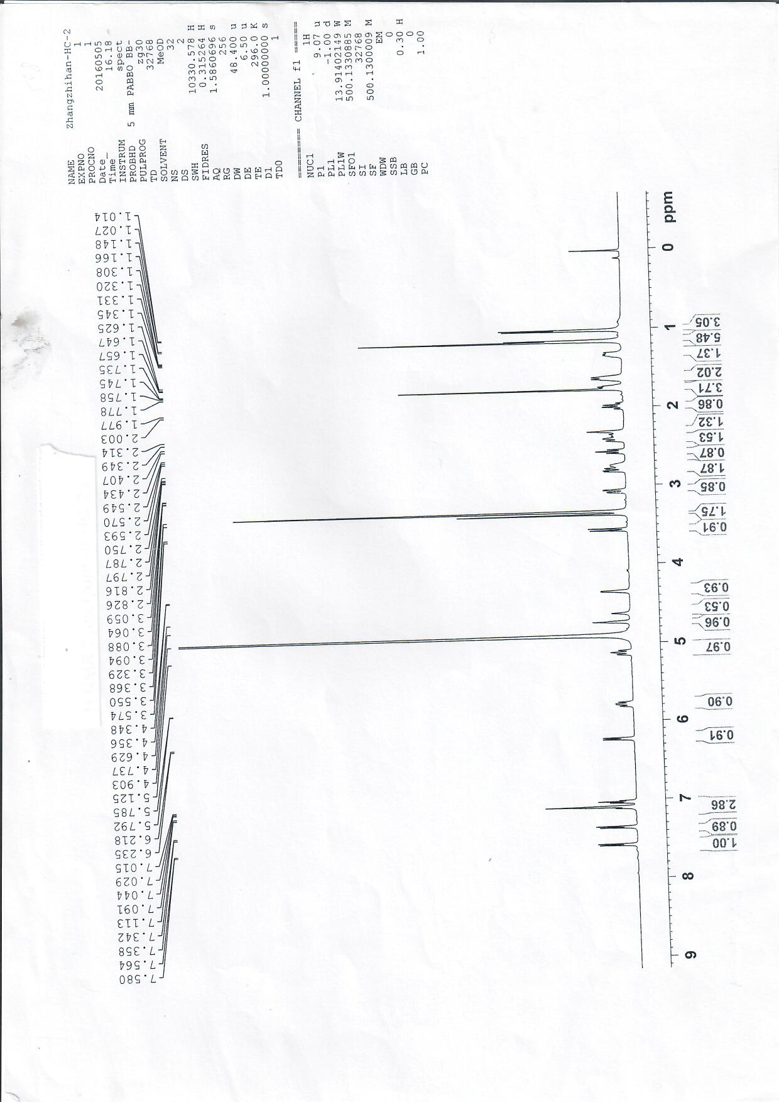
Figure 1. ¹H NMR spectrum of cytoglobosins H (1).
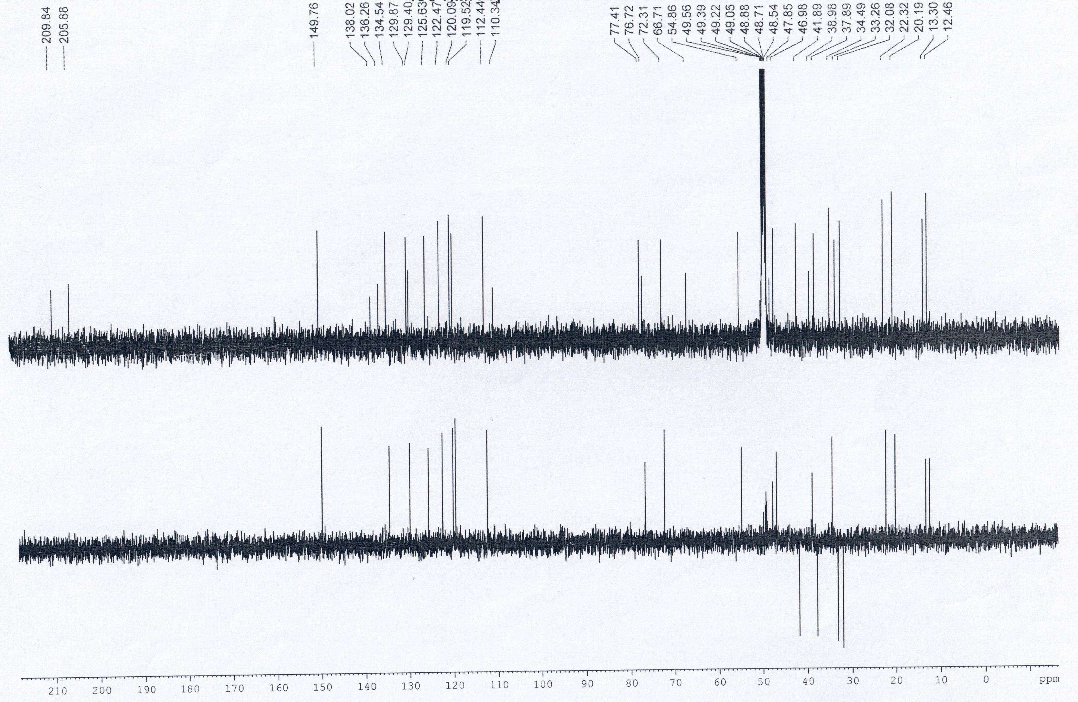
Figure 2. ¹³C NMR spectrum of cytoglobosins H (1).
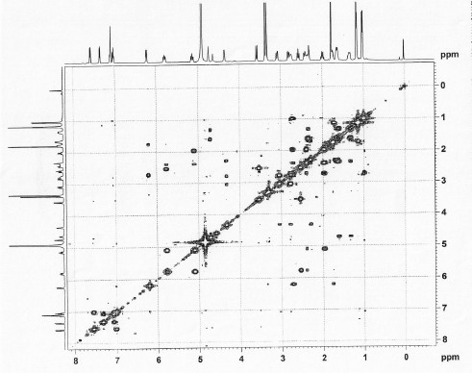
Figure S3. COSY spectrum of cytoglobosins H (1).
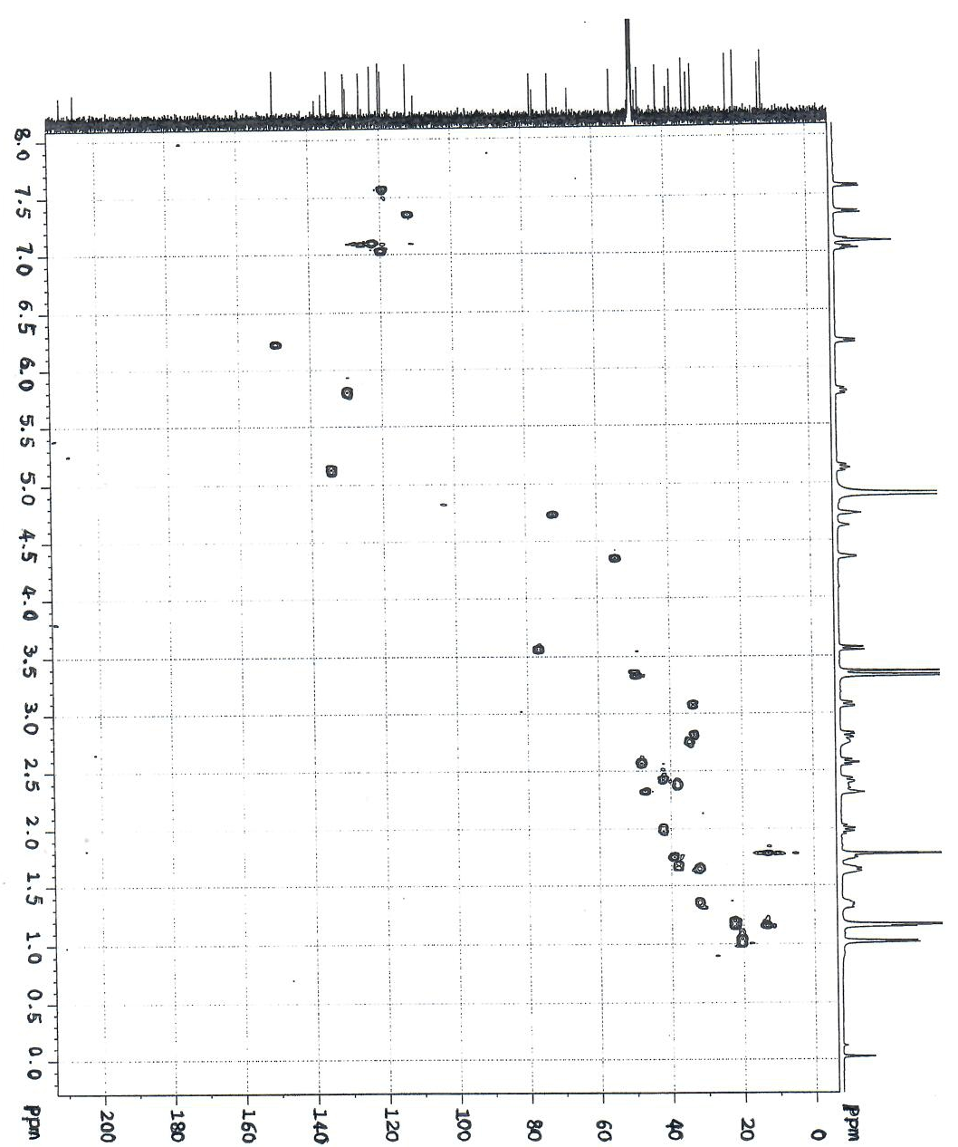
Figure S4. HSQC spectrum of cytoglobosins H (1)
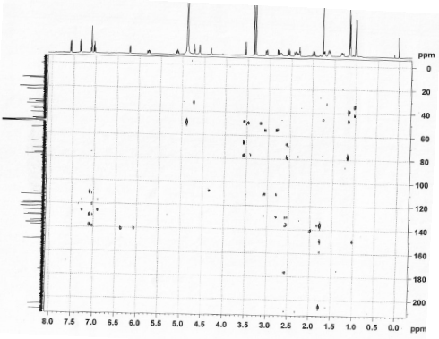
Figure S5. HMBC spectrum of cytoglobosins H (1)
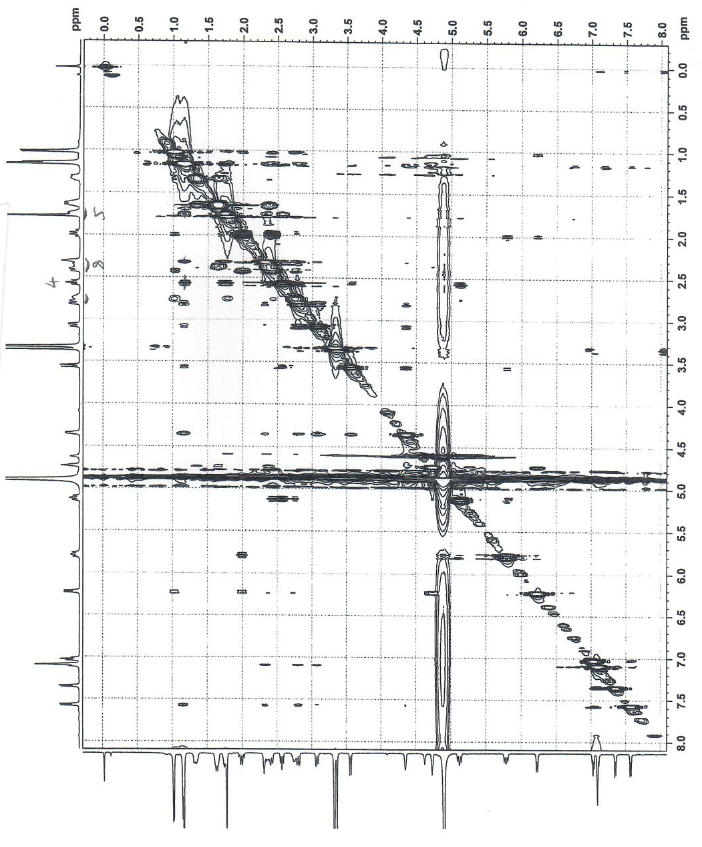
Figure S6. ROESY spectrum of cytoglobosins H (1).
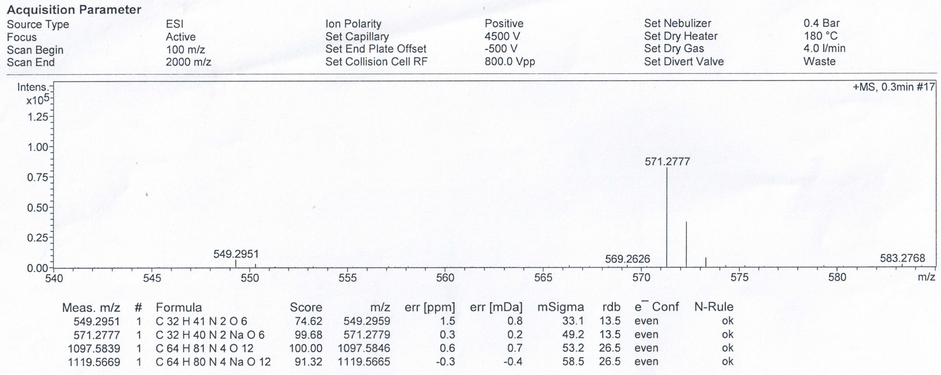
Figure S7. HRESIMS spectrum of cytoglobosins H (1).
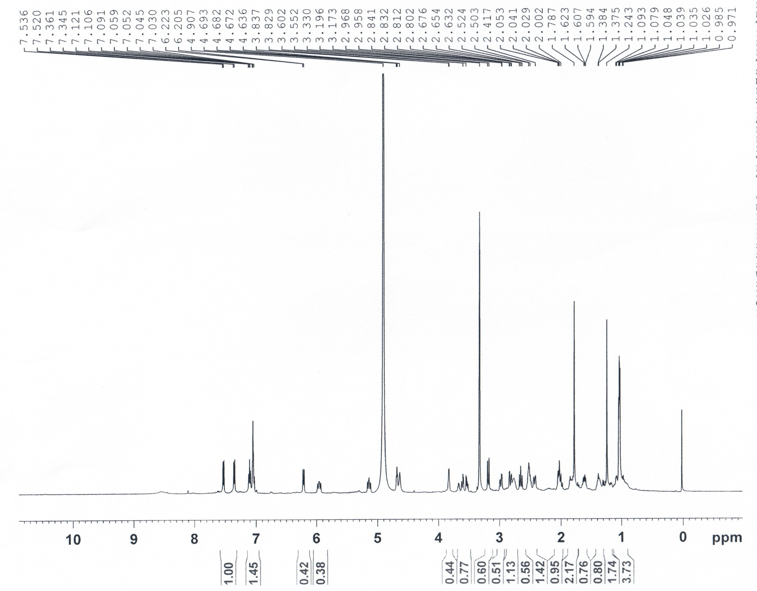
Figure S8. ¹H NMR spectrum of cytoglobosins I (2).
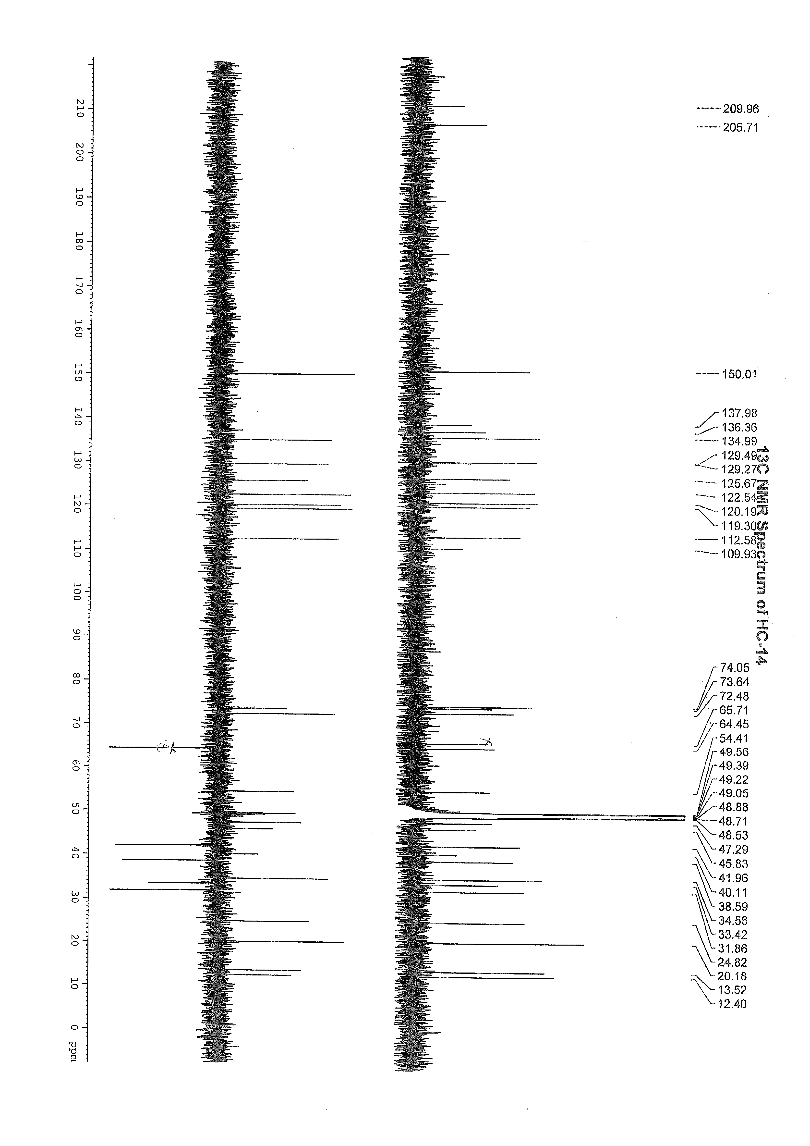
Figure S9. ¹³C NMR spectrum of cytoglobosins I (2).
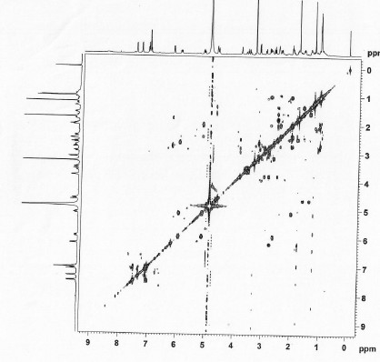
Figure S10. COSY spectrum of cytoglobosins I (2).
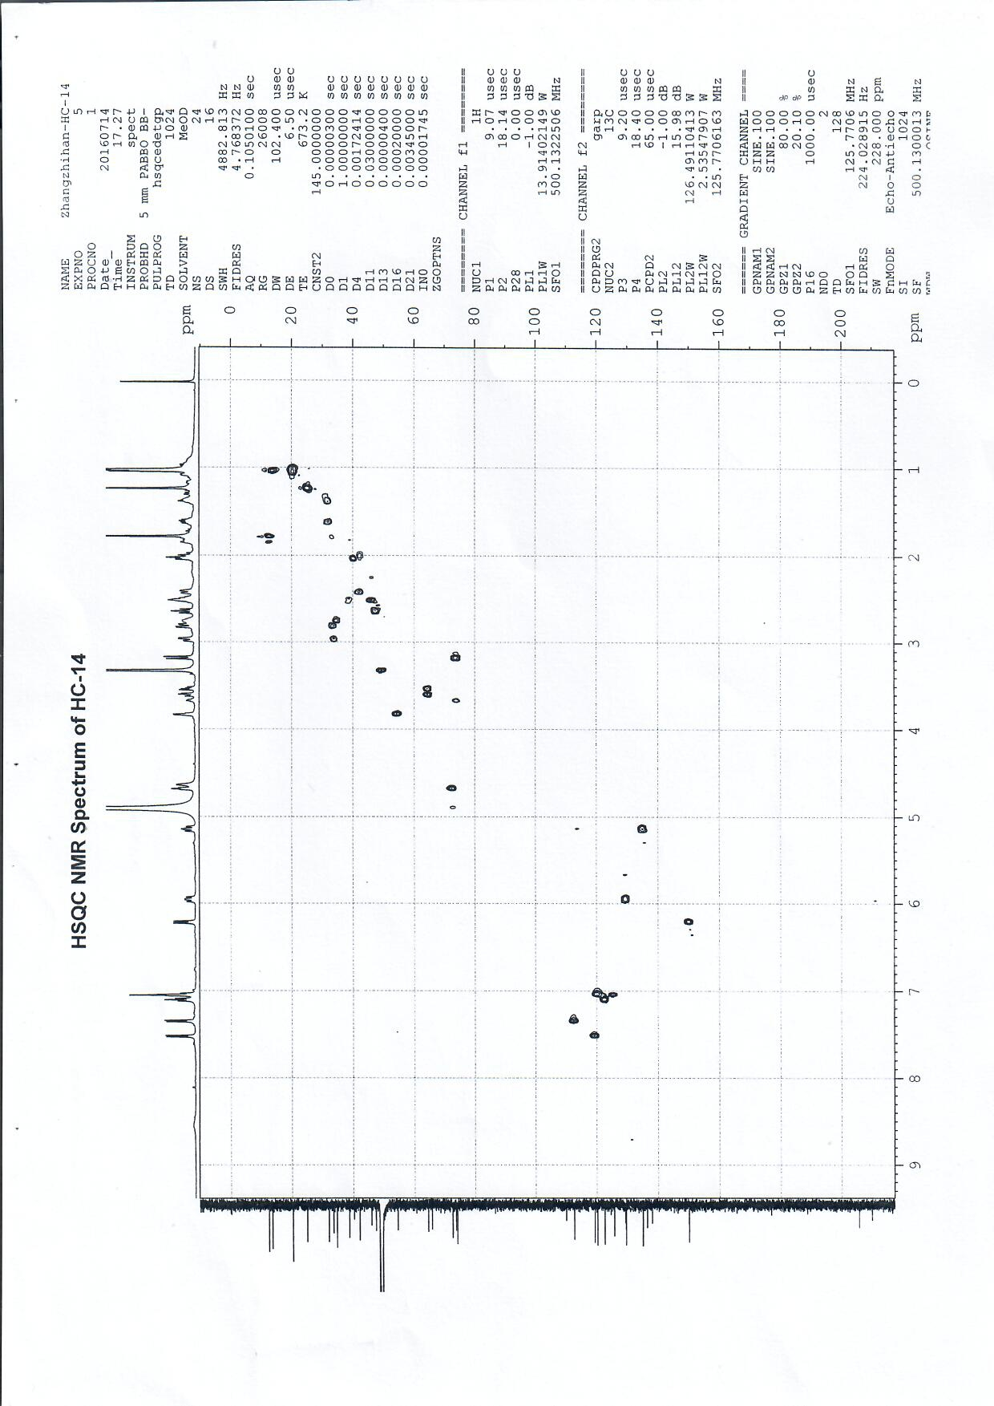
Figure S11. HSQC spectrum of cytoglobosins I (2).
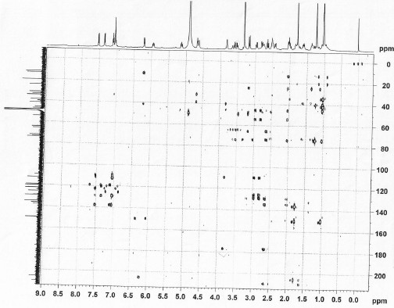
Figure S12. HMBC spectrum of cytoglobosins I (2).

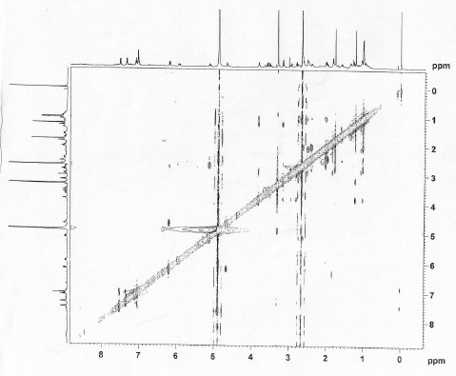
Figure S13. ROESY spectrum of cytoglobosins I (2).
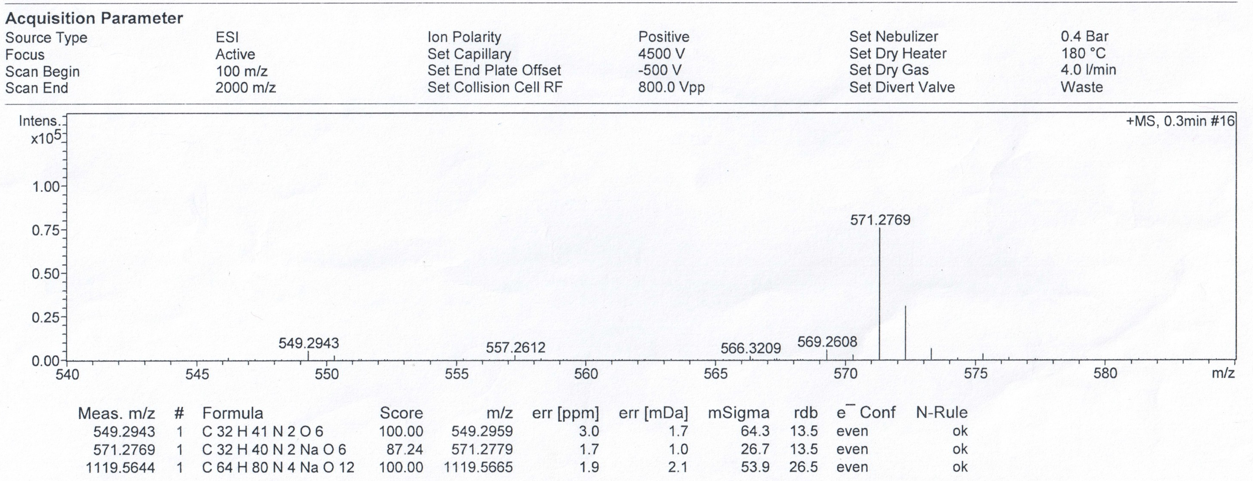
Figure S14. HRESIMS spectrum of cytoglobosins I (2).
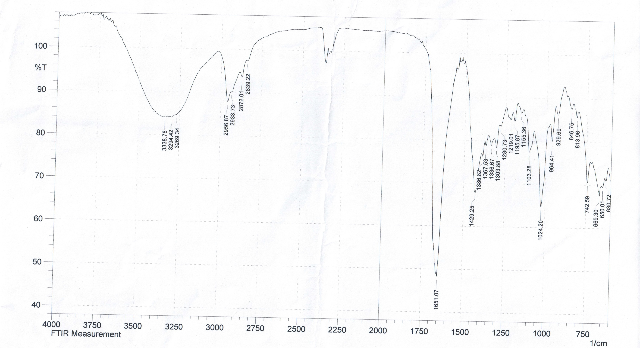
Figure S15. IR spectrum of cytoglobosins H (1).
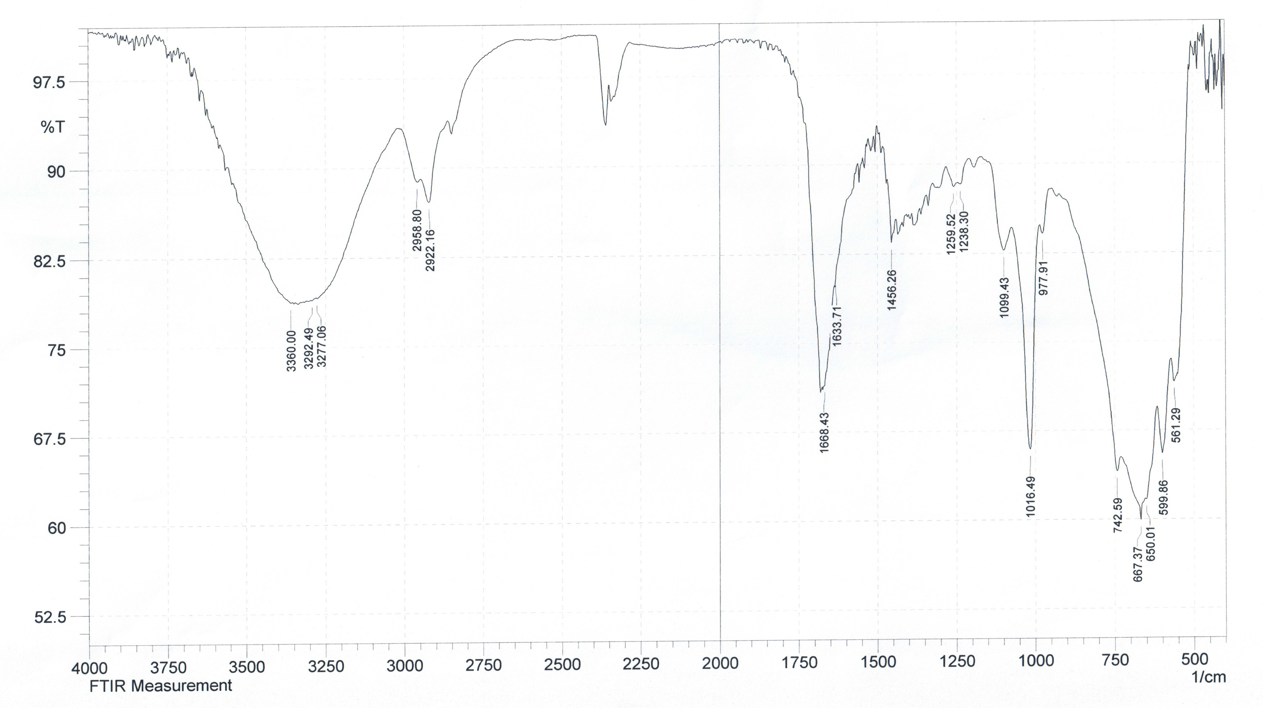
Figure S16. IR spectrum of cytoglobosins I (2).
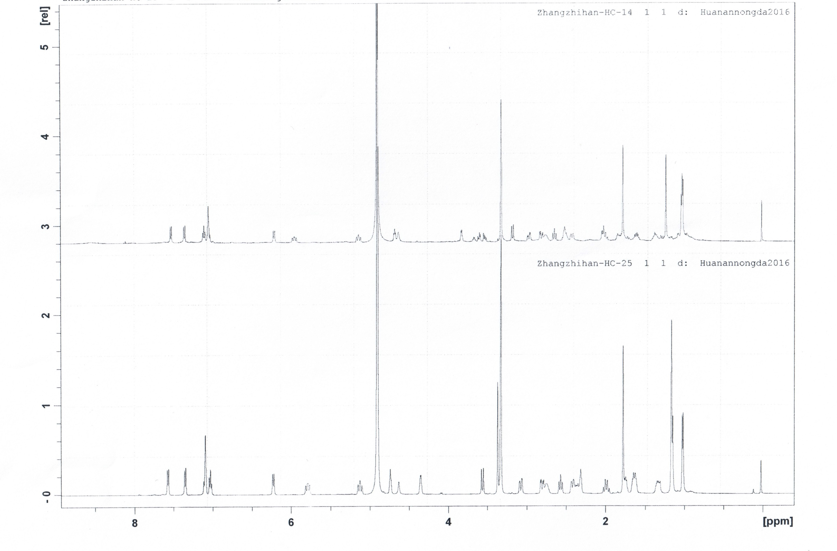
Compound 1
Compound 2
Figure S17. Comparison of ¹H spectra between 1 and 2.

