SupplementaryMaterials: Two New Diphenylketones and a New Xanthone from Talaromyces islandicus EN-501, an Endophytic Fungus Derived from the Marine Red Alga Laurencia okamurai
Hong-Lei Li, Xiao-Ming Li, Hui Liu, Ling-Hong Meng and Bin-Gui Wang
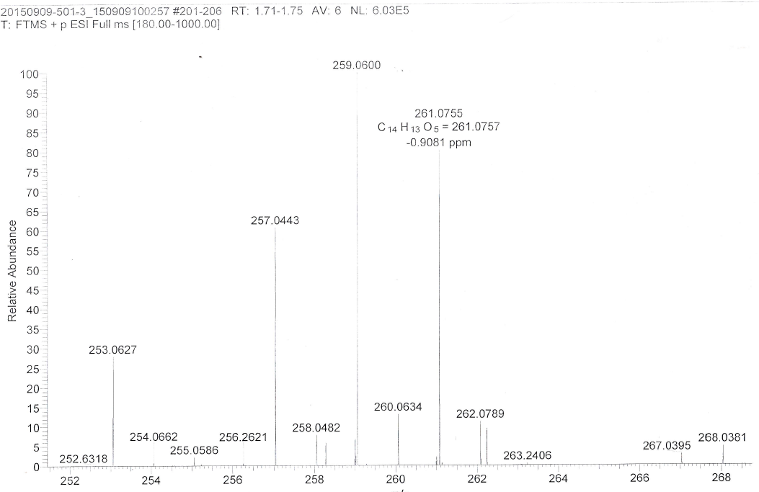
Figure S1. HRESIMS spectrum of compound 1.
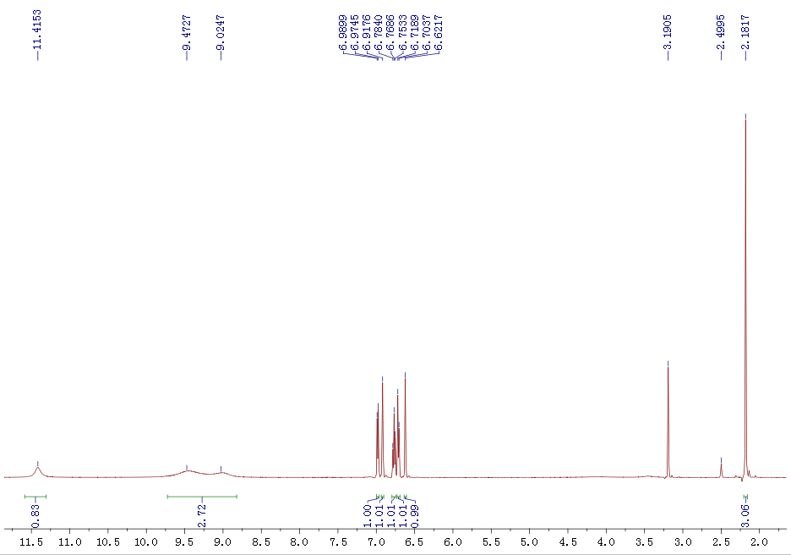
Figure S2.¹H NMR (500 MHz, DMSO-d₆) of compound 1.
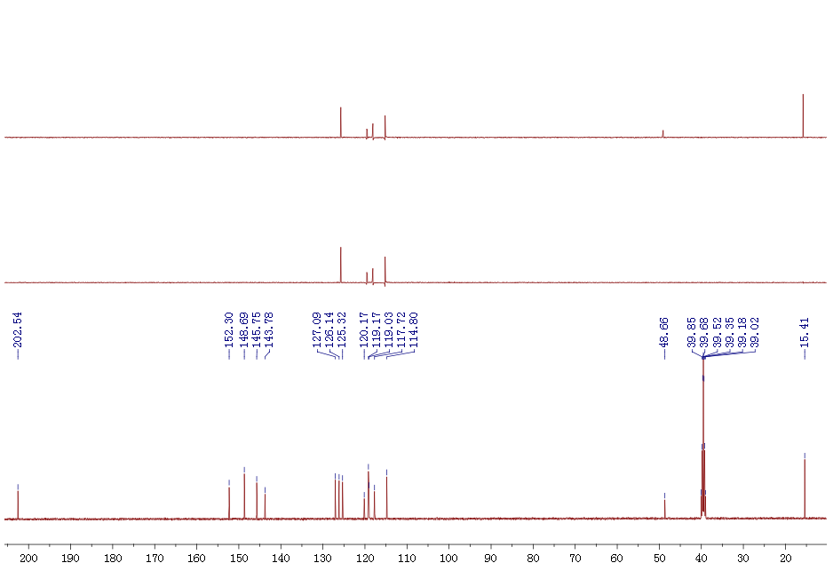
Figure S3.¹³C NMR and DEPT (125 MHz, DMSO-d₆) of compound 1.
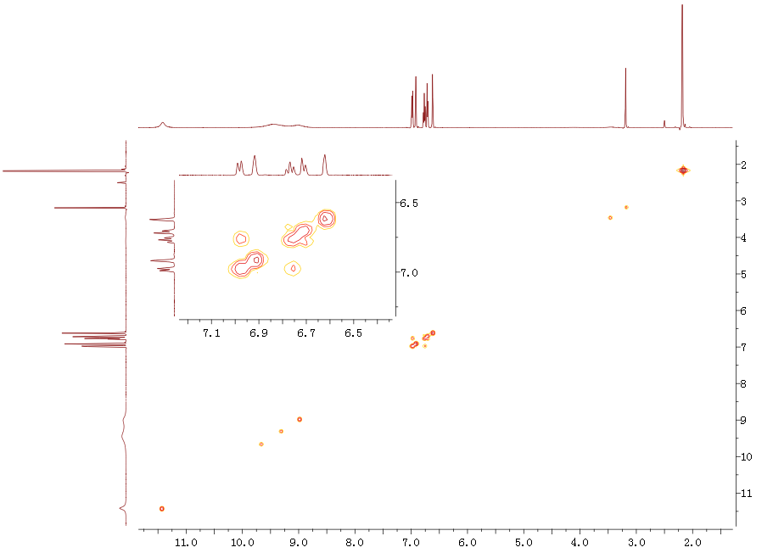
Figure S4. COSY spectrum of compound 1.
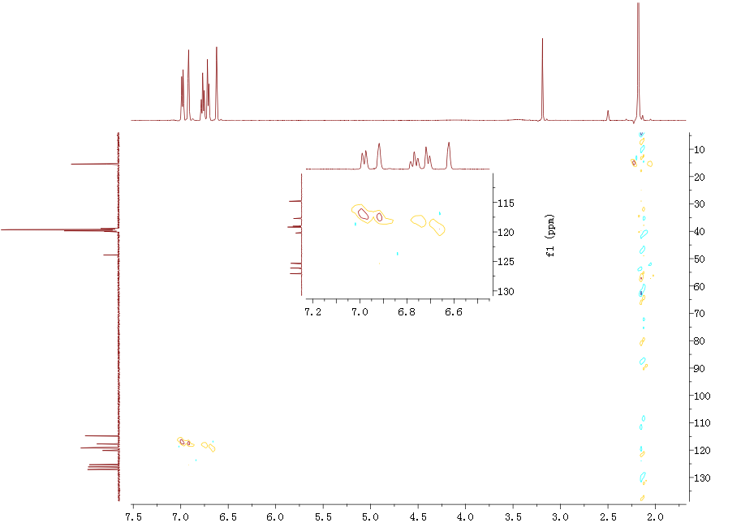
Figure S5. HSQC spectrum of compound 1.
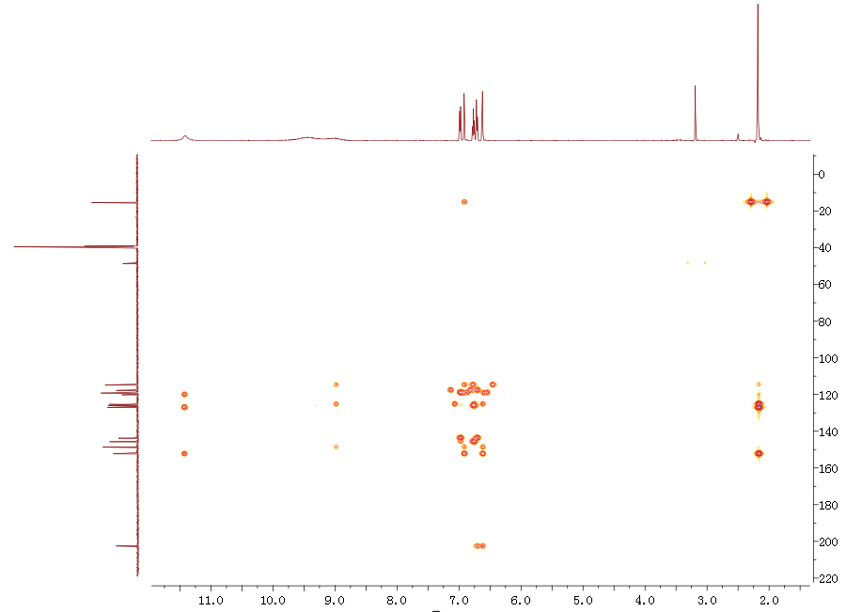
Figure S6. HMBC spectrum of compound 1.
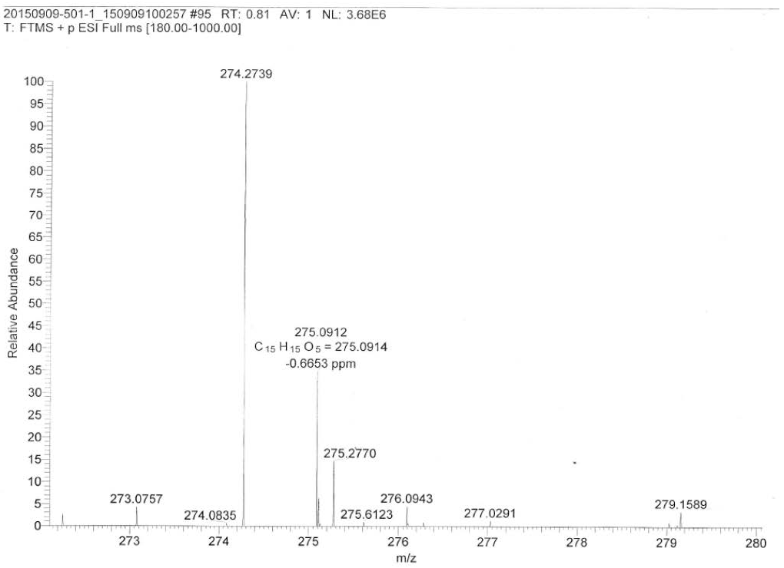
Figure S7. HRESIMS spectrum of compound 2.
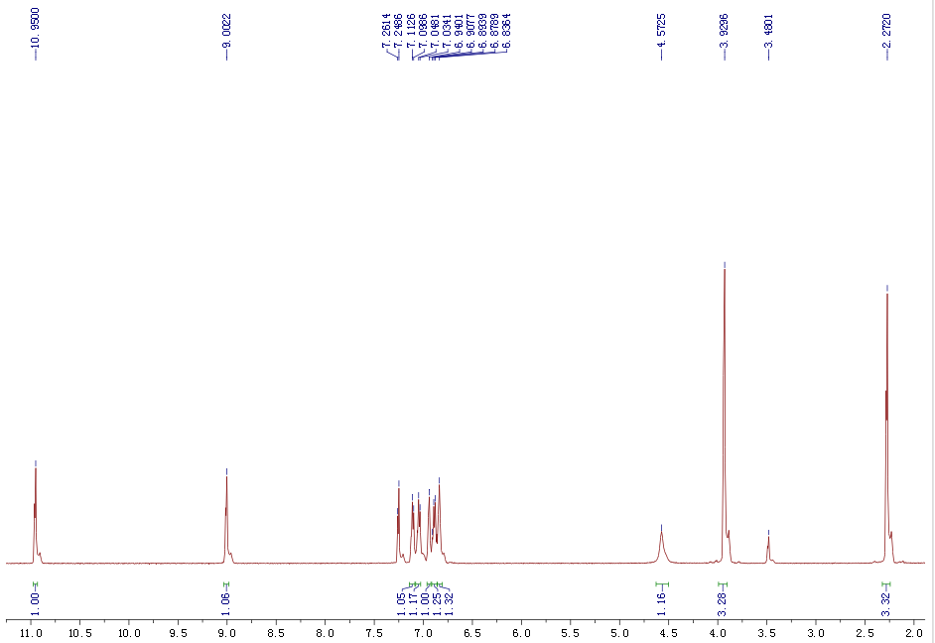
Figure S8.¹H NMR (500 MHz, CDCl₃) of compound 2.
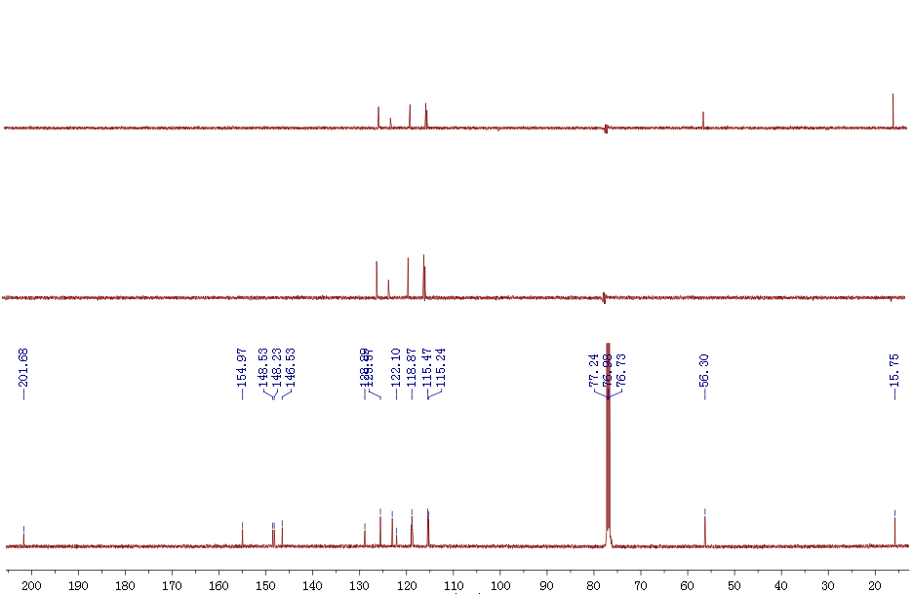
Figure S9.¹³C NMR and DEPT (125 MHz, CDCl₃) of compound 2.
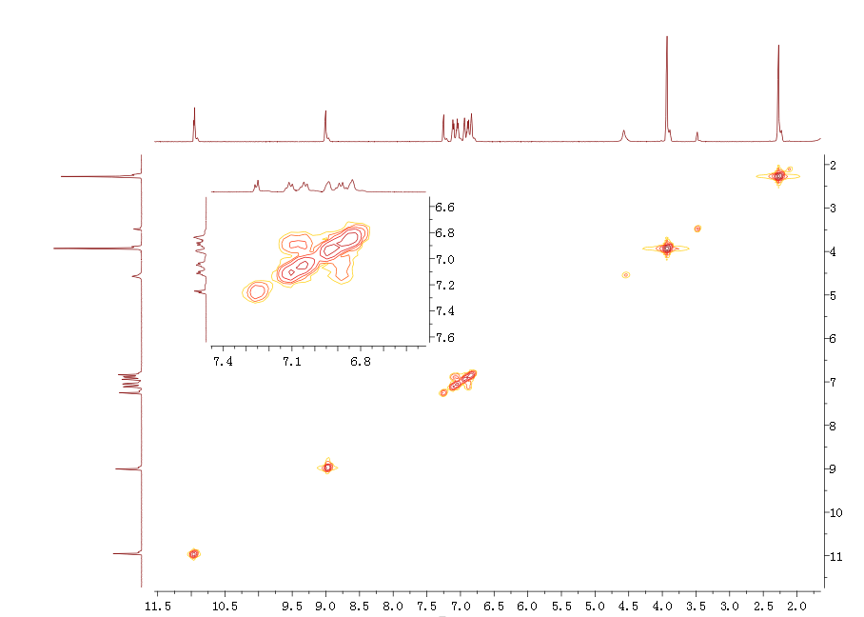
Figure S10. COSY spectrum of compound 2.
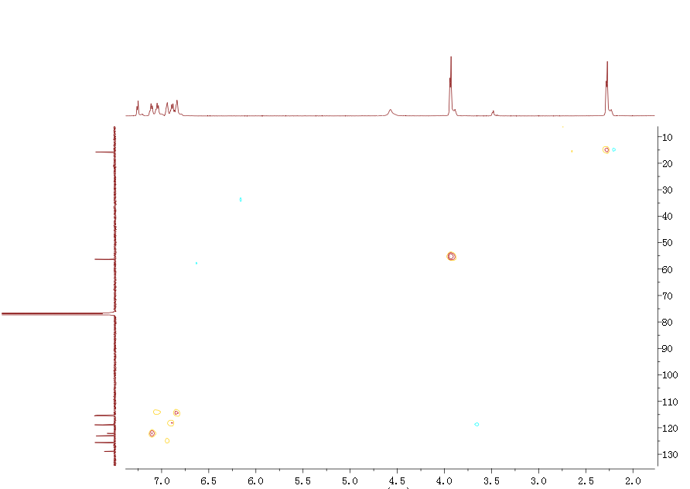
Figure S11. HSQC spectrum of compound 2.
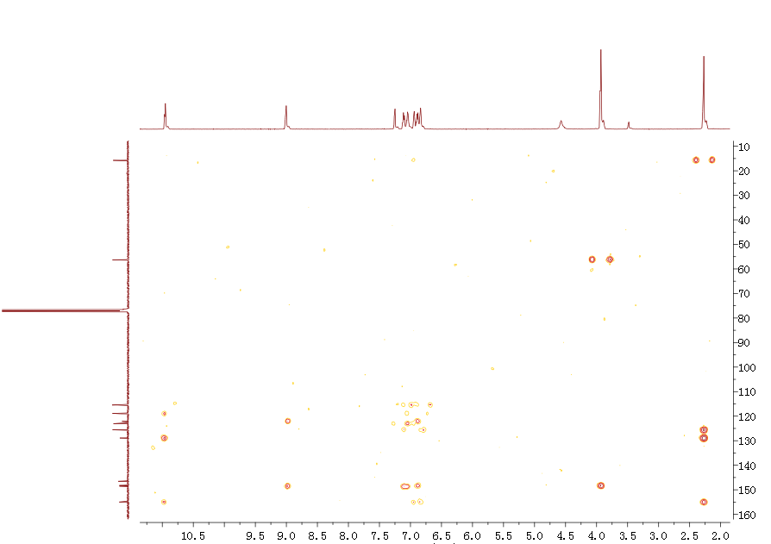
Figure S12. HMBC spectrum of compound 2.
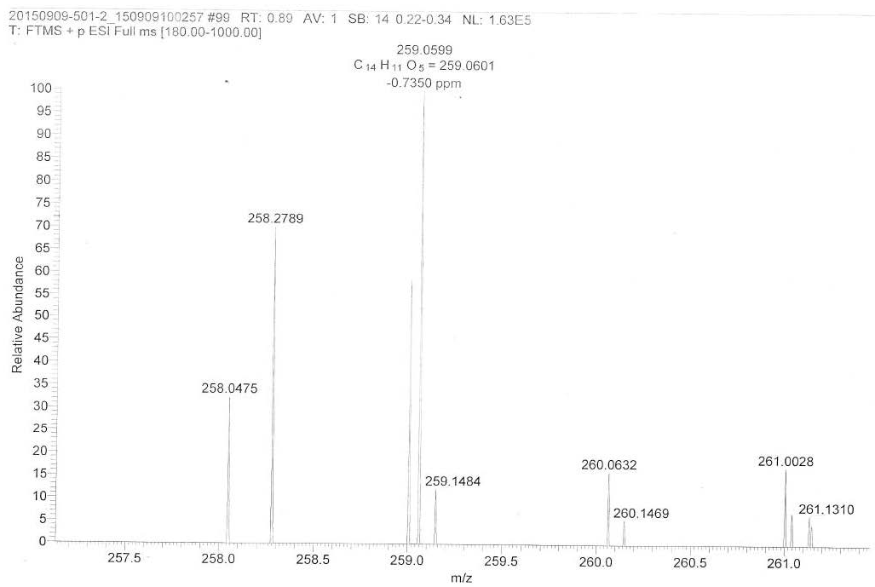
Figure S13. HRESIMS spectrum of compound 3.
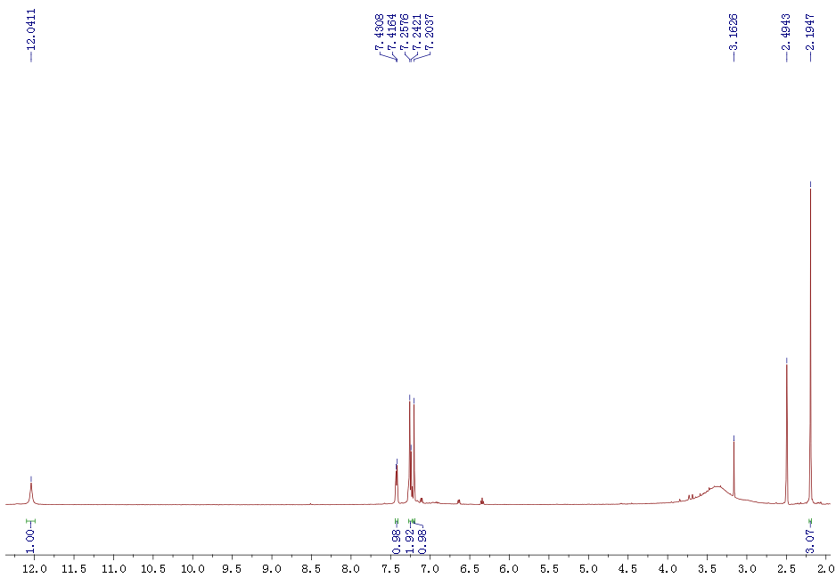
Figure S14.¹H NMR (500 MHz, DMSO-d₆) of compound 3.
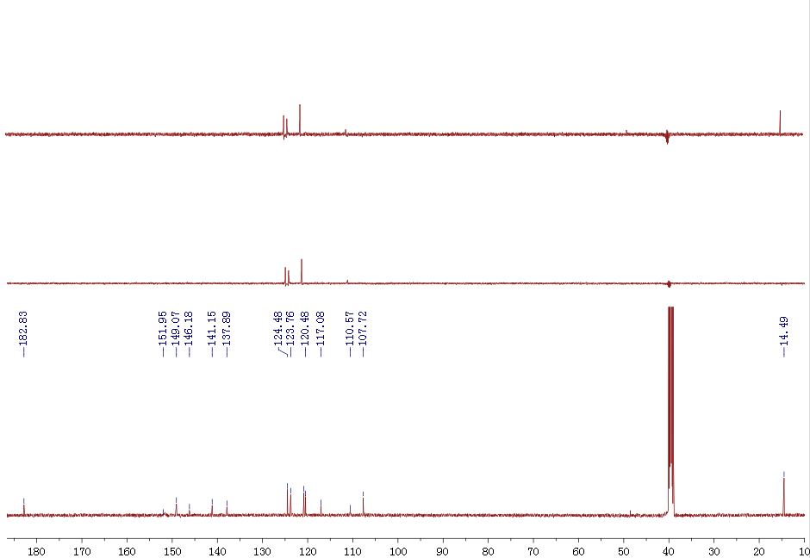
Figure S15.¹³C NMR and DEPT (125 MHz, DMSO-d₆) of compound 3.
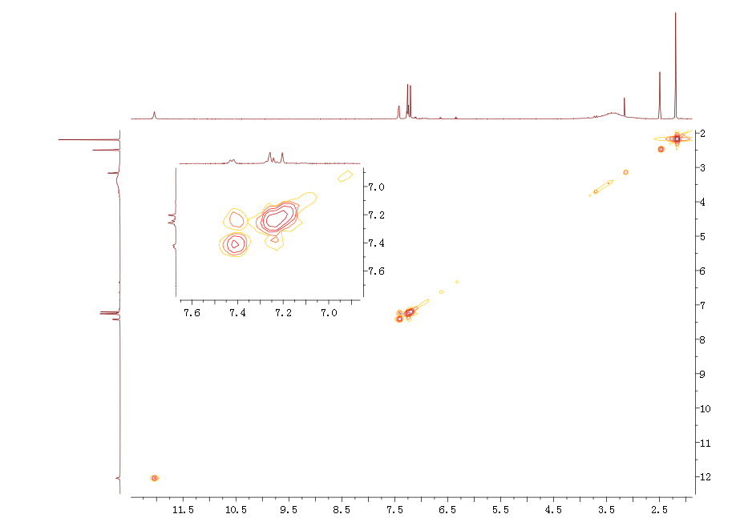
Figure S16. COSY spectrum of compound 3.
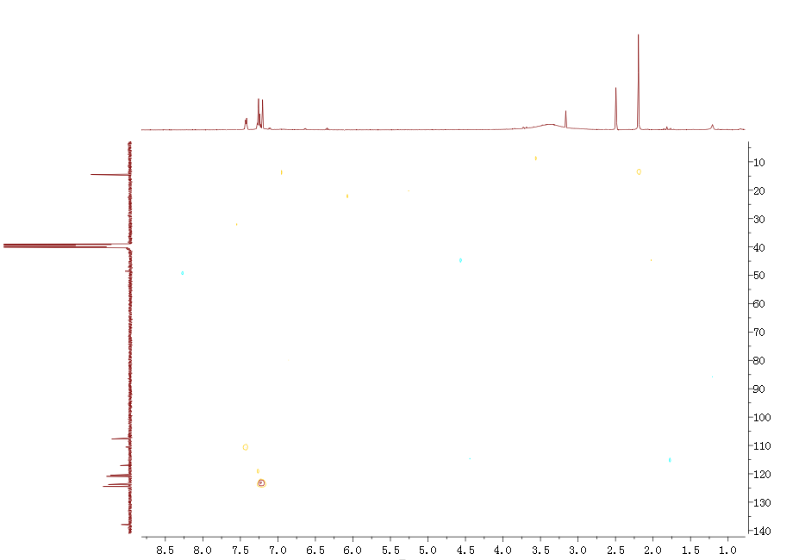
Figure S17. HSQC spectrum of compound 3.
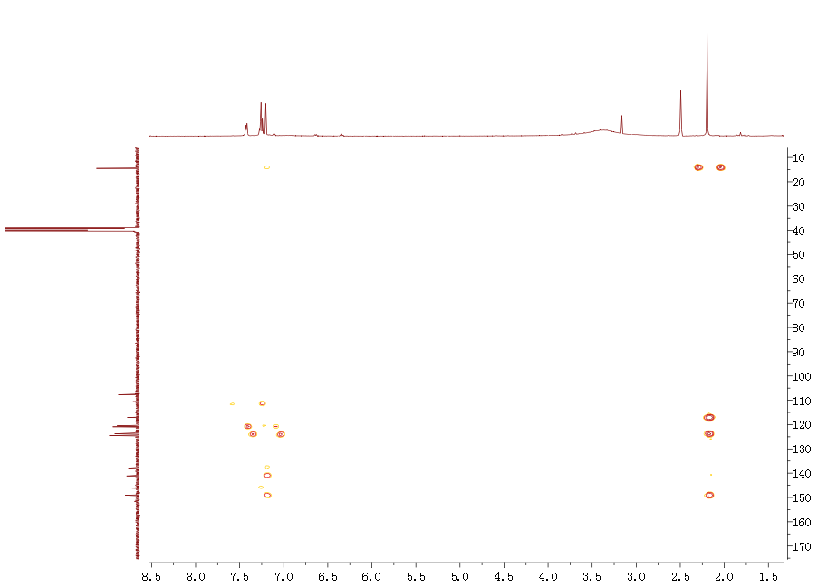
Figure S18. HMBC spectrum of compound 3.
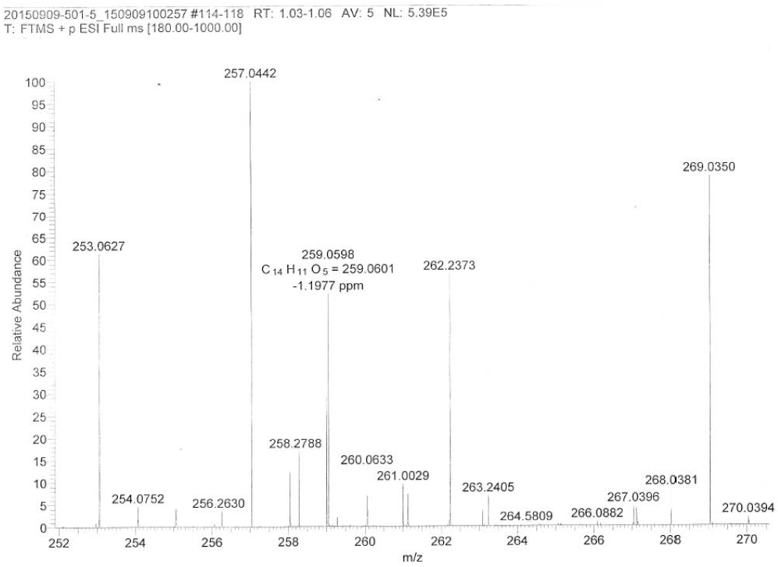
Figure S19. HRESIMS spectrum of compound 4.
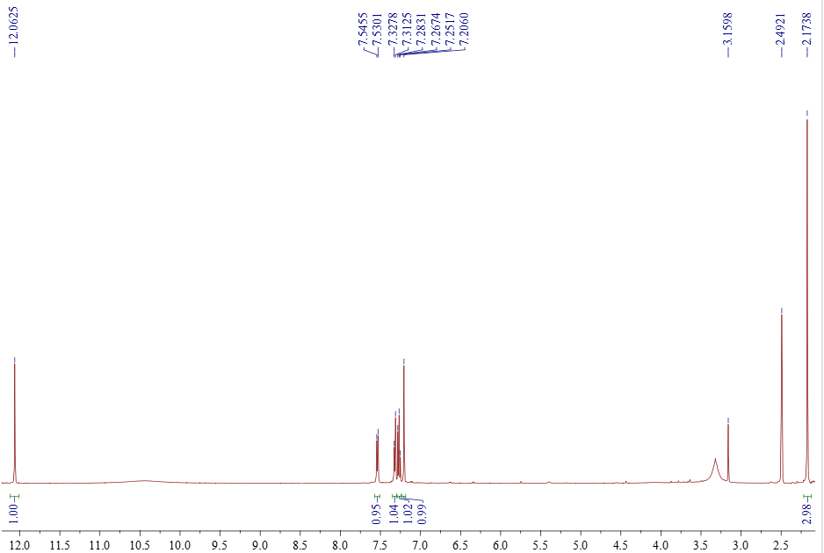
Figure S20.¹H NMR (500 MHz, DMSO-d₆) of compound 4.
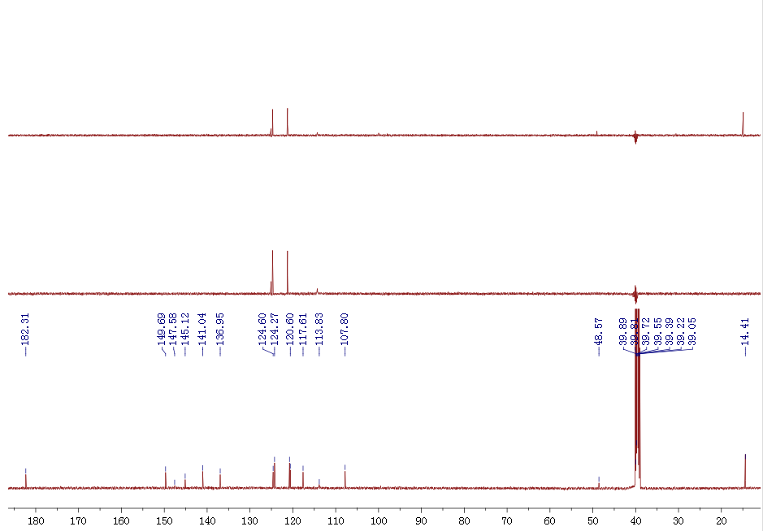
Figure S21.¹³C NMR and DEPT (125 MHz, DMSO-d₆) of compound 4.
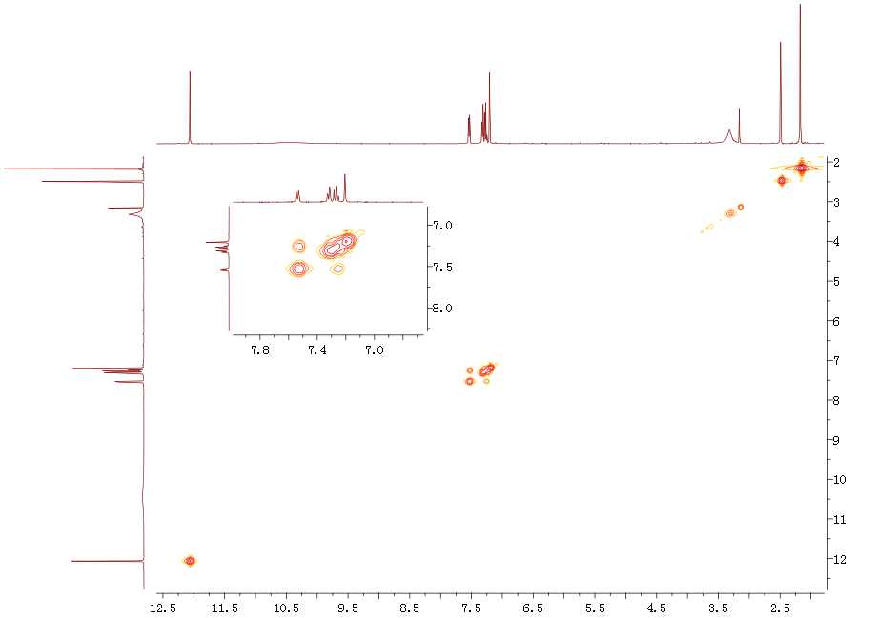
Figure S22. COSY spectrum of compound 4.
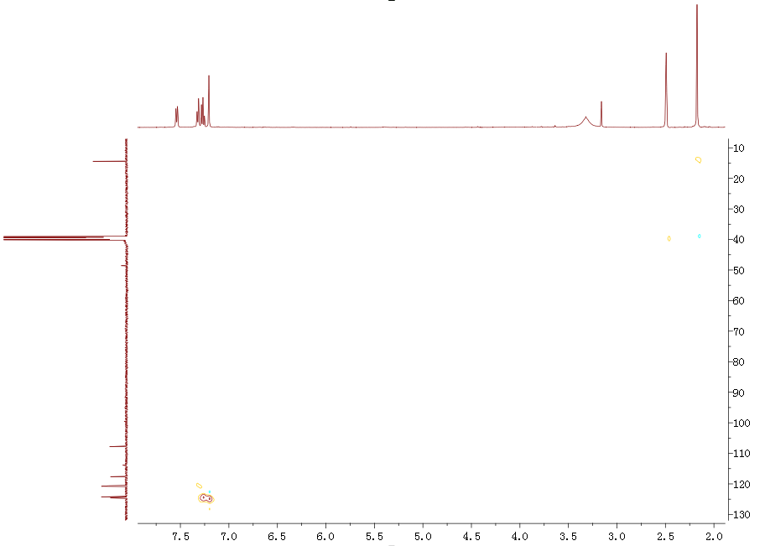
Figure S23. HSQC spectrum of compound 4.
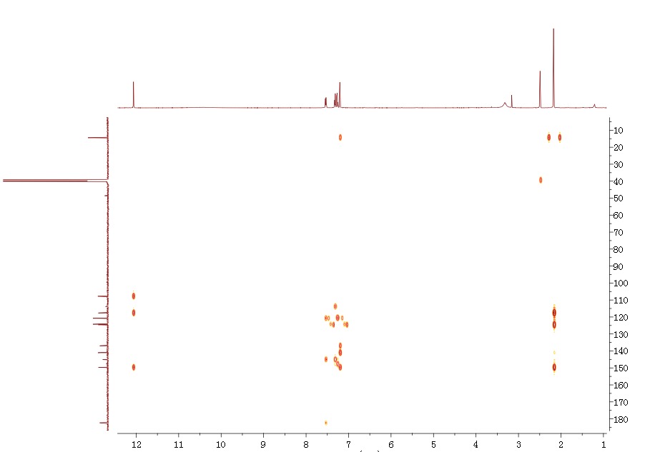
Figure S24. HMBC spectrum of compound 4.

