Supplementary Materials

General Experimental Procedures
Unless otherwise specified, ¹H and ¹³C NMR spectra were recorded at 30 °C in DMSO-d6 on Varian INOVA 500 or 600 MHz NMR spectrometers. The latter spectrometer was equipped with a triple resonance cold probe. The ¹H and ¹³C NMR chemical shifts were referenced to the solvent peak for DMSO-d6 at δ_{H} 2.50 and δ_{C} 39.5.
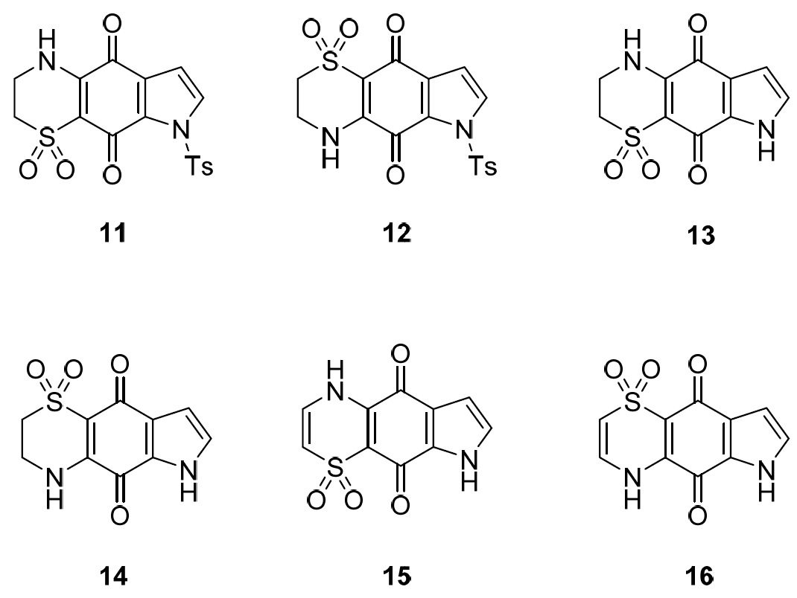
Chart 1. Structure of compounds 11–16.

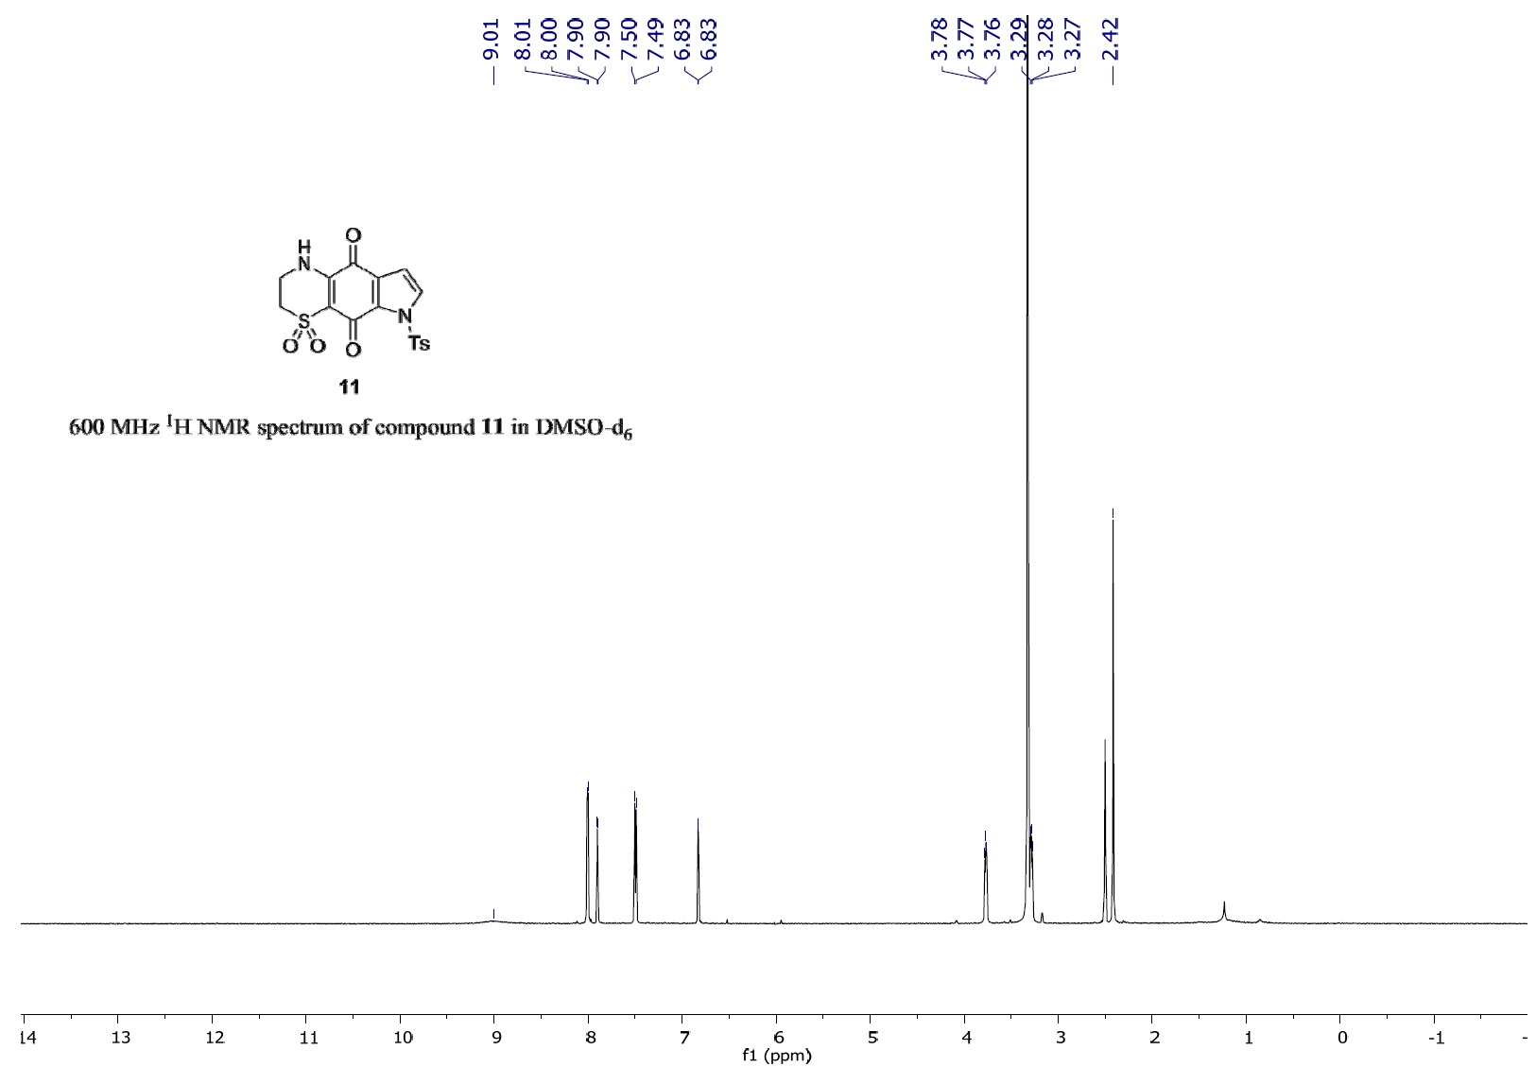
Figure S1. 600 MHz ¹H NMR spectrum of compound 11 in DMSO-d6.
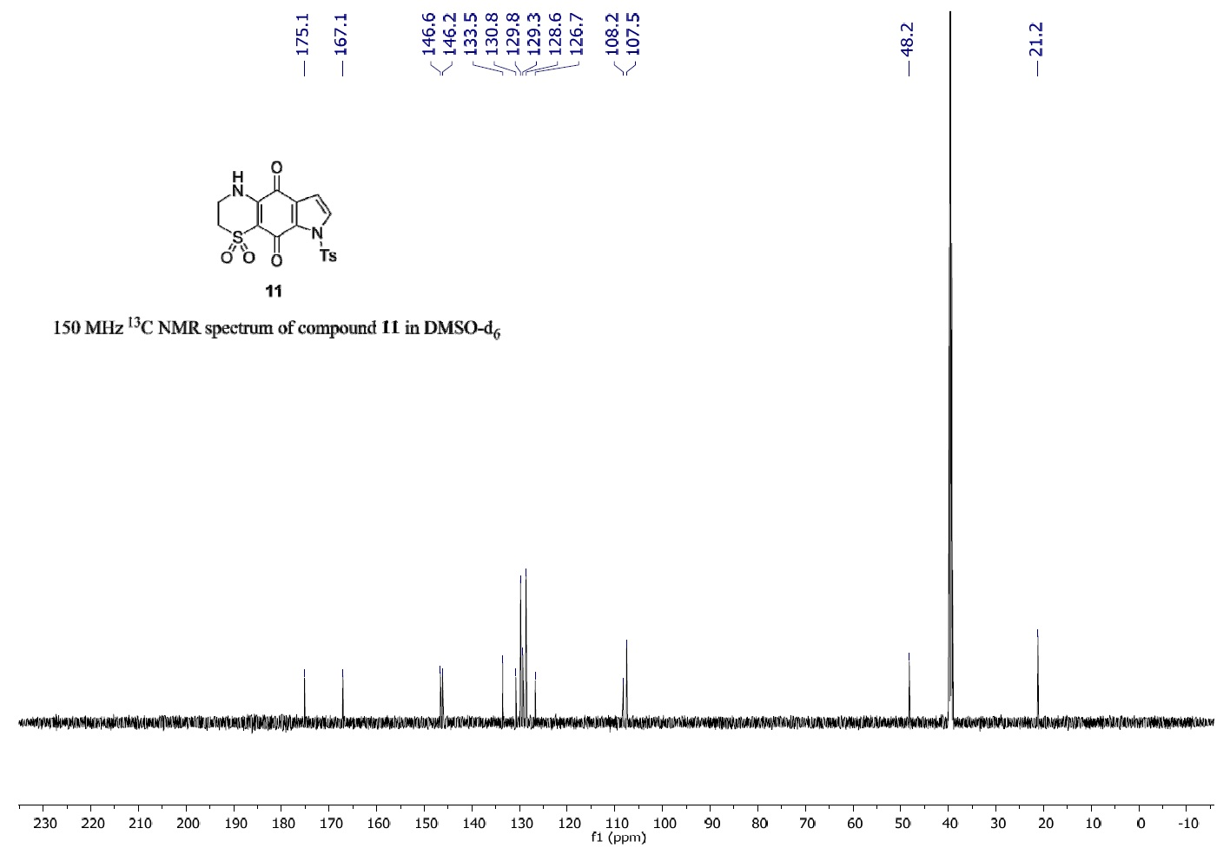
Figure S2. 150 MHz ¹³C NMR spectrum of compound 11 in DMSO-d6.
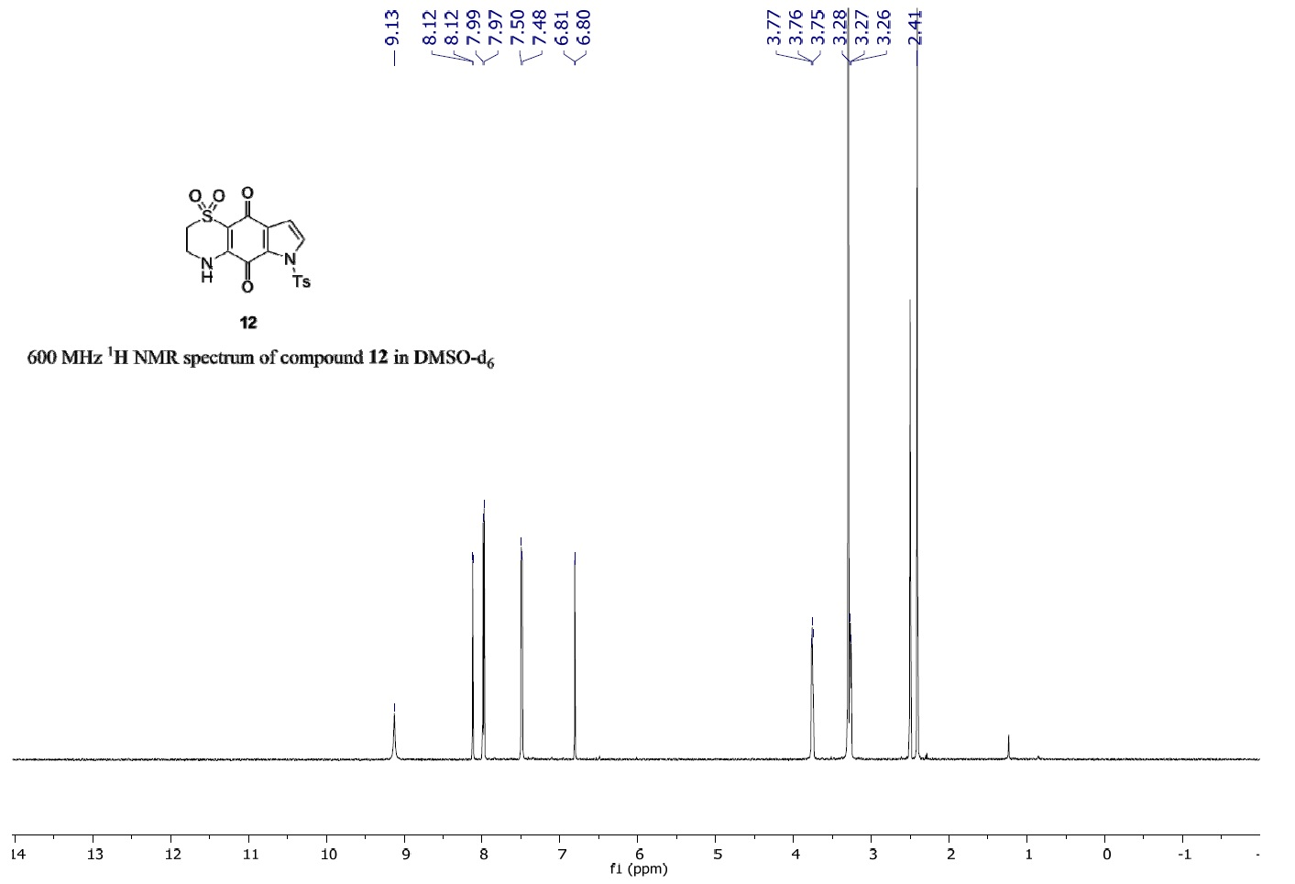
Figure S3. 600 MHz ¹H NMR spectrum of compound 12 in DMSO-d6.
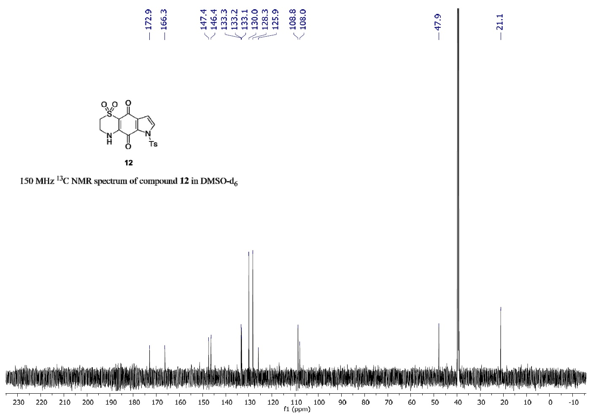
Figure S4. 150 MHz ¹³C NMR spectrum of compound 12 in DMSO-d6.
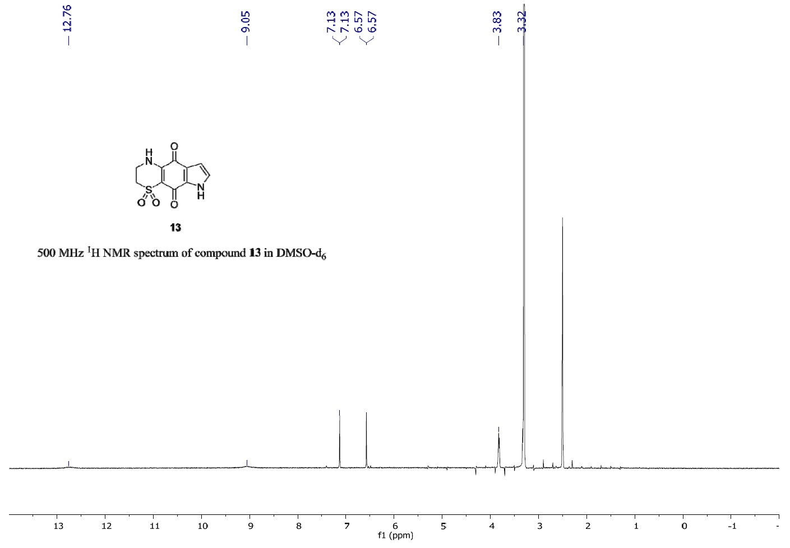
Figure S5. 500 MHz ¹H NMR spectrum of compound 13 in DMSO-d6.
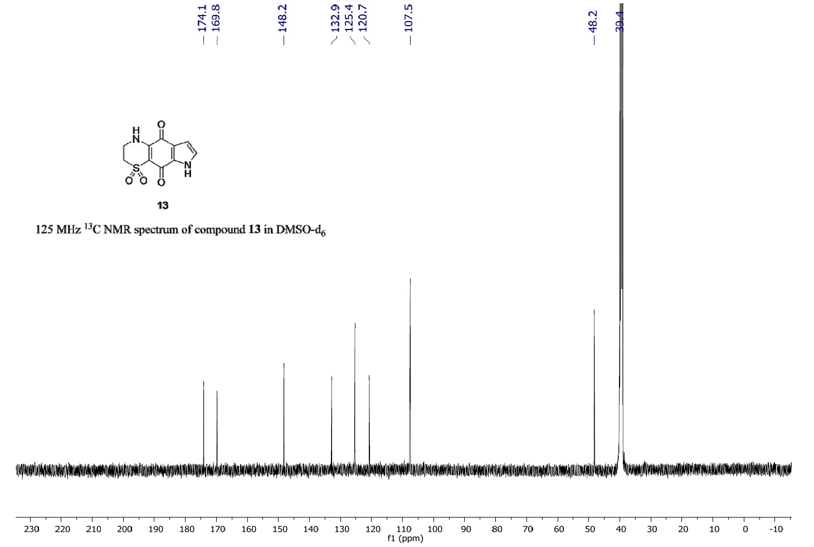
Figure S6. 125 MHz ¹³C NMR spectrum of compound 13 in DMSO-d6.
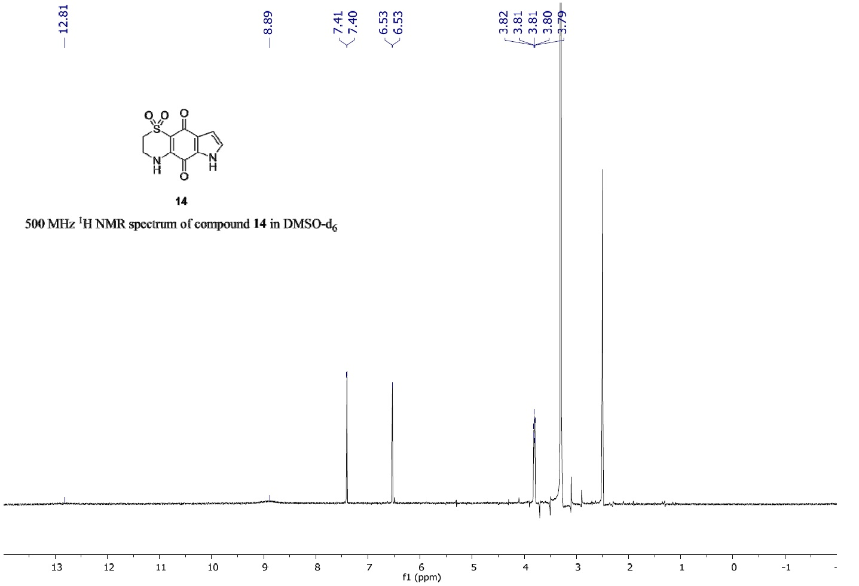
Figure S7. 500 MHz ¹H NMR spectrum of compound 14 in DMSO-d6.
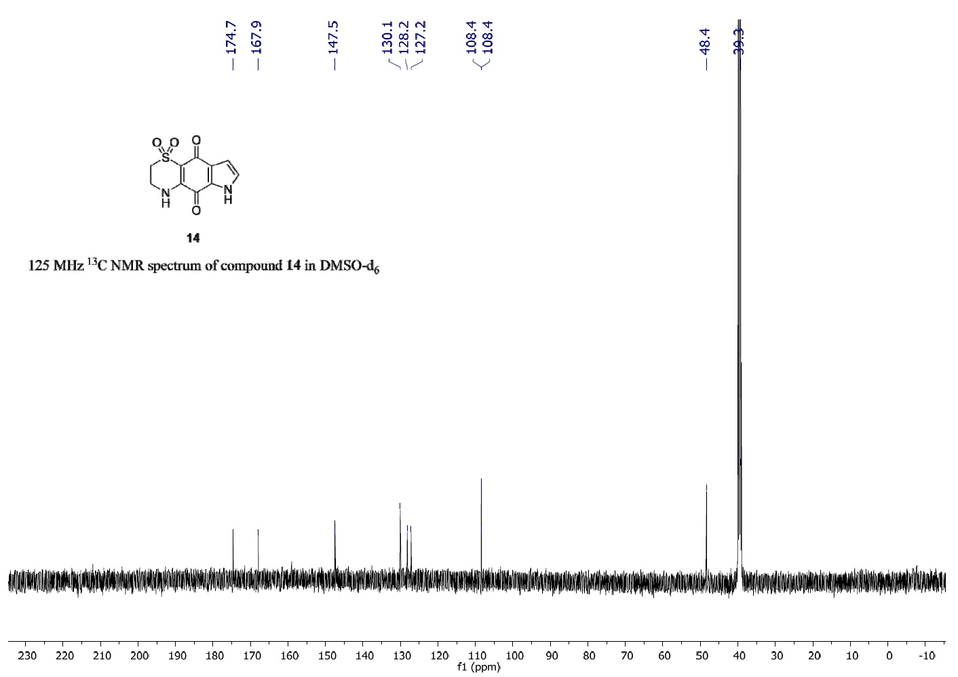
Figure S8. 125 MHz ¹³C NMR spectrum of compound 14 in DMSO-d6.
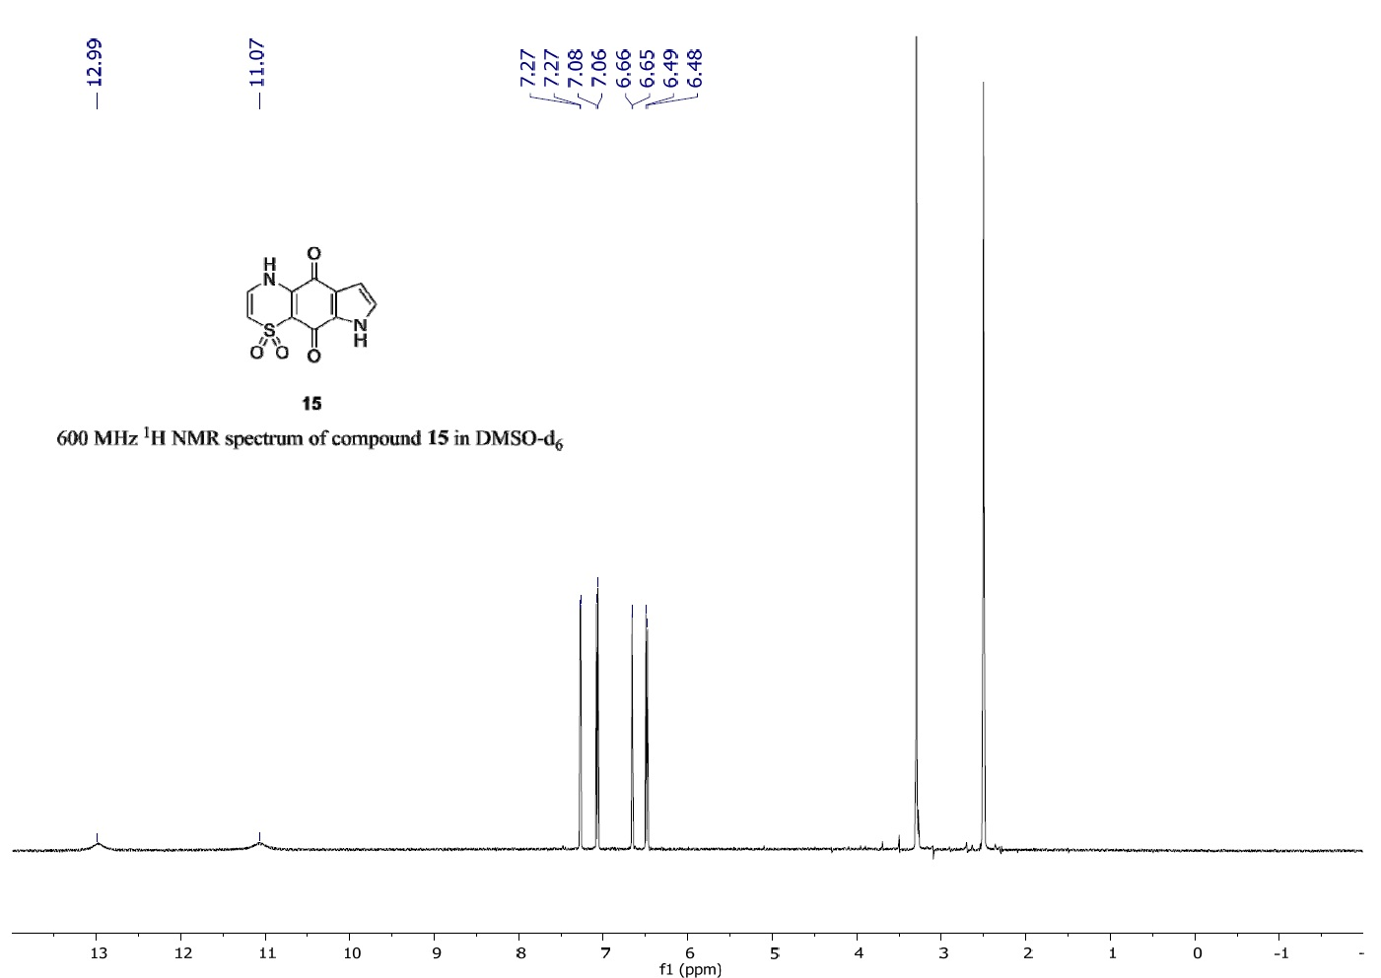
Figure S9. 600 MHz ¹H NMR spectrum of compound 15 in DMSO-d6.
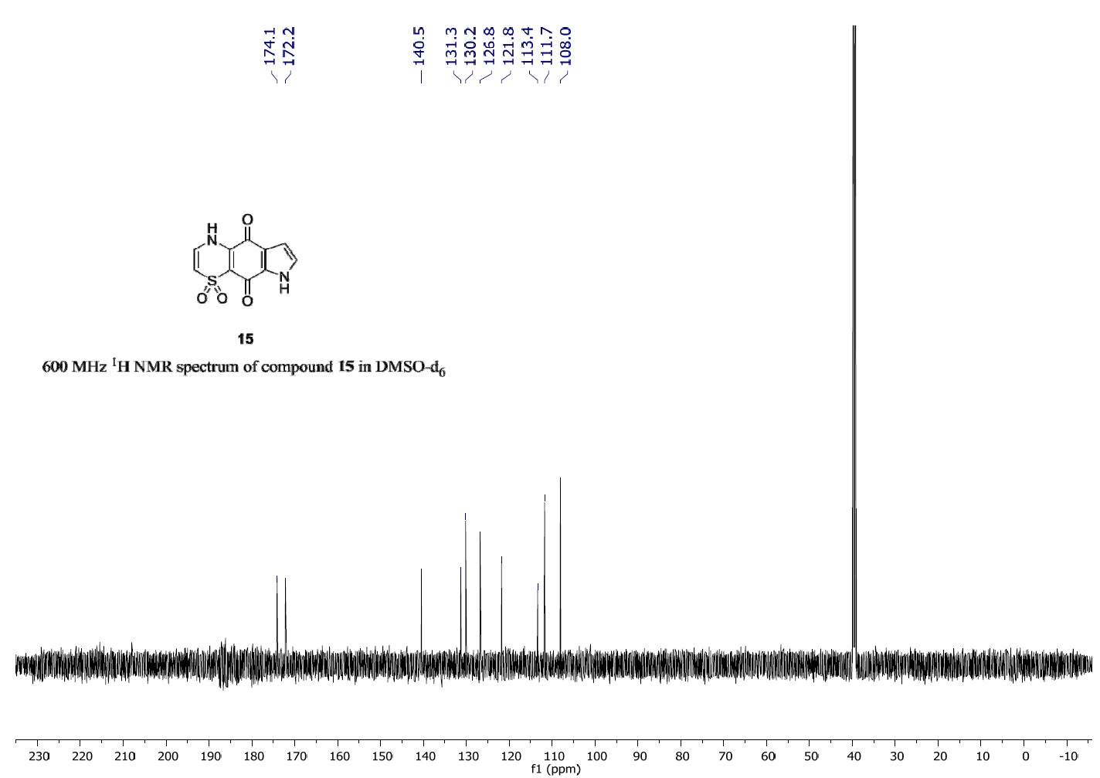
Figure S10. 600 MHz ¹H NMR spectrum of compound 15 in DMSO-d6.
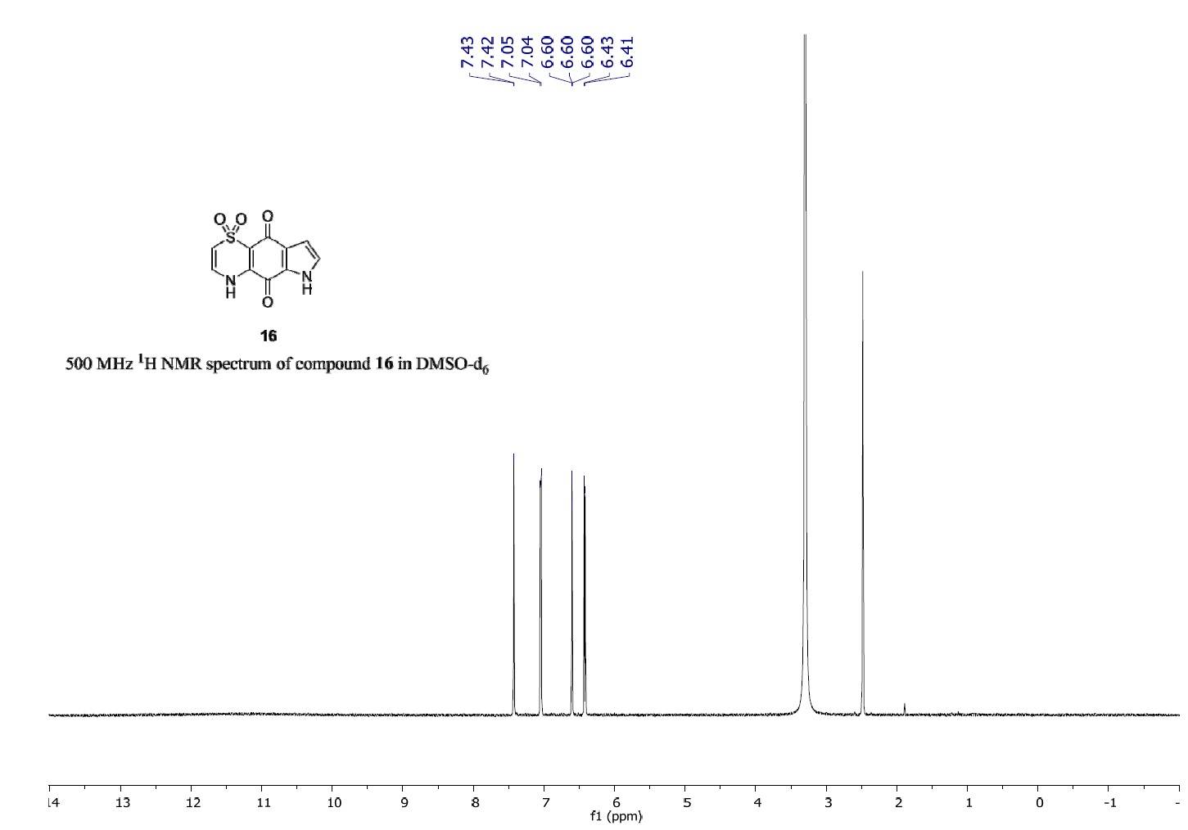
Figure S11. 500 MHz ¹H NMR spectrum of compound 16 in DMSO-d6.
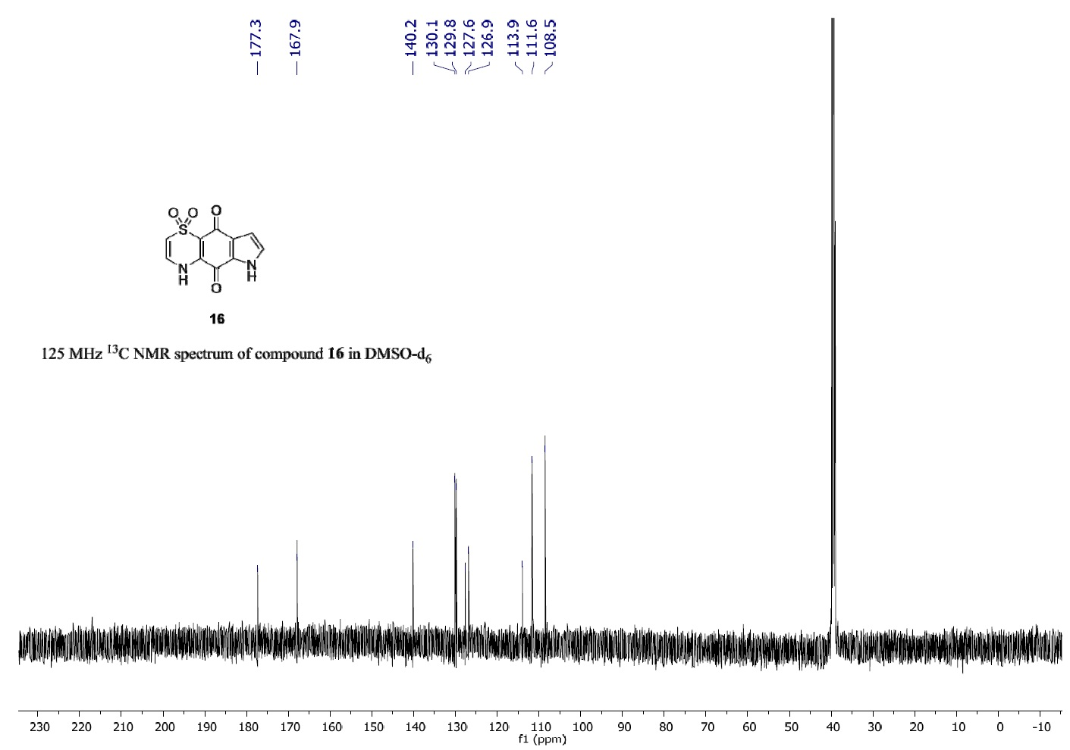
Figure S12. 125 MHz ¹³C NMR spectrum of compound 16 in DMSO-d6.

X-ray Crystallographic Data for Compound 11
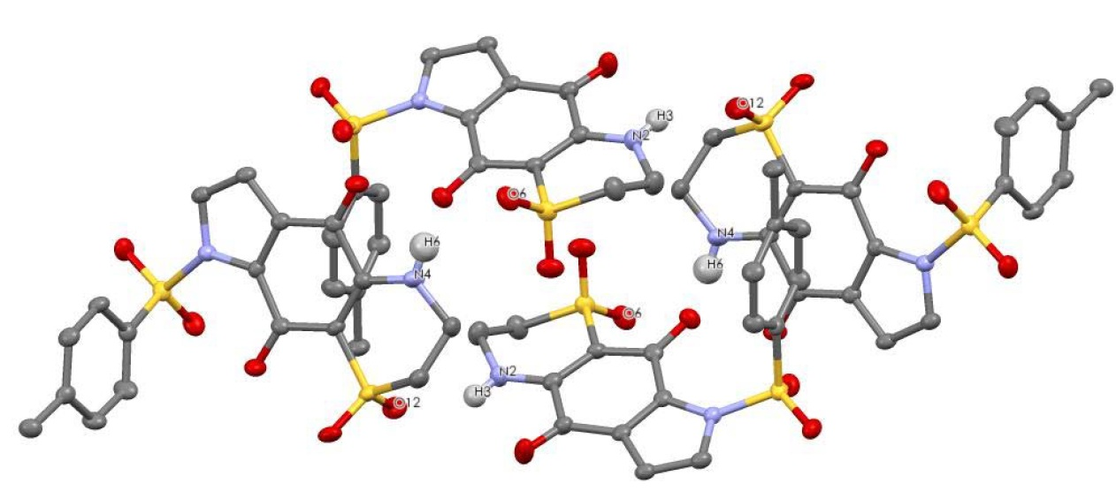
Figure S13. Tetrameric cluster of compound held together by N–H···O hydrogen bonds.
The molecules of 11 are held together by N–H···O intermolecular hydrogen bonds forming a
H-bonded tetramer (Figure S13), the H-bond parameters are summarized in Table S1.
Table S1. Hydrogen bond parameters for Compound 11 [Å and °].
D–H···A | d(D–H) | d(H···A) | d(D···A) | <(DHA)
N(2)–H(3) ···O(12)#1 | 0.81(4) | 2.28(4) | 3.019(4) | 151(4)
N(4)–H(6) ···O(6)#2 | 0.82(5) | 2.35(5) | 2.965(4) | 132(4)
Symmetry transformations used to generate equivalent atoms: #1 −x+2, −y, −z; #2 x+1, y, z; #3 x, −y+1/2, z−1/2; # 4 x+1, −y+1/2, z+1/2; #5 −x+2, −y, −z+1.
© 2015 by the authors; licensee MDPI, Basel, Switzerland. This article is an open access article distributed under the terms and conditions of the Creative Commons Attribution license (http://creativecommons.org/licenses/by/4.0/).

