Supplementary Information
Table S1. 600 MHz ¹H and 150 MHz ¹³C NMR data of 2 in DMSO-d₆. ª
Position | 2a (2′β-OH: 2′S) |  |  |  | 2b (2′α-OH: 2′R)
 | δ_{H} (J in Hz) | δ_{C} | HMBC ^{b} | NOE ^{c} | δ_{H} (J in Hz) | δ_{C} | HMBC ^{b} | NOE ^{c}
1 | — | 170.8 s | — | — | — | 171.3 s | — | —
2 | — | 88.2 s | — | — | — | 89.5 s | — | —
3 | 3.78 (dd, 9.2, 9.0) | 47.0 d | C-1, 2, 3′, 4, 4′, 5, 14 | H-3′, H-4 | 3.88 (dd, 9.0, 8.4) | 46.6 d | C-1, 2, 3′, 4, 4′, 5, 14 | H-3′, H-4, 2′–OH
4 | 4.98 (d, 9.0) | 36.9 d | C-3, 3′, 5, 5′, 13′, 14, 14′,15 | H-3 | 5.02 (d, 9.0) | 36.2 d | C-3, 3′, 5, 5′, 13′, 14, 14′,15 | H-3
5 | — | 169.3 s | — | — | — | 168.9 s | — | —
7 | — | 156.78 s | — | — | — | 156.75 s | — | —
8 | 6.79 (s) | 108.3 d | C-7, 10, 12, 13,15 | H-15 | 6.77 (s) | 108.3 d | C-7, 10, 12, 13,15 | H-15
9 | — | 147.5 s | — | — | — | 147.5 s | — | —
10 | 6.64 (s) | 112.3 d | C-7, 8, 12, 13,15 | H-15 | 6.64 (s) | 112.3 d | C-7, 8, 12, 13,15 | H-15
11 | — | 159.87 s | — | — | — | 159.85 s | — | —
12 | — | 108.4 s | — | — | — | 108.4 s | — | —
13 | — | 178.87 s | — | — | — | 178.89 s | — | —
14 | — | 119.2 s | — | — | — | 118.7 s | — | —
15 | 2.30 (s) | 21.5 q | C-8, 9, 10 | H-8, H-10 | 2.28 (s) | 21.4 q | C-8, 9, 10 | H-8, H-10
16 | 3.69 (s) | 52.8 q | C-1 | — | 3.70 (s) | 52.6 q | C-1 | —
1′ | — | 169.4 s | — | — | — | 167.7 s | — | —
2′ | — | 105.7 s | — | — | — | 106.2 s | — | —
3′ | 3.10 (ddd, 10.1, 9.2, 6.4) | 42.7 d | C-1′, 2, 2′, 3, 4′, 5′ | H-3, Hα-4′, Hβ-4′, 2′–OH | 2.79 (ddd, 12.5, 8.4, 5.9) | 47.3 d | C-1′, 2, 2′, 3, 4′, 5′ | H-3, Hα-4′, Hβ-4′, 2′–OH
4′α | 2.70 (dd, 17.0, 6.4) | 26.3 t | C-2′, 3, 3′, 5′, 14′ | H-3′, Hβ-4′, 2′–OH | 2.48 (dd, 15.9, 5.9) | 26.9 t | C-2′, 3, 3′, 5′, 14′ | H-3′, Hβ-4′, H₃-16
β | 2.64 (dd, 17.0, 10.1) |  | C-2′, 3, 3′, 5′, 14′ | H-3′, Hα-4′, 2′–OH | 2.43 (dd, 15.9, 12.4) |  | C-2′, 3, 3′, 5′, 14′ | H-3′, Hα-4
5′ | — | 168.0 s | — | — | — | 167.4 s | — | —
7′ | — | 155.5 s | — | — | — | 155.6 s | — | —
8′ | 6.90 (s) | 107.6 d | C-7′, 10′, 12′, 13′,15′ | H-15′ | 6.88 (s) | 107.6 d | C-7′, 10′, 12′, 13′,15′ | H-15′
9′ | — | 147.40 s | — | — | — | 147.44 s | — | —
10′ | 6.71 (s) | 112.0 d | C-7′, 8′, 12′, 13′,15′ | H-15′ | 6.71 (s) | 112.0 d | C-7′, 8′, 12′, 13′,15′ | H-15′
11′ | — | 159.52 s | — | — | — | 159.55 s | — | —
12′ | — | 107.7 s | — | — | — | 107.8 s | — | —
Table S1. Cont.
13′ | — | 179.4 s | — | — | — | 179.3 s | — | —
14′ | — | 111.9 s | — | — | — | 111.7 s | — | —
15′ | 2.38 (s) | 21.77 q | C-8′, 9′, 10′ | H-8′, H-10′ | 2.38 (s) | 21.79 q | C-8′, 9′, 10′ | H-8′, H-10′
16′ | 3.74 (s) | 52.28 q | C-1′ | — | 3.75 (s) | 52.31 q | C-1′ | Hα-4′, Hβ-4′
11–OH | 12.15 (s) | — | C-9, 10, 11, 12 | H-10 | 12.12 (s) | — | C-9, 10, 11, 12 | H-10
2′–OH | 7.80 (s) | — | C-1′, 2′, 3′ | Hα-4′, Hβ-4′ | 7.53 (s) | — | C-1′, 2′, 3′ | H-3, H-3′
11′–OH | 12.49 (s) | — | C-9′, 10′, 11′, 12′ | H-10′ | 12.47 (s) | — | C-9′, 10′, 11′, 12′ | H-10′
ª Chemical shifts of ¹H and ¹³C nuclei were recorded in δ values using the solvent DMSO-d₆ signals (δ_{H} 2.50/δ_{C} 39.52) as references, respectively, and the signals were assigned on the basis of HMQC, HMBC, NOESY, and 1D GOESY experiments. The ratio of 2a to 2b was determined approximately to be 1:0.8 by the standard integrals of the H-4, HO-2′ and H-3′ signals in the DMSO-d₆ solution of 2. ^{b} Numbers in each line of this column indicate the carbons that showed HMBC correlations with the proton in the corresponding line in the HMBC experiments optimized for the 8.3 Hz of long-range J_{CH} value. ^{c} Numbers in each line of this column indicate the protons that showed NOE correlations with the proton in the corresponding line in 2D NOESY or 1D GOESY experiments. The NOEs between two protons in a spin coupling relationship were detected by the 1D GOESY experiments. In the 1D GOESY experiments, a more remarkably NOE was detected on 2′-OH in 2b than in 2a by irradiating H-3′ in 2a and 2b, respectively.

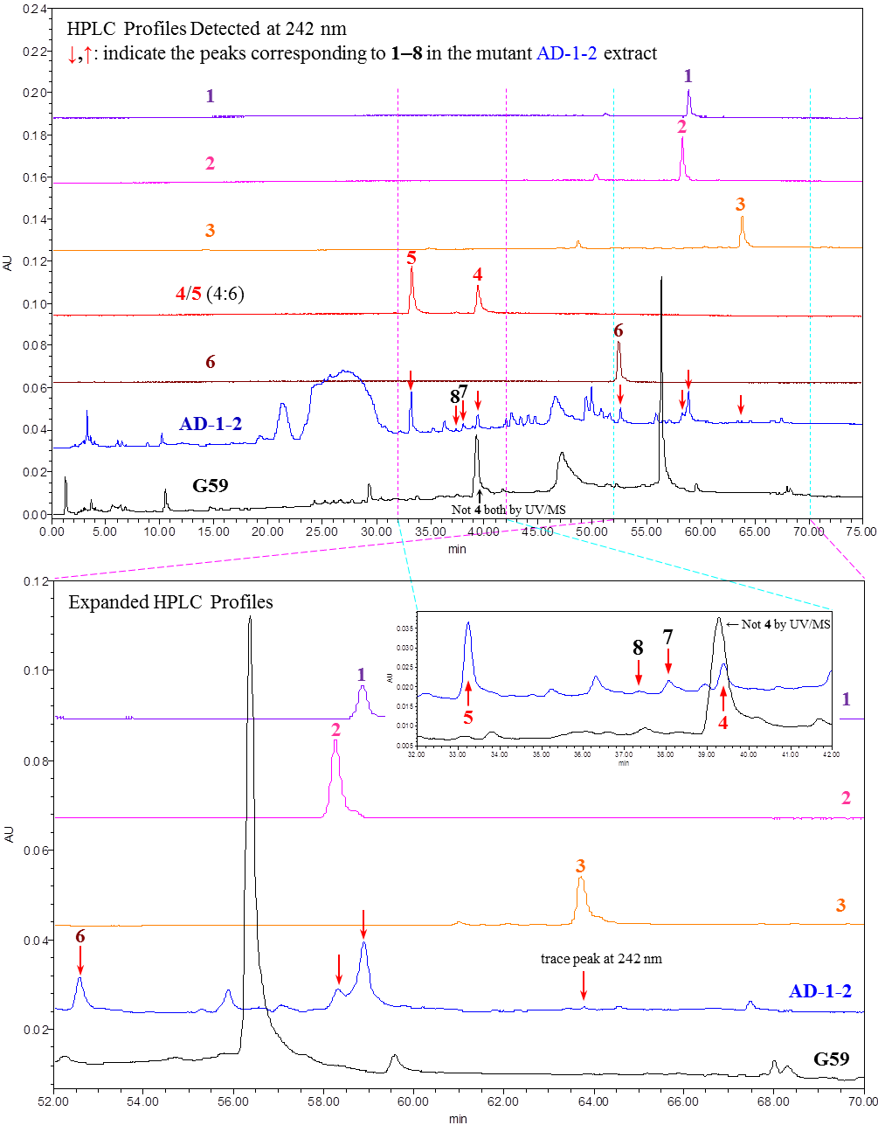
(A)
Figure S1. Cont.
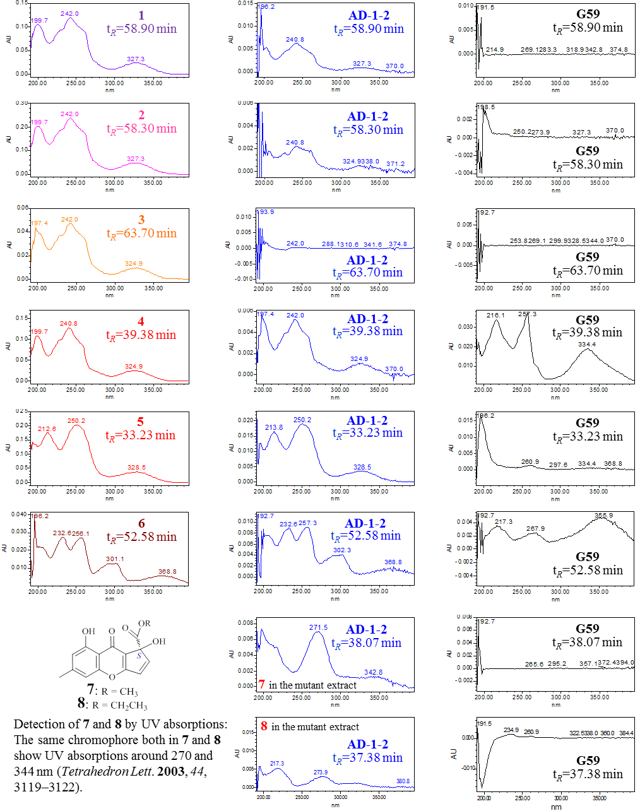
(B)
Figure S1. Cont.
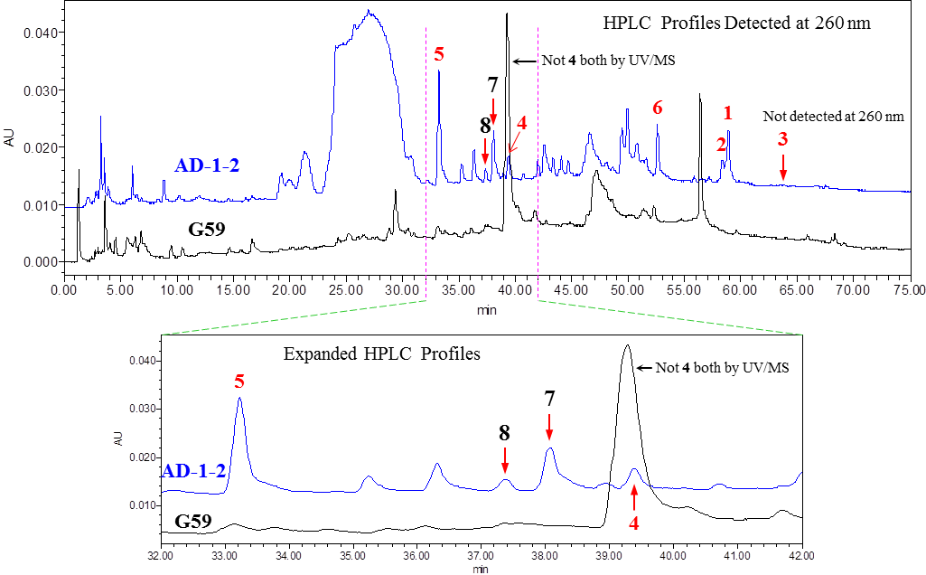
(C)
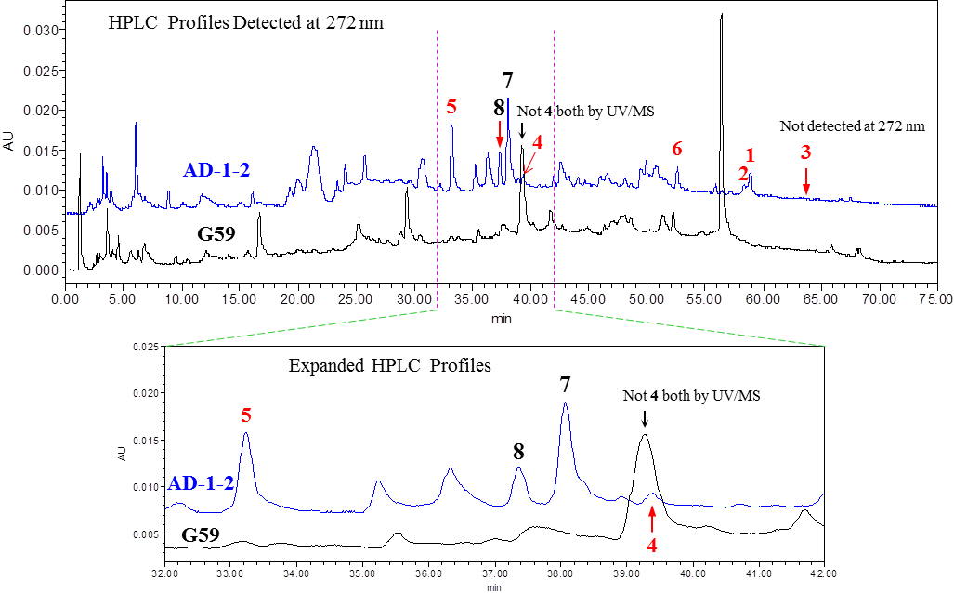
(D)
Figure S1. HPLC-PDAD-UV analysis of the EtOAc extracts of mutant AD-1-2 and the parent G59 strain for detecting 1–8. (A) HPLC profiles of 1–6 and the AD-1-2 and G59 extracts detected at 242 nm; (B) Detection of 1–8 in the AD-1-2 and G59 extracts by the UV absorptions in the HPLC profiles detected at 242 nm; (C) HPLC profiles of the EtOAc extracts of AD-1-2 and G59 cultures detected at 260 nm; (D) HPLC profiles of the EtOAc extracts of AD-1-2 and G59 cultures detected at 272 nm.
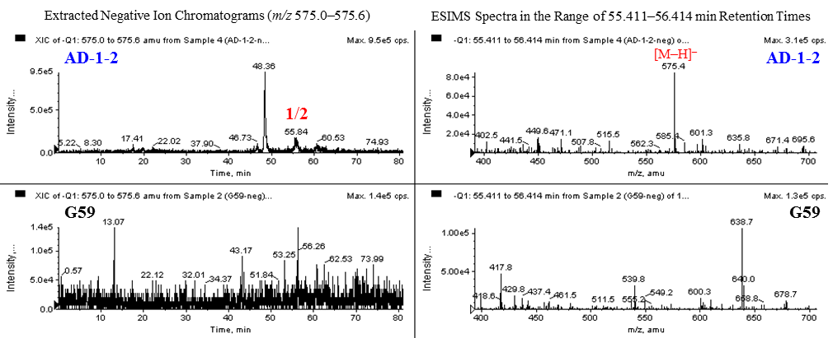
(A)
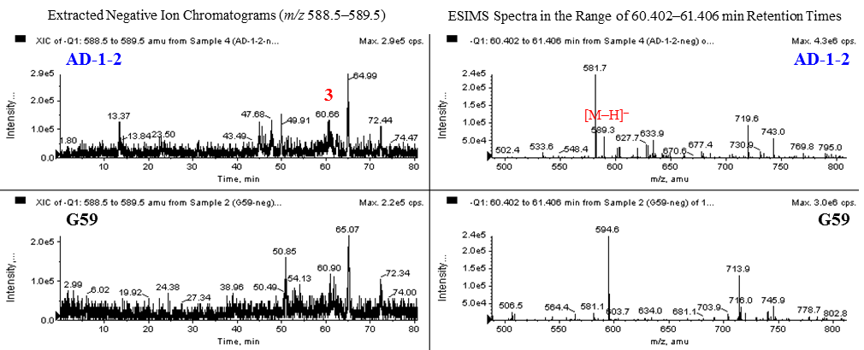
(B)
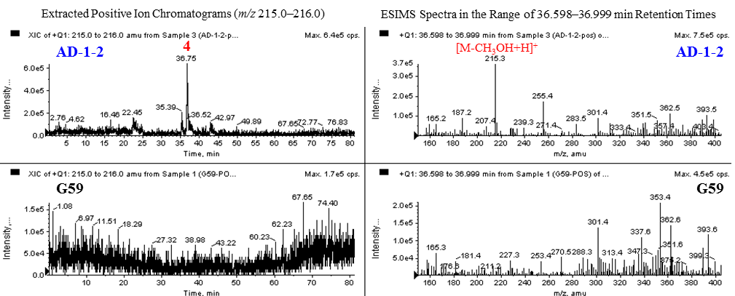
(C)
Figure S2. Cont.
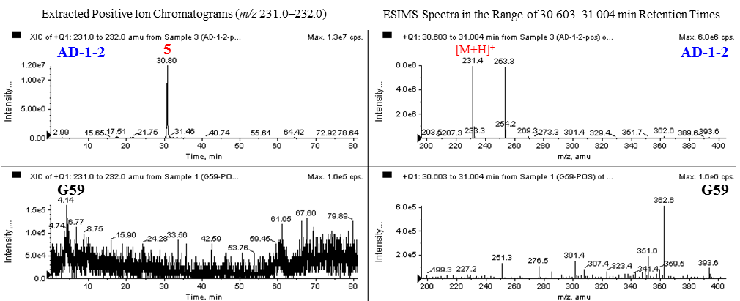
(D)
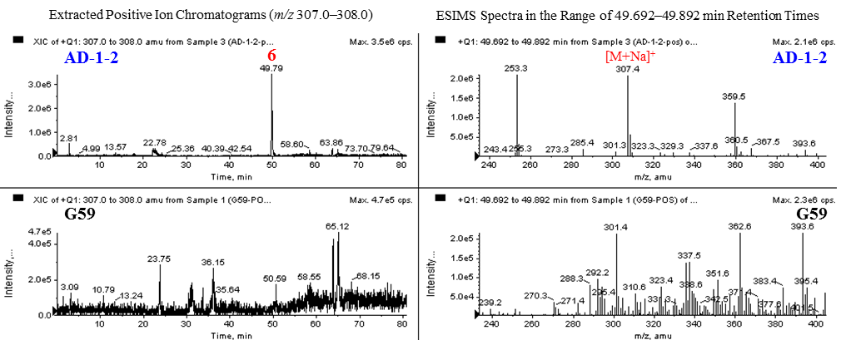
(E)
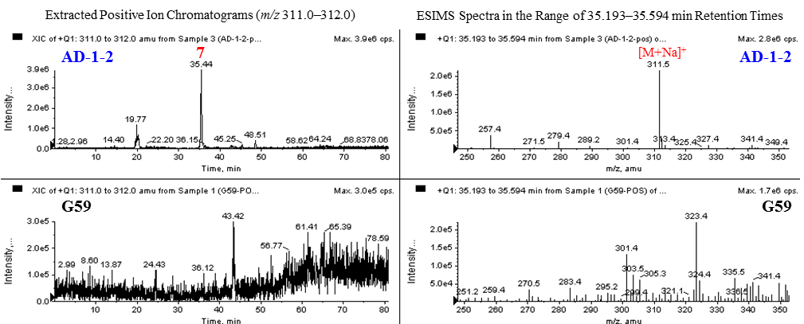
(F)
Figure S2. Cont.
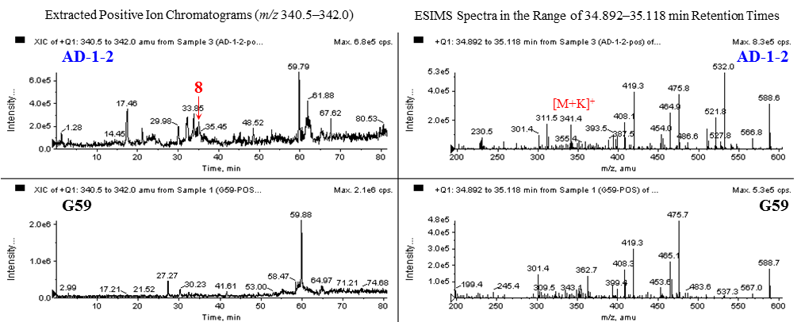
(G)
Figure S2. HPLC-ESI-MS analysis of the EtOAc extracts of mutant AD-1-2 and the
parent G59 strain for detecting 1–8. (A) HPLC-Negative ion ESI-MS analysis (ESIMS
m/z: 575 [M − H]⁻ for both 1 and 2); (B) HPLC-Negative ion ESI-MS analysis (ESIMS m/z: 589 [M − H]⁻ for 3); (C) HPLC-Positive ion ESI-MS analysis (ESIMS
m/z: 215 [M-CH₃OH + H]⁺ for 4); (D) HPLC-Positive ion ESI-MS analysis (ESIMS
m/z: 231 [M + H]⁺ for 5); (E) HPLC-Positive ion ESI-MS analysis (ESIMS
m/z: 307 [M + Na]⁺ for 6); (F) HPLC-Positive ion ESI-MS analysis (ESIMS
m/z: 311 [M + Na]⁺ for 7); (G) HPLC-Positive ion ESI-MS analysis (ESIMS
m/z: 341 [M + K]⁺ for 8).
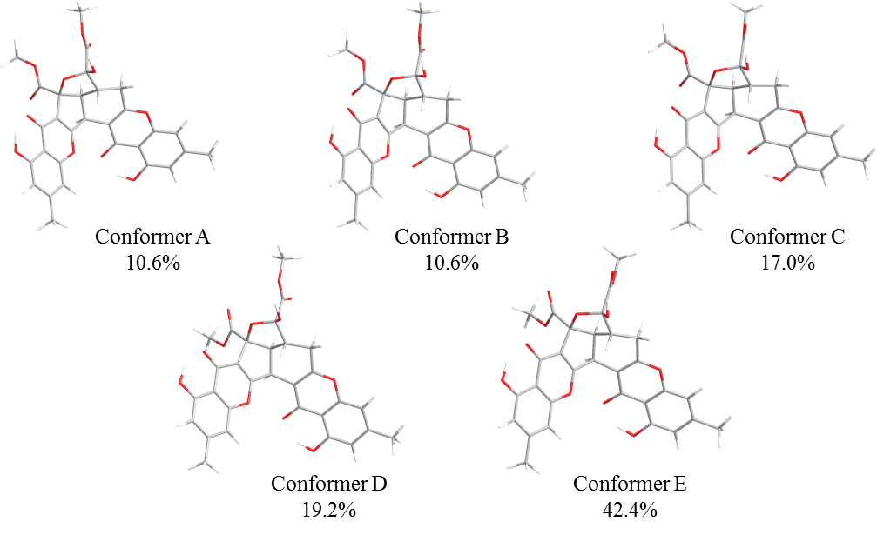
(A)
Figure S3. Cont.
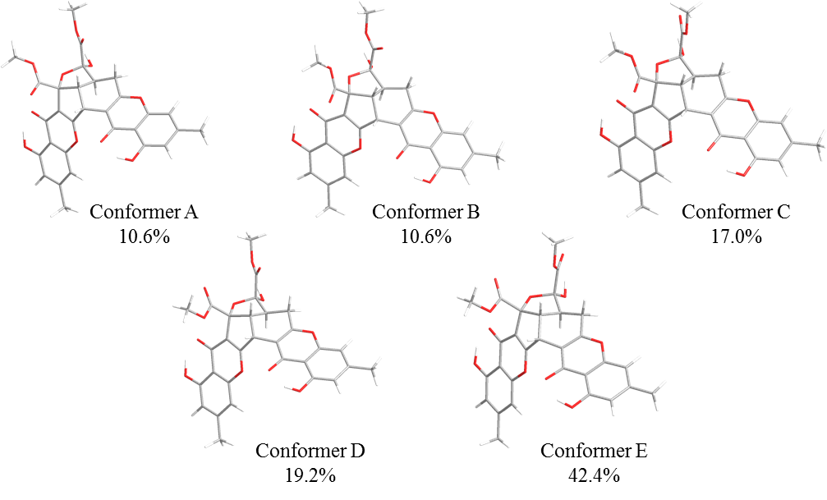
(B)
Figure S3. DFT-optimized structures for low-energy conformers of 1a/ent-1a at the B3LYP/6-31+g(d) level using a polarizable continuum model (PCM) in MeOH. Conformer populations were calculated using the Gibbs free energy and Boltzmann population at 298 K estimated thereof; (A) Low-energy conformers of 1a (2S,3R,4S,2′S,3′R); (B) Low-energy conformers of ent-1a (2R,3S,4R,2′R,3′S).
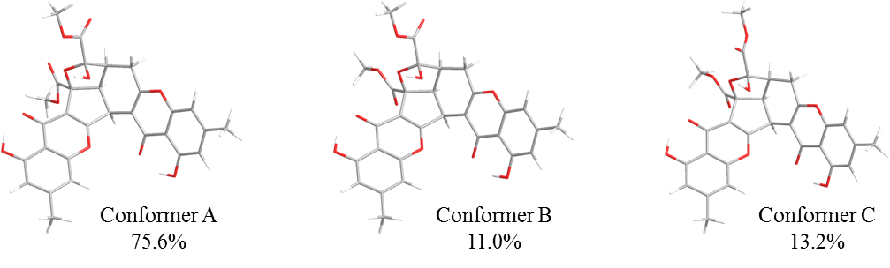
(A)
Figure S4. Cont.
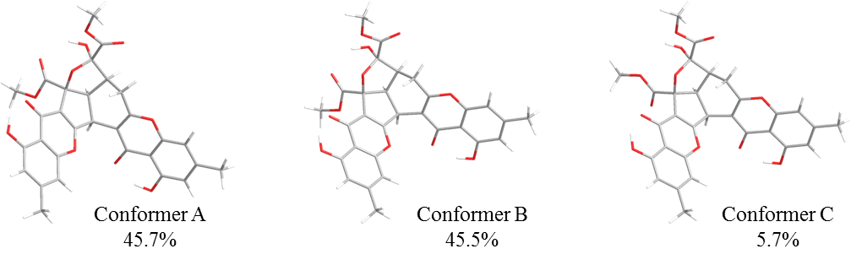
(B)
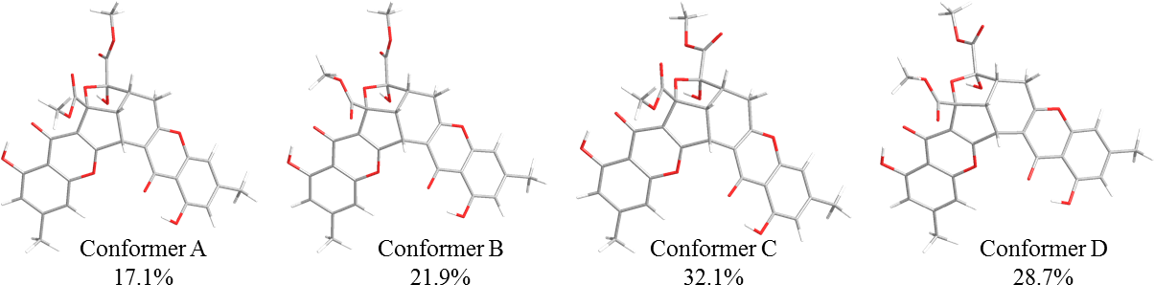
(C)
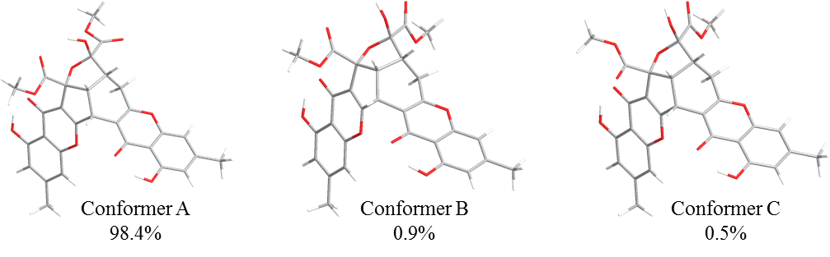
(D)
Figure S4. DFT-optimized structures for low-energy conformers of 2a, 2b, ent-2a and ent-2b for 2 in vacuum at the B3LYP/6-31+g(d) level. Conformer populations were calculated using the Gibbs free energy and Boltzmann population at 298 K estimated thereof; (A) Low-energy conformers of 2a (2S3R4S2′S3′S); (B) Low-energy conformers of 2b (2S3R4S2′R3′S); (C) Low-energy conformers of ent-2a (2R3S4R2′R3′R); (D) Low-energy conformers of ent-2b (2R3S4R2′S3′R).
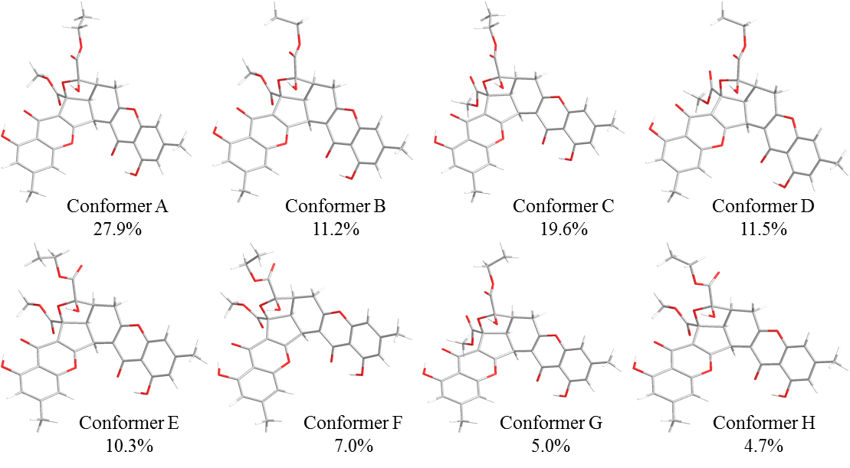
(A)
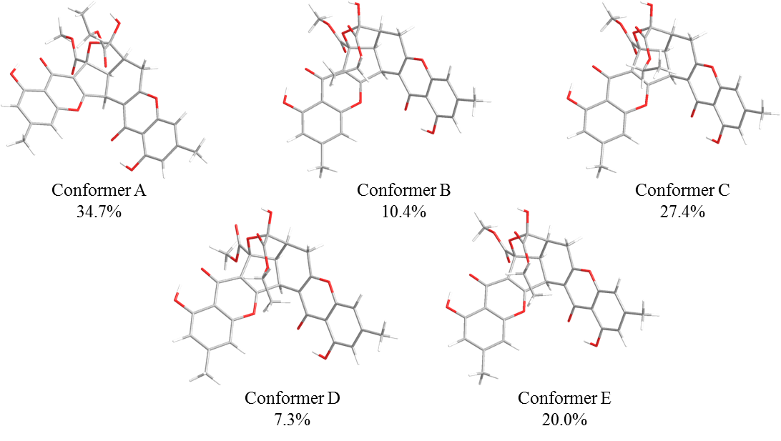
(B)
Figure S5. Cont.
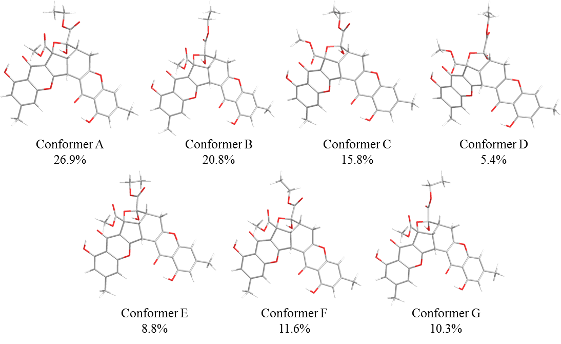
(C)
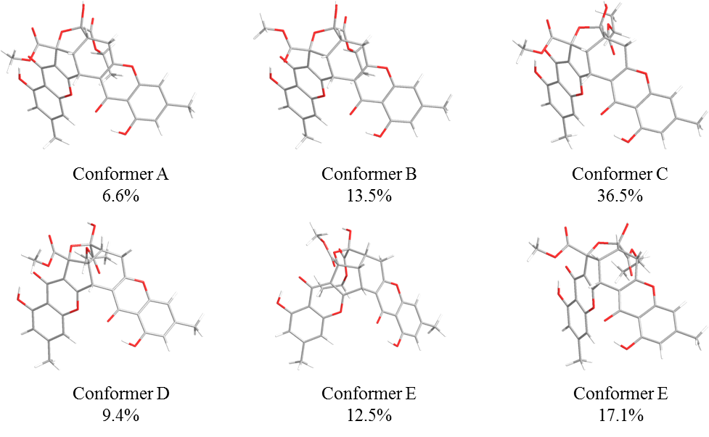
(D)
Figure S5. DFT-optimized structures for low-energy conformers of 3a, 3b, ent-3a and ent-3b for 3 in vacuum at the B3LYP/6-31g(d) level. Conformer populations were calculated using the Gibbs free energy and Boltzmann population at 298 K estimated thereof; (A) Low-energy conformers of 3a (2S3R4S2′S3′S); (B) Low-energy conformers of 3b (2S3R4S2′R3′S); (C) Low-energy conformers of ent-3a (2R3S4R2′R3′R); (D) Low-energy conformers of ent-3b (2R3S4R2′S3′R).
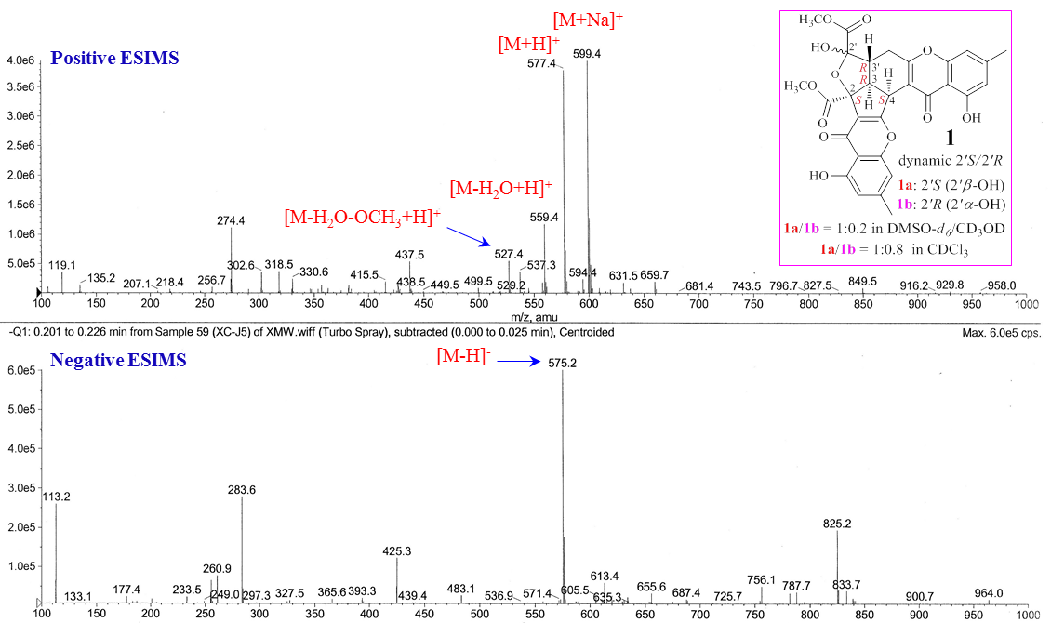
Figure S6. Positive and negative ESIMS spectra of 1.
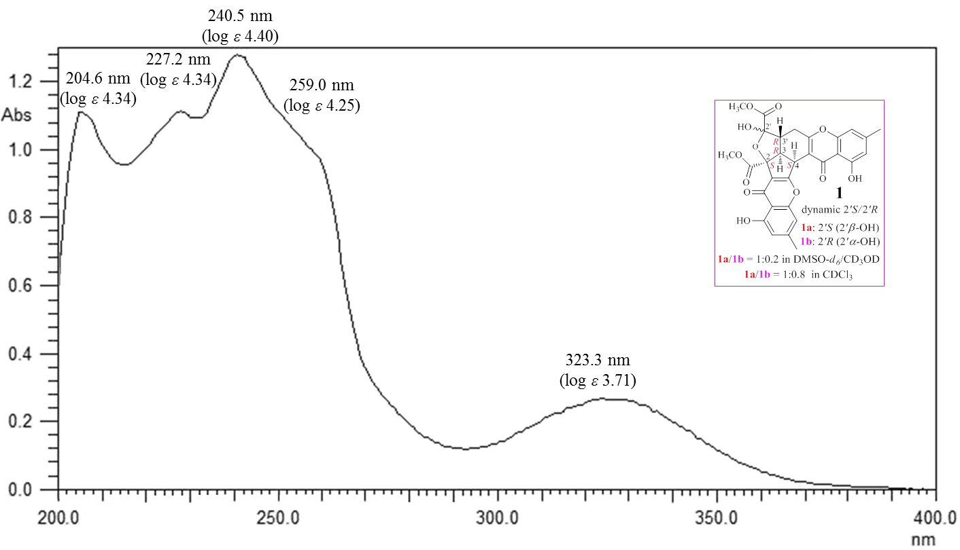
Figure S7. UV Spectrum of 1 in MeOH.
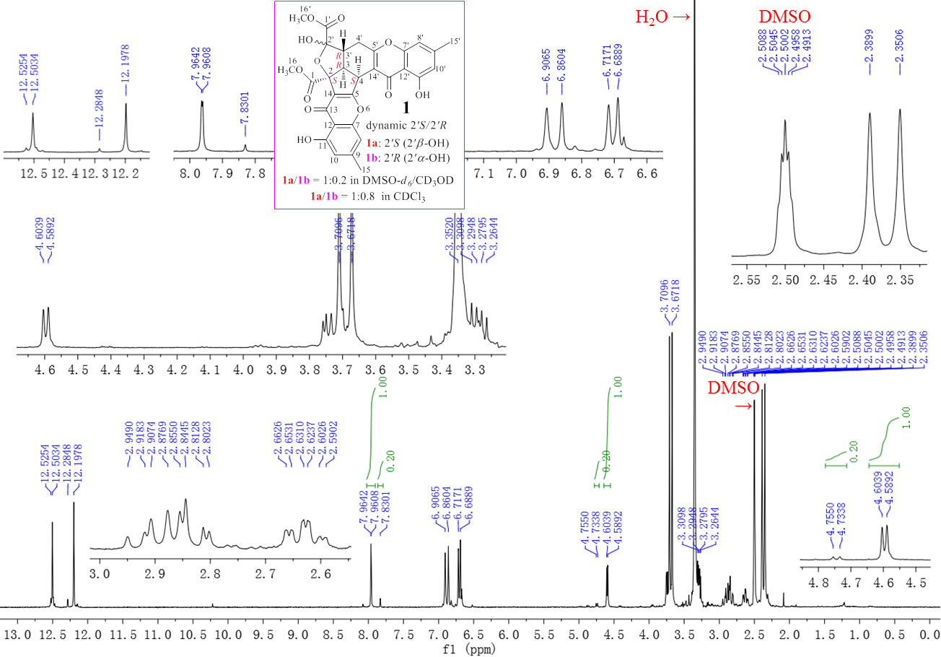
Figure S8. 400 MHz ¹H NMR Spectrum of 1 in DMSO-d₆.
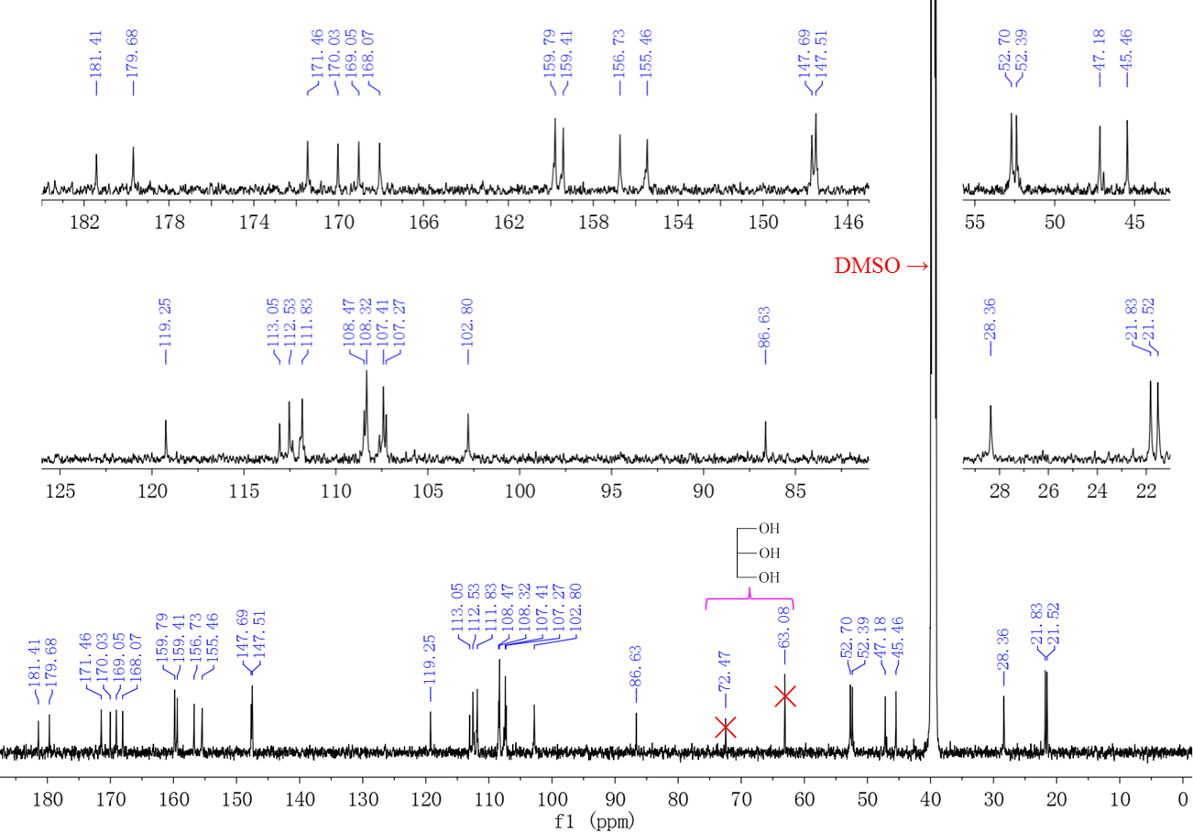
Figure S9. 150 MHz ¹³C NMR spectrum of 1 in DMSO-d₆.
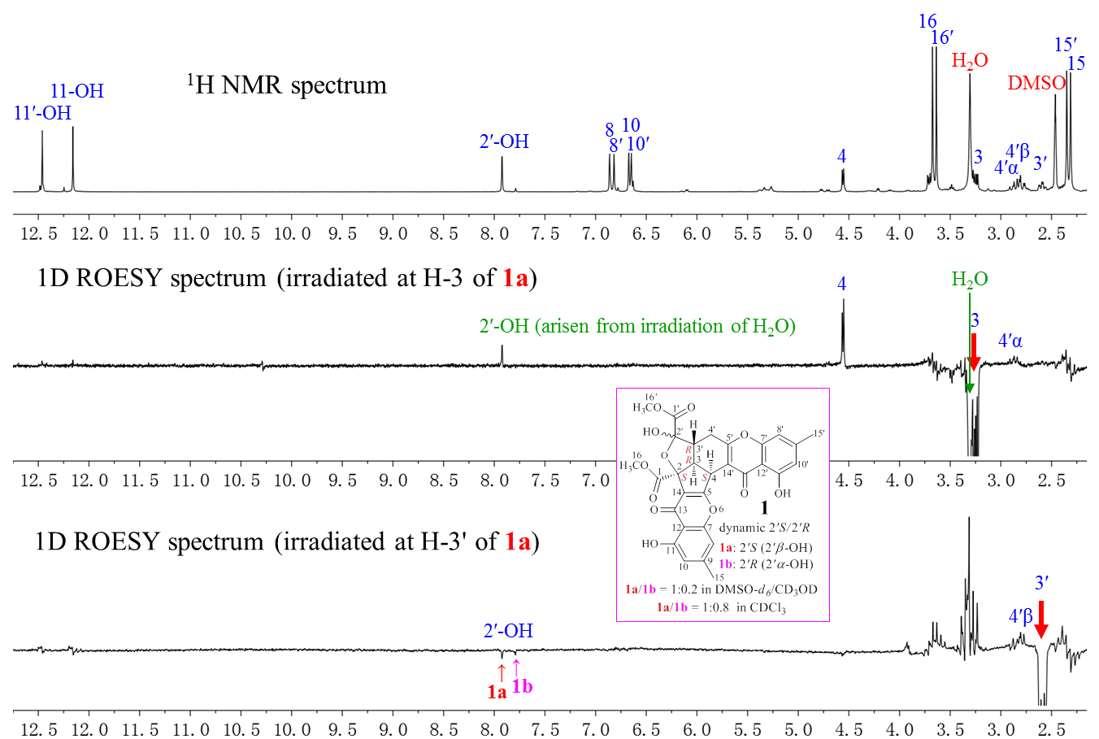
Figure S10. 400 MHz ¹H NMR and 1D ROESY spectra of 1 in DMSO-d₆.
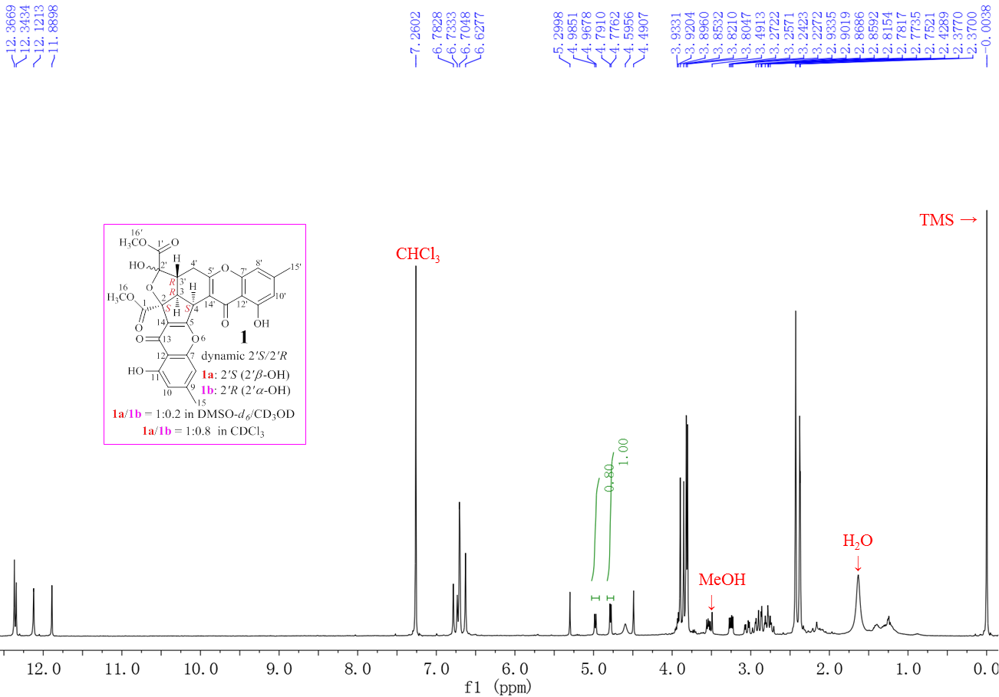
Figure S11. 400 MHz ¹H NMR spectrum of 1 in CDCl₃.
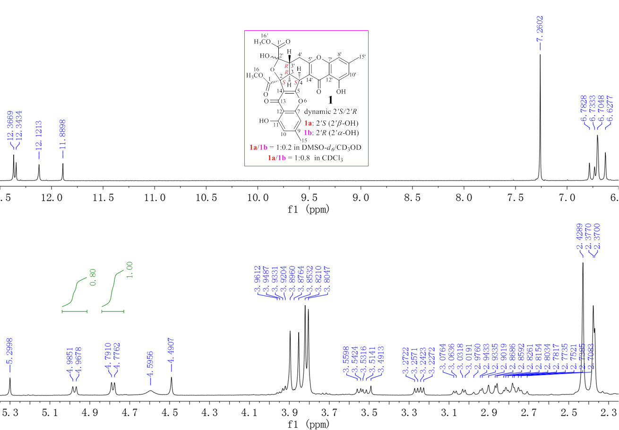
Figure S12. Expanded 400 MHz ¹H NMR spectrum of 1 in CDCl₃.
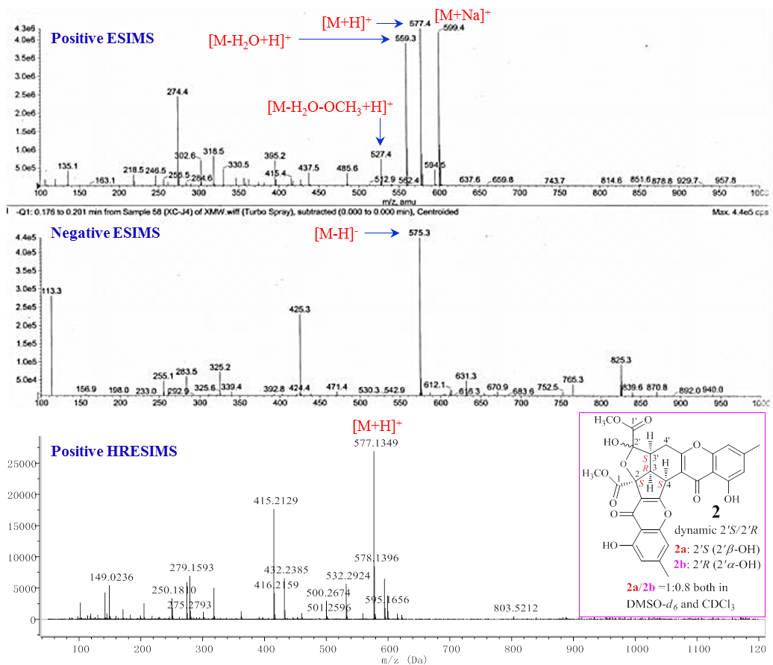
Figure S13. ESIMS and HRESIMS Spectra of 2.
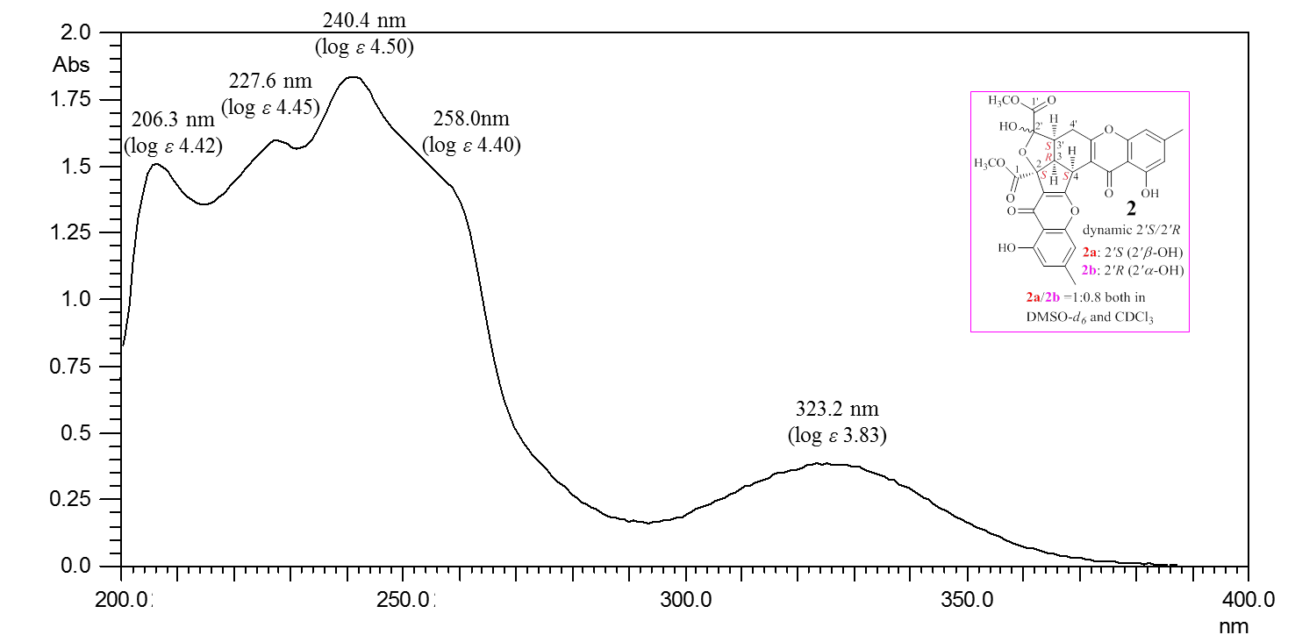
Figure S14. UV spectrum of 2 in MeOH.
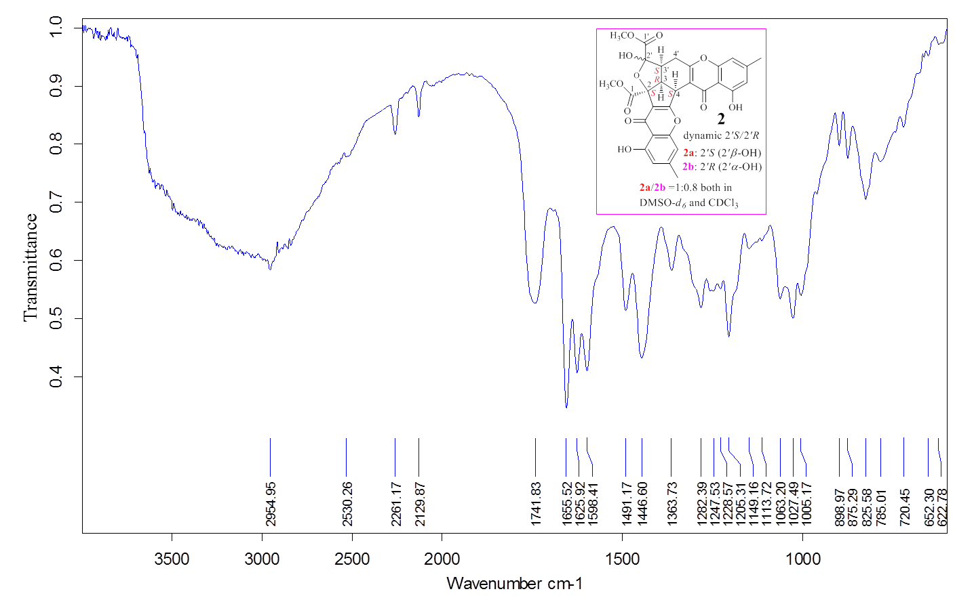
Figure S15. IR spectrum of 2.
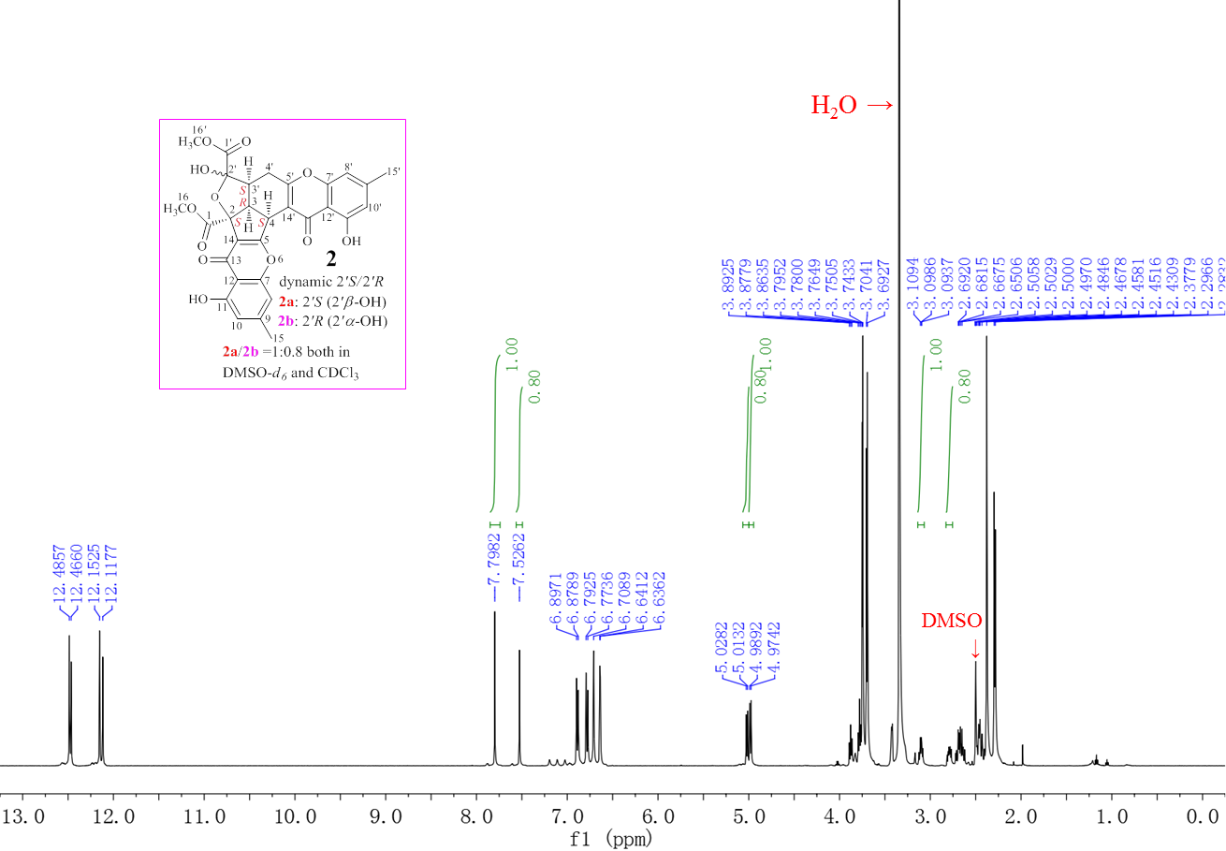
Figure S16. 600 MHz ¹H NMR spectrum of 2 in DMSO-d₆.
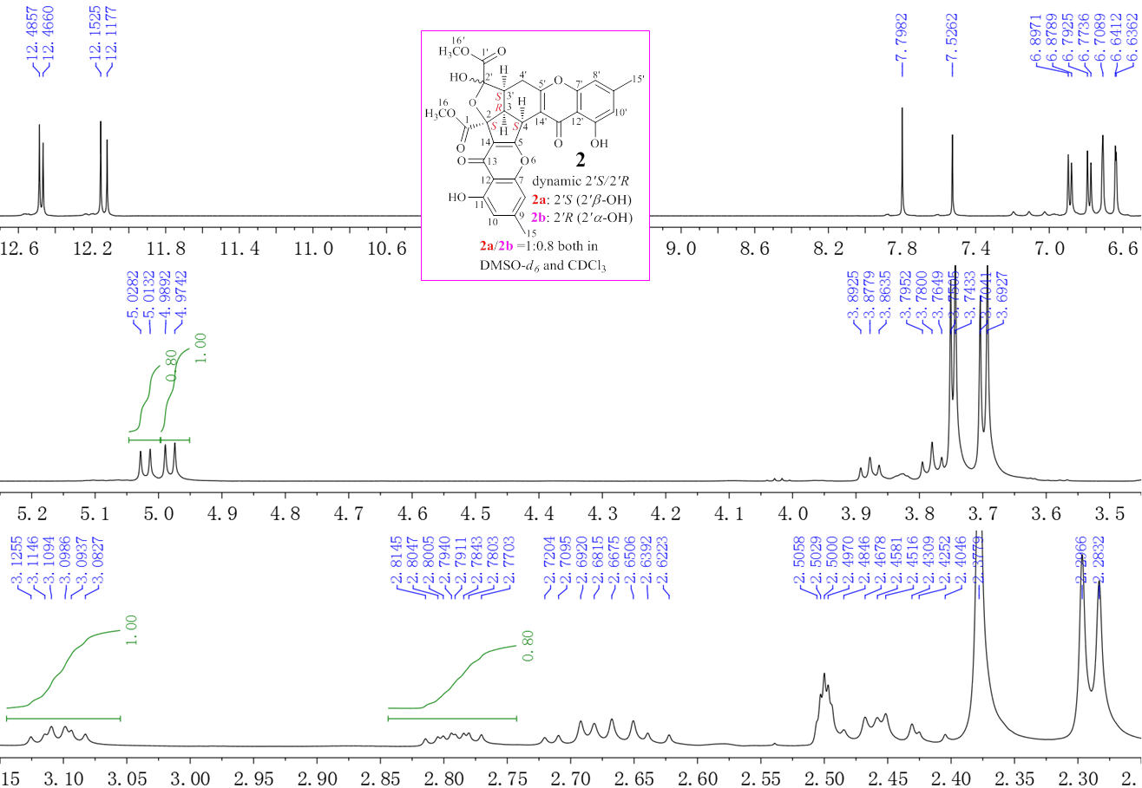
Figure S17. Expanded 600 MHz ¹H NMR spectrum of 2 in DMSO-d₆.
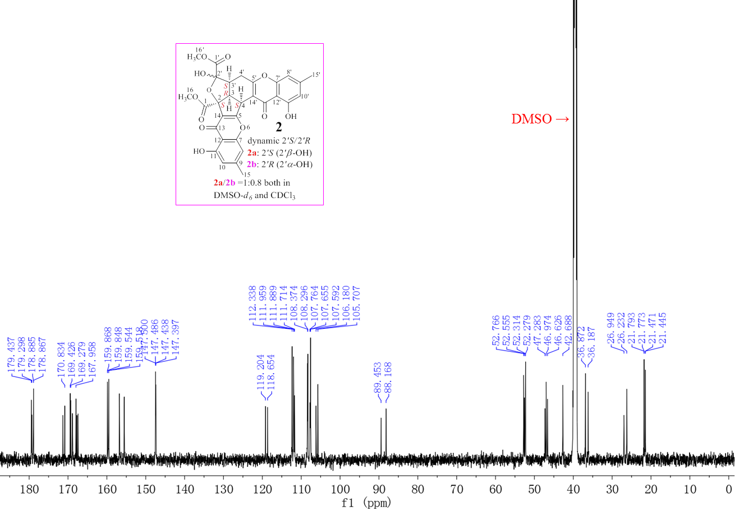
Figure S18. 150 MHz ¹³C NMR spectrum of 2 in DMSO-d₆.
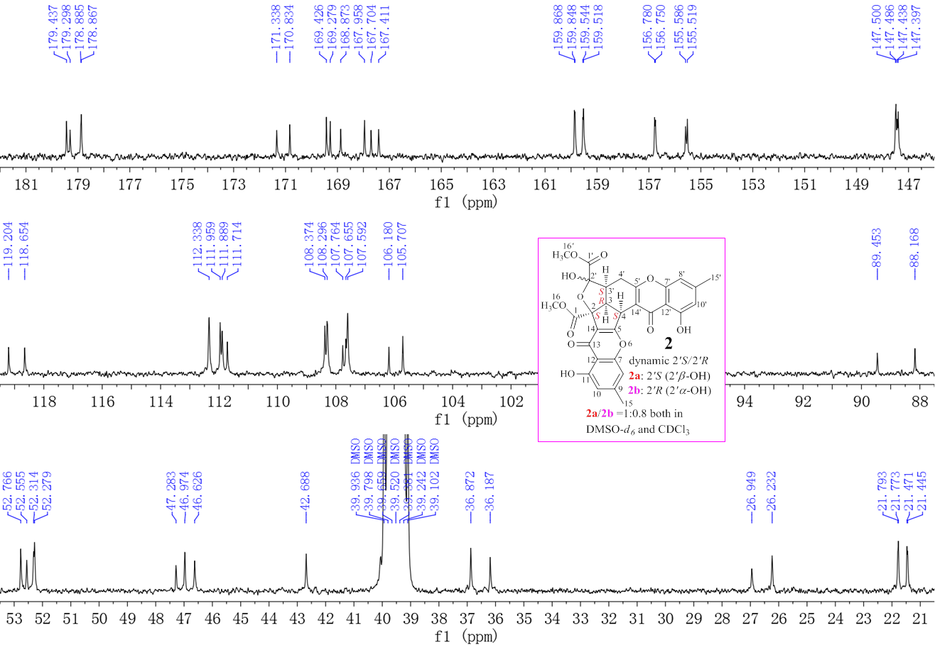
Figure S19. Expanded 150 MHz ¹³C NMR spectrum of 2 in DMSO-d₆.
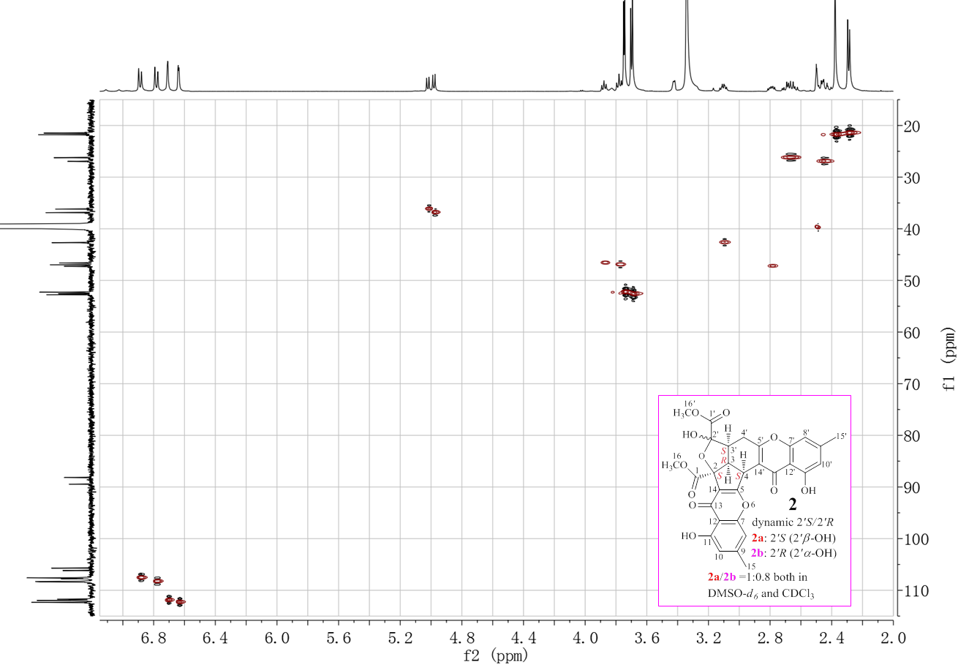
Figure S20. 600 MHz HMQC spectrum of 2 in DMSO-d₆.
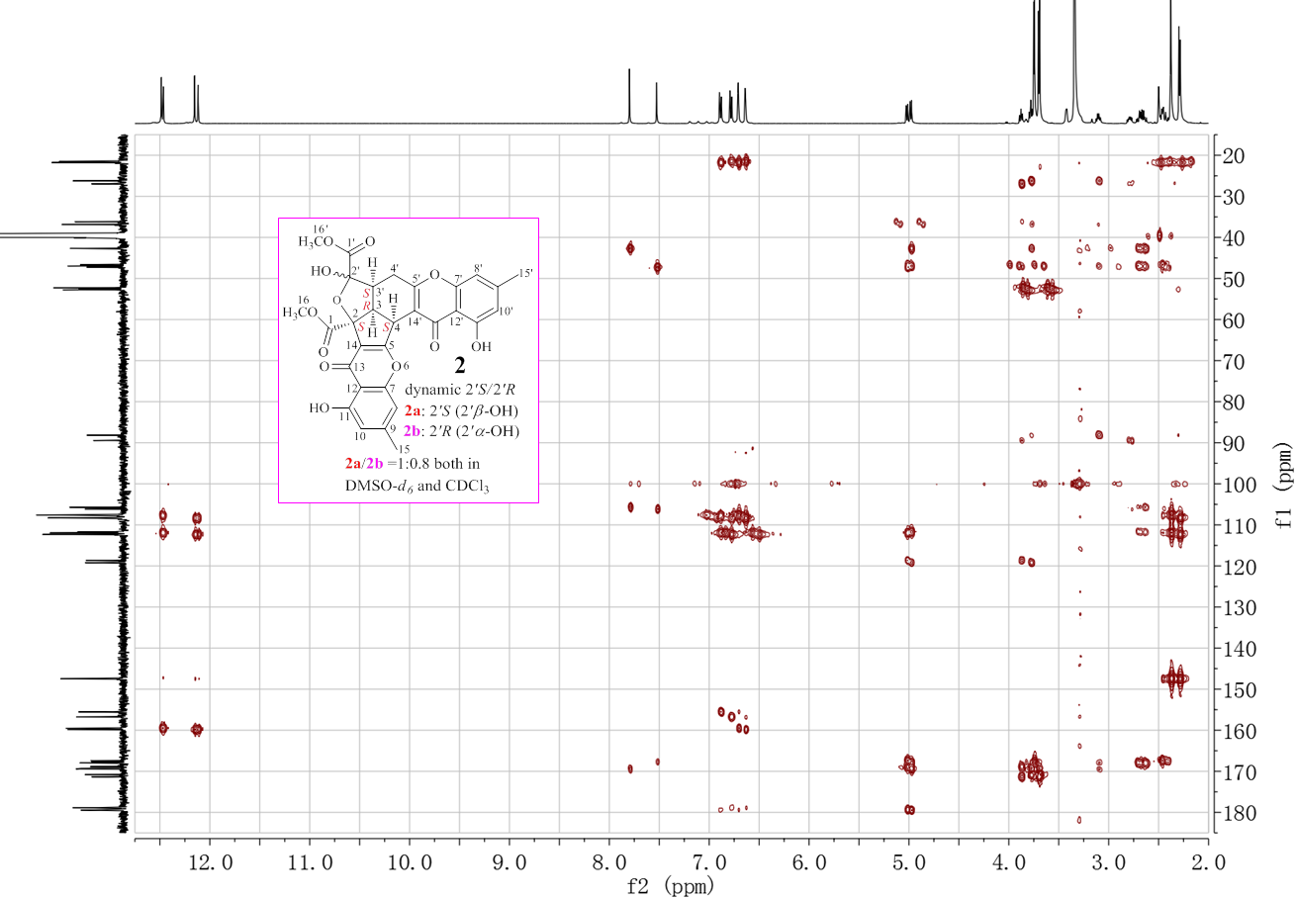
Figure S21. 600MHz HMBC spectrum of 2 in DMSO-d₆.
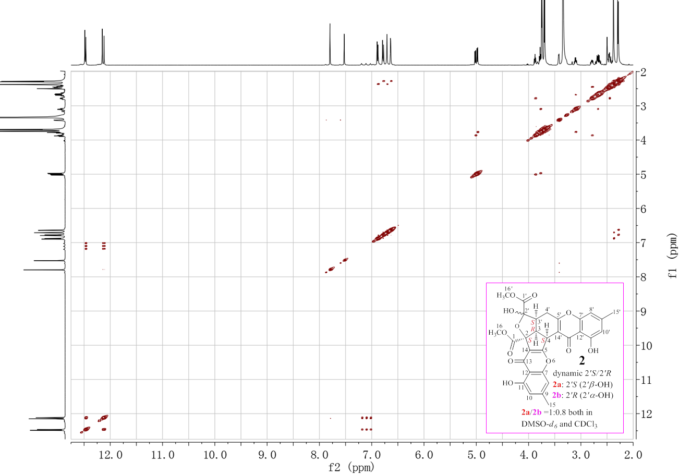
Figure S22. 600 MHz NOESY spectrum of 2 in DMSO-d₆.
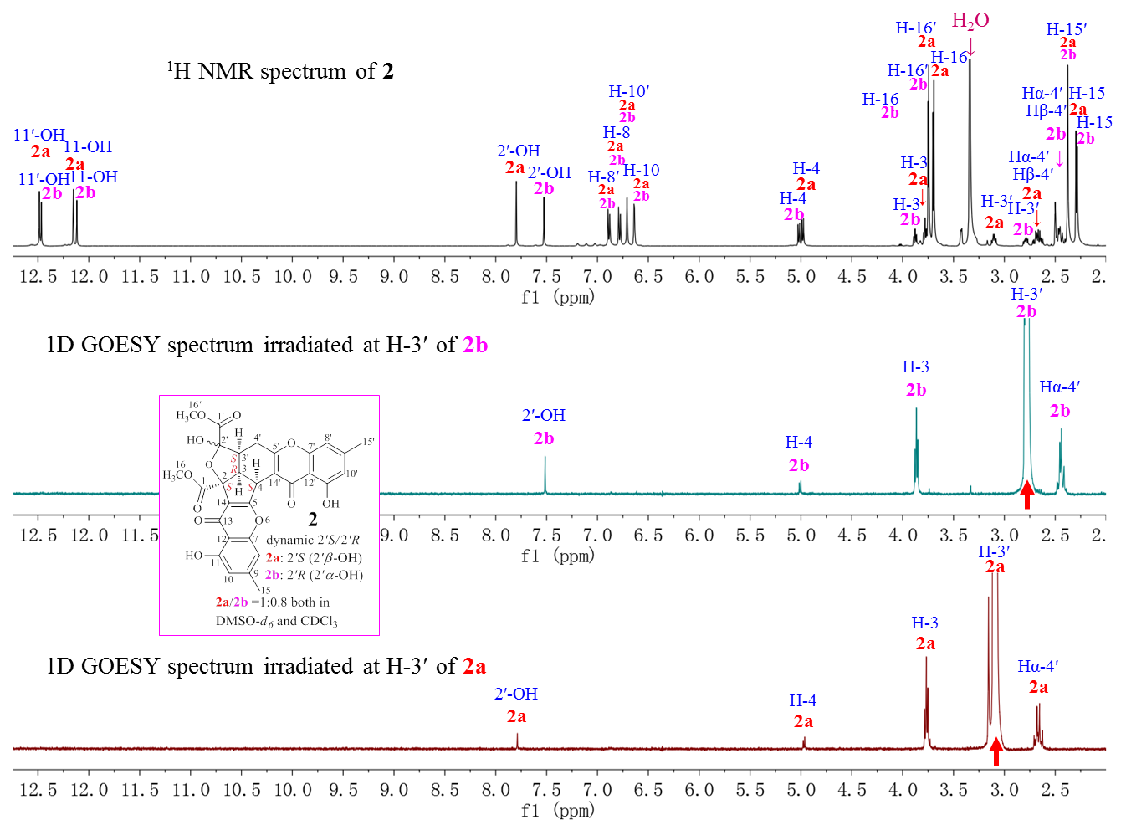
Figure S23. 600 MHz ¹H and 1D GOESY spectra of 2 in DMSO-d₆ (irradiated at H-3′).
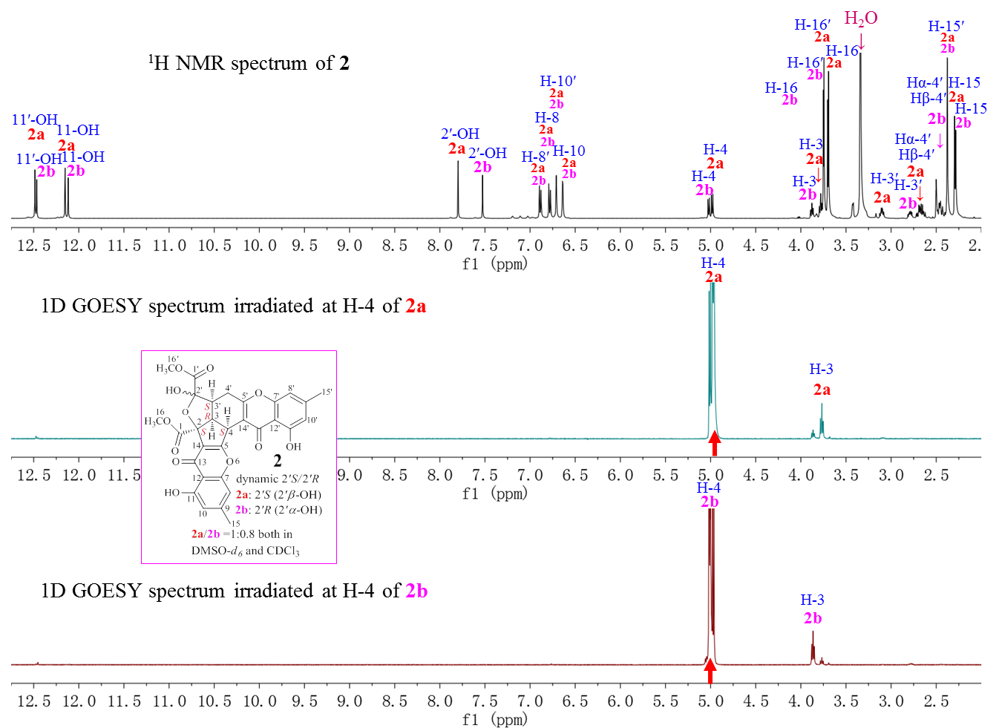
Figure S24. 600 MHz ¹H and 1D GOESY spectra of 2 in DMSO-d₆ (irradiated at H-4).
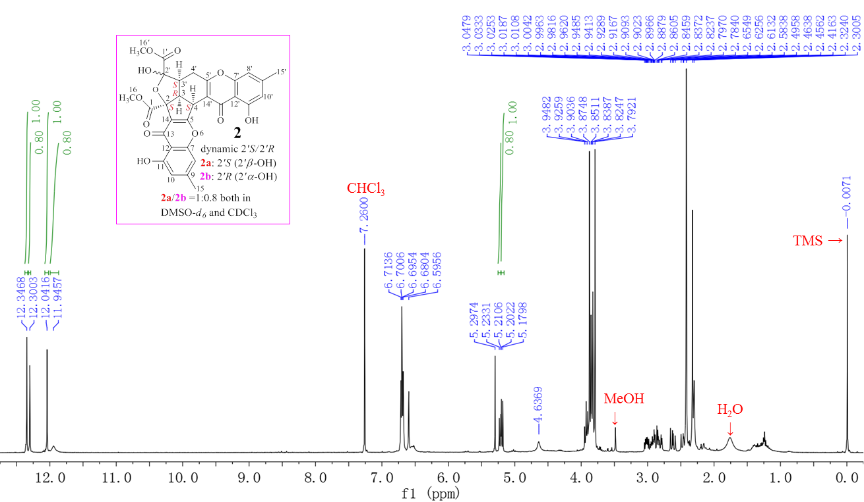
Figure S25. 400 MHz ¹H NMR spectrum of 2 in CDCl₃.
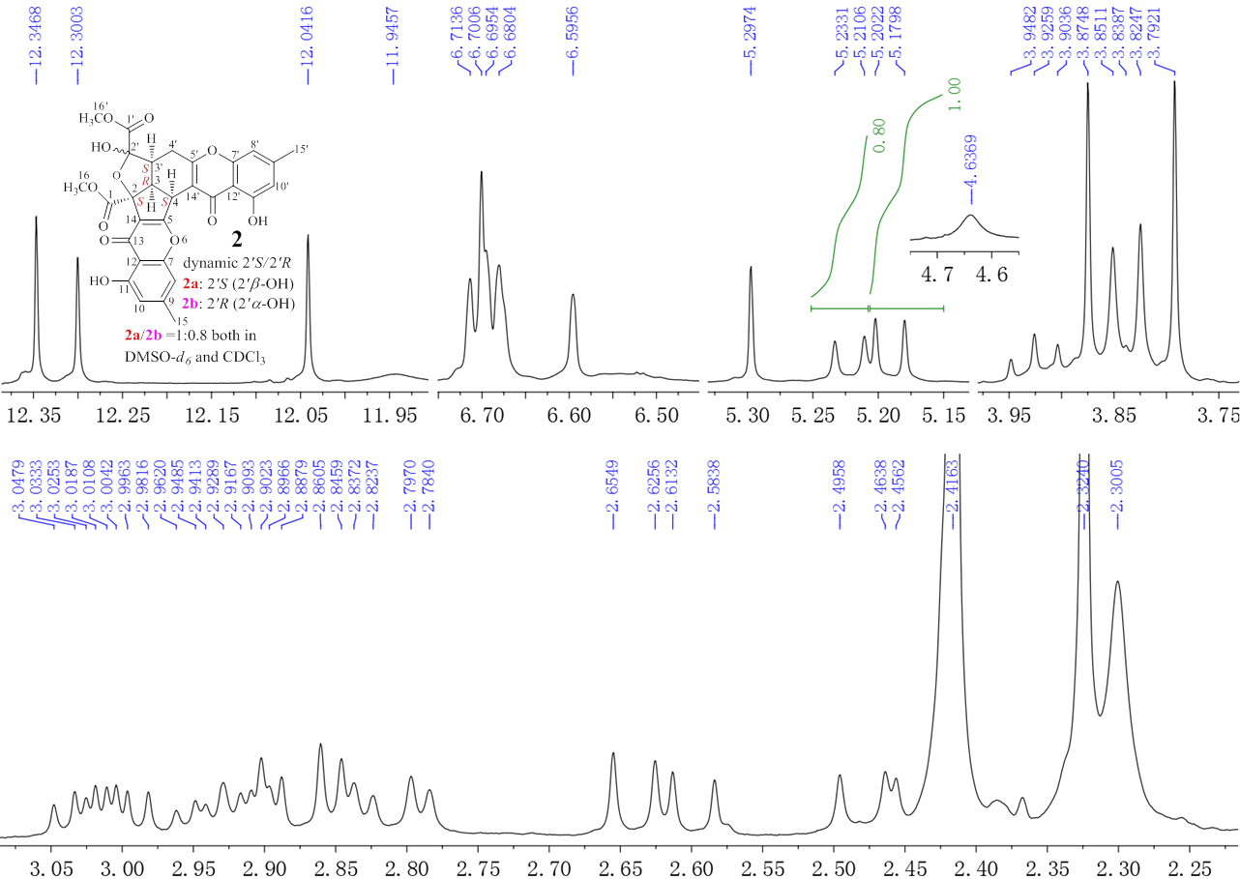
Figure S26. Expanded 400 MHz ¹H NMR spectrum of 2 in CDCl₃.
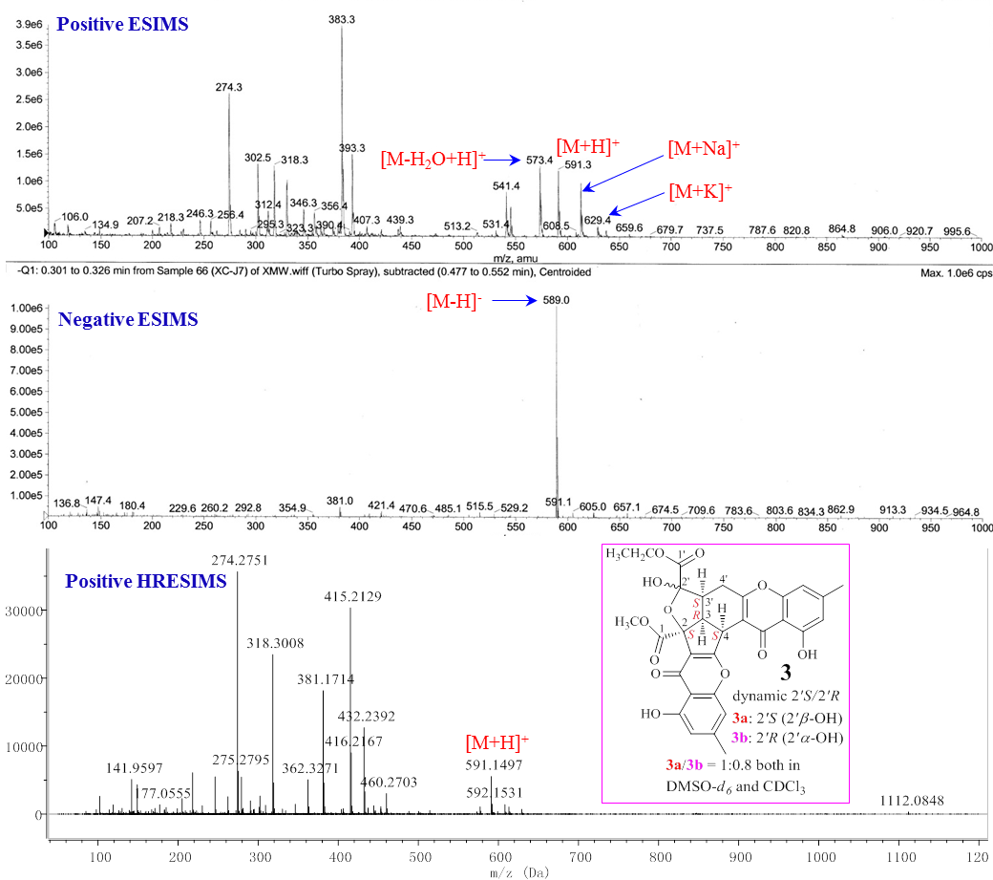
Figure S27. ESIMS and HRESIMS spectra of 3.
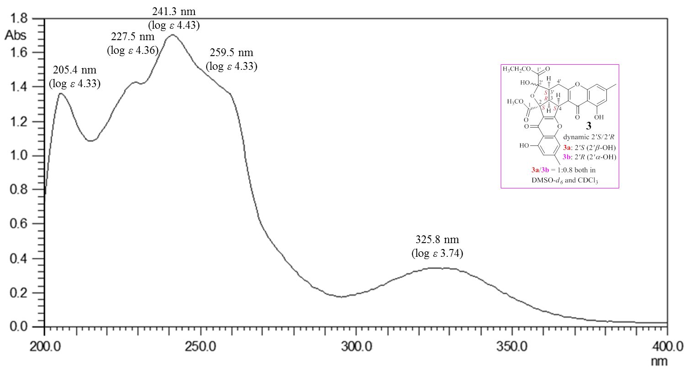
Figure S28. UV spectrum of 3 in MeOH.
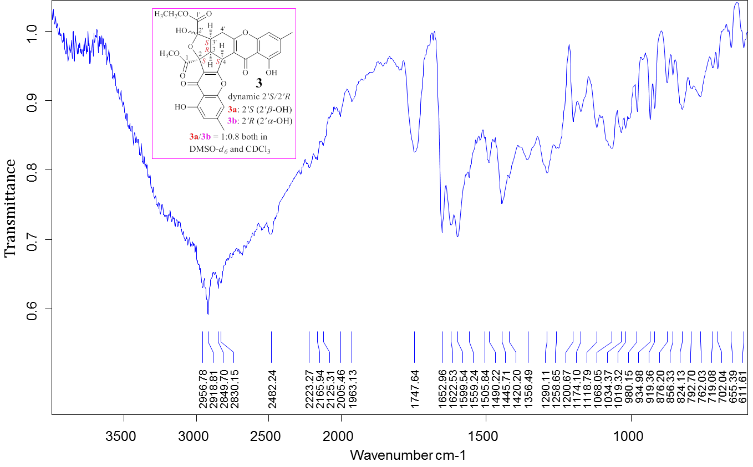
Figure S29. IR spectrum of 3.
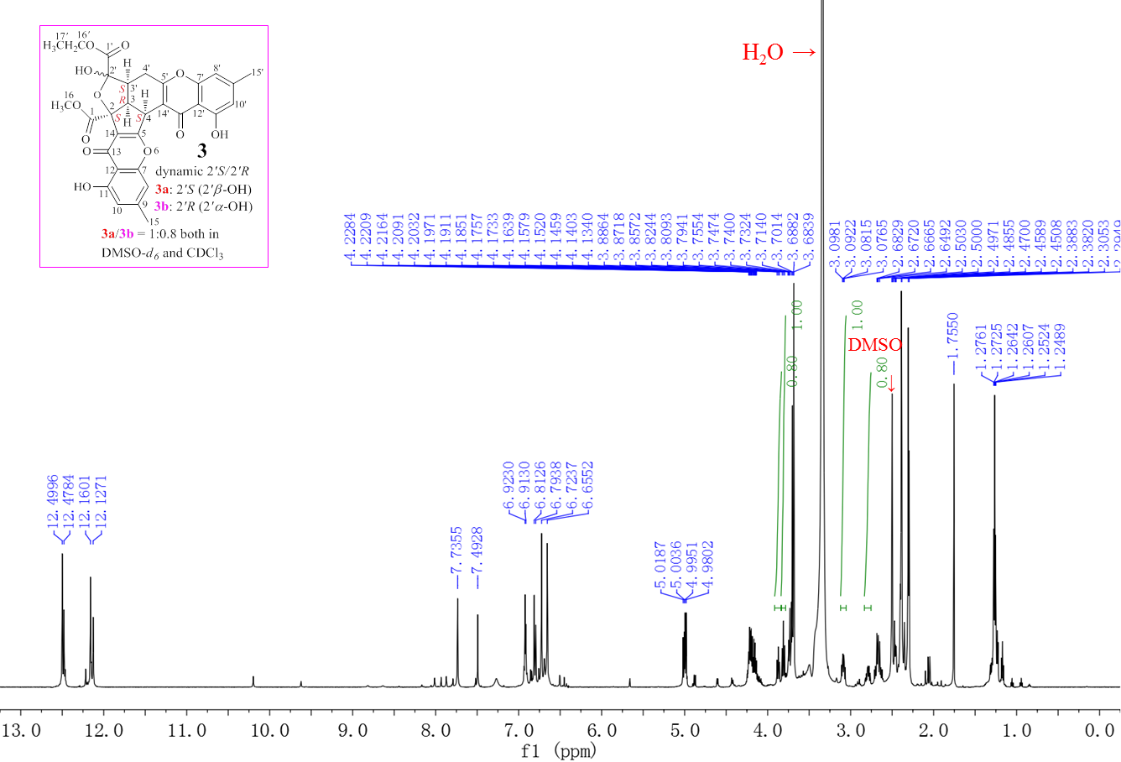
Figure S30. 600 MHz ¹H NMR spectrum of 3 in DMSO-d₆.
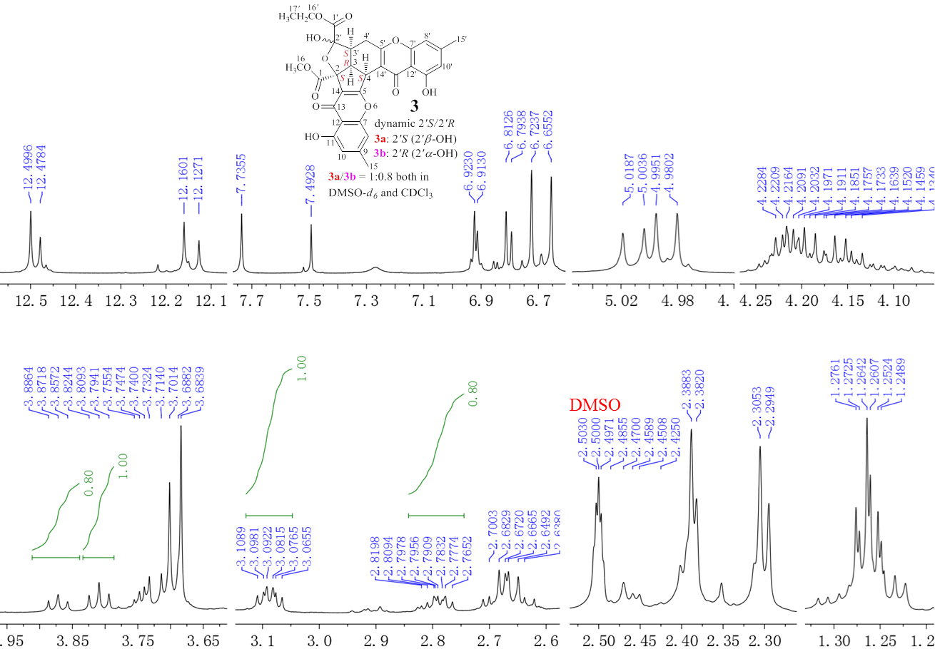
Figure S31. Expanded 600 MHz ¹H NMR spectrum of 3 in DMSO-d₆.
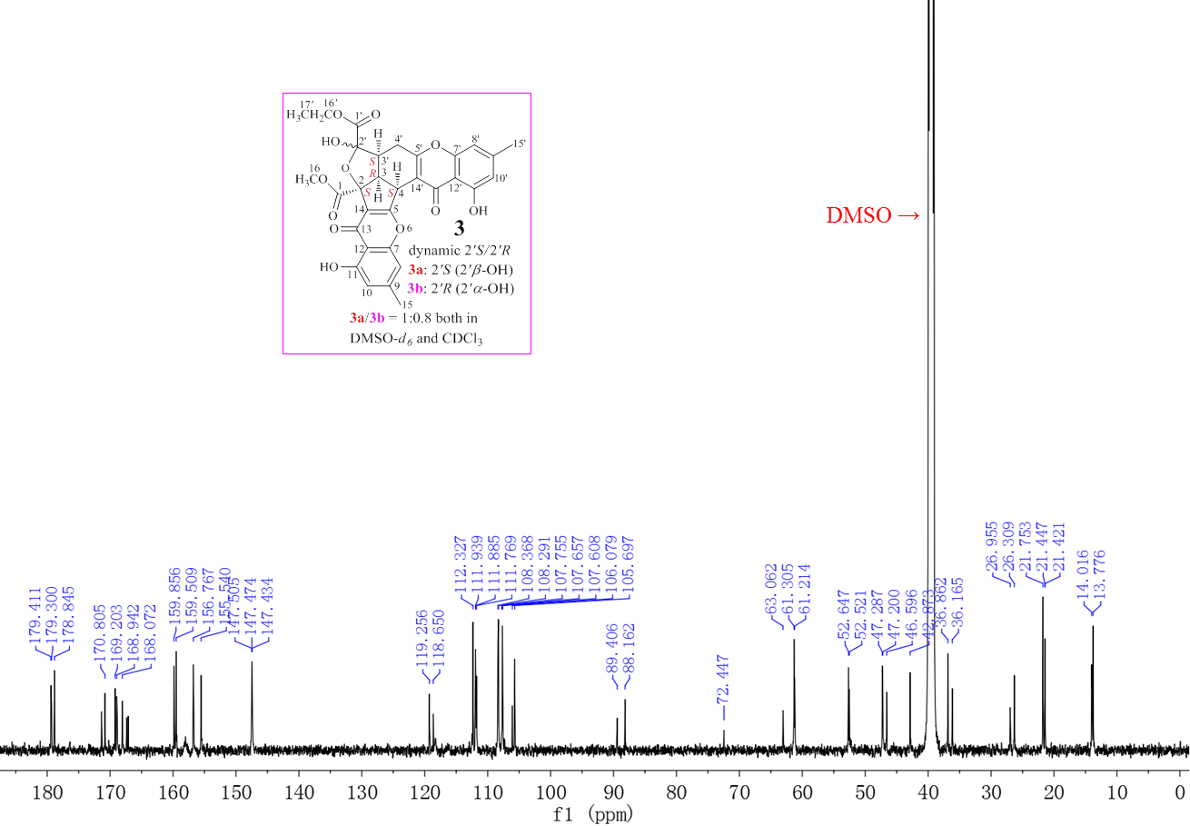
Figure S32. 150 MHz ¹³C NMR spectrum of 3 in DMSO-d₆.
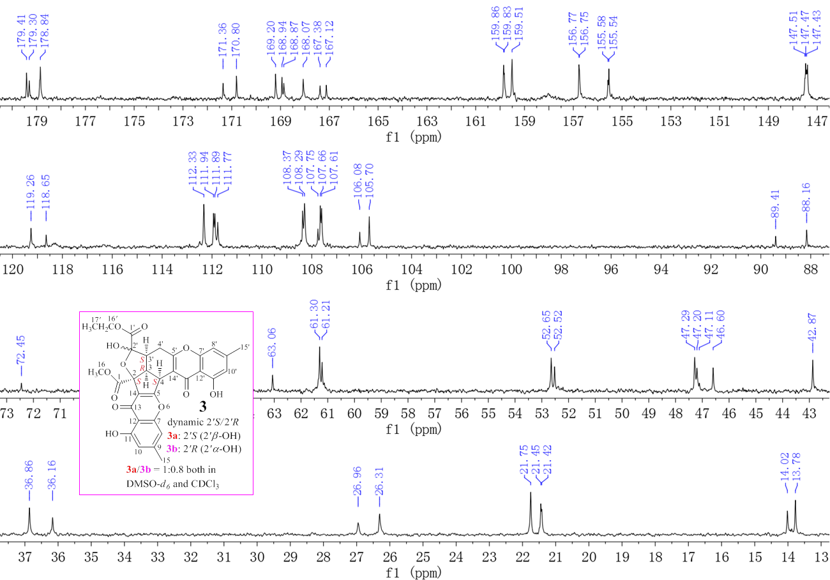
Figure S33. Expanded 150 MHz ¹³C NMR spectrum of 3 in DMSO-d₆.
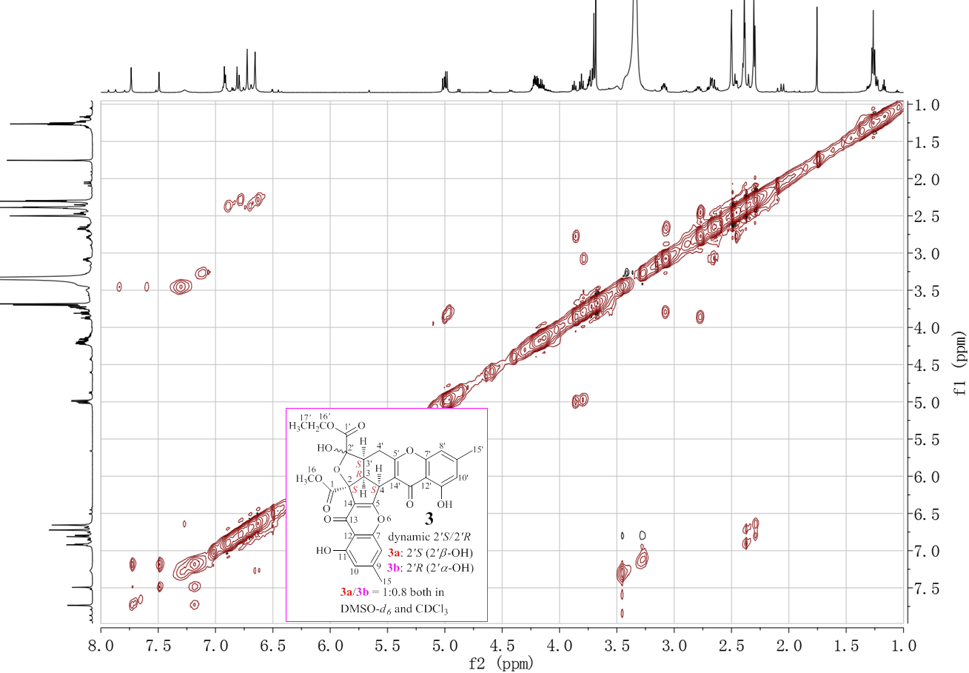
Figure S34. 600 MHz NOESY spectrum of 3 in DMSO-d₆.
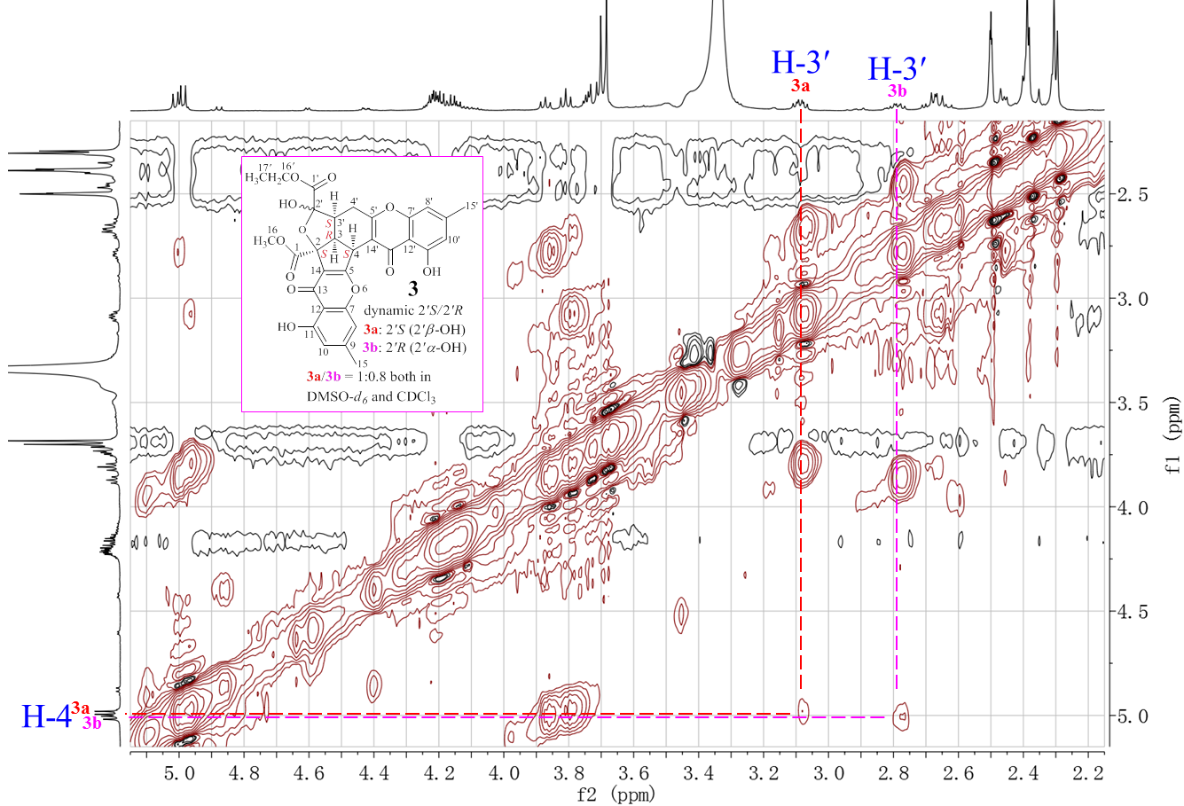
Figure S35. Expanded 600 MHz NOESY spectrum of 3 in DMSO-d₆.

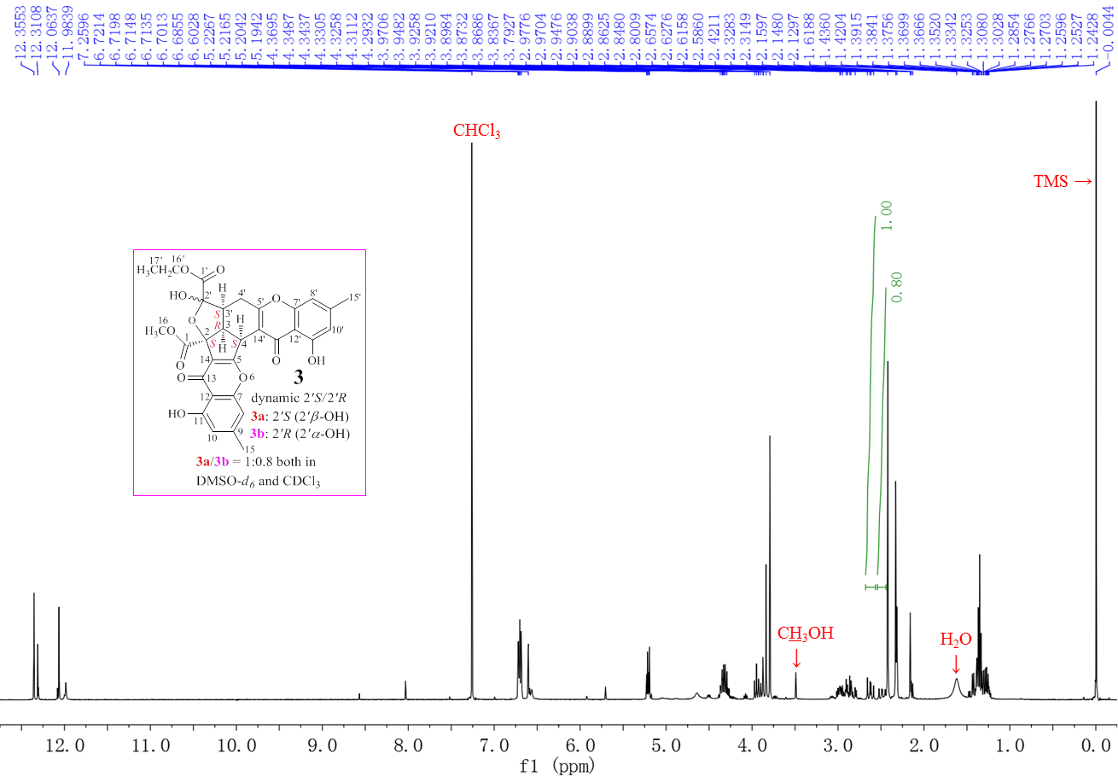
Figure S36. 400 MHz ¹H NMR spectrum of 3 in CDCl₃.
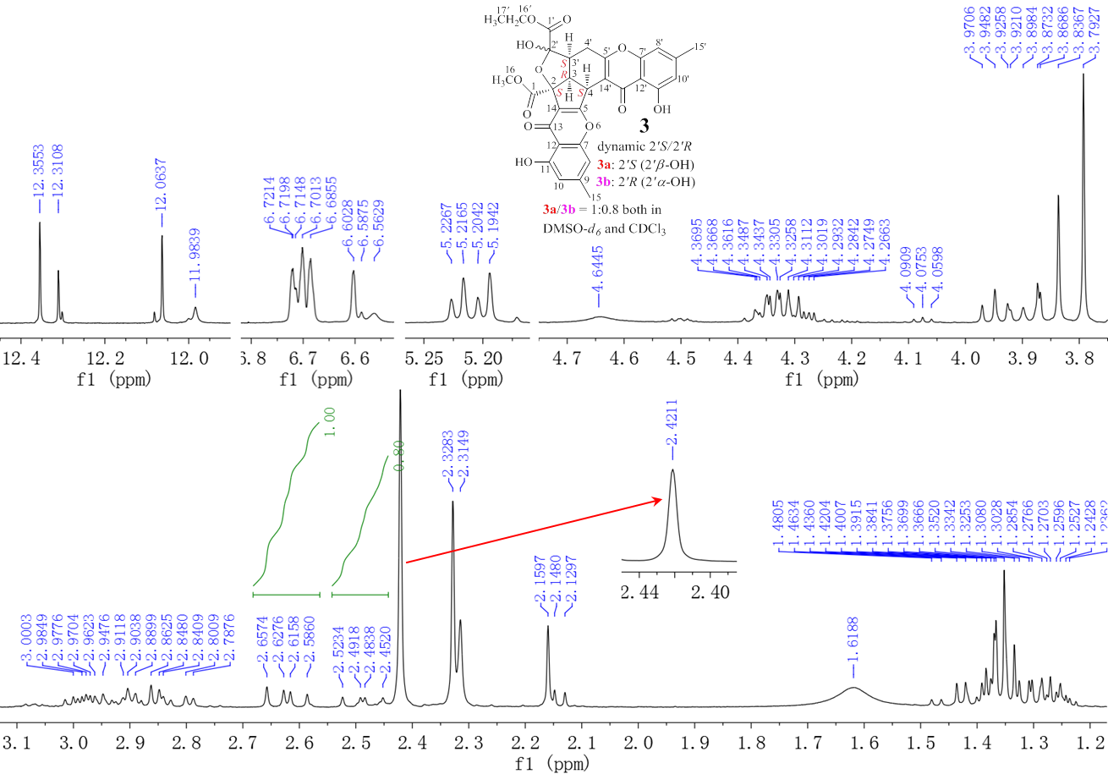
Figure S37. Expanded 400 MHz ¹H NMR spectrum of 3 in CDCl₃.

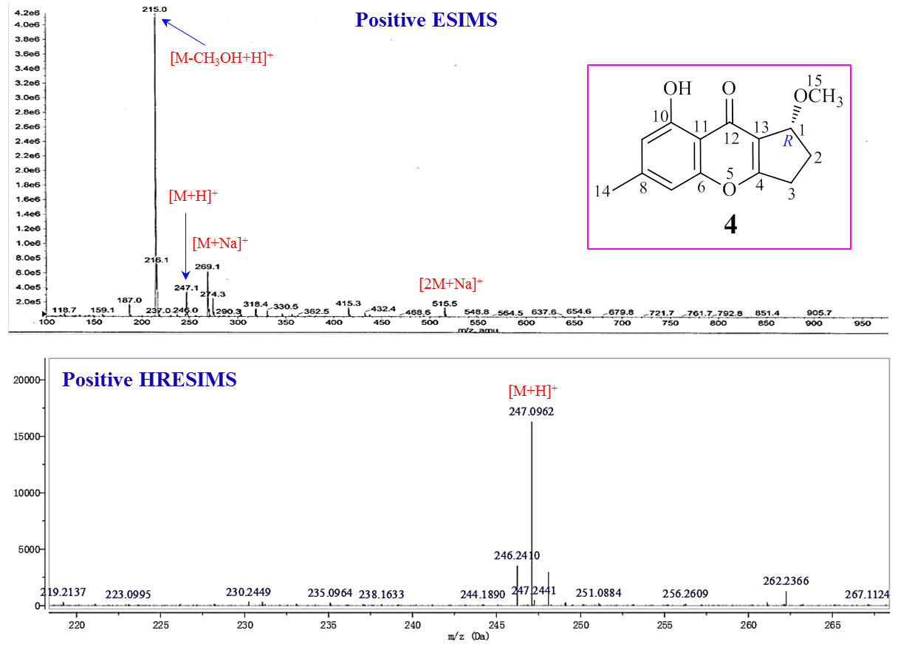
Figure S38. ESIMS and HRESIMS spectra of 4.
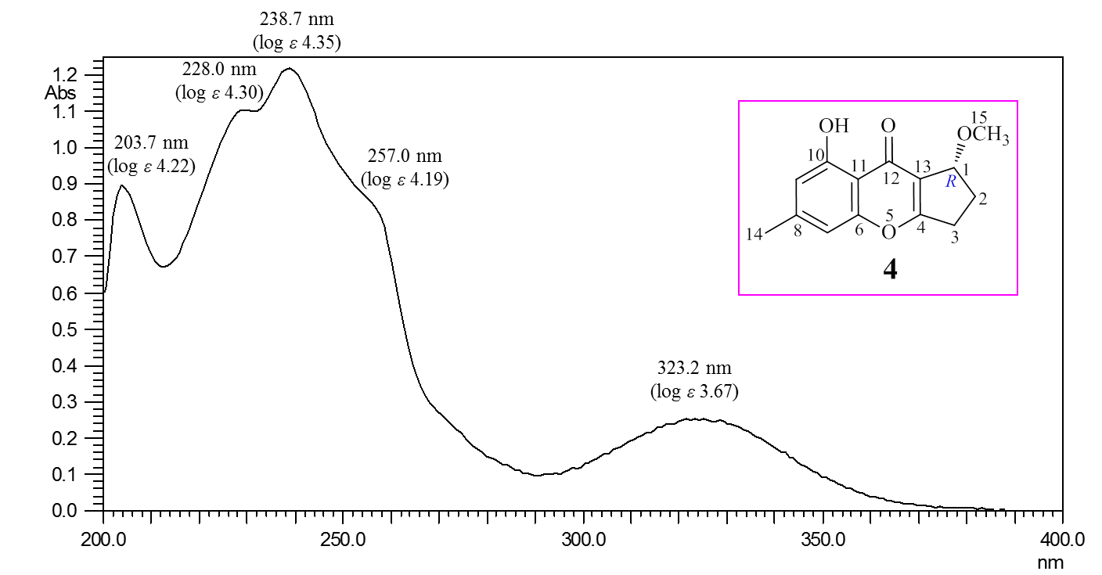
Figure S39. UV spectrum of 4 in MeOH.

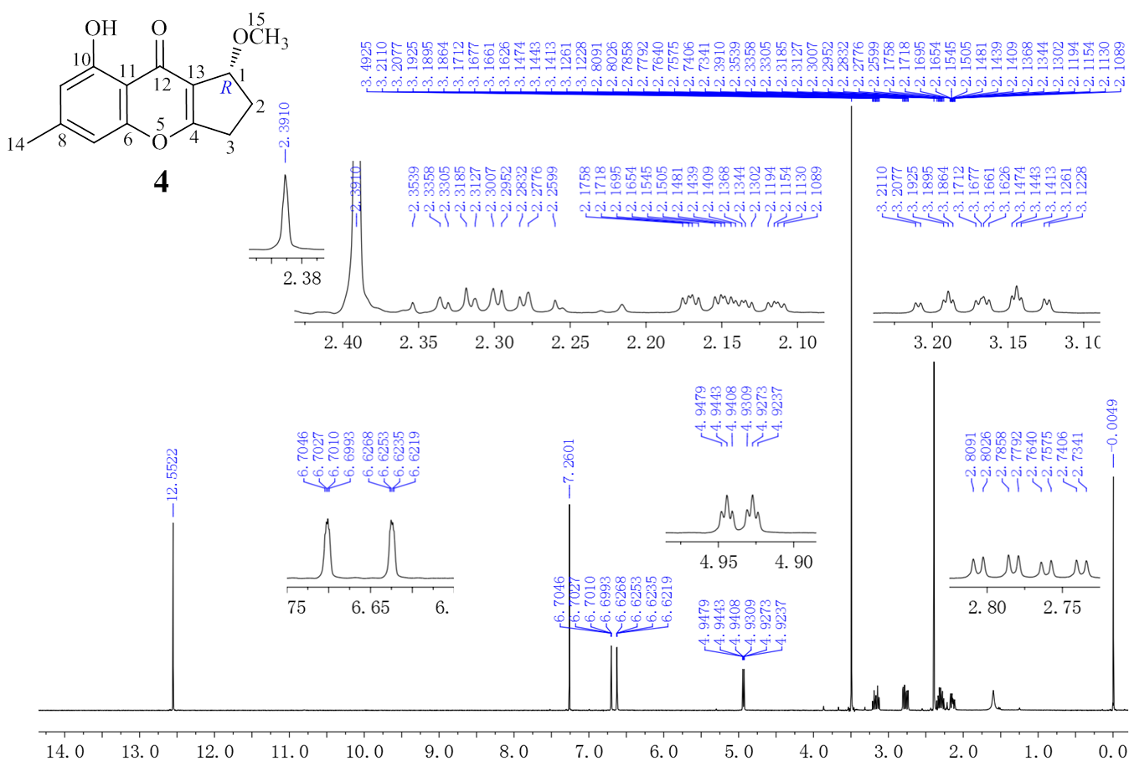
Figure S40. 400 MHz ¹H NMR spectrum of 4 in CDCl₃.
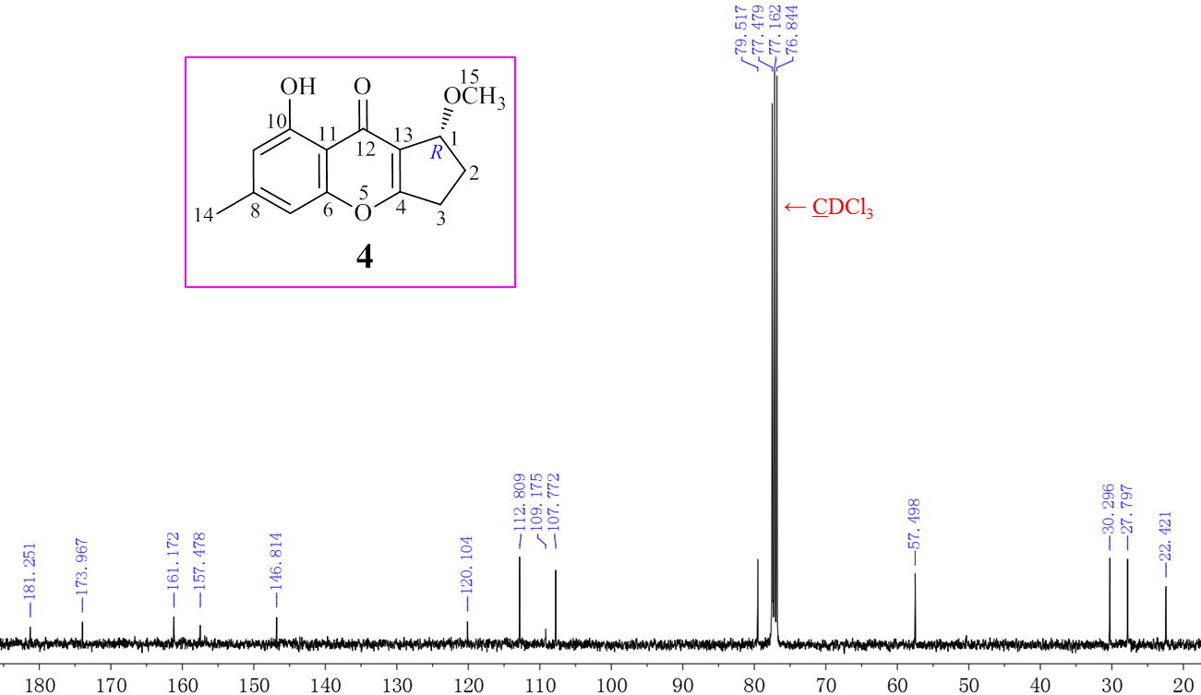
Figure S41. 100 MHz ¹³C NMR spectrum of 4 in CDCl₃.

