Supplementary Material:
Arabidopsis RabF1 (ARA6) Is Involved in Salt Stress and Dark-Induced Senescence (DIS)
Congfei Yin, Sazzad Karim, Hongsheng Zhang and Henrik Aronsson
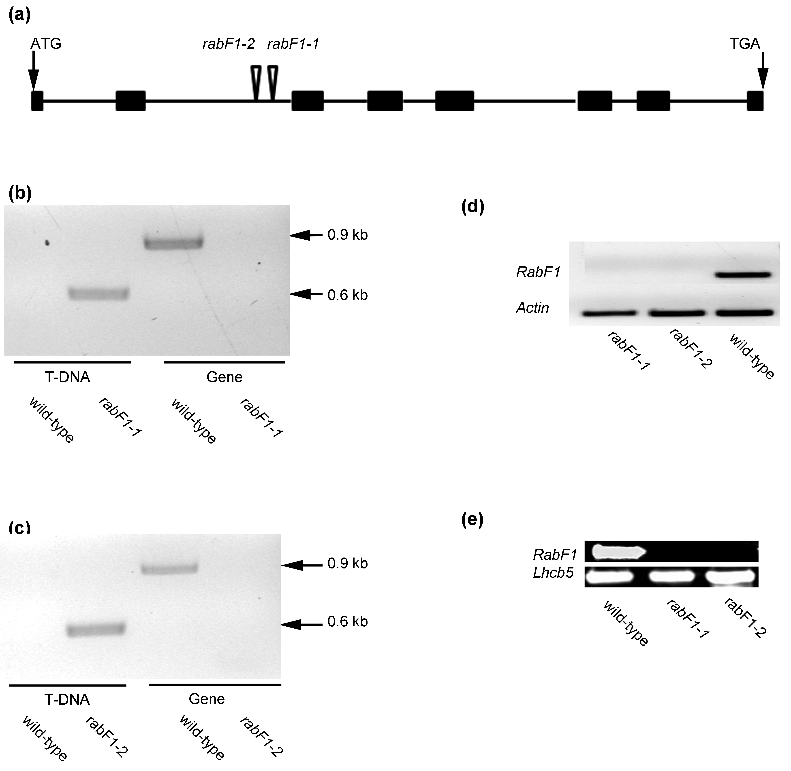
Figure S1. Verification of two knockout lines of RabF1. (a) Two Arabidopsis T-DNA insertion mutants of RabF1, rabF1-1 and rabF1-2 were collected with Col-0 as the wild-type background from NASC. The diagram shows the T-DNA insertion sites (triangles) of mutants to create the knockout mutants. Black boxes represent exons of RabF1; (b–c) PCR analysis revealed single PCR fragments from rabF1-1 and rabF1-2 genomic DNA when using the RabF1 gene and inserted T-DNA-specific primers (T-DNA) but no fragments from upstream or downstream of the RabF1 gene-specific primers (Gene), suggesting a homozygous condition in both lines for their knockout insertion. The corresponding fragment from the RabF1-related primers in wild-type genomic DNA was used as a control; (d) RT-PCR analysis showed rabF1-1 and rabF1-2 lacking the expression of RabF1 while the wild-type expressed RabF1. Actin was detected in similar amounts in each lane; this was used as a control for equal loading; (e) RabF1 is detected in the total leaf extract of wild-type plants but not in rabF1 knockout mutants (rabF1-1 and rabF1-2). Western blot was performed using a RabF1-specific antibody and the expected size of full RabF1 22 kDa, was detected. Detection of RabF1 was performed in 5 µg of total leaf extract per lane for all the lanes.
Figure S2. Different complementary transgenic lines overexpress RabF1. Expression of RabF1 in different transgenic lines overexpressing RabF1 compared to the wild-type. (a) RabF1^{OE} (35S-RabF1-EYFP) lines overexpressing RabF1 without any change; (b) Constitutively active RabF1^{Q93L} (35S-RabF1^{Q93L}-EYFP) lines overexpressing RabF1; (c) Dominant negative RabF1^{S47N} (35S-RabF1^{S47N}-EYFP) lines overexpressing RabF1. (d) Myristoylation RabF1^{Δ1–29} (35S-RabF1^{Δ1–29}-EYFP) lines overexpressing RabF1.
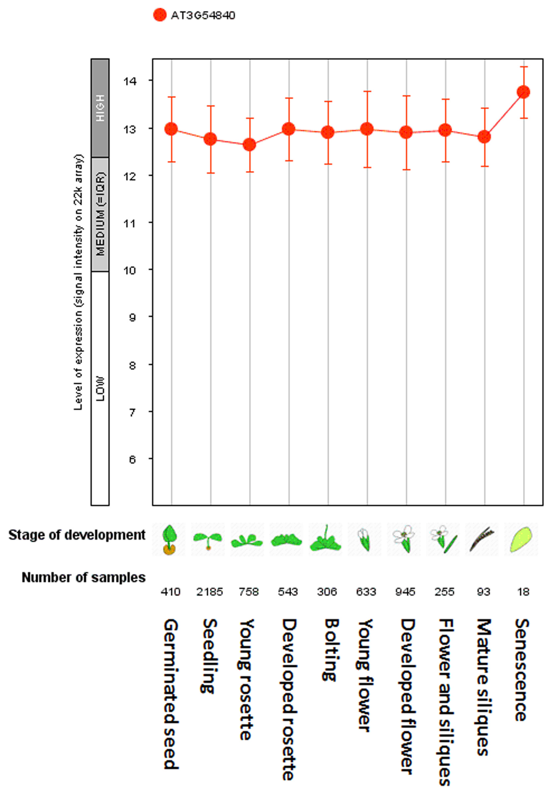
Figure S3. Expression of RabF1 at different developmental stages of Arabidopsis. Developmental expression profile of RabF1 according to the publicly available Affymetrix GeneChip microarray data. Data were retrieved using the Genevestigator v3 analysis tool (www.genevestigator.com/gv/plant.jsp) and prepared with the Meta-Profile Analysis tool using development representations in scatter-plot format. Data from all high-quality ATH1 (22 k) arrays were analysed [24]. The plot shows that RabF1 has a high expression level throughout all tissues with the highest level in senescing tissues.

Table S1. Primers used for knockout mutant identification, construct, cloning and RT-PCR.
Name | 5′–3′ | Function
LB1 | GCCTTTTCAGAAATGGATAAATAGCCTTGCTTCC | knockout mutant identification
atrabF1-1LP | TTGGAGAAACCGAATTGATTG | knockout mutant identification
atrabF1-1RP | AACGAGGCTCCAACAGTTACC | knockout mutant identification
P745 | AACGTCCGCAATGTGTTATTAAGTTGTC | knockout mutant identification
atrabF1-2LP | TTTCCGAAGGTGTAATCATCG | knockout mutant identification
atrabF1-2RP | TTCACTCACATCAGAGCATGG | knockout mutant identification
EGFP Rev | CTGAAGCACTGCACGCCGTAGGTCAG | construct
EYFP Rev | GCGAAGCACTGCAGGCCGTAGCCGAA | construct
AtRabF1^{∆1–29}For | CACCATGGGTCAGTTTGACGCTACA | cloning
AtRabF1For | CACCATGGGATGTGCTTCTTCTCTT | cloning
AtRabF1Rev | TGACGAAGGAGCAGGACGA | cloning
RabF1^{QL} For | TGGGATACAGCAGGACTGGAGAGGTATTAAACC | cloning
RabF1^{QL} Rev | GGTTTAATACCTCTCCAGTCCTGCTGTATCCCA | cloning
RabF1^{SN} For | TCTGGTGTTGGTAAAAATTGTATTGTCC | cloning
RabF1^{SN} Rev | GGACAATACAATTTTTACCAACACCAGA | cloning
AtRabF1For | ATGGGATGTGCTTCTTCTCTT | RT-PCR
AtRabF1Rev | AGCAGAATACCTCTCCTGTCC | RT-PCR
ActinFor | AGAGATTCAGATGCCCAGAAGTCTTGTT | RT-PCR
ActinRev | AACGATTCCTGGACCTGCCTCATC | RT-PCR
SEN1 For | GTCATCGGCTATTTCTCCACCT | RT-PCR
SEN1 Rev | GTTGTCGTTGCTTTCCTCCATC | RT-PCR
LHCB1.3 For | CCAGAGGCATTCGCTGAGTTG | RT-PCR
LHCB1.3 Rev | CCTTACCAGTGACGATGGCTTG | RT-PCR
RBCS1A For | CCACCCGCAAGGCTAACAAC | RT-PCR
RBCS1A Rev | TTCGGAATCGGTAAGGTCAGG | RT-PCR
SAG12 For | CAGCTGCGGATGTTGTTG | RT-PCR
SAG12 Rev | CCACTTTCTCCCCATTTTG | RT-PCR

